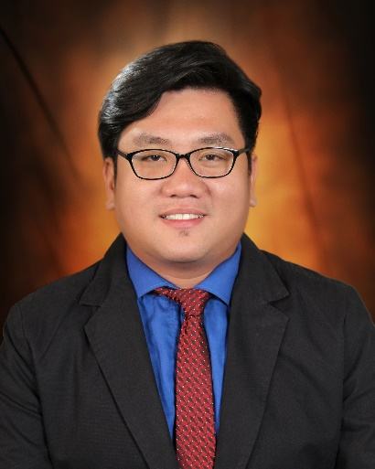

To secure a challenging position in a reputable organization to expand my learnings, knowledge, and skills.

**Rick Ryan A. Medillo**

**BACHELOR OF SCIENCE IN INFORMATION TECHNOLOGY**

**CAREER OBJECTIVE**

**Gender:** Male

**Age:** 35 Years Old

**Civil Status:** Single

**Religion:** Roman Catholic

**Citizenship:** Filipino

**Personal Background**

**REFERENCES**

September 1, 1986

**Date of Birth**

**E-mail**

*rickryan29.rr@gmail.com*

**Contact**

St. Joseph village, Tunghaan Minglanilla, Cebu

**Address**

Phone: 0961 - 133 - 5934

**DR. ALFREDO MORENO, JR.**

*Dean, College Department*

*St. Cecilia’s College - Cebu*

490-0767 / 0929-6621878

**TECHNICAL SKILLS**

**PERSONAL SKILLS**

* **Web Development** (HTML5, CSS3, Javascript , PHP & Bootstrap, Rest Api)
* **Adobe Creative Suite:** Photoshop, Dreamweaver & Flash
* **Microsoft Office:** MS Word, Excel, Powerpoint, etc
* **Framework:** Angular

**Primary School**

**(1999 - 1993)**

*Tungkop Elementary School*

Tungkop, Minglanilla, Cebu

**Secondary School**

**(2003 - 1999)**

*Siena School of Naga*

Naga, Cebu

**Bachelor of Science in Information Technology**

**(2014 – 2017)**

*St. Cecilia’s College - Cebu*

Poblacion, Ward II, Minglanilla, Cebu

**EDUCATIONAL BACKGROUND**

* Highly organized and efficient
* Ability to work independently or as part of a team
* Proven leadership skills and ability to motivate

**ACHIEVEMENTS**

**PRE-PROFESSIONAL EXPERIENCE**

**Graphic Artist - OJT**

Jomacker Photo Editing (June 2016 – Aug 2016)

1524 Charity St., Belmont Village, Minglanilla, Cebu

*Editing and Retouching Pictures*

* **Academic Awards** **(2017)**

Best in Web Development

* **Special Awards (2017)**

Technopreneurship / Capstone Awards - “Online Public Access Catalog”

**WORK EXPERIENCE**

* **CeNix Web Development / Aza Connect Center**

4/F 82 Vibo Center, N Escario St. Cebu City

(032) 231 8743

July 2017 – Feb 2020

* Home Based / Part –Time

**Front Developer**

2016 - 2017

Gorordo Ave, Lahug, Cebu City, Cebu

(032) 414-1438

July 2017 – Feb 2029

018

* **Portfolio**

Website Link:

<https://kcirnayr.000webhostapp.com/>

**PUBLISH WORK**

* **St. Cecilia’s College – Cebu Library**

Website Link:

https://rickmedillo.000webhostapp.com/

* **Ruvi Cave Resort**

Website Link:

https://ruvicaveresortcebu.000webhostapp.com/

I declare that the above information given is true and correct. I affix my signature as a proof.



Rick Ryan A. Medillo