1. add ChangeApp.js and ChangeApp.css to src folder in any development project

2. in index.js file simply do the following:

a) add an import for ChangeApp:

import ChangeApp from './ChangeApp';

b) render ChangeApp in ReactDOM:

ReactDOM.render(<ChangeApp />, document.getElementById('App'));

Unfortunately the github link didn’t work. It gave me an error:

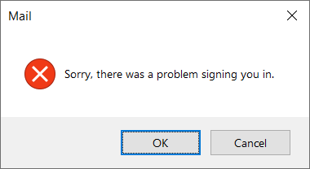

App screenshot:

