Program launch support

Dialog boxes provide an interface for running and debugging StreamIt programs that mirror Eclipse’s Java launching mechanisms (Figure 10).

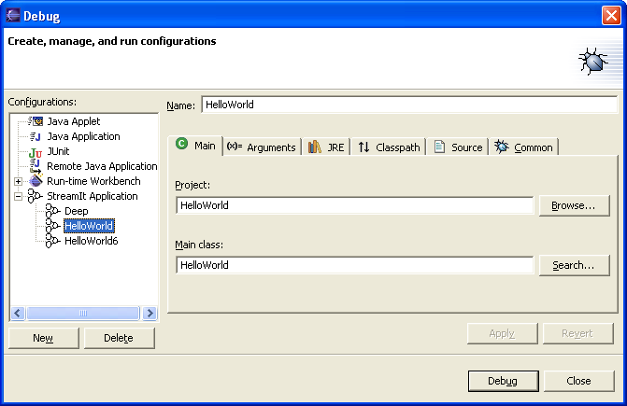
Figure 10: Disabled selections in the pop-up menu (left) and drop-down menu (right).

