StreamIt syntax highlighting

A graphical text editor provides default StreamIt syntax highlighting (Figure 1) and a preference page for adding and deleting keywords (Figure 2).

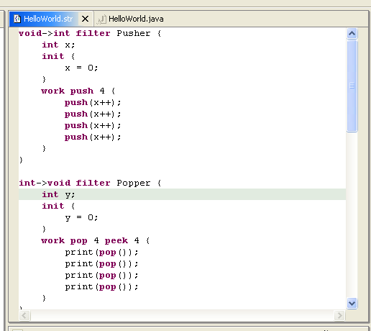
Figure 1: A StreamIt text editor window with default syntax highlighting.

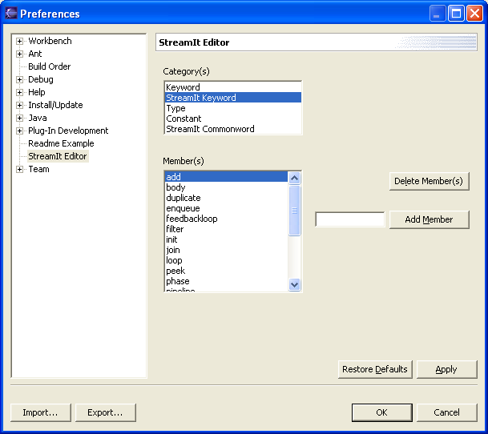
Figure 2: A preference page for adding and deleting StreamIt keywords.

