Data display, modification, and tracking

Methods for viewing data in a channel vary depending on how much data is in the channel. By default, the size of all channels in the graph is set to only allow three data to be shown because the number of data can often grow to an un-manageable size. When the user wants to view more the rest of the data, the plus and minus boxes found next to the channels can be clicked to expand the channel length-wise (Figure 18). The plus and minus boxes and the size of the channel displayed under the boxes all indicate what is currently being shown in the channel. Another option for viewing channel data is by right-clicking on a channel and selecting “Show Channel Values” from the pop-up menu (the selection is grayed-out when there is no data in the channel, etc). A dialog box displays all channel data, which is useful when the width of the data exceeds a channel (Figure 19). Using a read-only text box prevents the user from trying the change the data values, which must be done with the “Change Channel Values” option in the pop-up menu. Furthermore, each datum is displayed on a new line, which mirrors the vertical channel format of the graph window.

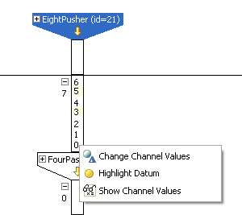
Figure 18: An expanded channel that has highlighted values in yellow. The pop-up menu allows the user to change channels values, highlight data, and show channel values in a dialog box.

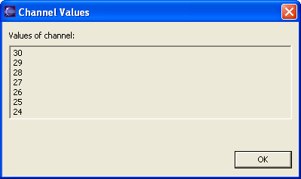
Figure 19: A dialog box for showing all of the data within a channel.

The graph window’s pop-up menu also allows the user to change channel values and highlight and unhighlight data. For the former task, a dialog box similar to the “Show Channel Values” dialog appears, enabling the user to modify all of the channel data at the same time (Figure 20). Entering in incorrect data is prevented and causes an “Invalid value(s)” to appear directly below the text box. There are two ways of highlighting and unhighlighting data: (1) right-clicking on “Highlight Datum” (Figure 18) or “Unhighlight Datum” (Figure 21) depending on whether the datum is currently highlighted and (2) double-clicking on a datum, toggling the datum between a highlighted and unhighlighted state.

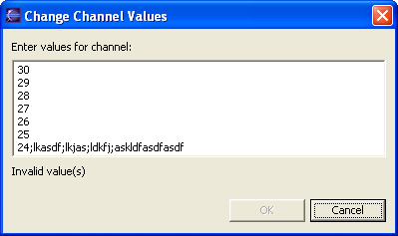
Figure 20: A dialog box for modifying data within a channel.

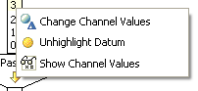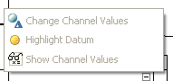
Figure 21: Enabled and disabled states of the graph window pop-up menu.

