Creating your first StreamIt project

In this section, you will create a new StreamIt project. You will be using a StreamIt program called Minimal as your example project. Refer to http://cag.lcs.mit.edu/streamit/papers/streamit-cookbook.pdf for more information on Minimal.

- Select the menu item File > New > Project… to open the New Project wizard.
- On the left pane of the first wizard page, select StreamIt, and on the right pane, select StreamIt Project. Then click Next.
- On the next page, type "Minimal" in the Project name field and click Finish. A StreamIt perspective opens inside the workbench with the new StreamIt project in the Package Explorer. When the StreamIt perspective is active, new menu options are loaded in the workbench toolbar. Depending on which view or editor is active, other buttons and menu options will be available.

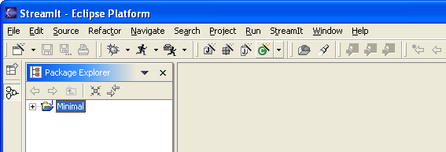
Creating a new StreamIt project

