Creating a StreamIt file

In this section, you will learn how to create a StreamIt file. You will also learn about some of the basic StreamIt editor features.

- Select the project Minimal in the Package Explorer.
- Select the menu item File > New > File.
- In the New File wizard, type “Minimal.str” in the File name field and click Finish. Streamit files must have “str” as their file extension.
- The StreamIt Development Tool has an editor capable of editing StreamIt files. A StreamIt editor is automatically opened on the newly created file.
- In the StreamIt Editor, type in the following twenty lines:

void->void pipeline Minimal {
add IntSource();
add IntPrinter();
}
void->int filter IntSource {
int x;
init {
x = 0;
}
work push 1 {
push(x++);
}
}
int->void filter IntPrinter {
init {
}
work pop 1 {
print(pop());
}
}
- In the Workbench window’s toolbar, click the Save button to save your work.
- Notice the syntax highlighting. Different kinds of elements in the StreamIt source are rendered in unique colors. Examples of StreamIt source elements that are rendered differently are:
  - Regular comments
  - Keywords
  - Strings.

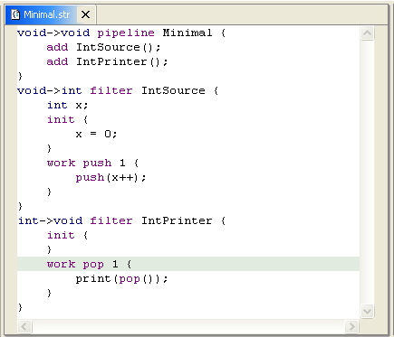

- Look at the Outline view. It displays an outline of the StreamIt file including fields, methods, and stream types. The Outline view uses icons to annotate StreamIt elements. For example, icons indicate whether a StreamIt element is a method () or field (). Different icons show you whether a stream type is a filter (), pipeline (), splitjoin (), or feedbackloop ().

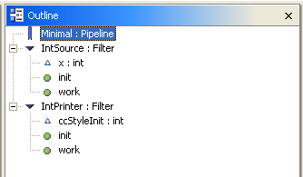

StreamIt syntax highlighting

Creating a new StreamIt file
Using the StreamIt editor
Modifying StreamIt syntax highlighting

