Compiling changes in a StreamIt file

In this section, you will learn more about compiling StreamIt programs in the workbench.

- In the Package Explorer view, find Minimal.str and double-click it to open it in an editor.
- Select StreamIt > Compile Changes. This will compile the source in the active editor, or the selected file in the Navigator, to an intermediary Java file.

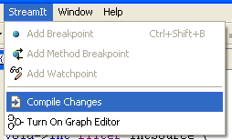

- Notice that the program has finished compiling and a Minimal.java file appears in the Package Explorer.

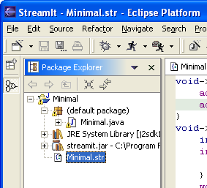

- You should compile changes to a StreamIt file whenever you would like to add breakpoints or watchpoints.

Breakpoints and watchpoints

Compiling a StreamIt program
Breakpoints

