Identifying problems in your code

In this section, you will review the different indicators for identifying problems in your code.

Compile problems are displayed in the Tasks view and annotated in the vertical ruler of your source code.

- Open Minimal.str in the editor from the Package Explorer view.
- Add a syntax error by deleting the semicolon at the end of the second line in the source code.

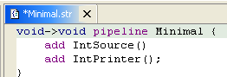

- Click the Save button. Select StreamIt > Compile Changes. The file is recompiled and the problem is indicated in several ways:
  - In the Tasks view, the problems are listed,
  - In the Package Explorer view, problem ticks appear on the affected StreamIt file.
  - In the editor's vertical ruler, a problem marker is displayed near the affected line,
  - Squiggly lines appear under the word which might cause the error, and
  - The editor tabs are annotated with a problem marker.

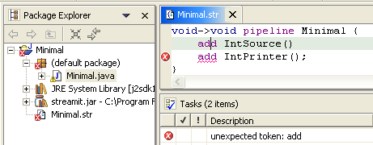

- You can hover over the problem marker in the vertical ruler to view a description of the problem.

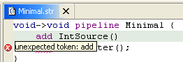

- Click the Close button on the editor's tab to close the editor.
- In the Tasks view, select a problem in the list. Open its context menu and select Go To. The file is opened in the editor at the location of the problem.

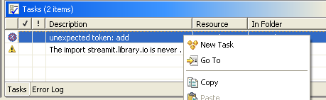

- Correct the problem in the editor by adding the semicolon. Click the Save button. Select StreamIt > Compile Changes. The project is recompiled and the problem indicators disappear.

Compiling a StreamIt program
Viewing compilation errors and warnings

