Viewing a Stream graph

In this section, you will view the Stream graphs of a StreamIt program.

- In the Package Explorer view, find Minimal.str and double-click it to open it in an editor.
- Place your cursor on the vertical ruler along the left edge of the editor area on line 11:

push(x++);

and double-click on the ruler to set a breakpoint. Repeat the same process on line 18.
- In the Package Explorer view, select the Minimal.str and select the Run menu. Within the Run menu, select Debug As, and then StreamIt Application.
- The program will run until the breakpoint is reached. Notice that the line where the breakpoint is set is highlighted, as are the corresponding IntSource filters in the Stream Graph view and Overview of Stream Graph view. The latter view is 75% smaller than the former view.

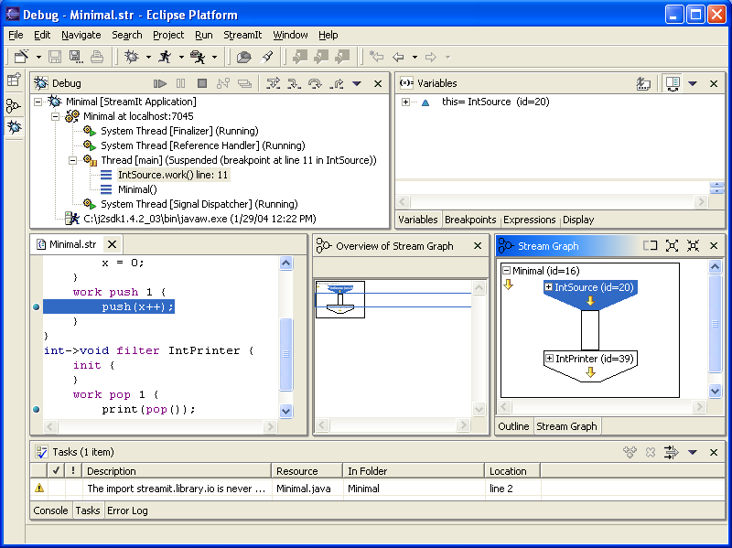

- To view more information about the IntSource filter, click on the plus within the IntSource.

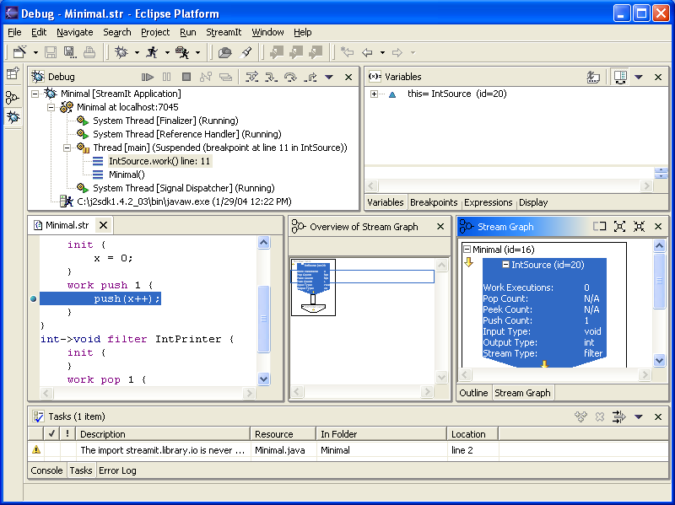

- Since the IntPrinter filter is now not visible in the Stream Graph view, click on the IntPrinter filter in the Overview of Stream Graph view to navigate the Stream Graph to its corresponding filter. Notice how a blue outline in the Overview of Stream Graph view moves what is currently being displayed in the Stream Graph view.

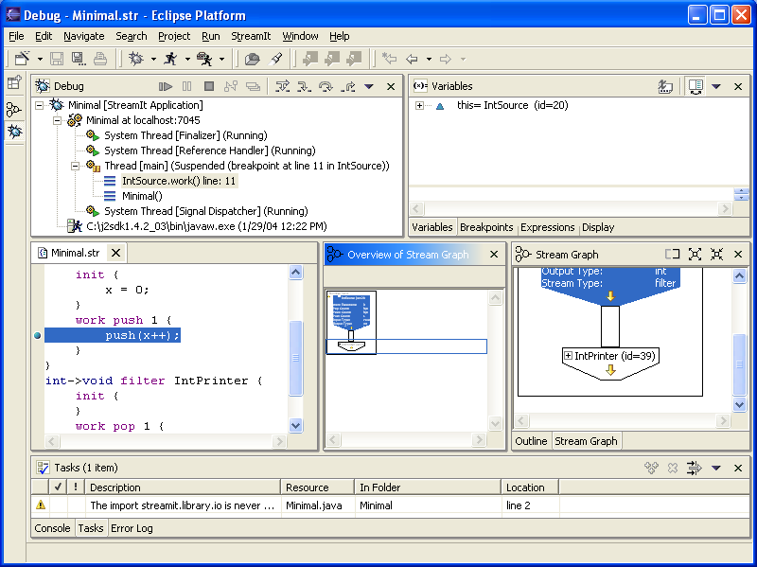

- Click the Resume button.
- Now, data within the Stream Graph view is visible on the channel connecting the IntSource and IntPrinter filters.

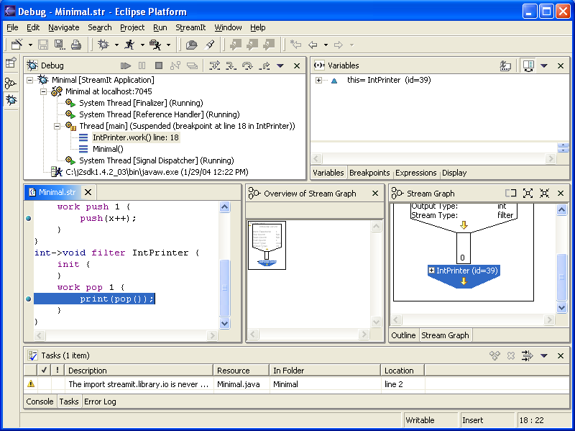

Breakpoints and watchpoints
Program launch support
General debugging support and Eclipse integration
Stream graph display and navigation

Local debugging
Launching a StreamIt program in debug mode
Resuming the execution of suspended threads
Breakpoints
Adding breakpoints
Viewing and navigating Stream graphs
Identifying stream elements and channels
Viewing information within stream elements
Navigating with the Overview of Stream Graph view

