Identifying stream elements and channels

Stream elements and channels in the Stream Graph view and Overview of Stream Graph view are represented as shapes that were chosen to suggest the type of stream the element was:

- A filter: 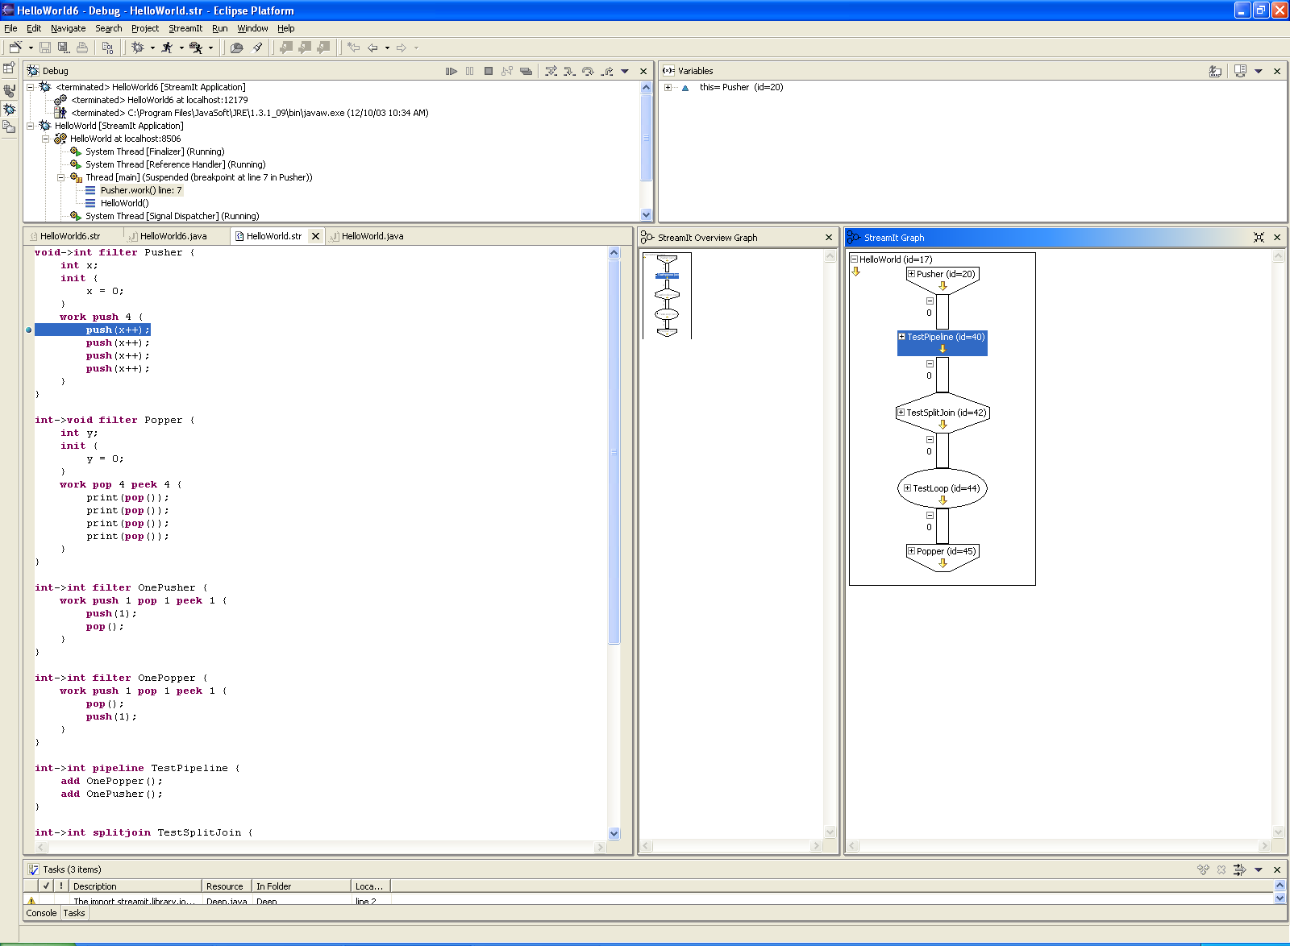

- A pipeline: 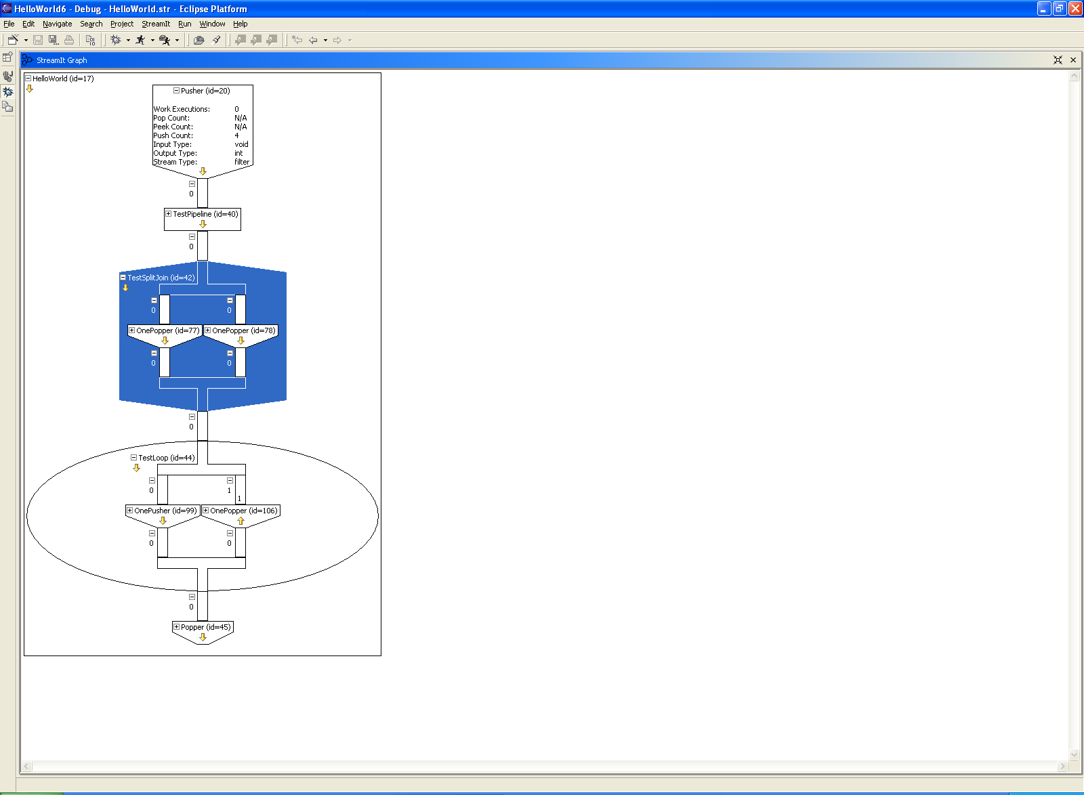

- A splitjoin:

- A feedbackloop:

- A channel:

General debugging support and Eclipse integration
Stream graph display and navigation
Data display, modification, and tracking

Viewing and navigating Stream graphs
Expanding and collapsing stream elements
Viewing information within stream elements
Hiding the lines of stream elements
Navigating with the Overview of Stream Graph view

