Richard Roath

CMSC 203 PM Spring

2/19/20

Lab 4

**Task #4 and #5**

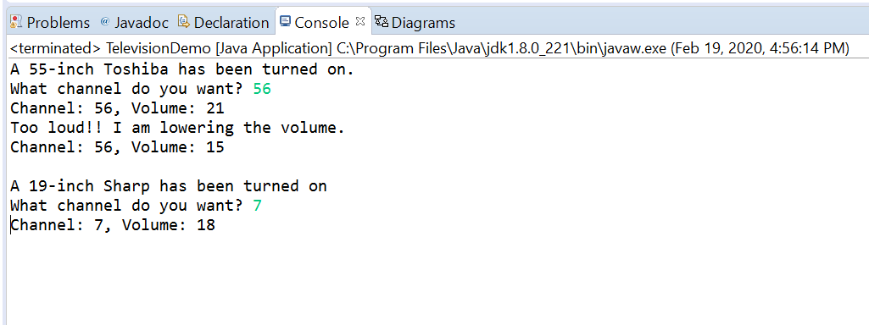

**Task #6**

