

GMS Data Analysis

João Pedro
Johannes Rajala
2007

Table of contents:

1 Introduction 1
2 Reasoning Process 1
2.1 Gathering Information 1
2.1.1 Data Sources 1
2.1.2 Data Mining 2
2.2 Re-Representation 3
2.2.1 Preliminary Usability Study 3
2.2.2 Presentation 3
2.3 Insight 6
2.3.1 Application Layout 6
2.4 Results 8
3 Conclusions 8
4 References 9

- Introduction
This paper, which is part of a project in Information Visualization course, explores relations between musical styles and country data in the whole world. Suitable source data was selected and interesting attributes were chosen. Suitable visualizations were tested and appropriate ones chosen.

Reasoning Process
The reasoning process was followed quite strictly. The followed approach was directed to an exploratory analysis of the data, given the fact that no assumptions existed about it; though, some confirmatory analysis has also been done. After the information has been collected, the visual representation of the data has been thoroughly analysed with usability studies and personal decisions. The choices produced a good insight of the data, which lead to also good results.

Gathering Information
The gathered information was collected from three different sources and was crossed using custom-built Data Miner.

Data Sources
The three sources of data had some shared attributes, making them, therefore, good for Data Mining. It should be noticed, however, that the data contained on the musical databases is not on a standardized format. This issue is discussed deeply on the Data Mining sub-section.

FreeDB.org
This database contains nearly 22 Million albums from the whole world. The extracted features from this database where:
- Album Name
- Artist Name
- Music Style Name

The database was downloaded completely – around 600 MB. The information was stored in ASCII format, in which each album was represented by a single file and stored in a hierarchical way – 11 folder representing global styles of music, e.g.: rock, pop, etc.

MusicBrainz.org
The MusicBrainz database is much smaller than the FreeDB database, but it contains important features to be crossed with latter. This database is also downloadable, but it requires the installation of a SQL server, and all the scripts to create and set it up are done in Linux. Therefore, the decision of using a C# Client was made. The client was embedded in out Data Mining application, and information was fetched using Internet.
The data attributes fetched from this database where:
- Albums releases years
- Release Countries
- Artists

CIA World Factbook
The CIA World Factbook is a huge collection of data available online in HTML format – usually in form of tables. It is completely up to date and it contains lots of relevant information per Country.
It has been decided that just a small group of attributes would be collected to join the other collected data, since the Data Mining must be done manually – copy, pasting and formatting in Excel – and is just a part of the process of creating the whole application.
The chosen attributes where:
- List of Countries
- Per Country
    - Government Type
    - Median Age
    - GDP per Capita
    - Unemployment Rate

Data Mining

Manually Parsing Data
Some data, as referred before, was mined manually due to limitations on format and other issues. The data collected from the CIA’s World Factbook database was copied from HTML to Excel format. Once in Excel, the data was added as column attributes per country.
The other database that required manual parsing was FreeDB. Some files contained albums written in Unicode format, but the MusicBrainz’s database did not support that format. For each of the 11 music styles, an output file was generated with the result of parsing all the input files on that folder (mentioned in the previous section) and skipping the ones containing only Unicode characters.

Musical DataMiner Application
The Musical DataMiner application (seen on Picture XXXXX) was created to fetch the data from the MusicBrainz online server, cross that data with FreeDB and World Factbook databases and produce a final, serializable result in a format convenient (common data structures like Hashtables and Lists) for further usage on the final application.
The application was developed for Multithreaded usage and to be able to stop and restart on the previously stop point. It also contains a feature to filter data for European countries only – the reasons for that are explained further on the document.

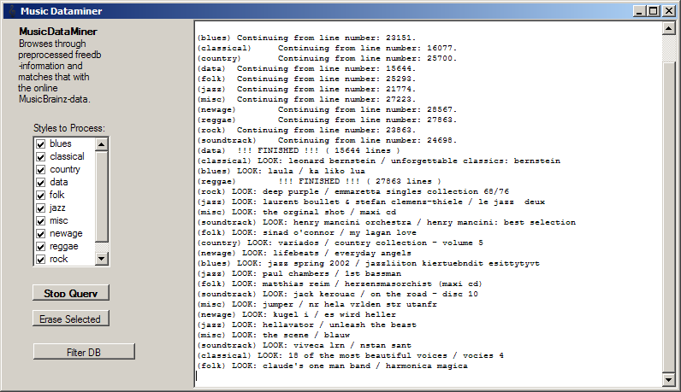
Figure 1 - Music DataMiner Application

Re-Representation

Preliminary Usability Study
With the gathered data, it is possible to draw some conclusions, but in order to have an insight to the data proper visualizations have to be chosen. Already in an early phase, simple qualitative user studies were performed in order to obtain information in the selection of:
- Colours
- Interfaces and Visual Representation
- Correct and Easy interaction

These studies were helpful and provided new views and ideas to visualize even more items that are interesting.

One of the problems in visualization was the large amounts of nominal data. Such nominal attributes as:
- Country names
- Albums and Artists
- Government Types
- Music styles

Many of the attributes can be considered as ordinal data and while it was possible to show these on parallel coordinates, the treemap was considered more informative when comparing this kind of ordinal data.

Presentation

For the visualizations the three connected views, Geographical Map, Treemap, and Parallel Coordinates with a simple table lens to increase perception, was observed to be optimal.

Geographical Map
As the gathered information was strongly connected to the countries of the world, using a geographical map provided very informative and quick to adapt to interface even for the non-experienced users.

Glyphs
Here instead of using generic types of glyphs, such as pie charts or Chernoff faces, users seemed to prefer the customized descriptive glyphs instead. The glyphs were stacked on top of each other, and the highest pile represents highest values in that attribute.

 |  | 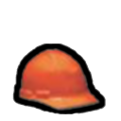 | 
Albums | GDP | Employment | Median Age

Colours
The colour is linked with the other views, and can be selected to show either different attributes or groups. Selection is shown by showing thicker border around a country and increasing the intensity of the selected region.

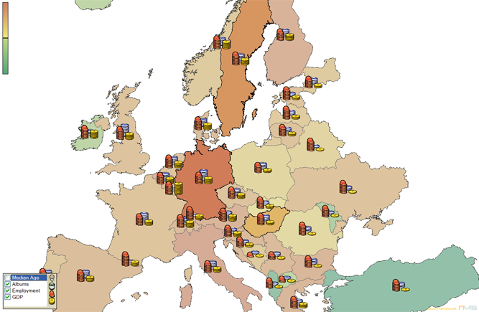
Figure 2 - Geographical Map

Treemap
The amount of nominal data was apparent when the data gathering was on going, but a lot of it could also be considered ordinal data. This allowed many different kinds of grouping. For representing ordinal groupings, the Treemap provided very good visualization approach. From different implementations, the Squarified Treepmaps seemed the most appropriate and visually pleasing approach. /1/

The Treemap is constructed from three levels:
- Root level
- Ordinal level for grouping
- Quantitative level for calculating suitable areas for all the levels

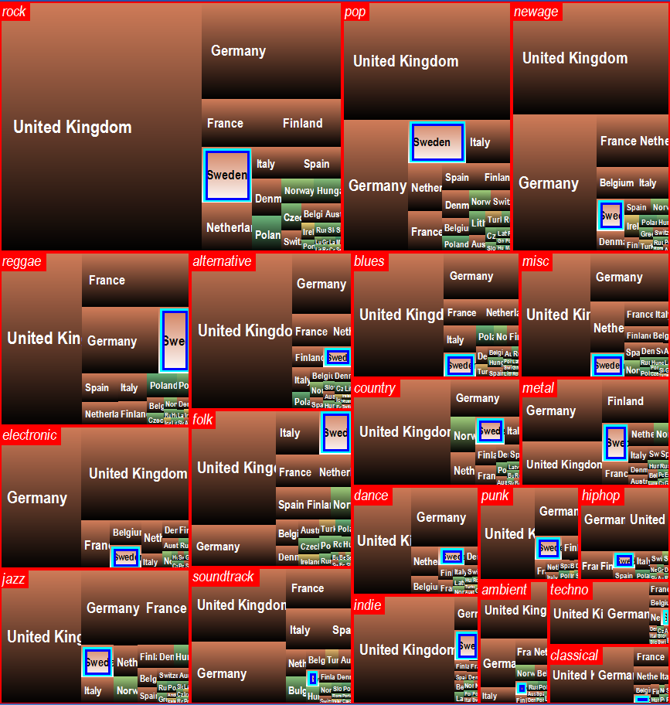  Figure 3 - Treemap with Styles and Countries as  ordinal and amount of Albums as Quantitative data | 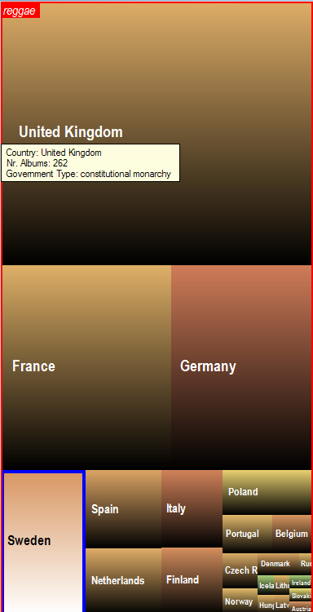  Figure 4 - Treemap Zoomed in (Reggae Style), with Tooltip being shown

Various kinds of groupings can be done using Treemap, and the application supports the following:
- Styles per country
- Countries per Style
- Countries per Government

Colouring
The red colour proved to be easiest to distinguish groups. The basic colours are the same than in other views but are drawn with a gradient to black for distinguishing the Treemap cells, while optimizing the screen space. For selection the blue and cyan borders help to locate items in the Treemap.

Parallel Coordinates
Finding trends, locating outliers, and to be able to freely compare attributes, especially quantitative, the Parallel Coordinates was an ideal solution. As the data was having not only many attributes but also lot of rows, for which it was necessary to display nominal information, it was needed to have a way to show data even in a restricted screen space. For this, a simple table lens proved to be a suitable solution. The Parallel Coordinates in its basic form worked nicely otherwise.

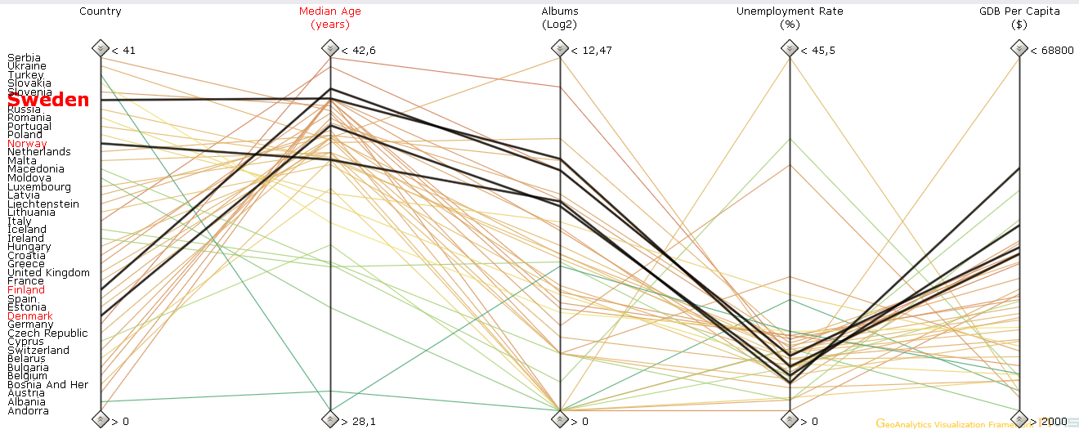
Figure 5 - Parallel Coordinates and a simple Table Lens

Colouring
Colours of the lines can be set according to the attributes in the parallel coordinates. Visual queries can be made with the axis filter, and picking can be used to locate countries interesting attributes. The selection works and shows also on the Table lens.

Insight
The layout of the application was chosen to allow the user to gain a deeper insight of the data through easy manipulation of its graphical interface. The usability studies were very useful to manage issues like colour, mouse interaction, size, location and many other important features.

Application Layout
The application layout is divided into three main views (with a supplementary one):
- Treemap View
- Parallel Coordinates View
- Map Plot View

As said before, most of our data is Nominal, which constraints the list of visual representations to just a few, justifying the above choices.
All three components are synchronized by a common ColorMap, which makes the comprehension of data much easier. That ColorMap is created based on any of the Parallel Coordinates attributes, and can be controlled by a colour legend locate on the top left corner of the Map Plot. Those colours where chosen in order to be pre-attentively distinguished and without tiring the eyes. Therefore, the choice has fallen on a pastel palette.

Main Treemap (Countries per Music Style)
The main Treemap displays countries grouped by music style. On this view, it is easy to see, for a given style, the countries that have the biggest amount of album releases in it. The zoom function allows the user to dig up into the style and eventually find countries with less releases. The colour map helps on linking a country on the Treemap with its representation in other view.

Map Plot
The Map Plot is probably the most intuitive component. Any person used to geography, can quickly locate a country, select it, and see it as well selected on other views. It is good to distinguish features on regions (as it will be outlined on the Results). The glyphs were chosen to be as more intuitive as they can be:
- Median Age: represented by an old man face. More faces depict higher Median Age on that country.
- GDP per Capita: represented by a dollar gold coin (since the GDP units are in dollars). The gold colour, the coin shape and dollar sign, all represent money;
- Unemployment Rate: represented by a worker’s orange helmet. More helmets depict less employment, thus more unemployment; the orange colour was used to distinguish from the blue of the CD’s and coin’s golden yellow.
- Albums: represented by a CD. More CD’s mean more released albums on that country; blue was used instead of silver, since it might be confused (according to usability studies) with coins silver colour.
The user also can also choose the number of used glyphs, but the usability studies have given two (2) as being the best number without visual clutter and for more clearance. Therefore, the default is set to two.

Parallel Coordinates
The Parallel Coordinates Plot is the complementary view of the main three. It provides the textual basis to locate the countries, as mentioned previously. The additional feature added is the ability to group or cluster the data, using the K-Means algorithm. This, as it will be mentioned further, was useful for the quick detection of trends and outliers.

Additional Treemaps
Together with the main Treemap, three more Treemaps are available as mentioned before (one is the same as the main one – described ahead). Those representations (see example in FIGURE NEXT) are separated in another window because their colouring is not related to the colouring of the data represented on the main view. There is, though, one exception. The main Treemap (countries per style) is replicated here so that the user can be able to compare two different styles at the same time. Regarding the other Treemaps, the colouring has been chosen to be quite different so the user cannot, unconsciously, relate any of those with the main view.

Brushing
The information displayed on all the previously mentioned views is not sufficient, though, to give the user full information about the data. Brushing, is a very useful and intuitive way of providing the user with easy, although not pre-attentive, information. All the views, except the Parallel Coordinates, have Tooltip information. See FIGURE NEXT for reference.
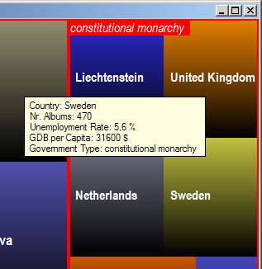  Figure 6 - Brushing in Government Types Treemap | 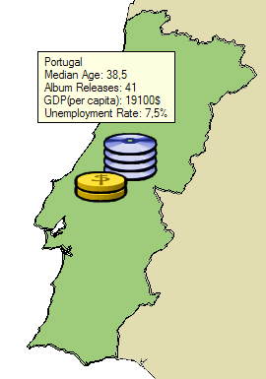  Figure 7 - Brushing in MapPlot

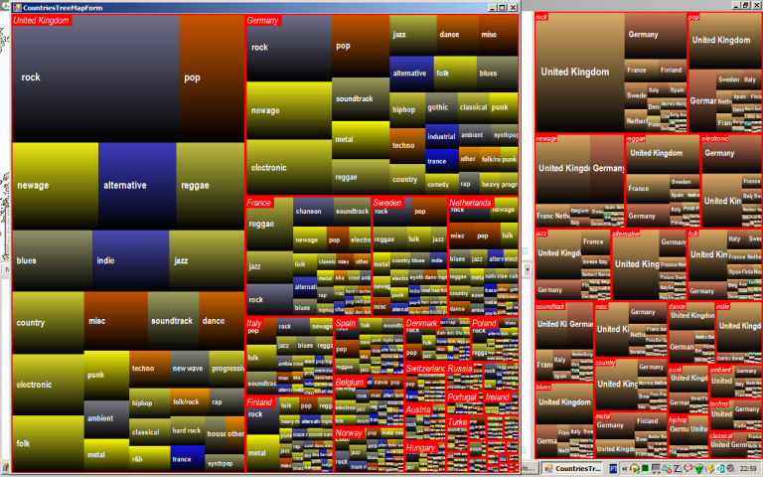
Figure 8 - Comparing different data using Main and Additional Treemaps

Results
to do

Conclusions
to do

References

- Bruls M., Huizing K, Van Wijk J.J., Squarified Treemaps, 1999, Eindhoven, Netherlands.
- Jern, Mikael, Information Visualization Notes, 2007, Norrköping, Sweden.
- Panopticon Website, Treemaps, www.panopticon.com, 2007.

