**Jamaica Artists Represent**

**JCAL: Jamaica Center for the Arts and Learning expands live performances;**

**art, music and technology classes**

RACHEL RODGERS

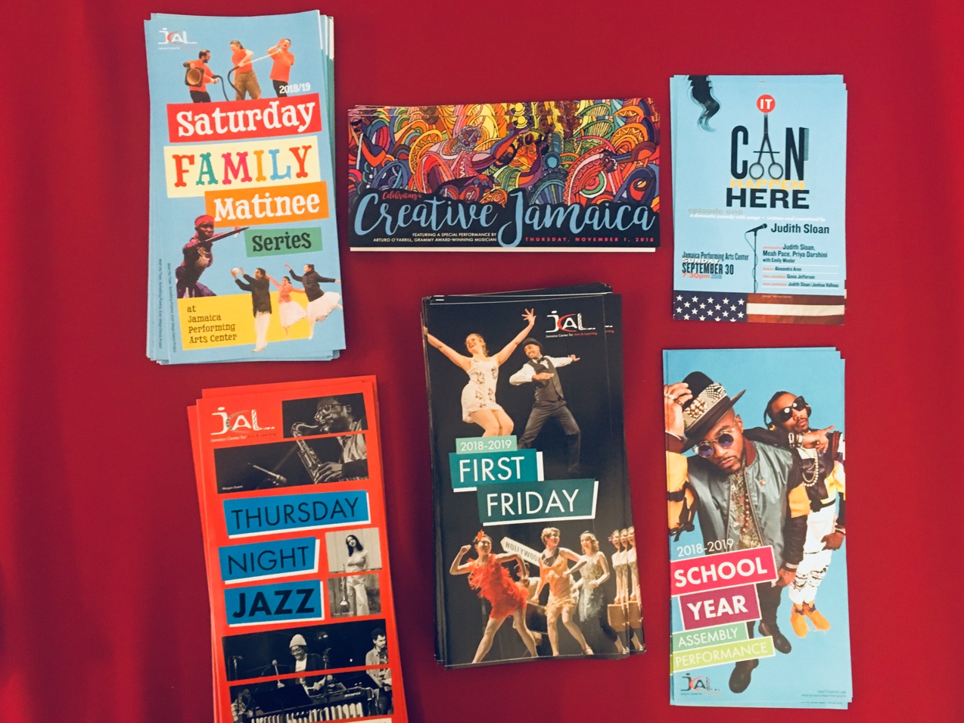

2018-2019 Programs at JCAL: Jamaica Center for Arts and Learning| *PHOTO CREDIT: Rachel Rodgers*

The art scene in Jamaica is growing quickly; much of the success is because of JCAL, Jamaica Center for Arts and Learning. The center offers year-long art classes for students and adults, plus evening performances held in-house and at the Jamaica Center for the Performing Arts four blocks away. An arts center since 1972, this year’s increasing attendance makes it the go-to place for creative people in Jamaica. The building includes a theatre and two galleries, music, dance and art studios. In recent years, nearly 30,000 people attend JCAL arts programming each year.

JCAL’s *Saturday School of the Arts* focuses on kids. Each Saturday, classes range from hip hop to ceramics, acting to comic book creation, ballet to 3D video game design. Some options for adults include yoga, dance, studio art, guitar.

At just $150 for 10 classes, the programs are more affordable than similar classes for Brooklyn and Manhattan’s school children.

JCAL’s *Music and Drama Summer Camps* continue to be a popular choice too.

“I went to hip-hop class last summer, and I loved it” says student Monique Jackson, 13, Jamaica. Teachers can introduce students to JCAL classes for free by booking in-school workshops for all ages.

Local attendance at large performances continues to increase. The *Saturday Family Matinee Series* held once per month at 2pm, debuts Afro-Caribbean diaspora dances, and live plays.

*First Fridays* hosts a series of music and dance infused with influences of regional tradition. Worldly performances on, the Swing era, or Bajan and Jaap tradition of the Silk Road, teach cultural history through interpretive dance.

Art exhibits like the current *Moods and Expressions: A Caribbean Sensation* and the *Black History Month Series* showcase artwork from Jamaica’s rich history of Caribbean and African-influenced artists.African-American Jazz musicians in Harlem, Brooklyn and Queens continually perform for the popular *Thursday Night Jazz Series.*

JCAL’s newest program, STE‘A’M Academy, actively inserts Art into the STEM fields. Classes in 2D/3D game design, music production and animation teach cutting-edge applications that incorporate math, coding, algorithms and VR technology to ultimately create a new appreciation for art.

The current exhibit presents the work of Artist-in-Residence: Emmett Wigglesworth. A prolific artist for 40 years, he has commissioned pieces in NYC and elsewhere. Wigglesworth’s pieces are bright and abstract though the work is serious and conceptual – exploring the tensions of race, politics and poverty. His style evokes the cubism of Picasso’s Guernica and African sculptural forms blending both together with bright color palette.

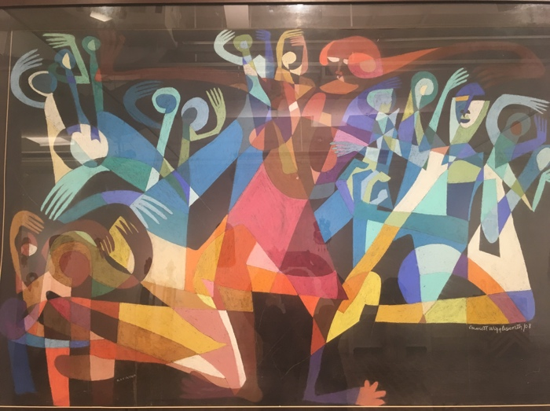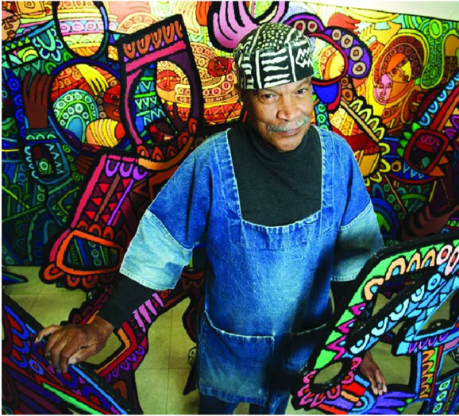

Emmett Wigglesworth PHOTO CREDIT: Fulton Art Fair | Works at JCAL PHOTO CREDIT: Rachel Rodgers

Professional artists of New York are encouraged to apply for ARTWorks, Inc., the new Artists Residency & Training Workshop Series. Each May, the program slects 12 eligible artists. Two win $10,000 fellowships.

JCAL’s Board Chair Michelle Stoddart prepares for *Creative Jamaica,* JCAL’s Annual Benefit Dinner on November 1. The NYC Office of Cultural Affairs and regional beneficiaries will attend to donate and discuss progress for the coming year. JCAL’s programming continues to expand as it increasingly represents locals of all ages – boosting Jamaica’s interest in the arts.

Word Count: 496