Supplementary Material — A Pre-Registered Ledger of Feature Families for Single-Energy CT Stone-Composition Prediction: What Works, and What Does Not

S1. Rationale
The clinically actionable question in single-energy non-contrast CT (NCCT) stone imaging is whether stone composition can be estimated well enough, from data already collected at presentation, to guide definitive management. The dominant decisions are uric-acid vs. non-uric-acid (dissolvable vs. not) and, among calcium stones, calcium oxalate (CaOx) vs. calcium phosphate (CaP) — a distinction with metabolic and preventive consequences. Struvite is not a modeling target: infection stones are a clinical diagnosis (alkaline, turbid, malodorous urine at pH 7–8.5; dysuria, flank pain, recurrent UTI, frequently impending sepsis) that any emergency clinician makes without a model.
This supplement reports, in one place, every feature family we tested — the hypothesis and mechanistic rationale that motivated each, the extraction/derivation method, the evaluation, the result, and the disposition — with the successes grouped alongside the failures. Negative results are reported deliberately and in full: publishing only positive findings leaves others to repeatedly expend resources on avenues that do not bear fruit. Our aim is to delineate the boundary of what single-energy NCCT plus routinely available data can and cannot resolve, so that subsequent work is directed at the informative gaps (Section S4).
Unless stated otherwise, evaluation is repeated stratified patient-grouped 5-fold cross-validation with patient-clustered bootstrap 95% CIs; the calcium-subtype tests use a dedicated CaOx-vs-CaP binary head (positive class = CaP) with the deltas expressed against the HU + routine-labs baseline (AUROC 0.710). Cohort: 319 laboratory-analyzed stones from 223 patients (CaOx 107, CaP 144, UA 36, struvite 27, other 5).

S2. Master ledger (Table S1)
# | Domain | Feature family | Hypothesis / rationale | Key result | Verdict
Retained
R1 | Model | Lean UA model (stone peak/mean HU; urine pH; CO₂/Cl/anion gap; BUN, Cr, Ca, glucose; age, sex) | UA is acid-driven and low-HU; routine data should identify it | AUROC 0.781 (0.677–0.867), NPV 0.97, Brier 0.086; positive net benefit across 10–50% thresholds | Deployed
R2 | Model | CaOx-vs-CaP head, HU + routine labs | Acid–base chemistry (pH, RTA pattern, Ca) separates the calcium subtypes better than HU alone | HU 0.665 → HU+labs 0.710 (0.637–0.778); beats 5-class CaP OvR (0.674) | Deployed (cascade + high-sensitivity CaP screen)
R3 | Imaging | Nephrocalcinosis (parenchymal calcific foci) | dRTA / hyperparathyroidism / MSK cause parenchymal Ca deposition and CaP stones | Biology clean (CaP frac 10× CaOx) but head Δ +0.013 (CI crosses 0); outlier-driven | Radiologic flag, not a model feature
Rejected — imaging
F1 | Imaging | Hb-anchored HU calibration (air + aortic-blood anchors) | Normalize scanner HU offset to sharpen composition-HU mapping | No same-composition variance reduction (scanner offset ~10 HU ≪ ~220 HU biological spread) | Rejected
F2 | Imaging | Self-supervised 3D CNN (frozen-encoder deep features) | Learned volumetric features may capture texture beyond handcrafted HU | Underperformed; deep features did not cluster by composition; degraded fusion | Rejected
F3 | Imaging | HU-distribution-shape radiomics (skew, kurtosis, entropy, GMM modes, Shapiro) | Multi-component / zoned stones have distinctive HU histograms | Reduced cross-validated AUC | Rejected
F4 | Cohort | Multi-stone N-lift (volume↔mass rank matching, 131→319) | More labeled stones per patient → power | Neutral (kept for N; no lift) | Rejected (as a lift)
F5 | Imaging | Stone density gradient (core/periphery HU ratio) | CaOx retains a dense core; CaP tapers | CaOx 2.86 vs CaP 2.80 (gap 0.06 vs SD 1.2); head Δ −0.013; SHAP 13/17 | Rejected
F6 | Labs | Normal-AG (hyperchloremic) acidosis composite + hyperchloremia index | Explicit dRTA/GI-loss signature the tree may not synthesize | Δ −0.000 (CI −0.009,+0.008); redundant with raw CO₂/Cl/AG | Rejected
F7 | Labs | eGFR (CKD-EPI 2021) | CKD shifts mineral metabolism toward CaP | Δ −0.009; SHAP rank 7 yet OOF-flat (redundant with Cr/age/sex) | Rejected
F8 | Imaging | Opportunistic vertebral BMD (L1–L3 trabecular HU) | Hypercalciuria/dRTA ↔ low BMD ↔ calcium stones | Full-cohort +0.028 but complete-case crosses 0; flat by-composition (187 vs 194); 35% missing (FOV) | Rejected
F9 | Imaging | Hepatic steatosis (liver−spleen HU) | Gut dysbiosis raises enteric oxalate (CaOx) and hepatic fat → fatty liver > in CaOx | Steatosis CaOx 13% vs CaP 17% (p=0.71, reversed); Δ −0.006; signal is UA (already captured) | Rejected
F10 | Imaging | Sarcopenia / muscle quality (paraspinal+psoas HU, volume) | Body composition indexes metabolic phenotype | Δ −0.023 (P 0.03, worse); muscle-volume SHAP rank 5 while hurting (body-size confound) | Rejected
F11 | Imaging | Aortic calcification (Agatston-style, denoised) | Ca×PO₄ / CKD-MBD mineral axis (no serum PO₄/PTH in data) → CaP | Age-adjusted coef −0.10 (CI −0.41,+0.21); CaOx ≥ CaP (330 vs 249); head Δ +0.001 | Rejected
F12 | Imaging | Bladder wall fraction / volume | Chronic cystitis/obstruction → struvite | Bladder-only Δ +0.017 (P 0.79); distension-confounded | Rejected
F13 | Imaging | Prostate calcification | Chronic prostatitis → struvite | SHAP rank 1/22 but a sex proxy (79% M / 1% F); non-significant; lowers 5-class struvite AUC 0.686→0.626 | Rejected (leak)

S3. Detail by family

A. Retained models (R1–R2) and the one flag (R3)
The lean UA model (R1) is the primary clinical product: at a high-sensitivity operating point it rules out uric acid with NPV 0.97 and shows positive decision-curve net benefit across the plausible threshold range. The CaOx-vs-CaP head (R2) is the only feature *addition* that improved the calcium-subtype decision: adding the routine metabolic panel to stone HU raised AUROC from 0.665 to 0.710 — the discriminating information for the calcium split is chemical, not morphological (Main Figs 6–7). Nephrocalcinosis (R3) is the sole imaging feature with clean, correct biology (mean parenchymal-calcification fraction ~10× higher in CaP than CaOx; prevalence CaOx 21% → CaP 33%); it is retained as a deterministic radiologic flag that prompts a CaP/dRTA/hyperparathyroidism work-up when substantial foci are auto-detected, because as a learned feature it is carried by a handful of high-burden cases and does not survive outlier removal (Δ +0.013 → +0.004).

B. Rejected imaging features (F1–F5, F8–F13)
These span three mechanistic bets. HU fidelity (F1 calibration, F2 CNN, F3 shape radiomics, F5 density gradient): none beat handcrafted peak/mean HU — the composition signal in attenuation is low-dimensional and adding HU-derived complexity overfits at this N. Bone/mineral-metabolism surrogates (F8 BMD, F11 aortic calcification): both index axes (bone loss, vascular calcium) that are dominated by age — already modeled — and, for vascular calcium, index the hypercalciuria/CaOx phenotype as much as the phosphate/CaP one, netting to null. Systemic/metabolic surrogates (F9 hepatic steatosis, F10 sarcopenia, F12–F13 bladder/prostate): each re-encodes the metabolic-syndrome/urine-pH axis (F9's steatosis signal is real but belongs to UA, already captured) or, worse, a confound — F13 prostate calcification is a sex indicator (present in 79% of males, 1% of females) that the model exploits, ranked first by SHAP yet non-significant and harmful to its intended target class.

C. Rejected lab/derived features (F6–F7)
The routine chemistry is fully exploited by the raw analytes: an explicit normal-anion-gap-acidosis composite (F6) and CKD-EPI eGFR (F7) are deterministic functions of values already in the model (CO₂/Cl/anion gap; creatinine/age/sex) and add nothing out-of-fold, despite SHAP attending to eGFR (rank 7).

S4. Methodological through-line and interpretation
Three recurring findings organize the ledger:
1. Feature importance is not predictive value. Repeatedly, a feature drew high SHAP attention while adding nothing (eGFR, rank 7) or actively hurting (muscle volume, rank 5; prostate calcification, rank 1) out-of-fold. Adjudication was therefore on grouped-CV ΔAUROC with patient-clustered bootstrap CIs, never on importance. Figure S1 shows every family's Δ against the HU+labs baseline: all confidence intervals cross zero.
2. Apparent gains require verification. The one nominally significant full-cohort result (nephrocalcinosis + BMD, +0.038) dissolved under complete-case analysis (removing the 35% of scans without lumbar spine in the field of view: +0.024, CI crossing zero) and outlier removal. The bladder/prostate "gain" (+0.039) was a sex-proxy leak. Every candidate was subjected to complete-case, age-adjusted, and/or outlier-robustness checks before disposition.
3. The information boundary. Across thirteen rejected families spanning HU fidelity, mineral-metabolism surrogates, systemic-metabolic surrogates, and derived chemistry, single-energy composition prediction is saturated by stone attenuation and urine/acid–base chemistry. The residual CaOx-vs-CaP ceiling (~0.71) is not a modeling limitation to be engineered away with additional CT-derived or routine-lab features; it reflects the absence of the stone-specific analytes that define the two supersaturation states — most directly urinary oxalate (the swing driver of CaOx supersaturation) and its modifiers (magnesium, citrate), which are not present in routine data and are not inferable from single-energy attenuation.

S5. Figures
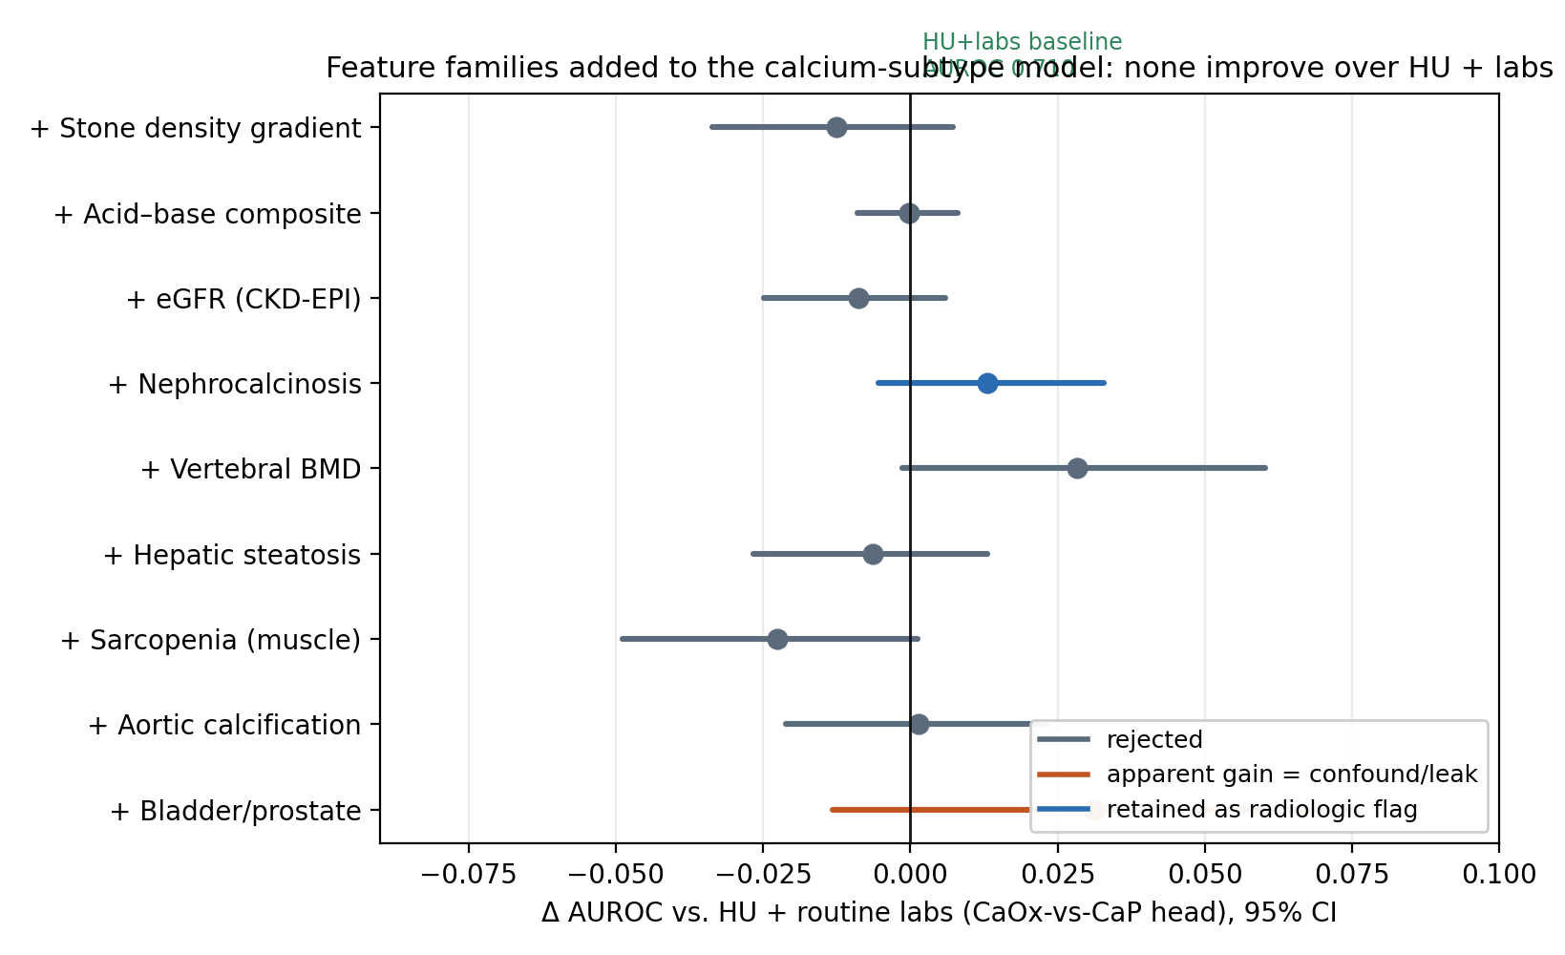
Figure S1. Forest plot of ΔAUROC for each feature family added to the HU+labs CaOx-vs-CaP head (patient-clustered bootstrap 95% CI). All intervals cross zero; the only genuine improvement was adding the routine metabolic panel to stone HU (baseline, AUROC 0.710). Grey = rejected; orange = apparent gain traced to a confound/leak (bladder/prostate = sex proxy); blue = retained as a radiologic flag (nephrocalcinosis).
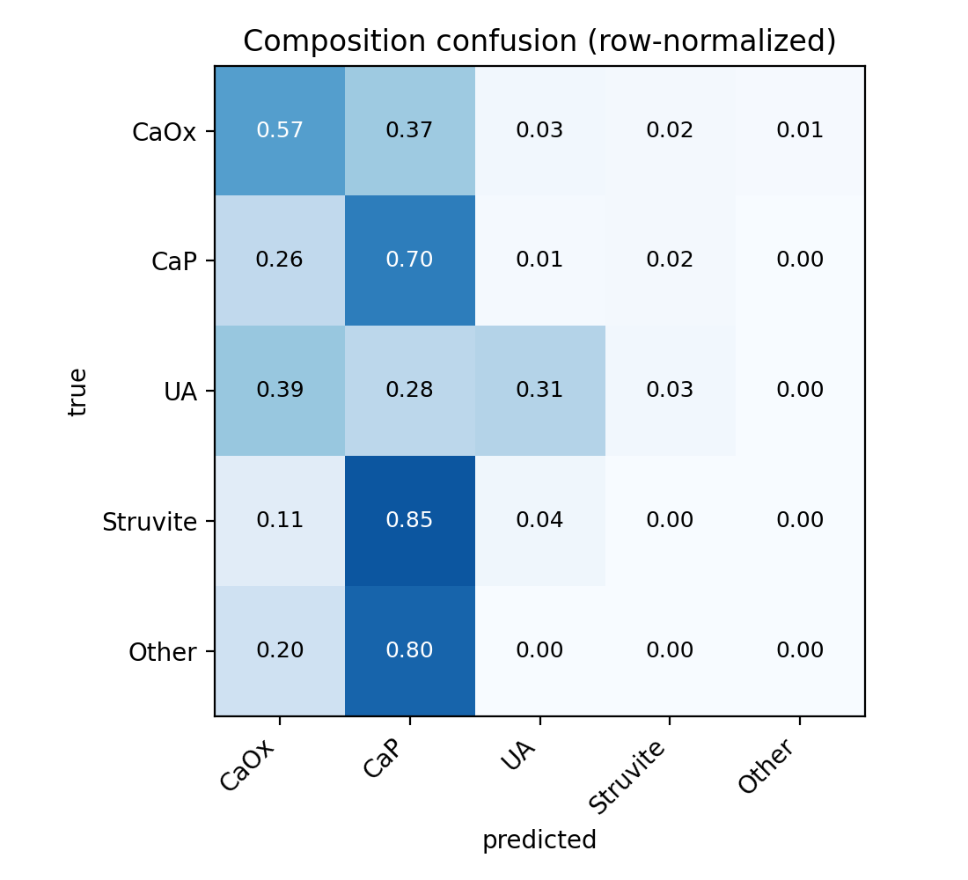
Figure S2. Five-class composition confusion matrix (row-normalized), patient-level cross-validation.
- Main-text figures cross-referenced: Fig 1 UA ROC; Fig 2 decision-curve; Fig 3 calibration; Fig 4 UA SHAP; Fig 5 density-gradient per-class AUC; Fig 6 CaOx-vs-CaP head ROC by feature set; Fig 7 CaP-screen operating point.

