Prerequisite: node.js is installed in the system

1. Navigate to folder and start server by running following command-

*node nodeserver.js*

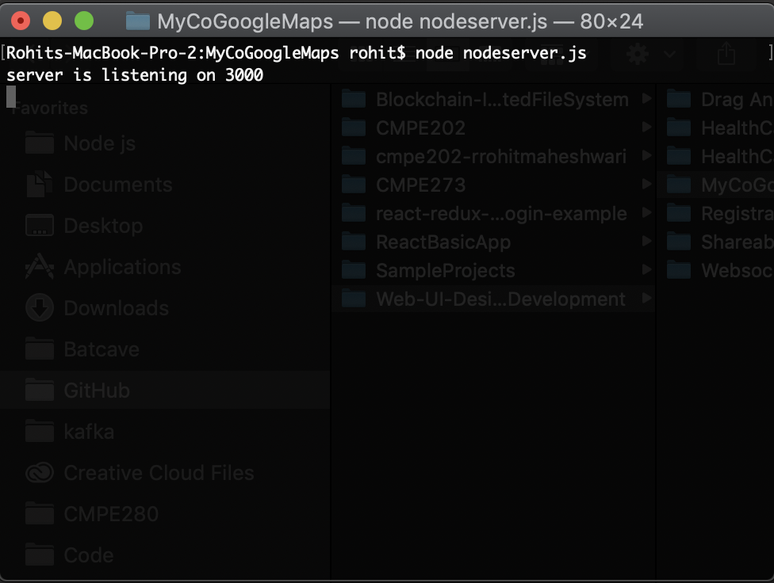

1. Now open “MyCOGoogleMaps.html” in the browser-

