**Steps-**

Prerequisite: npm and node is already installed

Open terminal and navigate to folder: “WebsocketChatApplication”

Run Commands:

*npm install ws*

*node nodeServer.js*

Open “frontendClient.html” in browser in two tabs-

Intial screen(Incase node server is not running)-

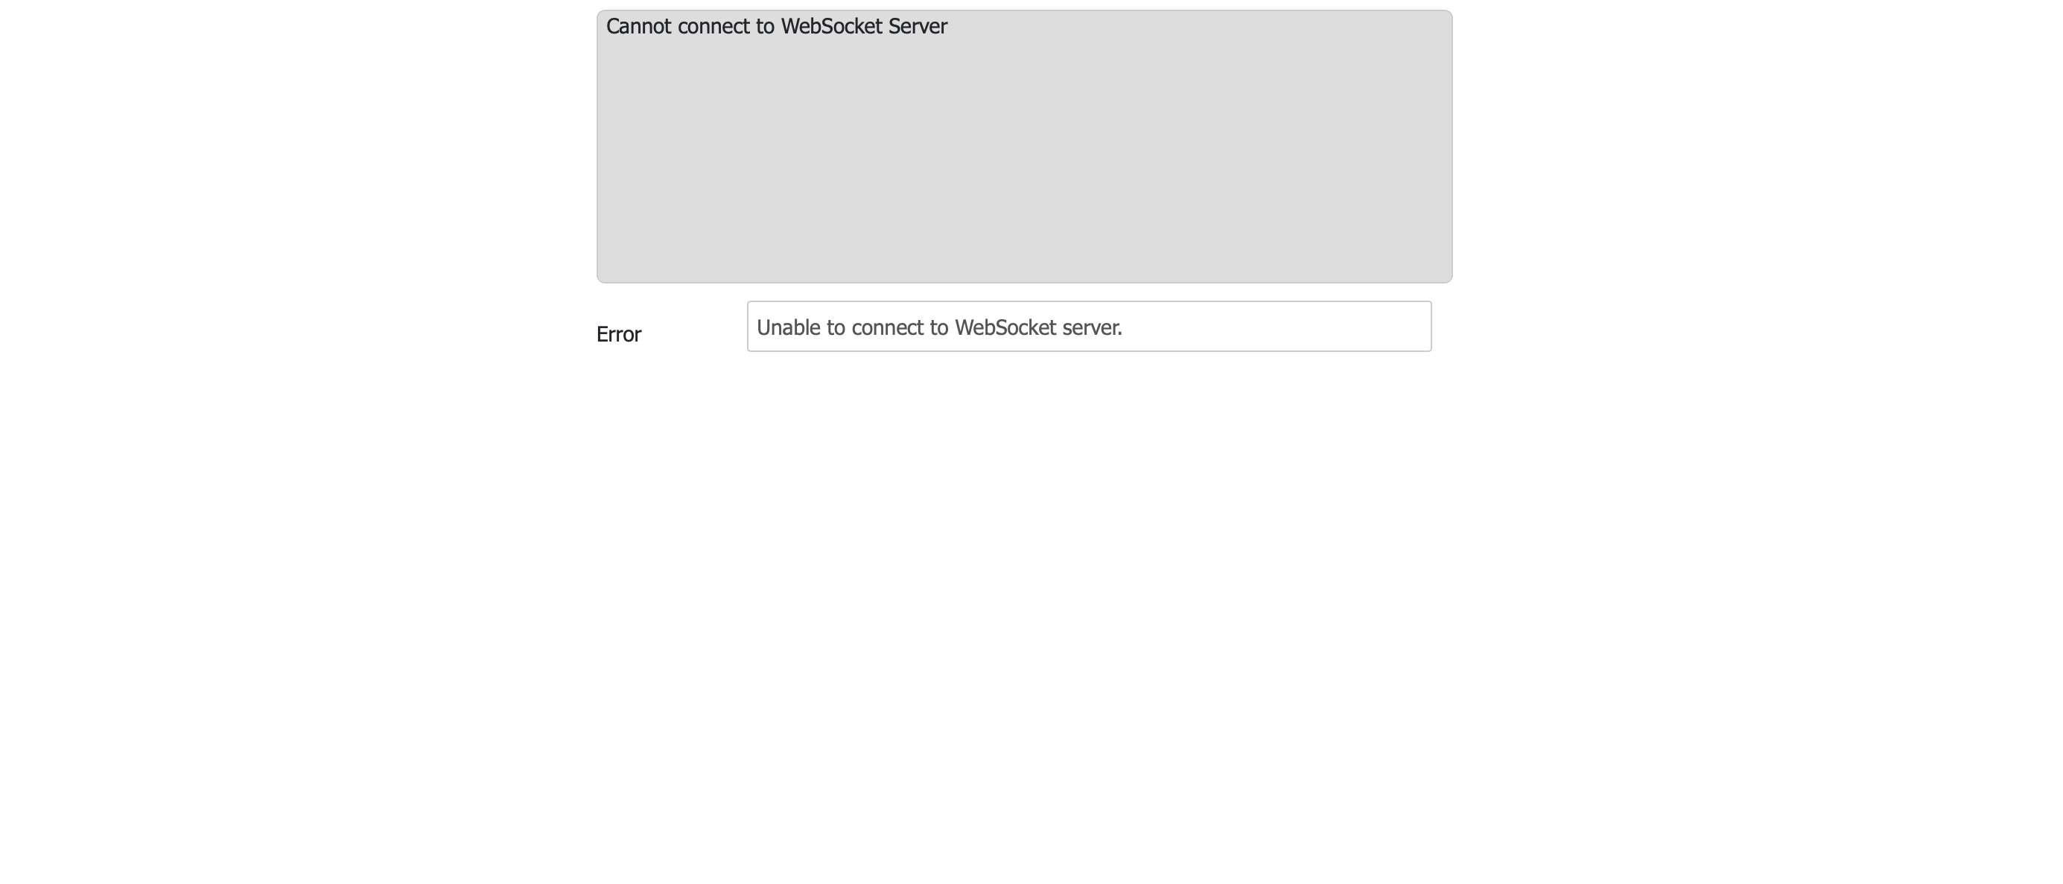

Intial screen(Incase node server is running)-



Open two tabs-> One using Doctor and another using Patient and start chatting

