**Name:** Rohit Maheshwari **SJSU ID:** 012423918

**Assignment:** GoogleCharts(BuildYourOwnPizza)

**Instructions and Details**

Assignment is made on React using Material-UI.

Navigate to ***google-charts-pizza*** and run following commands (Pre-requisite NodeJS is already been installed)

*$ npm install*

*$ npm start*

This will install all the required npm packages and start the application

**Application Screenshots:**

**Page1:**

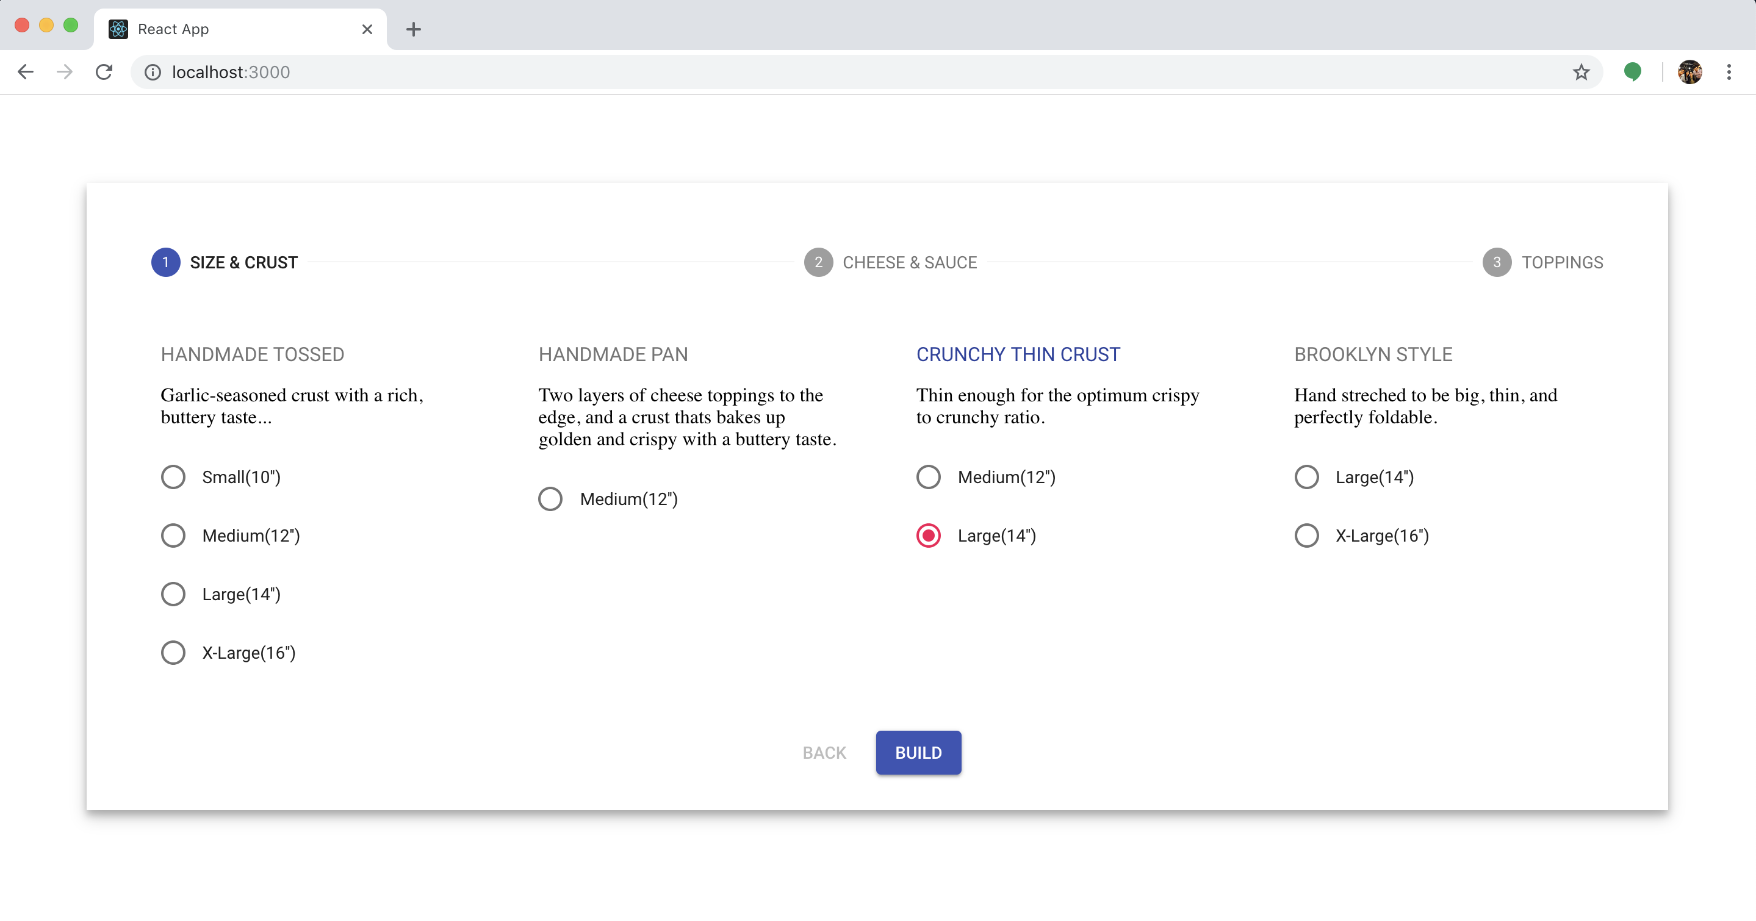

**Page 2:**

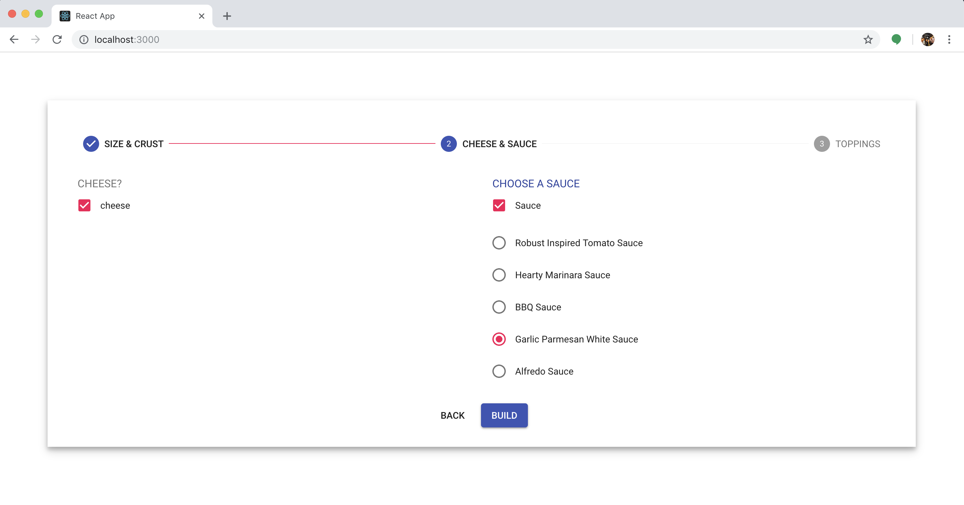

**Page 3:**

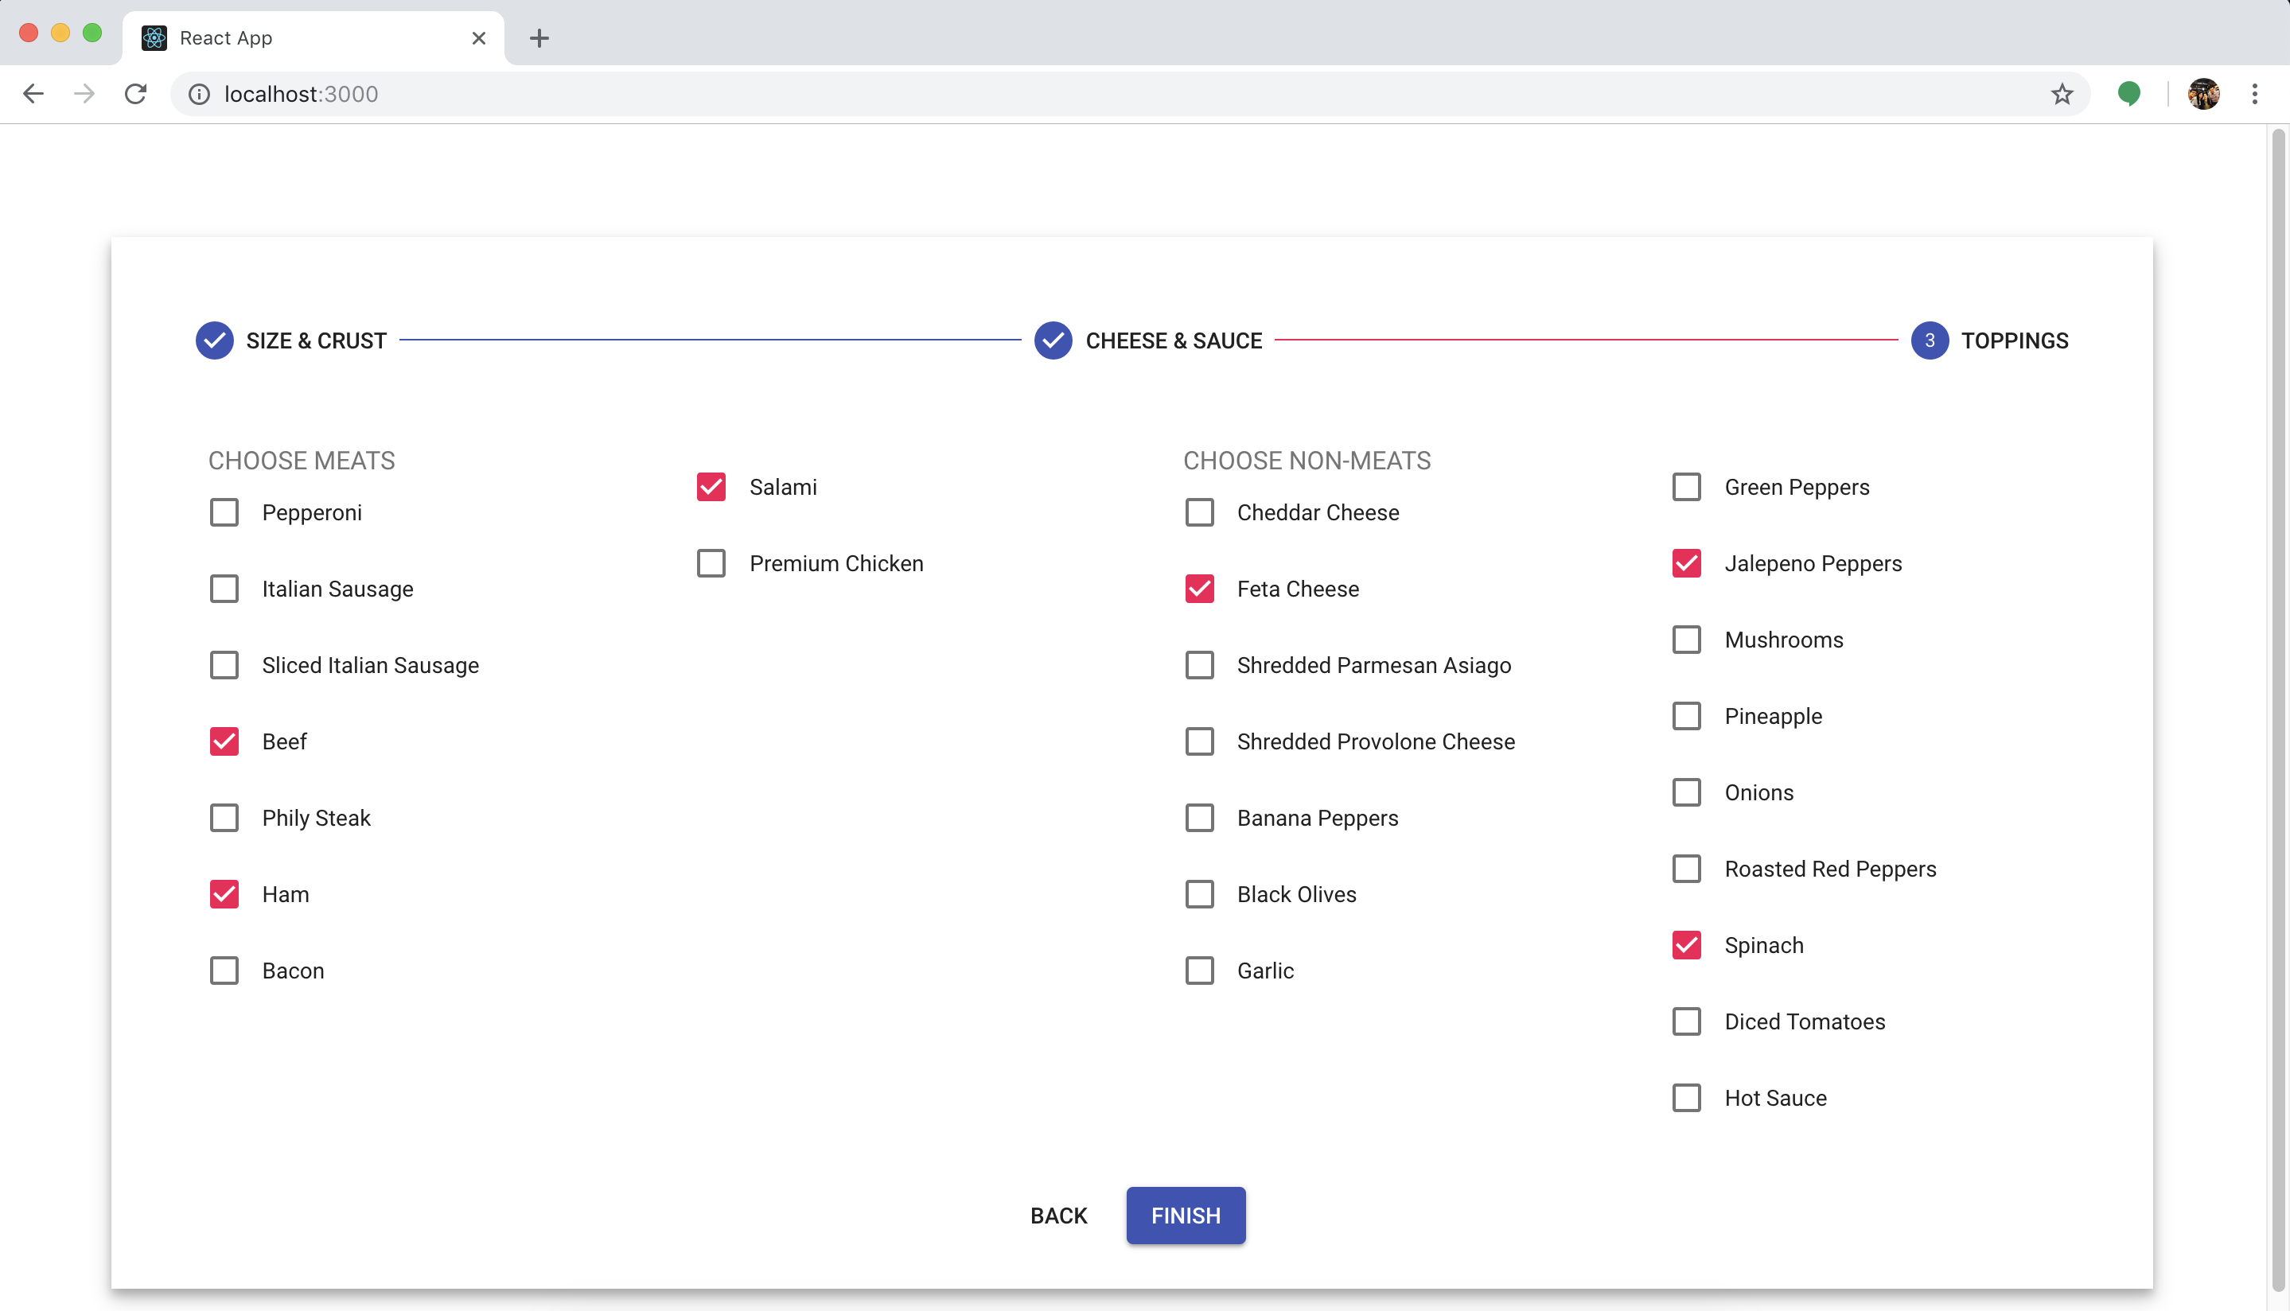

**Dashboard:**

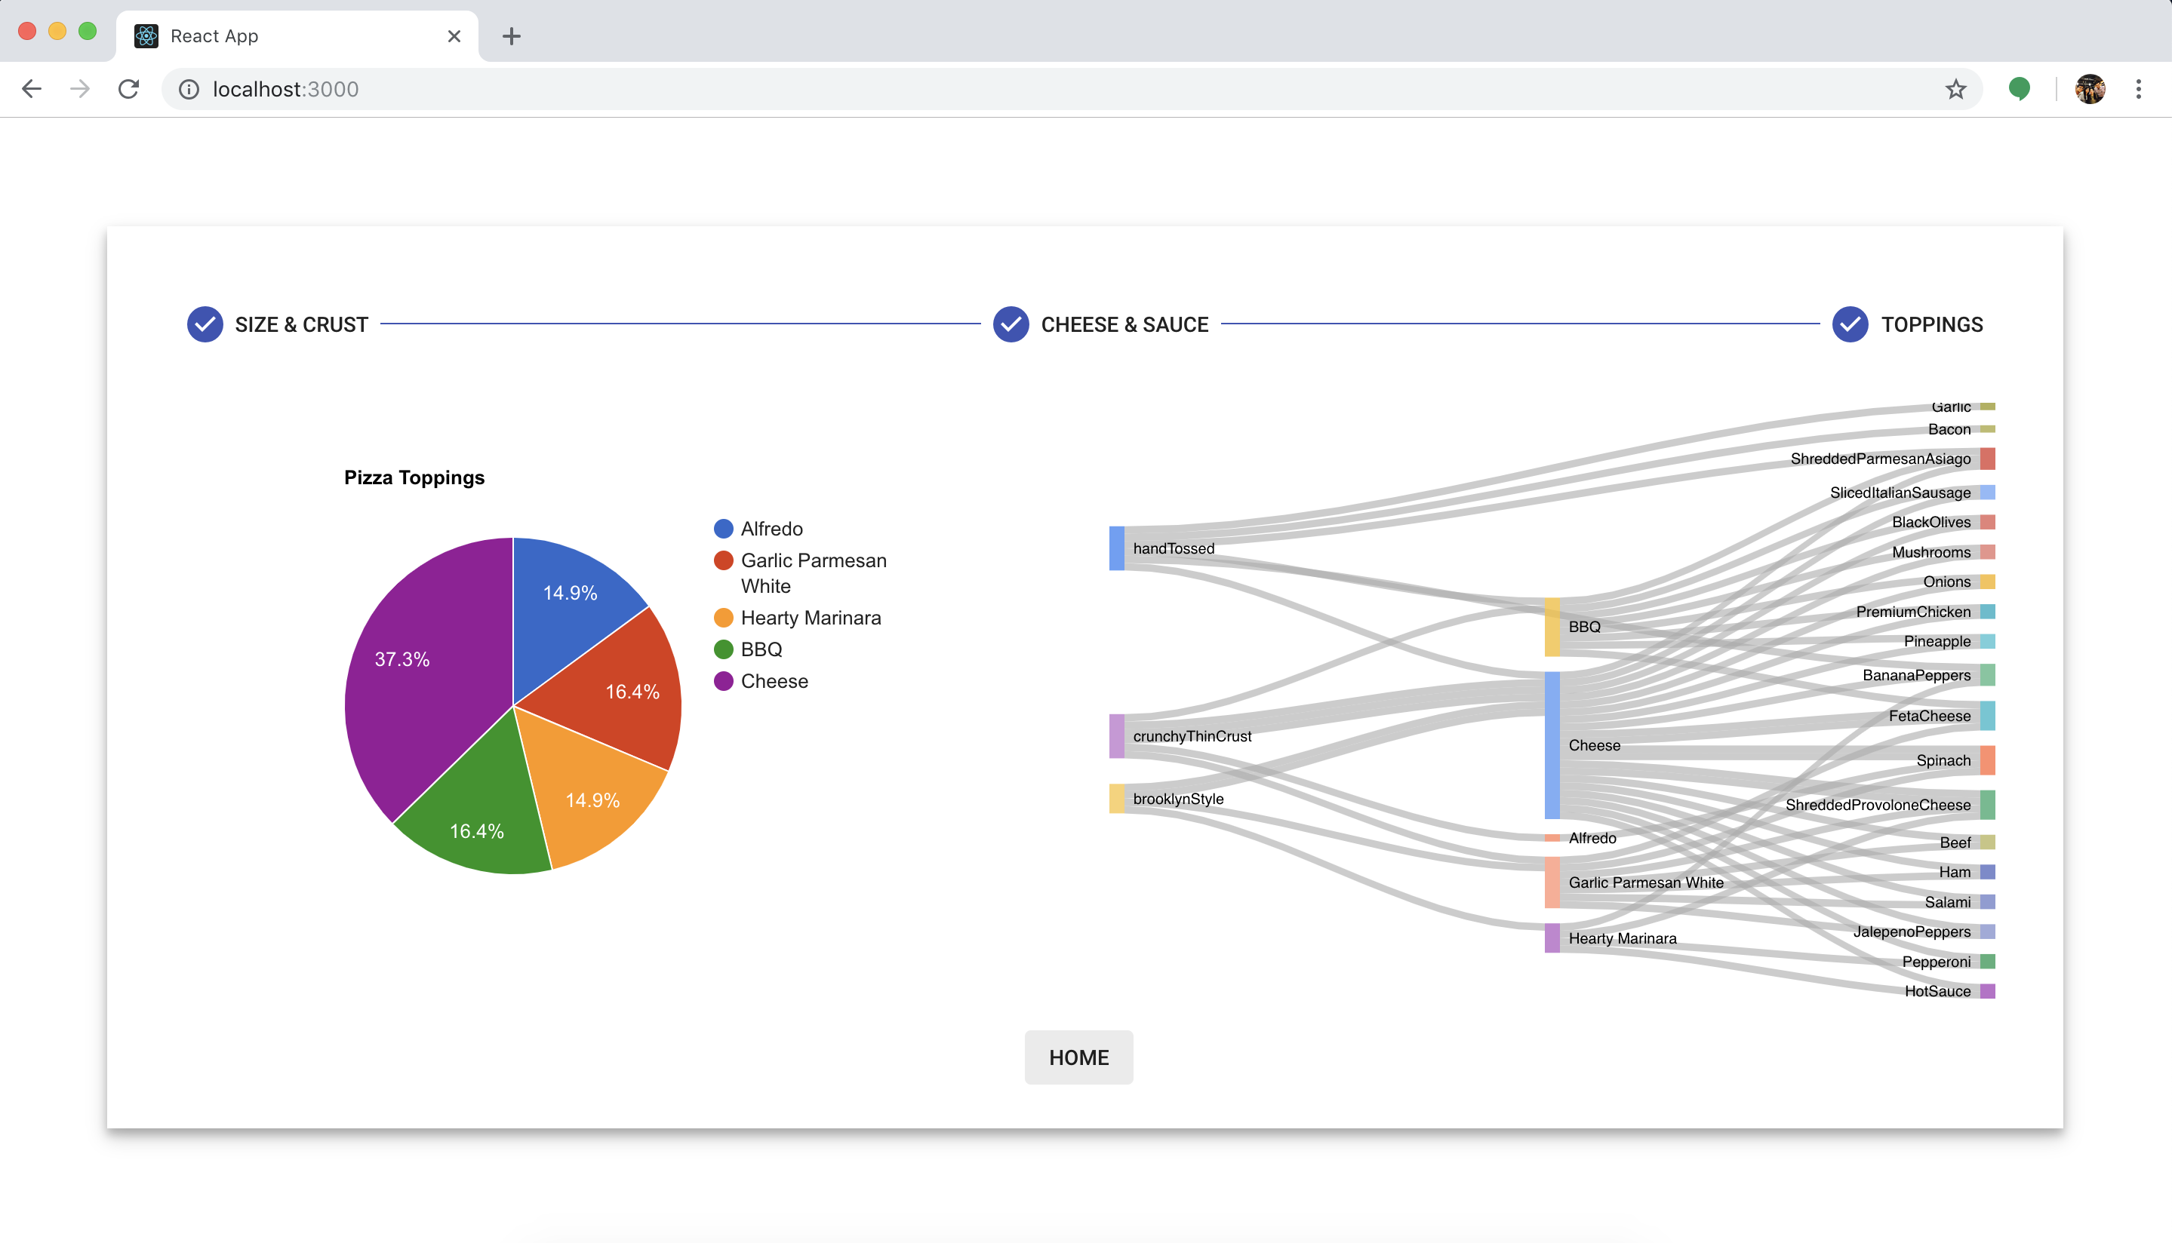

Dashboard contains Google Pie chart and Google Sankey chart