In electrical_export.py, cost_by_type and crossing_cost are summed to get total_cable_cost, which is returned as the cable cost from the output of run_parametrics.py

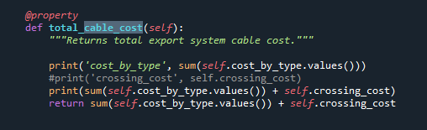

cost_by_type is defined in In ORBIT\phases\design\_cables.py:

And crossing_cost is defined as 0 for our configuration.

total_cable_length_by_type:

cable_lengths_by_type is defined:

Something here? In electrical_export.py

In _cables.py:

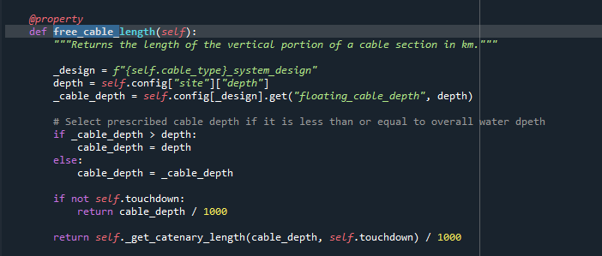

sections