**HVDC (there are two.. one for 525kV and one for 320 kV):**

Export cable installation ($/kW) for HVDC_2500mm_525kV for a 1 GW farm = 7.161471763335986*distance*distance_from_landfall + 40324776.55775206

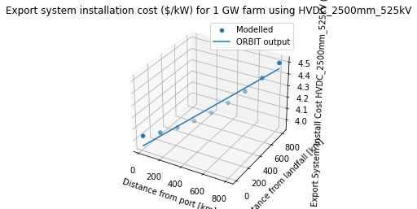

Export cable installation ($/kW) for HVDC_2000mm_320kV_dynamic for a 1 GW farm = 3.5807358816679944*distance*distance_from_landfall + 20412092.57253386

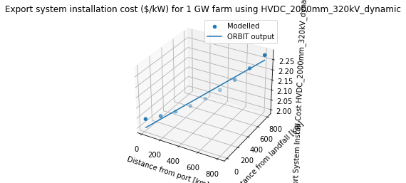

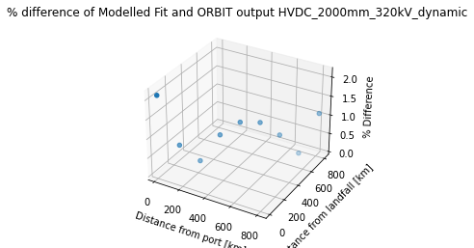

**HVAC**

Export cable installation ($/kW) for XLPE_1000m_220kV_dynamic for a 1 GW farm = 23.871572544453286*distance*distance_from_landfall + 84708397.49227189

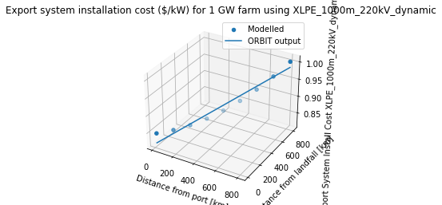

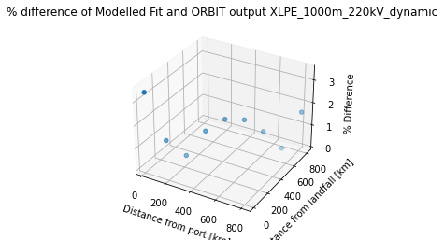

**Now we need to combine the above equations so that the HVAC is not used further than the same cutoff distance as the cable design module**

* First we have to determine the distance threshold where the cable design module designates HVAC vs HVDC
  + There are different threshold distances, depending on HVDC 320 kV vs. HVDC 525 kV.

320kV: threshold distance is ~50 km (check in code)

--

525kV: threshold distance is ~130km (check in code)

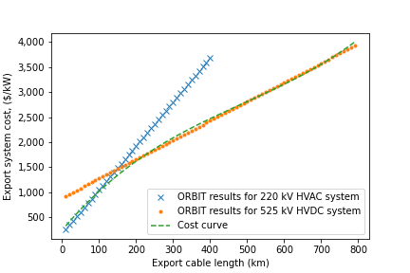

Make the 525kV combined equation first, using the 130km threshold: