Rene Romo

EECS 351

Project A

**Concordia 161 Solar System**

**Goals:** The goal of this project was to create an animation using HTML,javascript and WebGl, which had several features. The animation must have 2 parts designed by the student, in this case the two parts are a mouse controlled spaceship shaped like a diamond and a UFO. The project must also make use of per-vertex colors, which were used in the UFO and Spaceship and use jointed objects which were the planets rotating around the sun, the moon rotating around the planet, and the UFO rotating around the planet. Along with animation without any user input they project also includes mouse and keyboard interactions.

**User Guide:** Controls

Left Arrow - Decrease Speed/Reverse  
Right Arrow - Increase Speed  
Space Bar - Start/Stop   
Mouse Click - Toggle Spaceship Follow Mouse   
Click and Drag - Rotate UFO

**Scene Graph Diagram:**

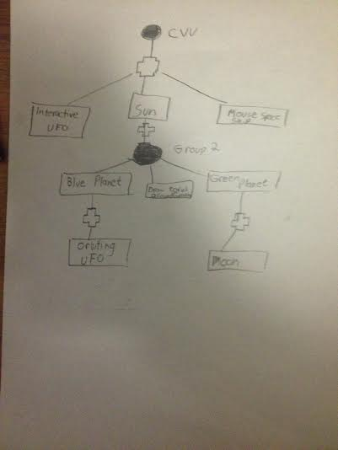

**Pictures:**

**Default View**

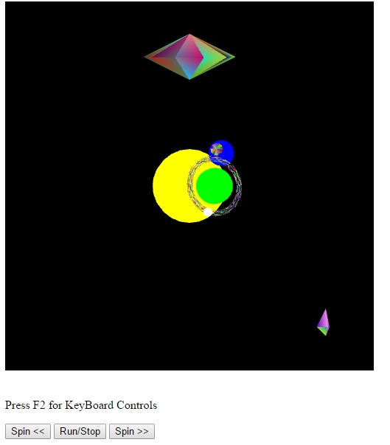

**After Pressing F2**

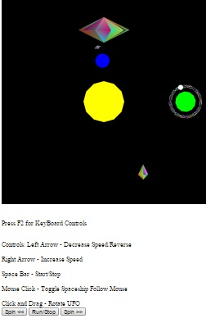

**User Designed Part : Spaceship**

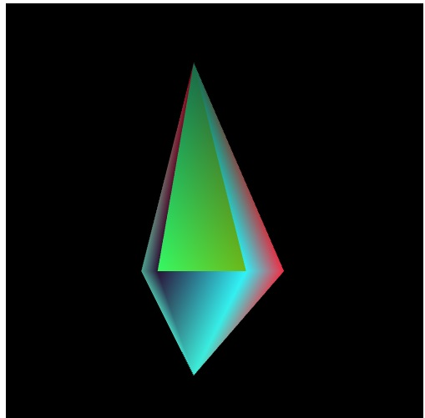

**User Designed Part : UFO**

