Rene Romo

EECS 351

Project B

**Concordia 161 Solar System**

**Goals:** The goal of this project was to create cameras in WebGL by using view matrix. The requirements were to have a perspective camera and orthographic camera each in its own viewport. Along with the camera’s we were to have controls to move our camera which allow us to move in the 3d world. I created a perspective camera along with a top down orthographic camera. The camera can be moved and tilted in any direction in the 3d world. Along with this we had a requirement of animation, a ground plane grid, 3d axes, and simple diffuse shading. I chose to have the diffuse shading only on my spheres (planets) as their normal were the easiest to calculate. The final requirement were a few more shapes to be spread around the world and a 3 jointed shape, for this I reused my objects from project A with a few modifications.

**User Guide:** Controls

Controls: Arrows - Move   
WASD - Look Around

E/Q – Fly Up/Down  
Click and Drag - Rotate tetrahedron and spaceship

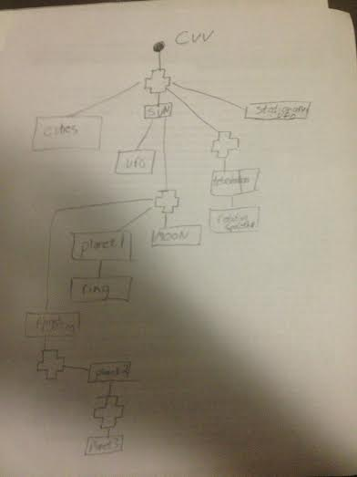**Scene Graph Diagram:**

**Pictures:**

**Both Cameras**

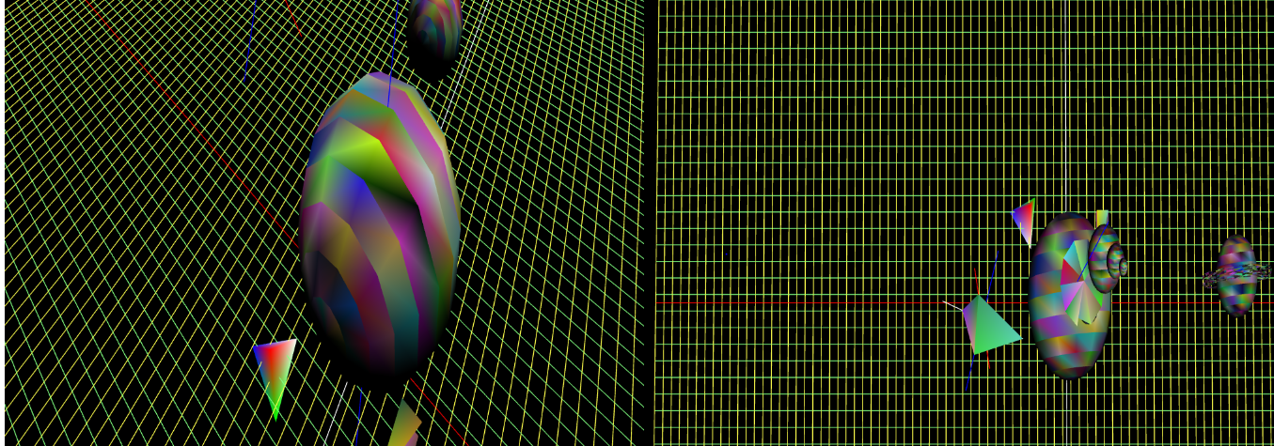

**Shading:**

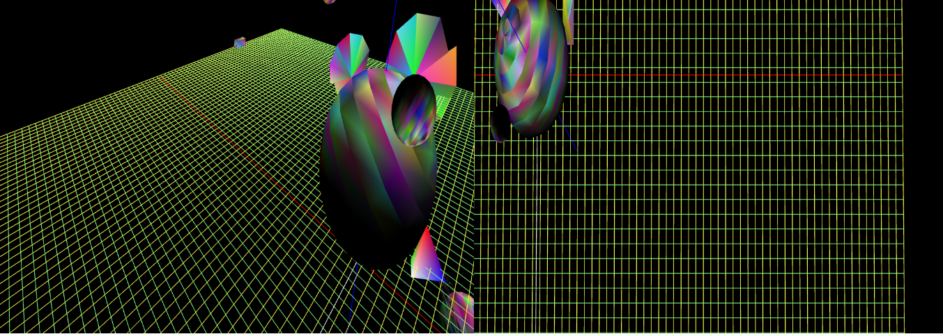

**Rotation Axes:**

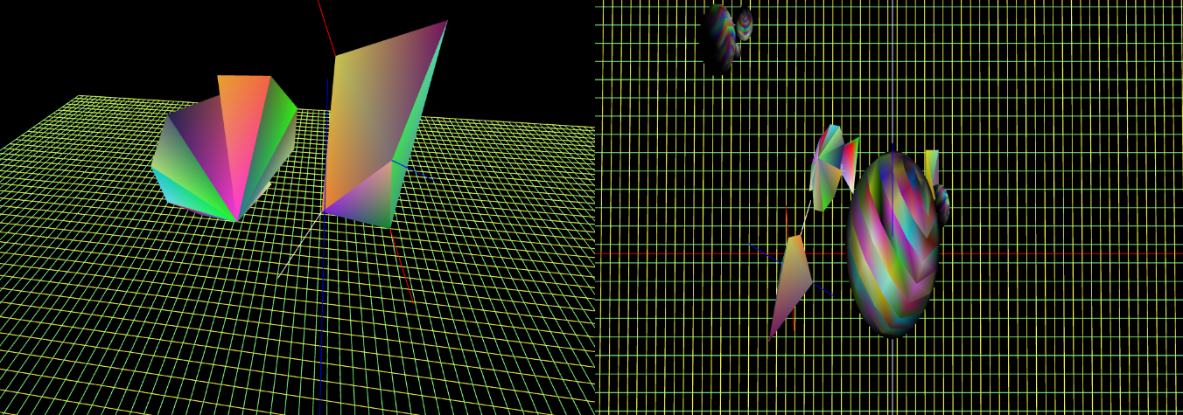

**Jointed Object (orbiting planets) and full world view**

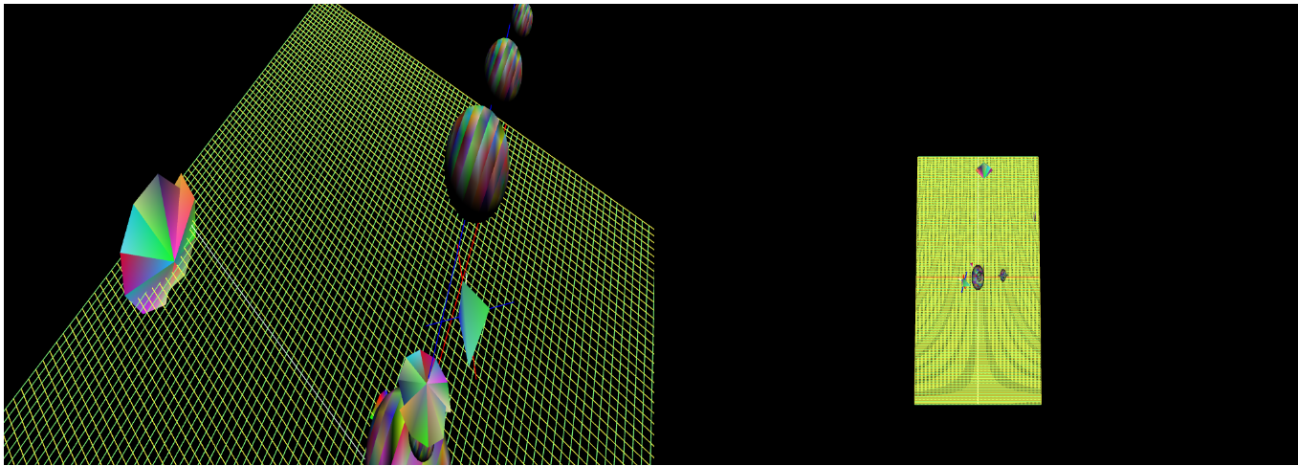

**User Designed Part : Spaceship**

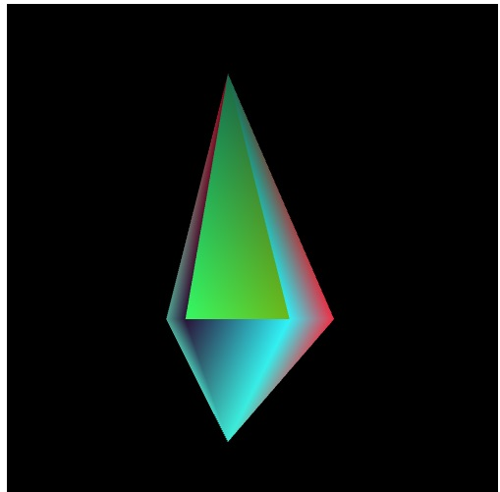

**User Designed Part : UFO**

