bambooBSC 0.6

bambooBSC Guide

Author: Chen Xin Nien
contact: chen.xin.nien@gmail.com Project site: https://github.com/billchen198318/bamboobsc

Overview 3
Basic Operations 3
Step sourcecard established 4
1. Vision 5
2. Perspectives 6
3. Strategy objective 7
4. KPI 8
5. Measure-data 12
6. KPI Report 13
7. Personal Report 14
8. Department Report 15
9. Strategy Map 16
10. SWOT 17
11. Report signature 18
12. Query Charts 20
13. Analytics ( OLAP ) 23
14. bambooBSC mobile version 27
15. PDCA ( Plan / Do / Check / Action ) 29
16. Audit settings ( if PDCA Project or 360 Project edit page cannot click “Confirm audit” button ) 39

Overview
bambooBSC is an opensource Balanced Scorecard (BSC) , It provides analysis of employee performance or department/organization performance.

Core Features:
Sourcecard:
Establish and maintain scorecards information or maintenance KPI measure data . And Strategy Map

Report:
The report includes a KPI reports, department/Organization scorecard reports, personal scorecard reports, SWOT reports, PDCA .

Basic Operations
Please look figure-A .
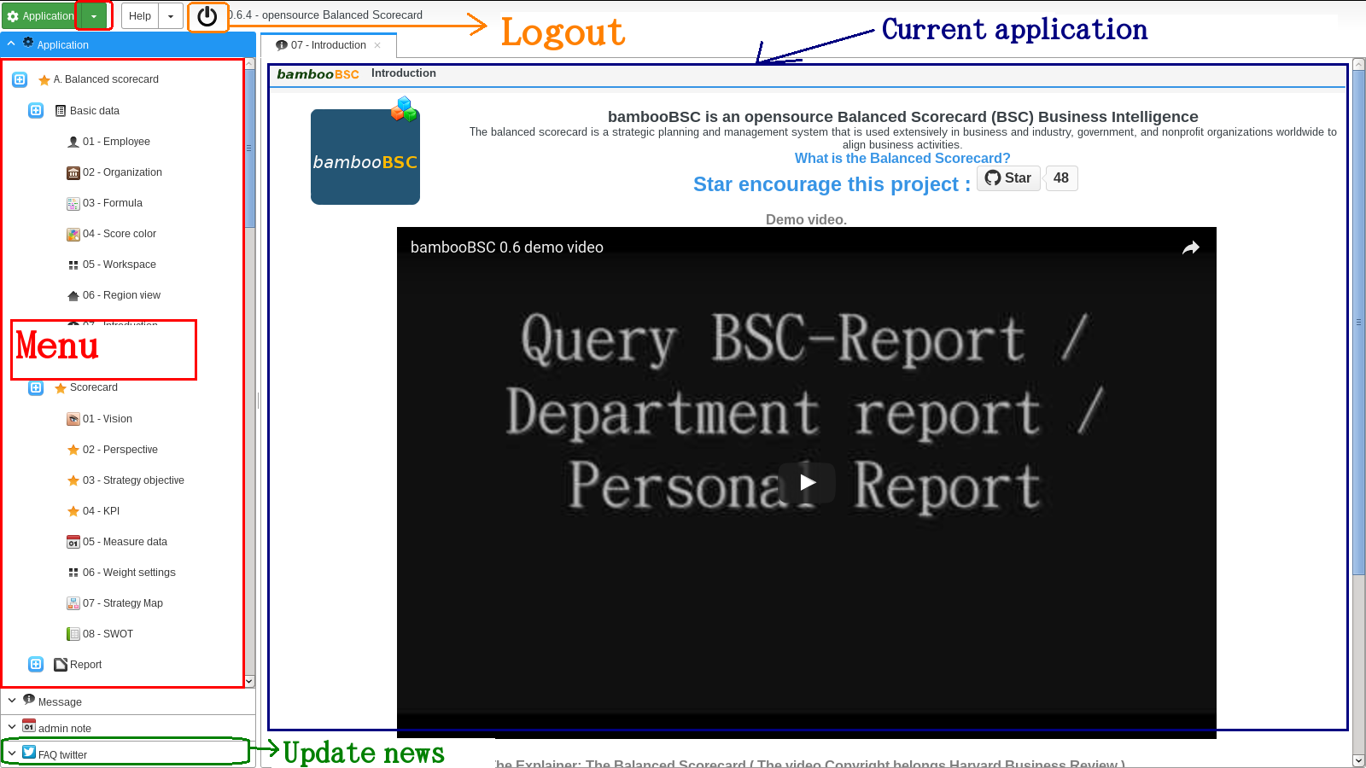

Step sourcecard established
How to build scorecard data , Reference Videos : https://www.youtube.com/watch?v=N5BsWZL8bxQ

1. establish a Vision
Complete proposed goals and vision

2. establish Perspectives
establish BSC four perspectives, about BSC perspectives please Reference : http://en.wikipedia.org/wiki/Balanced_scorecard
Established with the heads of each of the vision must have Perspective, otherwise this vision is invalid

3. establish Strategy Objectives
Each set has established Objective item for a Perspective
The main goal of the strategic objectives narrative direction

4. establish KPI
The establishment of key project of objectives can be measured create a KPI items.

5. maintain Measure-data
Each KPIs item will need to maintain measure-data, no masure-data will not be calculated KPI performance scores .

1. Vision
First click “ 01 – Vision “ item on menu or tree menu. Look figure 1-01, 1-02
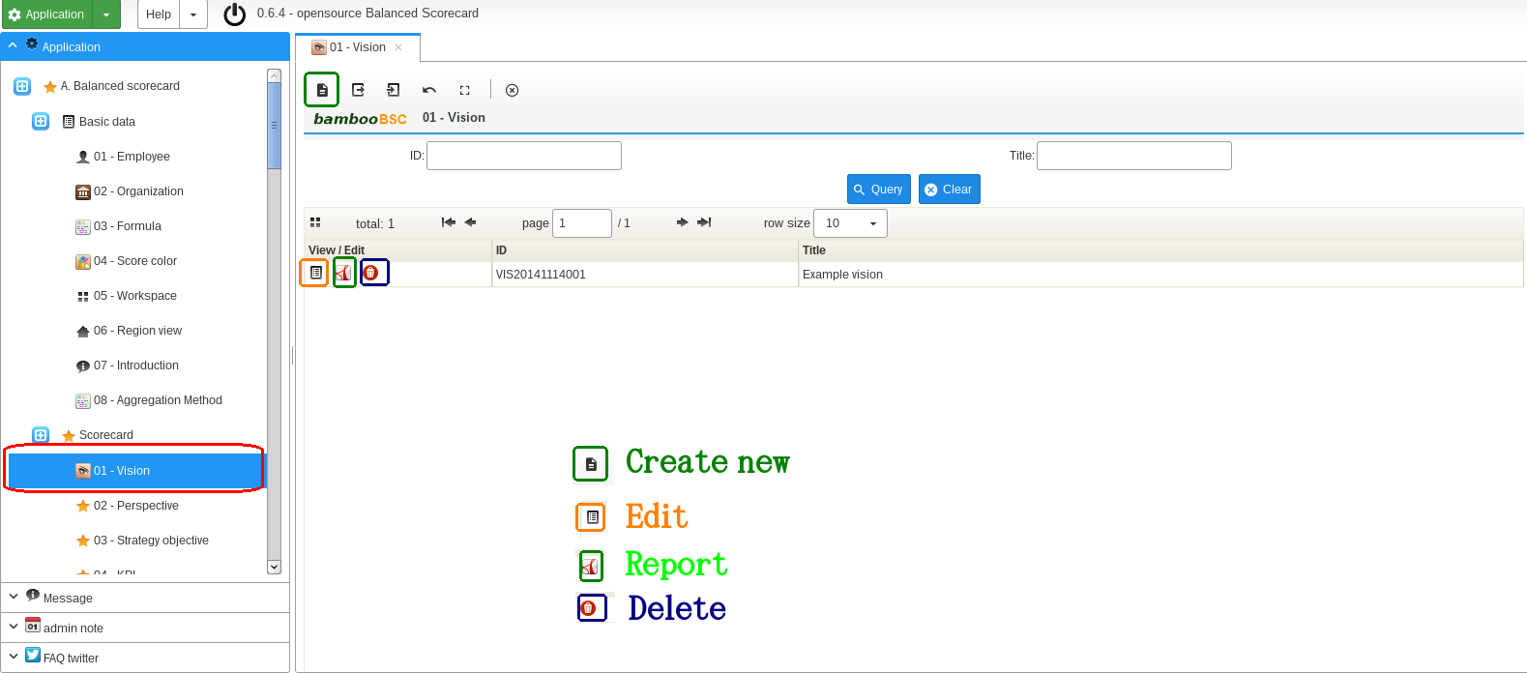

figure 1-01

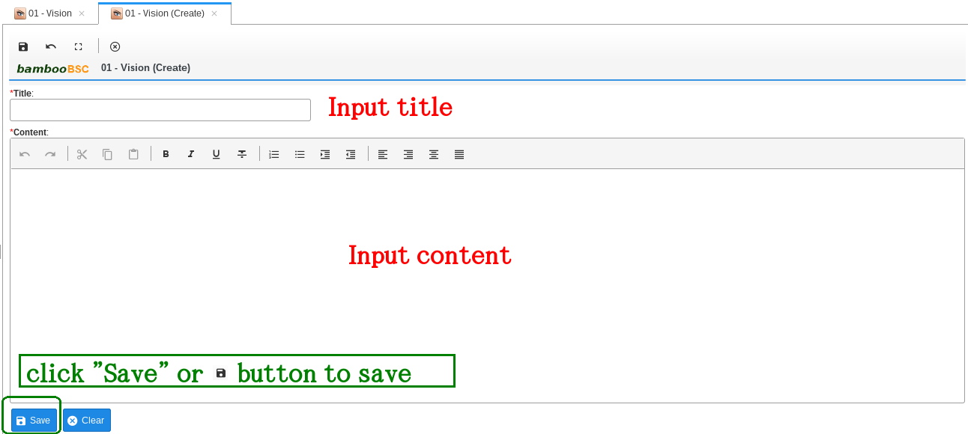

figure 1-02

2. Perspectives
Click “ 02 – Perspective “ item on menu or tree menu. Look figure 2-01 , 2-02
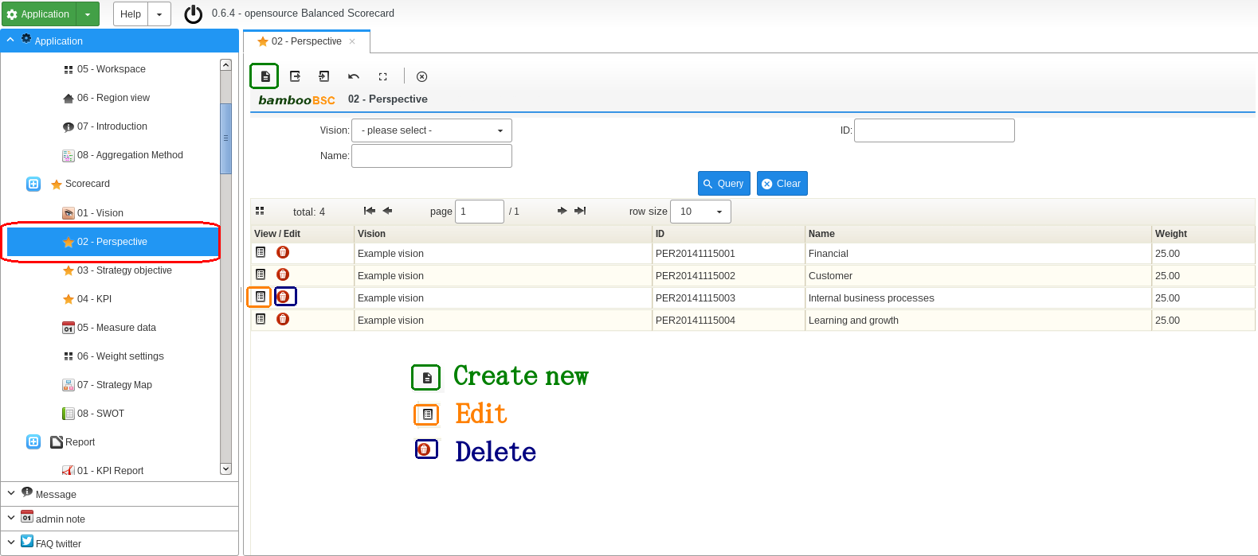

figure 2-01

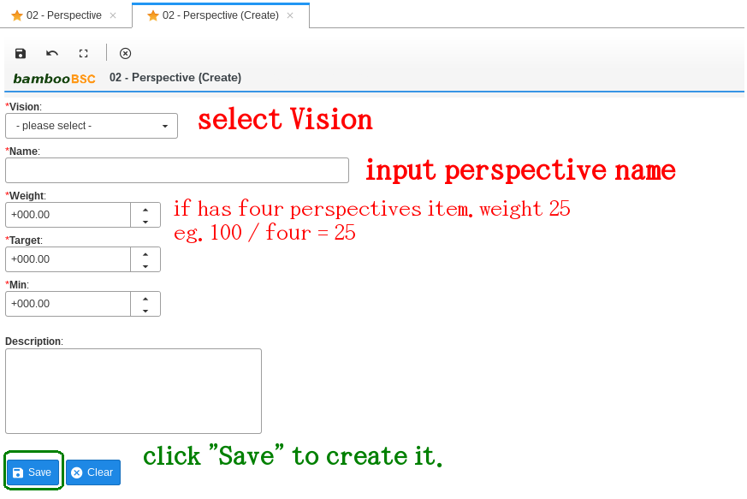

figure 2-02

3. Strategy objective
Click “ 03 – Strategy objective “ item on menu or tree menu. look figure 3-01, 3-02
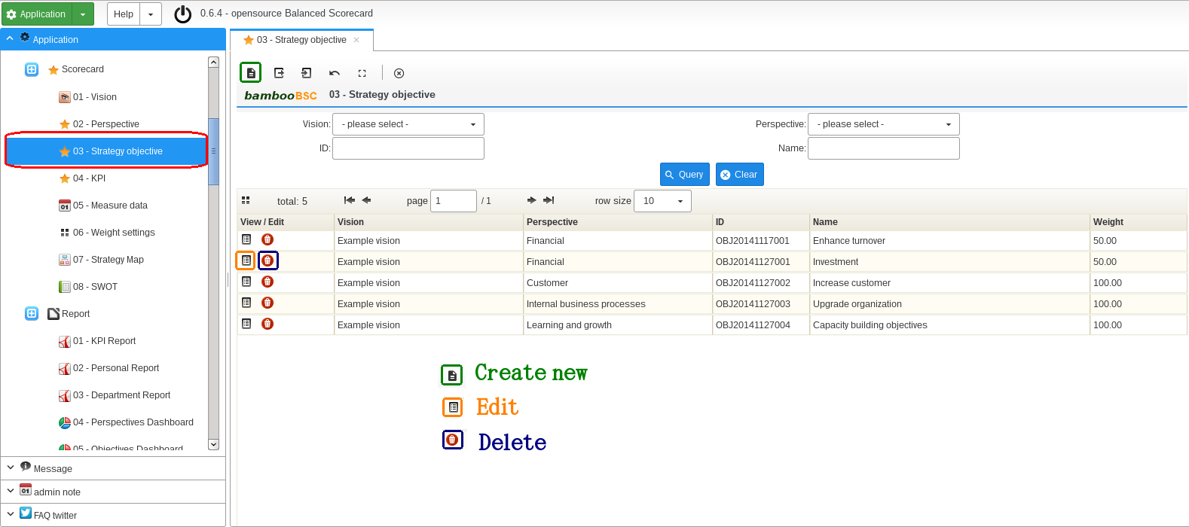

figure 3-01

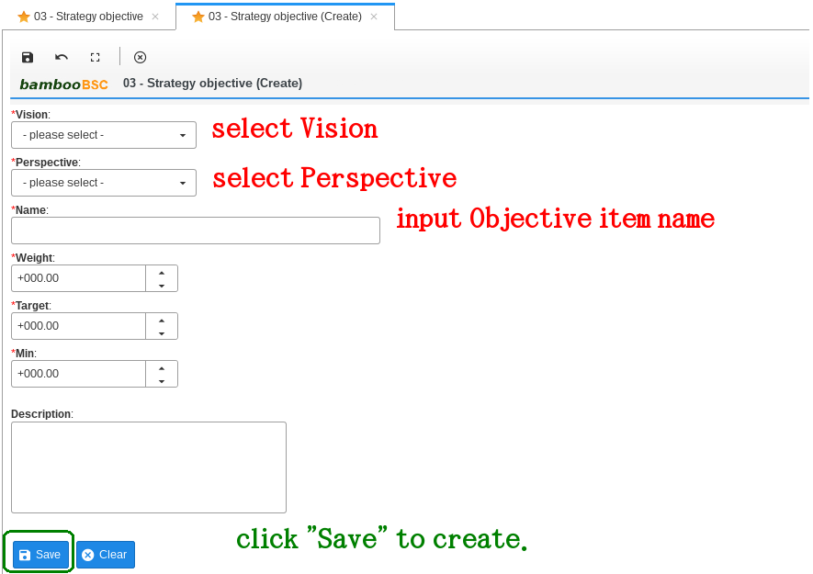

figure 3-02

4. KPI
Click “ 04 – KPI “ item on menu or tree menu. look figure 4-01, 4-02

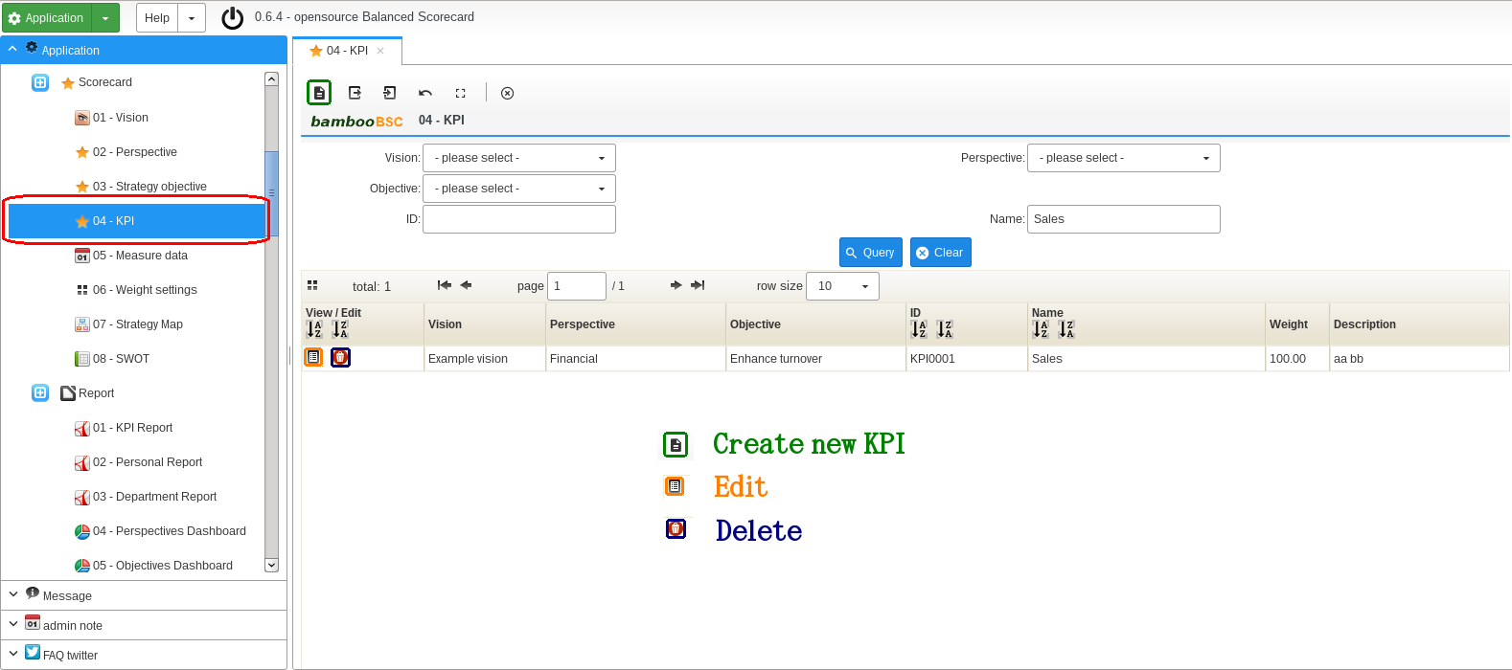

figure 4-01

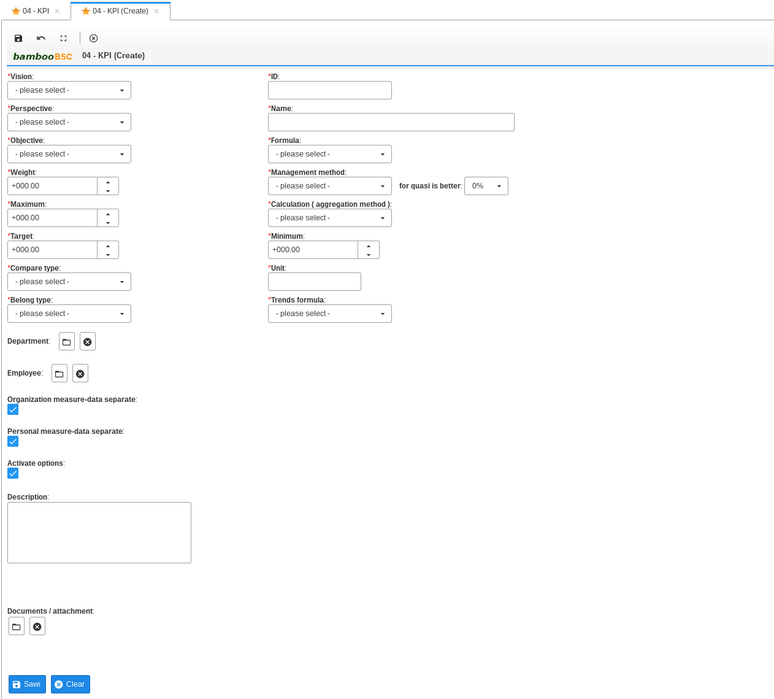

figure 4-02

Vision: select KPI's vision
Perspective: select KPI's perspective
Objective: select KPI's objective
Id: KPI's id
Name: KPI's name
Formula: KPI's formula , It will affect the calculation of scores, Formula create or edit/modify please try “Basic data / 03 – Formula”
Trends formula: trends formula, only for 07 - KPI Period Trends report calculation score need.
weight: Must be greater than ZERO. If set to ZERO does not make sense
Maximum: max value, need input value big over then target field.
target: target value.
min: min value.
Compare type: with target (the KPI scores compare target value) , with min (the KPI scores compare min value)
Unit: KPI's unit ( eg: %, USD, TWD, million, piece …. )
Management method: Bigger ( score bigger is better) / Smaller ( score smaller is better) / Quasi ( score quasi is better)
Calculation ( aggregation method ): Average , Total , Max , Min… , maintain of 08 - Aggregation Method ( It will affect the calculation of scores )
Examples the KPI have TWO measure-data and Calculation is Average
A. 2014 measure-data score is 50
B. 2015 measure-data score is 80
range 2014 ~ 2015
Average score = (50 + 80) / 2 = 65
Belong type: recommend select “Both”

Department: click open pop-window to select ( figure 4-03 )

click clear select value
Employee: click open pop-window to select ( figure 4-04 )
click clear select value
Organization measure-data separate: recommend is checked / enable
Personal measure-data separate: recommend is checked / enable
Activate options: recommend is checked / enable, if no-checked disable will no show the KPI item of Report.
description: memo or explain
Documents / attachment: can upload attachment files.

Department pick
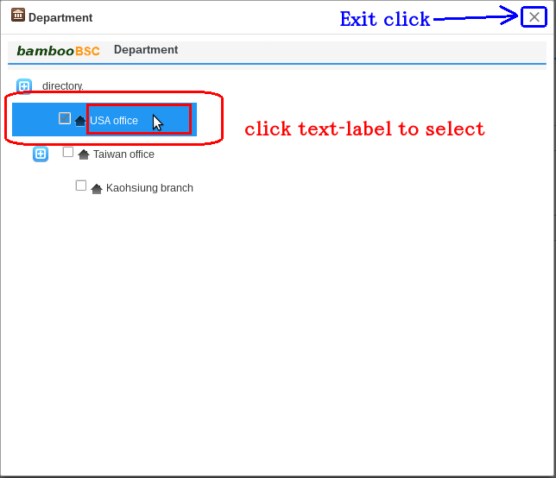

Figure 4-03

Employee pick
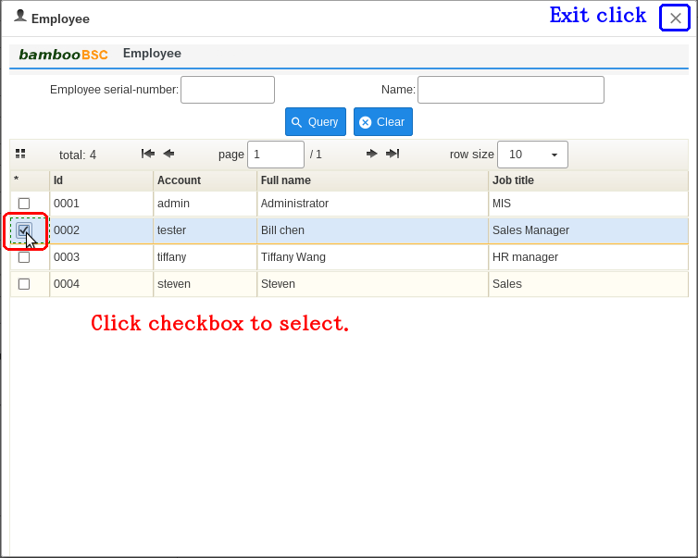

figure 4-04

5. Measure-data
Data needs regular updates and maintenance , If you do not enter data for measurable KPI, the KPI on the report does not make sense
click “ 05 – Measure data “ . look figure 5-01
1. select an KPI items
2. Settings options and Query
3. input measure-data field, click Save to update
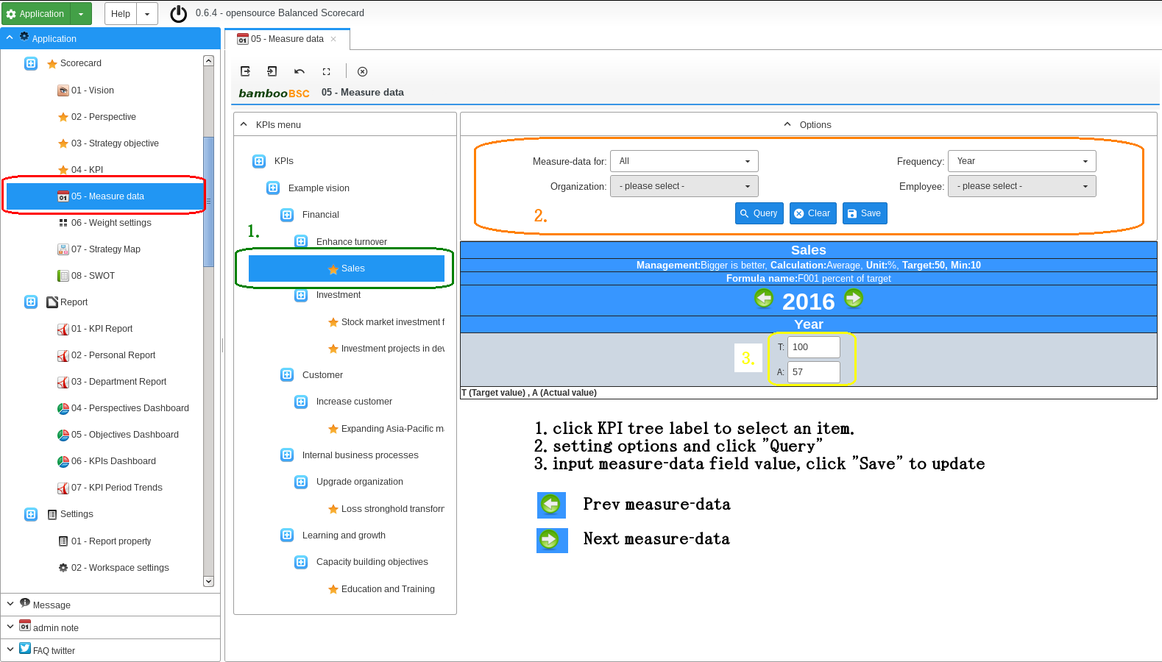

figure 5-01

6. KPI Report
Query organization/Department or Employee 's performance score . first click Report “ 01 – KPI Report ” look figure 6-01
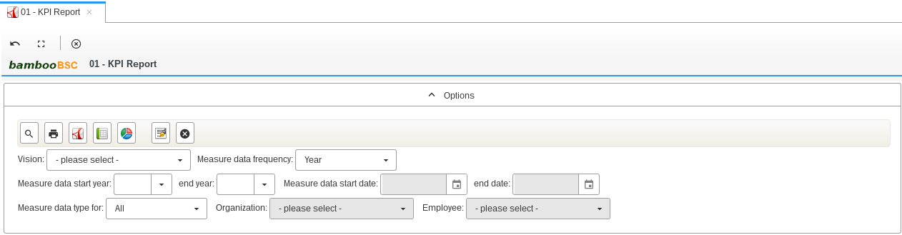

figure 6-01

ICON | Description
 | Query report content
 | Export query report as PNG image, ( used IE browser the function failure )
 | Export query report as PDF file, ( used IE browser the function failure )
 | Export query report as Excel file, ( used IE browser the function failure )
 | Select an Vision
 | Select frequency
 | If Frequency is “ Year” , “ Half of year ” , “ Quarter ” , must input start year and end year
 | If Frequency is “ Month” , “ Week ” , “ Day “ , must input start day and end day
All: Measure data type is non-departmental and non-employee class
Organization: Measure data type only for an organization/Department
Employee: Measure data type only for an employee
 | If measure data for organization type. Need select the option
 | If measure data for employee type. Need select the option

7. Personal Report
Query employee's BSC report. first click Report “ 02 – Personal Report ” look figure 7-01
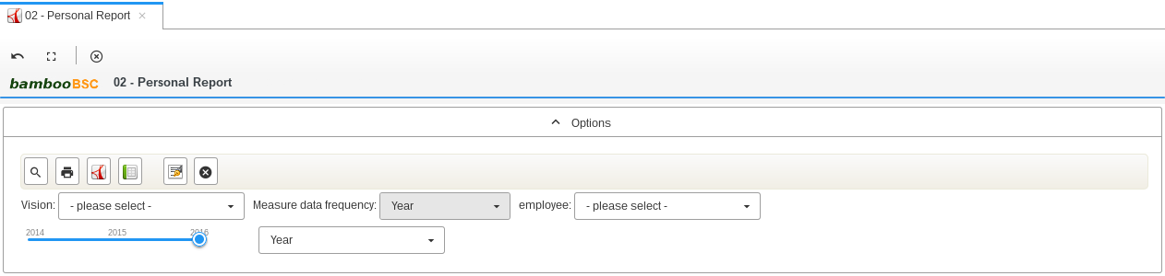

figure 7-01

ICON | Description
 | Query report content
 | Export query report as PNG image, ( used IE browser the function failure )
 | Export query report as PDF file, ( used IE browser the function failure )
 | Export query report as Excel file, ( used IE browser the function failure )
 | Select an Vision
 | No need select, system auto settings.
 | Select an employee
 | Select report year.
In the first half: measure-data frequency basic of first half
In the second half: measure-data frequency basic of second half
Year: measure-data frequency basic of Year

8. Department Report
Query organization/Department BSC report. first click Report “ 03 – Department Report ” look figure 8-01
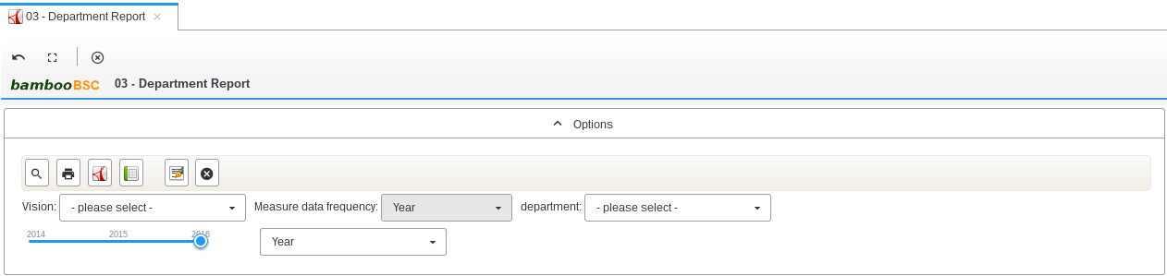

figure 08-001

ICON | Description
 | Query report content
 | Export query report as PNG image, ( used IE browser the function failure )
 | Export query report as PDF file, ( used IE browser the function failure )
 | Export query report as Excel file, ( used IE browser the function failure )
 | Select an Vision
 | No need select, system auto settings.
 | Select an organization/Department
 | Select report year.
In the first half: measure-data frequency basic of first half
In the second half: measure-data frequency basic of second half
Year: measure-data frequency basic of Year

9. Strategy Map
Query or edit the strategy map. First click “ 07 – Strategy Map ” look figure 9-01
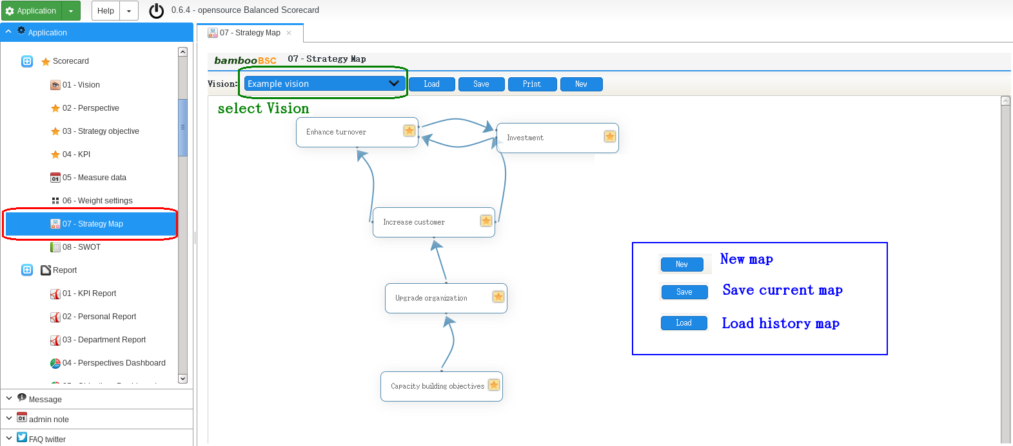

figure 9-01
How to drag Line on MAP

10. SWOT
Query or edit BSC S.W.O.T. first click “ 08 – SWOT ” look figure 10-01
1. first select an Vision and department/Organization
2. Query
3. input content on text-box
4. click save
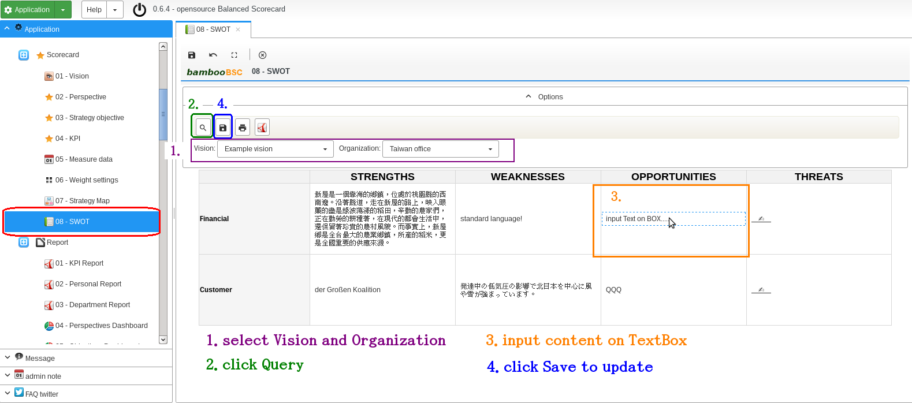

figure 10-01

ICON | Description
 | Query content
 | Save content
 | Export query report as PNG image, ( used IE browser the function failure )
 | Export query report as PDF file, ( used IE browser the function failure )
 | Select an Vision
 | Select an department/Organization

11. Report signature
Managers signature on the report for “01 – KPI Report” / “02 – Personal Report” / “03 – Department Report” . Only export Excel or PDF found signature picture.

ICON | Description
 | Open signature pop-window.
 | Clear current signature picture.
1. first click

2. drawing name on signature pop-window . Look figure 11-01

figure 11-01

3. click export PDF or Excel button , result look figure 11-02

figure 11-02

12. Query Charts
The main function is SQL query to chart .

12-1. Settings datasource
please use “01 – Data source config” to create or modify Datasource settings.
If you want to provide other DB connection driver( SQL-Server or Oracle, pqSQL ... ), please put Driver LIB jar file to WEB-INF/lib and add config of table named qc_data_source_driver . Currently, the system only provides MySQL Driver .

12-2. Settings data mapped
Settings Charts's Label and Value mapped. Click “02 – Data query mapper” on menu . Create new items please look ( figure 12-01 )

figure 12 - 01

Name: Please input mapped item name.
Description: memo or explain
Mapper Label: sql query's fields name
Mapper Value: sql query's fields name

12-3. Query expression to Charts
Charts have provided BAR, PIE, LINE, AREA and html table. Click “01 – Basic query” on menu tree. Look ( figure 12-02 ) , Example results Look ( figure 12-03 )

figure – 12-02

ICON | Description
 | Query results show as HTML table.
 | Query results show as Pie charts
 | Query results show as Bar charts
 | As Line charts
 | As Area charts
 | Save query expression to history data.
 | Clear
 | Delete history data.
 | Select history data.
 | Select datasource.
 | input query name when need Save query
 | Select mapped item for query Charts
 | Select mapped items for Pie charts
 | input SQL query expression

The is Area Charts example.

figure 12-03

13. Analytics ( OLAP )
This feature is to provide a simple OLAP . MDX Query results can be exported into HTML file or EXCEL file .

13-1. Settings datasource
click “03 - Analytics config “ on menu tree. And to create mode look ( figure 13 – 01 ) .

figure 13 – 01

Id: input config Id.
Name: input config name.
Drivers: input jdbc driver class name. ( If you want to provide other DB connection driver( SQL-Server or Oracle, pqSQL ... ), please put Driver LIB jar file to WEB-INF/lib )
Jdbc url: jdbc url. ( url string parameter must include the account and password )
Description: memo or explain

13-2. Upload Mondrian Catalog file
Upload Mondrian catalog file and management. How to build catalog xml file please download mondrian schema workbench ( http://sourceforge.net/projects/mondrian/files/schema%20workbench/ ) now vision is 3.9.0 , use workbench create catalog example ( figure 13-02 )

figure 13 - 02

After the schema workbench output of the catalog xml file using the " 04 - Analytics Catalog " to upload it . Look ( figure 13 – 03 )

figure 13 – 03

Id: input catalog Id.
Name: input catalog name.
Mondrian Catalog: select an catalog xml file to upload.
Description: memo or explain

13-3. Analytics MDX query
Execute MDX query and display or output results. Click “02 - Analytics ” on menu tree. Look ( figure 13 – 04 )

figure 13 – 04

ICON | Description
 | Query results show as HTML results.
 | Export HTML results as a file.
 | Export results as a Excel file.
 | Save MDX to history data.
 | Clear
 | Delete current select history data.
 | Select history data.
 | Query name.
 | Check show Title.
 | Check show members.
 | Select OLAP datasource config.
 | Select OLAP catalog config.
 | input MDX query string.

14. bambooBSC mobile version
14-1. Mobile web.
Provide scorecard query for a mobile-device browser.

Logout: click to logout.
Refresh / Query: click to query new scorecard
Options: click show options pane, to settings measure-data begin/end date range and frequency.

When re-setting measure-data start / end date or frequency, you must re-click Query / refresh button

14-2. Mobile web base operation

15. PDCA ( Plan / Do / Check / Action )

Create new PDCA Project

PDCA Project department pick.

PDCA Project owner/Employee pick.

PDCA KPIs tree pick

PDCA Project item add.

Audit project.

View now audit step of PDCA Project

Confirm audit for PDCA Project

PDCA Report query operation

16. Audit settings ( if PDCA Project or 360 Project edit page cannot click “Confirm audit” button )
Please use “05 – BPMN Resource role” to management. Add an task audit for an user Role.
The default account has permission to audit. Later new added account, please set audit permission by self (admin can do it).

360 Degree feedback project audit process.
Resource ID | Task icon | Task name
DFProjectPublishProcess |  | To apply
DFProjectPublishProcess |  | HR Manager Approval

PDCA project audit process.
Resource ID | Task icon | Task name
PDCAProjectProcess |  | Plan
PDCAProjectProcess |  | Do
PDCAProjectProcess |  | Check
PDCAProjectProcess |  | Action

