1. Write a program to simulate **n nested loops** from **1** to **n**.

using System;

namespace Detyra1

{

class Program

{

static void Loops(int[] arr, int index)

{

if (index >= arr.Length)

{

foreach (int element in arr)

{

Console.Write("{0} ", element);

}

Console.WriteLine();

}

else

for (int i = 1; i <= arr.Length; i++)

{

arr[index] = i;

Loops(arr, index + 1);

}

}

static void Main(string[] args)

{

Console.Write("Enter N: ");

int n = int.Parse(Console.ReadLine());

int[] arr = new int[n];

Loops(arr, 0);

Console.ReadKey();

}

}

}

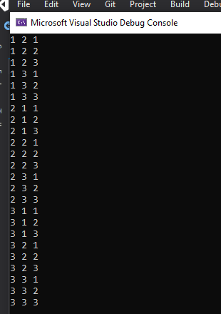

1. Write a program to generate **all variations with duplicates** of **n** elements class **k**.

using System;

namespace Detyra2

{

class Program

{

static void GetCombinations(int[] arr, int index, int start, int end)

{

if (index >= arr.Length)

{

Console.Write("(");

for (int i = 0; i < arr.Length; i++)

{

if (i < arr.Length - 1) Console.Write("{0} ", arr[i]);

else Console.Write(arr[i]);

}

Console.Write("), ");

}

else

for (int i = start; i <= end; i++)

{

arr[index] = i;

GetCombinations(arr, index + 1, i, end);

}

}

static void Main(string[] args)

{

Console.Write("Enter N: ");

int n = int.Parse(Console.ReadLine());

Console.Write("Enter K: ");

int k = int.Parse(Console.ReadLine());

var arr = new int[k];

GetCombinations(arr, 0, 1, n);

Console.ReadKey();

}

}

}

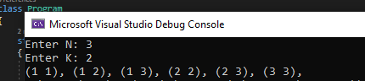

3.Write a program to generate and print **all combinations with duplicates**of **k** elements from a set with **n**elements.

using System;

namespace Detyra3

{

class Program

{

static void GetCombinations(int[] arr, int index, int start, int end)

{

if (index >= arr.Length)

{

Console.Write("(");

for (int i = 0; i < arr.Length; i++)

if (i < arr.Length - 1) Console.Write("{0} ", arr[i]);

else Console.Write(arr[i]);

Console.Write("), ");

}

else

for (int i = start; i <= end; i++)

{

arr[index] = i;

GetCombinations(arr, index + 1, i, end);

}

}

static void Main(string[] args)

{

Console.Write("Enter N: ");

int n = Int32.Parse(Console.ReadLine());

Console.Write("Enter K: ");

int k = Int32.Parse(Console.ReadLine());

int[] arr = new int[k];

GetCombinations(arr, 0, 1, n);

}

}

}

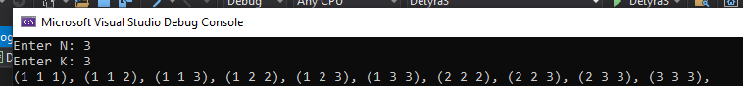

4.You are given a **set of strings**. Write a **recursive program**, which **generates all subsets**, consisting exactly **k** strings chosen among the elements of this set.

using System;

namespace Detyra4

{

class Program

{

static string[] wordsArr;

static void FindSubsets(int[] arr, int index, int start, int end)

{

if (index >= arr.Length)

{

Console.Write("(");

for (int i = 0; i < arr.Length; i++)

{

Console.Write("{0}", wordsArr[arr[i]]);

if (i != arr.Length - 1) Console.Write(" ");

}

Console.Write("), ");

}

else

for (int i = start; i < end; i++)

{

arr[index] = i;

FindSubsets(arr, index + 1, i + 1, end);

}

}

static void Main(string[] args)

{

Console.Write("Enter array length: ");

int length = int.Parse(Console.ReadLine());

wordsArr = new string[length];

Console.WriteLine();

for (int i = 0; i < wordsArr.Length; i++)

{

Console.Write("Enter {0} word: ", i + 1);

wordsArr[i] = Console.ReadLine();

}

Console.Write("\nEnter K: ");

int k = int.Parse(Console.ReadLine());

int[] arr = new int[k];

Console.WriteLine();

FindSubsets(arr, 0, 0, length);

Console.ReadLine();

}

}

}

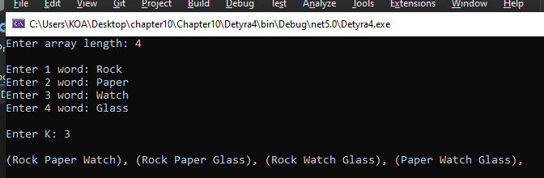

5.    Write a **recursive program**, which prints **all subsets of a given set** of **N** words.

using System;

namespace Detyra5

{

class Program

{

static string[] strings, str;

static int length;

static void cycle(int iter, int index, int k)

{

if (iter == k)

{

for (int i = 0; i < length; i++)

Console.WriteLine("({0})", str[i]);

return;

}

for (int i = index; i < strings.Length; i++)

{

str[iter] = strings[i];

cycle(iter + 1, i + 1, k);

}

}

static void Main(string[] args)

{

Console.Write("Enter words length: ");

length = Int32.Parse(Console.ReadLine());

strings = new string[length];

for (int i = 0; i < length; i++)

{

Console.Write("Enter {0} word: ", i + 1);

strings[i] = Console.ReadLine();

}

for (int i = 0; i <= length; i++)

{

str = new string[length];

cycle(0, 0, i);

}

}

}

}

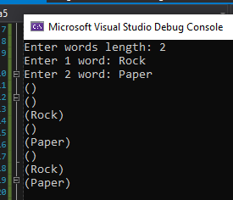

6.   Implement the **merge-sort algorithm recursively**. In it the initial array is divided into two equal in size parts, which are sorted (recursively via merge-sort) and after that the two sorted parts are merged in order to get the whole sorted array.

using System;

namespace Detyra6

{

class Program

{

static public void DoMerge(int[] numbers, int left, int mid, int right)

{

int[] temp = new int[25];

int i, left_end, num_elements, tmp_pos;

left_end = (mid - 1);

tmp_pos = left;

num_elements = (right - left + 1);

while ((left <= left_end) && (mid <= right))

{

if (numbers[left] <= numbers[mid])

temp[tmp_pos++] = numbers[left++];

else

temp[tmp_pos++] = numbers[mid++];

}

while (left <= left_end)

temp[tmp_pos++] = numbers[left++];

while (mid <= right)

temp[tmp_pos++] = numbers[mid++];

for (i = 0; i < num_elements; i++)

{

numbers[right] = temp[right];

right--;

}

}

static public void MergeSort_Recursive(int[] numbers, int left, int right)

{

int mid;

if (right > left)

{

mid = (right + left) / 2;

MergeSort_Recursive(numbers, left, mid);

MergeSort_Recursive(numbers, (mid + 1), right);

DoMerge(numbers, left, (mid + 1), right);

}

}

static void Main(string[] args)

{

Console.Write("Enter array length: ");

int length = Int32.Parse(Console.ReadLine());

int[] arr = new int[length];

for (int i = 0; i < length; i++)

{

Console.Write("Enter {0} element: ", i + 1);

arr[i] = Int32.Parse(Console.ReadLine());

}

Console.WriteLine("\nSorted");

MergeSort_Recursive(arr, 0, length - 1);

for (int i = 0; i < length; i++)

Console.WriteLine(arr[i]);

}

}

}

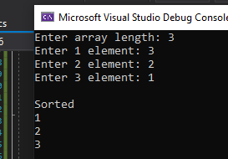

7.    Write a recursive program, which generates and prints **all permutations of the numbers 1, 2, …, n**, for a given integer **n**.

using System;

namespace Detyra7

{

class Program

{

static void FindCombinations(int[] arr, int index)

{

if (index == arr.Length)

{

Console.Write("{");

for (int i = 0; i < arr.Length; i++)

if (i < arr.Length - 1) Console.Write("{0} ", arr[i]);

else Console.Write(arr[i]);

Console.Write("}, ");

}

else

{

for (int i = index; i < arr.Length; i++)

{

int temp = arr[i];

arr[i] = arr[index];

arr[index] = temp;

FindCombinations(arr, index + 1);

temp = arr[i];

arr[i] = arr[index];

arr[index] = temp;

}

}

}

static void Main(string[] args)

{

Console.Write("Enter N: ");

int n = Int32.Parse(Console.ReadLine());

int[] arr = new int[n];

for (int i = 0; i < arr.Length; i++) arr[i] = i + 1;

FindCombinations(arr, 0);

}

}

}



8.    You are given an array of integers and a number **N**. Write a recursive program that finds **all subsets**of numbers in the array, which have a **sum N**. For example, if we have the array **{2**, **3**, **1**, **-1}** and **N=4**, we can obtain**N=4**as a sum in the following two ways: **4=2+3-1; 4=3+1**.

using System;

namespace Detyra8

{

class Program

{

public static bool isSubsetSum(int[] arr, int n, int sum)

{

bool[,] subset = new bool[sum + 1, n + 1];

for (int i = 0; i <= n; i++)

subset[0, i] = true;

for (int i = 1; i <= sum; i++)

subset[i, 0] = false;

for (int i = 1; i <= sum; i++)

for (int j = 1; j <= n; j++)

{

subset[i, j] = subset[i, j - 1];

if (i >= arr[j - 1])

subset[i, j] = subset[i, j] || subset[i - arr[j - 1], j - 1];

}

return subset[sum, n];

}

static void Main(string[] args)

{

Console.Write("Enter arr length: ");

int length = Int32.Parse(Console.ReadLine());

int[] arr = new int[length];

for (int i = 0; i < length; i++)

{

Console.Write("Enter {0} element: ", i + 1);

arr[i] = Int32.Parse(Console.ReadLine());

}

Console.Write("Enter sum: ");

int sum = Int32.Parse(Console.ReadLine());

if (isSubsetSum(arr, arr.Length, sum) == true)

Console.WriteLine("Found a subset with given sum");

else

Console.WriteLine("No subset with given sum");

Console.ReadKey();

}

}

}

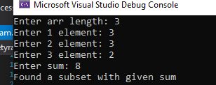

9.    You are given an array of **positive** integers. Write a program that checks whether there is one or more numbers in the array **(subset), whose sum is equal to S**. Can you solve the task **efficiently for large** **arrays**?

using System;

namespace Detyra9

{

class Program

{

static void Main(string[] args)

{

Console.Write("Enter array length: ");

int length = Int32.Parse(Console.ReadLine());

int[] arr = new int[length];

for (int i = 0; i < length; i++)

{

Console.Write("Enter {0} element: ", i + 1);

arr[i] = Int32.Parse(Console.ReadLine());

}

Console.Write("Enter sum: ");

int sum = Int32.Parse(Console.ReadLine());

for (int i = 0; i < arr.Length; i++)

{

int first = arr[i];

for (int j = i + 1; j < arr.Length; j++)

{

int second = arr[j];

if ((first + second) == sum)

Console.WriteLine("({0}, {1}) ", first, second);

}

}

}

}

}

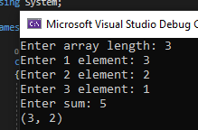

10.   You are given a **matrix** with passable and impassable cells. Write a recursive program that finds **all paths between two cells**in the matrix.

11.   Implement the algorithm **BFS** (breadth-first search) for finding the **shortest path in a labyrinth**.

12.   Modify the previous program to check **whether a path exists between two cells** without finding all possible paths. Test the program with a matrix 100x100 filled only with passable cells.

13.   You are given a matrix with passable and impassable cells. Write a program that finds the **largest area of neighboring passable cells**.

14.   Write a recursive program that **traverses the whole hard disk** **C:\ recursively** and prints all folders and files.