1. Write a program, which reads from the console a year and **checks if it is a leap year**.

using System;

namespace Detyra1

{

class Program

{

static void Main(string[] args)

{

Console.Write("Enter current year: ");

var year = int.Parse(Console.ReadLine());

Console.WriteLine(DateTime.IsLeapYear(year));

Console.ReadKey();

}

}

}

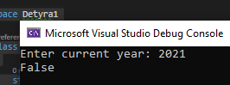

1. Write a program, which generates and prints on the console **10 random numbers** in the range [100, 200].

using System;

namespace Detyra2

{

class Program

{

static void Main(string[] args)

{

var random = new Random();

Console.Write("How many random numbers you want to be printed: ");

var num = int.Parse(Console.ReadLine());

for (int i = 0; i <= num; i++)

{

Console.WriteLine(random.Next(100, 200));

}

}

}

}

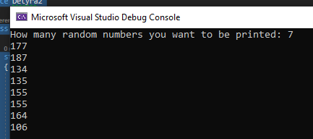

1. Write a program, which prints, on the console **which day of the week is today**.

using System;

namespace Detyra3

{

class Program

{

static void Main(string[] args)

{

Console.WriteLine(DateTime.Today.DayOfWeek);

}

}

}



5.Write a program which by given two sides **finds the hypotenuse of a right triangle**. Implement entering of the lengths of the sides from the standard input, and for the calculation of the hypotenuse use methods of the class **Math**.

using System;

namespace Detyra5

{

class Program

{

static void Main(string[] args)

{

Console.Write("First side: ");

int a = int.Parse(Console.ReadLine());

Console.Write("Second side: ");

int b = int.Parse(Console.ReadLine());

Console.Write("Hypotenuse is: " + Math.Sqrt(Math.Pow(a, 2) + Math.Pow(b, 2)));

}

}

}

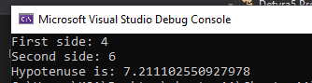

6.    Write a program which **calculates the area of a triangle** with the following given:

-     three sides;

-     side and the altitude to it;

-     two sides and the angle between them in degrees.

using System;

namespace Detyra6

{

class Program

{

public static void threeSides()

{

Console.WriteLine("Enter a: ");

var sideA = float.Parse(Console.ReadLine());

Console.WriteLine("Enter b: ");

var sideB = float.Parse(Console.ReadLine());

Console.WriteLine("Enter c: ");

var sideC = float.Parse(Console.ReadLine());

var p = sideA + sideB + sideC / 2;

Console.WriteLine("S is: {0}", (float)(Math.Sqrt(p * (p - sideA) * (p - sideB) * (p - sideC))));

}

public static void sideAltitude()

{

Console.WriteLine("Enter a: ");

float a = float.Parse(Console.ReadLine());

Console.WriteLine("Enter b: ");

float b = float.Parse(Console.ReadLine());

Console.WriteLine("S is: {0}", (a * b) / 2);

}

public static void twoSideAngle()

{

Console.WriteLine("Enter a: ");

float a = float.Parse(Console.ReadLine());

Console.WriteLine("Enter b: ");

float b = float.Parse(Console.ReadLine());

Console.WriteLine("Enter c: ");

float c = float.Parse(Console.ReadLine());

Console.WriteLine("S is: {0}", (a * b * Math.Sin(c)) / 2);

}

static void Main(string[] args)

{

Console.WriteLine("Calculate the area of triangle:");

Console.WriteLine("Type 1 if u want to calcuale Three side lengths.");

Console.WriteLine("Type 2 if u want to calcualte the Length of one side and it's altitude");

Console.WriteLine("Type 3 if u want to calcualte the Length of two sides and the angle between them");

var option = int.Parse(Console.ReadLine());

switch (option)

{

case 1:

threeSides();

break;

case 2:

sideAltitude();

break;

case 3:

twoSideAngle();

break;

}

}

}

}

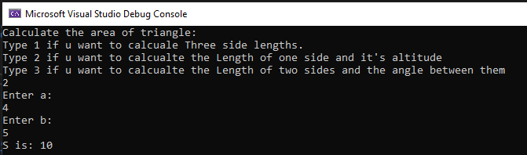

7.    Define your own namespace **CreatingAndUsingObjects** and place in it two classes **Cat** and **Sequence**, which we used in the examples of the current chapter. Define one more namespace and make a class, which calls the classes **Cat** and **Sequence**, in it.

8.    Write a program which creates 10 objects of type **Cat**, gives them names **CatN**, where **N** is a unique serial number of the object, and in the end call the method **SayMiau()** for each of them. For the implementation use the namespace **CreatingAndUsingObjects**.

9.    Write a program, which **calculates the count of workdays between the current date and another given date**after the current (inclusive). Consider that workdays are all days from Monday to Friday, which are not public holidays, except when Saturday is a working day. The program should keep a list of predefined public holidays, as well as a list of predefined working Saturdays.

using System;

namespace Detyra9

{

class Program

{

static void Main(string[] args)

{

DateTime[] holidays = new DateTime[]

{

new DateTime(2014, 12, 24),

new DateTime(2014, 12, 25),

new DateTime(2015, 01, 01),

new DateTime(2015, 01, 02),

new DateTime(2015, 03, 02),

new DateTime(2015, 03, 03),

new DateTime(2015, 04, 10),

new DateTime(2015, 04, 13),

new DateTime(2015, 05, 01),

new DateTime(2015, 05, 06),

new DateTime(2015, 09, 21),

new DateTime(2015, 09, 22),

new DateTime(2015, 12, 24),

new DateTime(2015, 12, 25),

};

DateTime[] workSaturdays = new DateTime[]

{

new DateTime(2015, 01, 24),

new DateTime(2015, 03, 21),

new DateTime(2015, 09, 12),

new DateTime(2015, 12, 12),

};

int workingDays = 0;

Console.Write("Enter end date (YYYY/MM/DD): ");

DateTime endDate = System.Convert.ToDateTime(Console.ReadLine());

DateTime now = DateTime.Now;

do

{

now = now.AddDays(1);

if ((now.DayOfWeek >= DayOfWeek.Monday) && (now.DayOfWeek <= DayOfWeek.Friday))

workingDays++;

foreach (var i in holidays)

if (i.Date == now.Date)

workingDays--;

foreach (var i in workSaturdays)

if (i.Date == now.Date)

workingDays++;

} while (now.Date != endDate.Date);

Console.WriteLine("{0} working days.", workingDays);

}

}

}

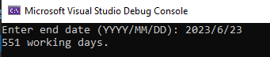

10.   You are given a **sequence of positive integer numbers** given as string of numbers separated by a space. Write a program, which **calculates their sum**. Example: "**43 68 9 23 318**" à **461**.

using System;

namespace Detyra10

{

class Program

{

static void Main(string[] args)

{

Console.Write("Enter some different numbers: ");

var number = Console.ReadLine();

var sum = 0;

string[] numbers = number.Split(" ");

int[] ints = Array.ConvertAll(numbers, s => int.Parse(s));

Console.WriteLine(String.Join(",", ints));

for (int i = 0; i < ints.Length; i++)

{

sum += ints[i];

}

Console.WriteLine(sum);

Console.ReadKey();

}

}

}

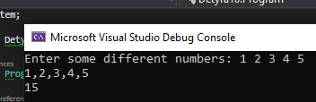

11.   Write a program, which **generates a random advertising message** for some product. The message has to consist of laudatory phrase, followed by a laudatory story, followed by author (first and last name) and city, which are selected from predefined lists. For example, let’s have the following lists:

-     **Laudatory phrases**: {"The product is excellent.", "This is a great product.", "I use this product constantly.", "This is the best product from this category."}.

-     **Laudatory stories**: {"Now I feel better.", "I managed to change.", "It made some miracle.", "I can’t believe it, but now I am feeling great.", "You should try it, too. I am very satisfied."}.

-     **First name** of the author: {"Dayan", "Stella", "Hellen", "Kate"}.

-     **Last name** of the author: {"Johnson", "Peterson", "Charls"}.

-     **Cities**: {"London", "Paris", "Berlin", "New York", "Madrid"}.

Then the program would print randomly generated advertising message like the following:

|  |
| --- |
| I use this product constantly. You should try it, too. I am very satisfied. -- Hellen Peterson, Berlin |

using System;

namespace Detyra11

{

class Program

{

static void Main(string[] args)

{

Random rnd = new Random();

string[] firstNames = new string[] { "Diana", "Petia", "Stela", "Elena", "Katia" };

string[] secondNames = new string[] { "Ivanova", "Petrova", "Kirova", "Popova" };

string[] cities = new string[] { "Sofia", "Plovdiv", "Varna", "Ruse", "Dolno konare" };

string[] reviews1 = new string[] { "This product is excelent.", "This is a great product.", "I use this product all the time.", "This is the best product of this category." };

string[] reviews2 = new string[] { "Now I feel better.", "I changed.", "It was a miracle.", "I can't believe it. Now I feel better.", "Try it yourself. I'm very greatful." };

Console.WriteLine("{0} {1}\n-- {2} {3}, {4}.", reviews1[rnd.Next(4)], reviews2[rnd.Next(5)], firstNames[rnd.Next(5)], secondNames[rnd.Next(4)], cities[rnd.Next(5)]);

}

}

}

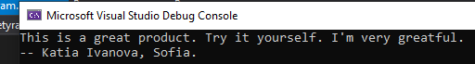

12.   * Write a program, which calculates the value of a given numeral expression given as a string. The numeral expression consists of:

-     real numbers, for example **5**, **18.33**, **3.14159**, **12.6**;

-     arithmetic operations: **+**, **-**, **\***, **/**(with their standard priorities);

-     mathematical functions: **ln(x)**, **sqrt(x)**, **pow(x,** **y)**;

-     brackets for changing the priorities of the operations: **(** and **)**.

Note that the numeral expressions have priorities, for example the expression **-1** **+** **2** **+** **3** **\*** **4** **-** **0.5** **=** **(-1)** **+** **2** **+** **(3** **\*** **4)** **-** **0.5** **=** **12.5**.