**1. Declare several variables** by selecting for each one of them the most appropriate of the types **sbyte**, **byte**, **short**, **ushort**, **int**, **uint**, **long** and **ulong** in order to assign them the following values: 52,130; -115; 4825932; 97; -10000; 20000; 224; 970,700,000; 112; -44; -1,000,000; 1990; 123456789123456789.

using System;

namespace Detyra1

{

class Program

{

static void Main()

{

ushort num1 = 52130;

sbyte num2 = -115;

int num3 = 4825932;

byte num4 = 97;

short num5= -10000;

ushort num6 = 20000;

byte num7 = 224;

uint num8 = 970700000;

byte num9 = 112;

sbyte num10 = -44;

int num11 = -1000000;

ushort num12 = 1990;

long num13 = 123456789123456789;

Console.WriteLine("{0}\n{1}\n{2}\n{3}\n{4}\n{5}\n{6}\n{7}\n{8}\n{9}\n

{11}\n{12}",

num1,num2,num3,num4,num5,num6,num7,num8,num9,num10,num11,

num12,num13);

}

}

}

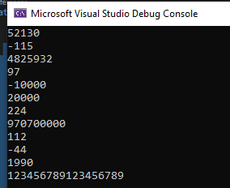

**2.** Which of the following values can be assigned to variables of type **float**, **double** and **decimal**: 5, -5.01, 34.567839023; 12.345; 8923.1234857; 3456.091124875956542151256683467?

using System;

namespace detyra2

{

class Program

{

static void Main(string[] args)

{

float numri1 = 5f;

float numri2 = -5.01f;

float numri3 = 12.345f;

double numri4 = 34.567839023d;

double numri5 = 8923.1234857d;

decimal numri6 = 3456.091124875956542151256683467M;

Console.WriteLine($"{numri1}\n{numri2}\n{numri3}\n{numri4}\n{numri5}\n

{numri6}\n", numri1, numri2, numri3, numri4, numri5, numri6);

}

}

}

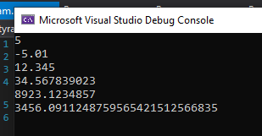

**3.** Write a program, which **compares correctly** **two real numbers** with accuracy at least **0.000001**.

using System;

class Program

{

static void Main(string[] args)

{

decimal num1 = 0.000001M;

decimal num2 = 0.000001M;

bool krahasimi = (num1 == num2) ? true : false;

Console.WriteLine(krahasimi);

}

}

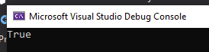

**4. Initialize** a variable of type **int** with a value of 256 in  
**hexadecimal** format (256 is 100 in a numeral system with base 16).

using System;

namespace Detyra4

{

class Program

{

static void Main(string[] args)

{

int hexNum = 0x100;

Console.WriteLine(hexNum);

}

}

}

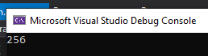

**5.** Declare a variable of type **char** and assign as a value the character, which has **Unicode** code, 72 (use the Windows calculator in order to find hexadecimal representation of 72).

using System;

namespace Detyra5

{

class Program

{

static void Main(string[] args)

{

char vlera = '\u0043';

Console.WriteLine(vlera);

}

}

}



**6.**  Declare a variable **isMale** of type **bool**and assign a value to it depending on your gender.

using System;

namespace Detyra6

{

class Program

{

static void Main(string[] args)

{

bool isMale = true;

Console.WriteLine(isMale);

}

}

}

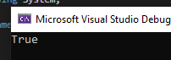

**7.**  Declare two variables of type **string** with values "Hello" and "World". Declare a variable of type **object**. Assign to this variable the value obtained of concatenation of the two string variables (add space if necessary). Print the variable of type **object**.

using System;

namespace Detyra7

{

class Program

{

static void Main(string[] args)

{

string fristLetter = "Hello";

string secondLetter = "World";

object obj = fristLetter + " " + secondLetter;

Console.WriteLine(obj);

}

}

}

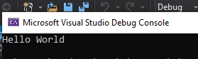

**8.**  Declare two variables of type **string** and assign them values "Hello" and "World". Declare a variable of type **object** and assign to it the value obtained of concatenation of the two variables of type **string** (do not miss the space in the middle). Declare a third variable of type **string** and initialize it with the value of the variable of type **object** (you should use type casting).

using System;

namespace Detyra8

{

class Program

{

static void Main(string[] args)

{

string str1 = "Hello";

string str2 = "World";

object obj = str1 + " " + str2;

string str3 = obj.ToString();

Console.WriteLine(str3);

}

}

}

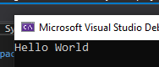

**9.**  Declare two variables of type **string** and assign them a value “**The "use" of quotations causes difficulties.**” (without the outer quotes). In one of the variables use quoted string and in the other do not use it.

using System;

namespace Detyra9

{

class Program

{

static void Main(string[] args)

{

string str1 = "The \"use\" of quotations causes difficulties.";

string str2 = "The " + "\u0022" + "use" + "\u0022" + " of quotations causes difficulties.";

Console.WriteLine(str1);

Console.WriteLine(str2);

}

}

}

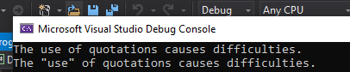

**10.** Write a program to print a figure in the shape of a **heart** by the sign "**o**".

using System;

namespace Detyra10

{

class Program

{

static void Main()

{

Console.WriteLine(" 00 00 ");

Console.WriteLine("0 0 0 0");

Console.WriteLine(" 0 0 0 0");

Console.WriteLine(" 0 00 0");

Console.WriteLine(" 0 0 ");

Console.WriteLine(" 0 0 ");

Console.WriteLine(" 0 0 ");

Console.WriteLine(" 00 ");

}

}

}

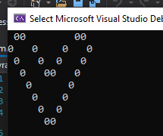

**11.**  Write a program that prints on the console **isosceles triangle** which sides consist of the copyright character "**©**".

using System;

namespace detyra11

{

class Program

{

static void Main(string[] args)

{

Console.OutputEncoding = System.Text.Encoding.UTF8;

Console.WriteLine(" ©");

Console.WriteLine(" © ©");

Console.WriteLine(" © ©");

Console.WriteLine("© ©");

Console.WriteLine("©©©©©©©©");

}

}

}

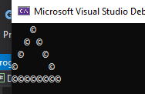

**12.**  A company dealing with marketing wants to keep a data record of its **employees**. Each record should have the following characteristic – first name, last name, age, gender (‘m’ or ‘f’) and unique employee number (27560000 to 27569999). **Declare appropriate variables** needed to maintain the information for an employee by using the appropriate data types and attribute names.

using System;

namespace Detyra12

{

class Program

{

static void Main(string[] args)

{

string firstName = "Rron";

string lastName = "Mustafa";

byte age = 18;

char gender = 'M';

int id = 2243576;

Console.WriteLine("This is your Personal Information: ");

Console.WriteLine("First name: " + firstName);

Console.WriteLine("Last name: " + lastName);

Console.WriteLine("Age: " + age);

Console.WriteLine("Sex: " + gender);

Console.WriteLine("ID Number: " + id);

}

}

}

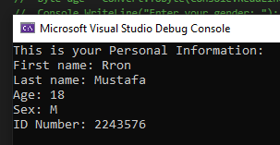

**13.** Declare two variables of type **int**. Assign to them values 5 and 10 respectively. **Exchange (swap) their values** and print them.

using System;

namespace detyra13

{

class Program

{

static void Main(string[] args)

{

int num1 = 5;

int num2 = 10;

int placeholder = num2;

num2 = num1;

num1 = placeholder;

Console.WriteLine(num1);

Console.WriteLine(num2);

}

}

}

