1.     Write a program that **reads** from the console **three numbers** of type **int** and prints their sum.

using System;

namespace detyra1

{

class Program

{

static void Main(string[] args)

{

Console.WriteLine("Enter three numbers: ");

int num1 = int.Parse(Console.ReadLine());

int num2 = int.Parse(Console.ReadLine());

int num3 = int.Parse(Console.ReadLine());

Console.WriteLine("the sum of three number is {0}", num1 + num2 + num3);

Console.ReadKey();

}

}

}

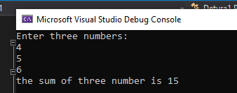

2.     Write a program that **reads** from the console the **radius** "**r**" of a circle and prints its **perimeter** **and area**.

using System;

class Program

{

public static void Main(string[] args)

{

double r, perimetriarea;

double pi = 3.14;

Console.WriteLine("Input the radius of the circle: ");

r = Convert.ToDouble(Console.ReadLine());

perimetriarea = 2 * pi * r;

Console.WriteLine("The perimeter of your circle is {0}", perimetriarea);

Console.ReadKey();

}

}

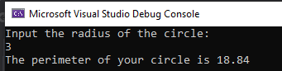

3.     A given company has name, address, phone number, fax number, web site and manager. The manager has name, surname and phone number. Write a program that **reads information about the company** and its manager and then **prints it** on the console.

using System;

namespace Detyra3

{

class Program

{

static void Main(string[] args)

{

Console.Write("Enter the company name: ");

string companyName = Console.ReadLine();

Console.Write("Enter the company Address: ");

string address = Convert.ToString(Console.ReadLine());

Console.Write("Enter the company phone number: ");

int phoneNumber = Convert.ToInt32(Console.ReadLine());

Console.Write("Enter the company fax number: ");

int faxNumber = Convert.ToInt32(Console.ReadLine());

Console.Write("Enter the company website: ");

string web = Convert.ToString(Console.ReadLine());

Console.Write("Enter the company Manager Name: ");

string managerName = Console.ReadLine();

Console.Write("Enter the Manager Last Name: ");

string managerSurName = Console.ReadLine();

Console.Write("Enter Manager age: ");

byte managerAge = byte.Parse(Console.ReadLine());

Console.Write("Enter Manager phone number: ");

int managerNumber = Convert.ToInt32(Console.ReadLine());

Console.WriteLine("\nYour Manager Infos are here: ");

Console.WriteLine("1.Name: {0, 11} ",managerName);

Console.WriteLine("2.LastName: {0, 10} ", managerSurName);

Console.WriteLine("3.Age: {0, 10}", managerAge);

Console.WriteLine("3.PhoneNumber: {0, 2} ", managerNumber);

Console.ReadKey();

}

}

}

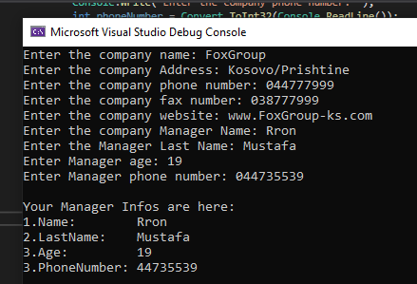

4.     Write a program that **prints three numbers in three virtual columns** on the console. Each column should have a width of 10 characters and the numbers should be **left aligned**. The first number should be an integer in **hexadecimal**; the second should be **fractional positive**; and the third – a **negative fraction**. The last two numbers have to be rounded to the second decimal place.

using System;

namespace Detyra4

{

class Program

{

static void Main(string[] args)

{

Console.Write("Enter a number: ");

int hexNum = Convert.ToInt32(Console.ReadLine());

Console.Write("Enter a fractional number: ");

double fractNumPoz = double.Parse(Console.ReadLine());

Console.Write("Enter a fractional negativ number: ");

double fractNumNeg = double.Parse(Console.ReadLine());

Console.WriteLine("|{0,-10:x}|", hexNum);

Console.WriteLine("|{0,-10:f2}|", fractNumPoz);

Console.WriteLine("|{0,-10:f2}|", fractNumNeg);

Console.ReadKey();

}

}

}

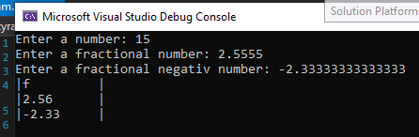

5.Write a program that reads from the console two integer numbers (**int**) and prints how many numbers between them exist, such that **the remainder of their division by 5 is 0**. Example: in the range (14, 25) there are 3 such numbers: 15, 20 and 25.

using System;

namespace Detyra5

{

class Program

{

static void Main(string[] args)

{

int sum = 0;

Console.Write("Enter first number: ");

int num1 = int.Parse(Console.ReadLine());

Console.Write("Enter second number: ");

int num2 = int.Parse(Console.ReadLine());

for (int i = num1; i <= num2; i++)

{

if (i % 5 == 0)

{

sum++;

}

}

Console.WriteLine("{0} numbers", sum);

Console.ReadKey();

}

}

}

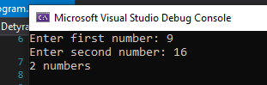

6.     Write a program that reads two numbers from the console and **prints the greater of them**. Solve the problem without using conditional statements.

using System;

class Program

{

static void Main()

{

Console.WriteLine("Write two different numbers: ");

int num1 = int.Parse(Console.ReadLine());

int num2 = int.Parse(Console.ReadLine());

int max = num1 > num2 ? num1 : num2;

Console.WriteLine("The greater number is {0}", max);

Console.ReadKey();

}

}

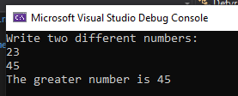

7.     Write a program that **reads five integer numbers and prints their sum**. If an invalid number is entered the program should prompt the user to enter another number.

using System;

namespace Detyra7

{

class Program

{

static void Main(string[] args)

{

int num1, num2, num3, num4, num5, sum;

bool parseSucceed = false;

do

{

Console.Write("Enter first number: ");

parseSucceed = Int32.TryParse(Console.ReadLine(), out num1);

Console.WriteLine(parseSucceed);

} while (!parseSucceed);

do

{

Console.Write("Enter second number: ");

parseSucceed = Int32.TryParse(Console.ReadLine(), out num2);

Console.WriteLine(parseSucceed);

} while (!parseSucceed);

do

{

Console.Write("Enter third number: ");

parseSucceed = Int32.TryParse(Console.ReadLine(), out num3);

Console.WriteLine(parseSucceed);

} while (!parseSucceed);

do

{

Console.Write("Enter fourth number: ");

parseSucceed = Int32.TryParse(Console.ReadLine(), out num4);

Console.WriteLine(parseSucceed);

} while (!parseSucceed);

do

{

Console.Write("Enter fifth number: ");

parseSucceed = Int32.TryParse(Console.ReadLine(), out num5);

Console.WriteLine(parseSucceed);

} while (!parseSucceed);

sum = num1 + num2 + num3 + num4 + num5;

Console.WriteLine("The sum of five numbers is {0}", sum);

Console.ReadKey();

}

}

}

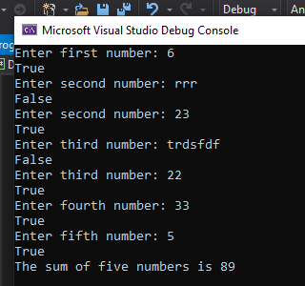

8.     Write a program that reads five numbers from the console and prints the **greatest** of them.

using System;

namespace Detyra8

{

class Program

{

static void Main(string[] args)

{

Console.WriteLine("Enter a number");

int num1 = int.Parse(Console.ReadLine());

Console.WriteLine("Enter a number");

int num2 = int.Parse(Console.ReadLine());

Console.WriteLine("Enter a number");

int num3 = int.Parse(Console.ReadLine());

Console.WriteLine("Enter a number");

int num4 = int.Parse(Console.ReadLine());

Console.WriteLine("Enter a number");

int num5 = int.Parse(Console.ReadLine());

if(num1 > num2 && num1 > num3 && num1 > num4 && num1 > num5)

{

Console.WriteLine("This is the greatest number {0}", num1);

}

else if(num2 > num1 && num2 > num3 && num2 > num4 && num2 > num5)

{

Console.WriteLine("This is the greatest number {0}", num2);

}

else if (num3 > num1 && num3 > num2 && num3 > num4 && num3 > num5)

{

Console.WriteLine("This is the greatest number {0}", num3);

}

else if (num4 > num1 && num4 > num2 && num4 > num3 && num4 > num5)

{

Console.WriteLine("This is the greatest number {0}", num4);

}

else if (num5 > num1 && num5 > num3 && num5 > num4 && num5 > num2)

{

Console.WriteLine("This is the greatest number {0}", num5);

}

else if (num1 == num2 && num1 == num3 && num1 == num4 && num1 == num5)

{

Console.WriteLine("all numbers are equal");

} else

{

Console.WriteLine("there are no greatest number");

}

Console.ReadKey();

}

}

}

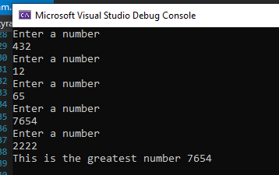

9.     Write a program that reads an integer number **n** from the console. After that reads **n** numbers from the console and prints their **sum**.

using System;

public class Program

{

static void Main(string[] args)

{

int sum = 0;

Console.Write("Enter numbers length: ");

int length = Int32.Parse(Console.ReadLine());

for (int i = 0; i < length; i++)

{

Console.Write("Enter {0} number: ", i + 1);

sum += Int32.Parse(Console.ReadLine());

}

Console.WriteLine("Sum of all numbers is {0}.", sum);

}

}

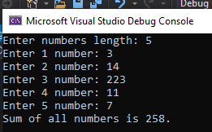

10.   Write a program that reads an integer number **n** from the console and **prints** **all numbers in the range** **[1…n]**, each on a separate line.

using System;

namespace Detyra10

{

class Program

{

static void Main(string[] args)

{

Console.Write("Enter number: ");

int length = int.Parse(Console.ReadLine());

for (int i = 1; i <= length; i++)

{

Console.WriteLine(i);

}

Console.ReadKey();

}

}

}

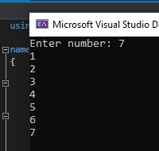

11.   Write a program that prints on the console the first 100 numbers in the **Fibonacci sequence**: 0, 1, 1, 2, 3, 5, 8, 13, 21, 34, 55, 89, 144, 233, …

using System;

namespace Detyra11

{

static void Main(string[] args)

{

ulong firstNum = 0, secondNum = 1, thirdNum = 0;

Console.WriteLine("First 100 numbers in the Fibonacci sequence");

Console.Write("0, 1,");

for (int i = 2; i < 100; i++)

{

thirdNum = firstNum + secondNum;

Console.Write(" {0},", thirdNum);

firstNum = secondNum;

secondNum = thirdNum;

}

}

}

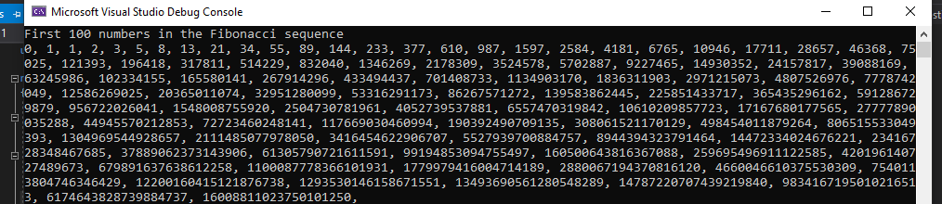

12.   Write a program that calculates the **sum** (with **precision of 0.001**) of the following sequence: 1 + 1/2 - 1/3 + 1/4 - 1/5 + …

using System;

namespace Detyra12

{

class Program

{

static void Main(string[] args)

{

Console.Write("Enter last number: ");

int length = Int32.Parse(Console.ReadLine());

double sum = 1.0;

for (int i = 2; i <= length; i++)

{

sum += (1.0 / i);

Console.WriteLine("{0:F3}", sum);

}

Console.ReadKey();

}

}

}

