1. Convert the numbers **151**, **35**, **43**, **251**, **1023**and **1024** to the **binary numeral system.**

using System;

namespace Detyra1

{

class Program

{

static void Main(string[] args)

{

int num1 = 151, num2 = 35, num3 = 43, num4 = 251, num5 = 1023,

num6 = 1024;

string numBin1 = Convert.ToString(num1, 2);

string numBin2 = Convert.ToString(num2, 2);

string numBin3 = Convert.ToString(num3, 2);

string numBin4 = Convert.ToString(num4, 2);

string numBin5 = Convert.ToString(num5, 2);

string numBin6 = Convert.ToString(num6, 2);

Console.WriteLine("Number {0} in binary is {1}",num1,numBin1);

Console.WriteLine("Number {0} in binary is {1}",num2, numBin2);

Console.WriteLine("Number {0} in binary is {1}",num3, numBin3);

Console.WriteLine("Number {0} in binary is {1}",num4, numBin4);

Console.WriteLine("Number {0} in binary is {1}",num5, numBin5);

Console.WriteLine("Number {0} in binary is {1}",num6, numBin6);

Console.ReadKey();

}

}

}

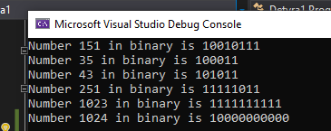

1. Convert the number **1111010110011110(2)** to **hexadecimal** and **decimal** numeral systems.

using System;

namespace Detyra2

{

class Program

{

static void Main(string[] args)

{

string num = "1111010110011110";

long numDec = Convert.ToInt32(num, 2);

string numHex = Convert.ToInt32(num, 2).ToString("X");

Console.WriteLine("Number {0} in decimal is {1}",num, numDec);

Console.WriteLine("Number {0} in Hexadecimal is {1}",num, numHex);

}

}

}

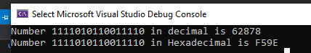

3.    Convert the hexadecimal numbers **FA**, **2A3E**, **FFFF**, **5A0E9** to **binary** and **decimal** numeral systems.

using System;

namespace Detyra3

{

class Program

{

static void Main(string[] args)

{

string num1 = "FA", num2 = "2A3E", num3 = "FFFF", num4 = "5A0E9";

int dec1 = Convert.ToInt32(num1, 16);

int dec2 = Convert.ToInt32(num2, 16);

int dec3 = Convert.ToInt32(num3, 16);

int dec4 = Convert.ToInt32(num4, 16);

string bin1 = Convert.ToString(Convert.ToInt32(num1, 16), 2);

string bin2 = Convert.ToString(Convert.ToInt32(num2, 16), 2);

string bin3 = Convert.ToString(Convert.ToInt32(num3, 16), 2);

string bin4 = Convert.ToString(Convert.ToInt32(num4, 16), 2);

Console.WriteLine("Hex Number {0} in decimal is {1}",num1, dec1);

Console.WriteLine("Hex Number {0} in decimal is {1}",num2, dec2);

Console.WriteLine("Hex Number {0} in decimal is {1}",num3, dec3);

Console.WriteLine("Hex Number {0} in decimal is {1}",num4, dec4);

Console.WriteLine("\nHex Number {0} in binary is {1}",num1, bin1);

Console.WriteLine("Hex Number {0} in binary is {1}",num2, bin2);

Console.WriteLine("Hex Number {0} in binary is {1}",num3, bin3);

Console.WriteLine("Hex Number {0} in binary is {1}",num4, bin4);

Console.ReadKey();

}

}

}

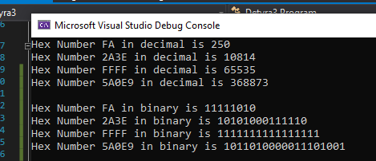

4.    Write a program that converts a **decimal number to binary** one.

using System;

namespace Detyra4

{

class Program

{

static void Main(string[] args)

{

Console.Write("Enter a random number: ");

int num = int.Parse(Console.ReadLine());

string num1 = Convert.ToString(num, 2);

Console.WriteLine("Your number in binary is {0}",num1);

Console.ReadKey();

}

}

}

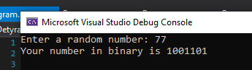

5.    Write a program that converts a **binary number to decimal** one.

using System;

namespace Detyra5

{

class Program

{

static void Main(string[] args)

{

Console.Write("Enter a binary number: ");

string num = Convert.ToString(Console.ReadLine());

int num1 = Convert.ToInt32(num, 2);

Console.WriteLine("Your binary {0} number convert to decimal is {1}"

,num, num1);

Console.ReadKey();

}

}

}

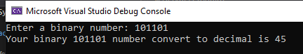

6.    Write a program that converts a **decimal number to hexadecimal** one.

using System;

namespace Detyra6

{

class Program

{

static void Main(string[] args)

{

Console.Write("Enter a random number: ");

int num = int.Parse(Console.ReadLine());

string numHex = num.ToString("X");

Console.WriteLine("Your number {0} in HexaDecimal is {1}",num , numHex);

}

}

}

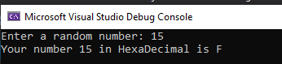

7.    Write a program that converts a **hexadecimal number to decimal** one.

using System;

namespace Detyra8

{

class Program

{

static void Main(string[] args)

{

Console.Write("Enter a Hexadecimal Number: ");

string num = Convert.ToString(Console.ReadLine());

int num1 = Convert.ToInt32(num, 16);

Console.WriteLine("Your Hex number {0} in decimal is {1}",num,num1);

Console.ReadKey();

}

}

}

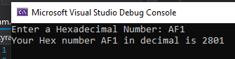

8.    Write a program that converts a **hexadecimal number to binary** one.

using System;

namespace Detyra8

{

class Program

{

static void Main(string[] args)

{

Console.Write("Enter a Hexadecimal Number: ");

string num = Convert.ToString(Console.ReadLine());

string num1 = Convert.ToString(Convert.ToInt32(num, 16), 2);

Console.WriteLine("Your Hex number {0} in binary is {1}",num,num1);

Console.ReadKey();

}

}

}

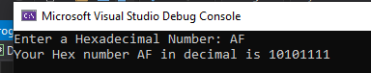

9.    Write a program that converts a **binary number to hexadecimal** one.

using System;

namespace Detyra9

{

class Program

{

static void Main(string[] args)

{

Console.Write("Enter a binary number:");

string num = Console.ReadLine();

string numHex = Convert.ToInt32(num, 2).ToString("X");

Console.WriteLine(numHex);

}

}

}

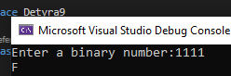

10.   Write a program that converts a **binary number to decimal** using the Horner scheme.

using System;

namespace Detyra10

{

class Program

{

static void Main(string[] args)

{

Console.Write("Enter a binary number:");

string num = Console.ReadLine();

int num1 = Convert.ToInt32(num, 2);

Console.WriteLine("Your number {0} to decimal is {1}", num,num1);

}

}

}

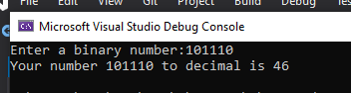

11.   Write a program that converts **Roman digits to Arabic** ones.

12.   Write a program that converts **Arabic digits to Roman** ones.

13.   Write a program that by given **N**, **S**, **D** (**2** **≤** **S**, **D** **≤** **16**) converts the number **N** from an **S**-based numeral system to a **D**based numeral system.

14.   Try **adding up 50,000,000 times the number 0.000001**. Use a loop and addition (not direct multiplication). Try it with **float** and **double** and after that with **decimal**. Do you notice the **huge difference in the results** and speed of calculation? Explain what happens.

15.   * Write a program that prints the value of the **mantissa**, the **sign of the mantissa** and **exponent** in **float** numbers (32-bit numbers with a floating-point according to the **IEEE 754** standard). Example: for the number **-27.25** should be printed: **sign** = **1**, **exponent** = **10000011**, **mantissa** = **10110100000000000000000**.