# IR Sensor Module for Reflective Sensor, Light Barrier, and Fast Proximity Applications

### FEATURES

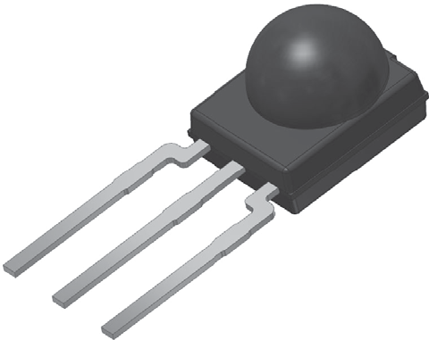

23051



* Presence sensor: up to 2 m distance,

find more info at: [www.vishay.com/doc?49009](http://www.vishay.com/doc?49009)

* Light barrier: up to 12 m distance, TSAL6200 with IF = 50 mA,



find more info at: [www.vishay.com/doc?49650](http://www.vishay.com/doc?49650)



* Fast proximity: up to 2 m range at 5 ms response time,



find more info at: [www.vishay.com/doc?82741](http://www.vishay.com/doc?82741)



* Supply voltage: 2.0 V to 3.6 V
* Material categorization: for definitions of compliance please see [www.vishay.com/doc?99912](http://www.vishay.com/doc?99912)

### LINKS TO ADDITIONAL RESOURCES

[](https://www.vishay.com/optoelectronics/opto-window-area-calculator/minimold/)[](http://www.vishay.com/doc?82765)**MECHANICAL DATA**



[Product Page](https://www.vishay.com/ir-receiver-modules/through-hole-minimold/)

[3D Models](http://www.vishay.com/ppg?82780&designtools-ppg) [Calculators](https://www.vishay.com/optoelectronics/opto-window-area-calculator/minimold/) [Marking](http://www.vishay.com/doc?80121) [Packages](http://www.vishay.com/doc?82765)

#### Pinning:

1 = OUT, 2 = GND, 3 = VS

[](https://www.vishay.com/ir-receiver-modules/holders-list/) [](https://www.vishay.com/ir-receiver-modules/bend-cut-list/)

[Holders](https://www.vishay.com/ir-receiver-modules/holders-list/) [Bends and Cuts](https://www.vishay.com/ir-receiver-modules/bend-cut-list/)

### DESCRIPTION

The TSSP930.. device is the latest generation of compact infrared detector module for presence, proximity, or light curtain applications. They provide an active low output in response to infrared bursts at 940 nm. The frequency of the burst should correspond to the carrier frequency shown in the parts table.

This component has not been qualified according to automotive specifications.

### ORDERING CODE

TSSP930.. - 1800 pieces in bags

### APPLICATIONS

* Reflective sensors for hand dryers, towel or soap dispensers, water faucets, toilet flush
* Vending machine fall detection
* Security and pet gates
* Person or object vicinity switch
* Fast proximity sensors for toys, robotics, drones, and other consumer and industrial uses

### BLOCK DIAGRAM PRESENCE SENSING

16833_8 +3 V



33 k

3

VS

Input

AMP

Band pass

1

OUT

PIN

2

GND

Demo- dulator



IR emitter

Envelope

signal 38 kHz

+3 V

Out to μC

|  |  |  |
| --- | --- | --- |
| **PARTS TABLE** | | |
| **Carrier frequency** | 38 kHz | TSSP93038 |
| 56 kHz | TSSP93056 |
| **Package** | | Minimold |
| **Pinning** | | 1 = OUT, 2 = GND, 3 = VS |
| **Dimensions (mm)** | | 5.4 W x 6.35 H x 4.9 D |
| **Mounting** | | Leaded |
| **Application** | | Presence sensors, fast proximity sensors |
| **Special options** | | * Narrow optical filter: [www.vishay.com/doc?81590](http://www.vishay.com/doc?81590) * Wide optical flter: [www.vishay.com/doc?82726](http://www.vishay.com/doc?82726) |

|  |  |  |  |  |
| --- | --- | --- | --- | --- |
| **ABSOLUTE MAXIMUM RATINGS** | | | | |
| **PARAMETER** | **TEST CONDITION** | **SYMBOL** | **VALUE** | **UNIT** |
| Supply voltage (pin 3) |  | VS | -0.3 to +3.6 | V |
| Supply current (pin 3) |  | IS | 5 | mA |
| Output voltage (pin 1) |  | VO | -0.3 to +3.6 | V |
| Voltage at output to supply |  | VS - VO | -0.3 to (VS + 0.3) | V |
| Output current (pin 1) |  | IO | 5 | mA |
| Junction temperature |  | Tj | 100 | °C |
| Storage temperature range |  | Tstg | -25 to +85 | °C |
| Operating temperature range |  | Tamb | -25 to +85 | °C |
| Power consumption | Tamb  85 °C | Ptot | 10 | mW |

**Note**

* Stresses beyond those listed under “Absolute Maximum Ratings” may cause permanent damage to the device. This is a stress rating only and functional operation of the device at these or any other conditions beyond those indicated in the operational sections of this specification is not implied. Exposure to absolute maximum rating conditions for extended periods may affect the device reliability

|  |  |  |  |  |  |  |
| --- | --- | --- | --- | --- | --- | --- |
| **ELECTRICAL AND OPTICAL CHARACTERISTICS** (Tamb = 25 °C, unless otherwise specified) | | | | | | |
| **PARAMETER** | **TEST CONDITION** | **SYMBOL** | **MIN.** | **TYP.** | **MAX.** | **UNIT** |
| Supply current (pin 3) | Ev = 0, VS = 3.3 V | ISD | 0.25 | 0.37 | 0.45 | mA |
| Ev = 40 klx, sunlight | ISH | - | 0.8 | - | mA |
| Supply voltage |  | VS | 2.0 | - | 3.6 | V |
| Output voltage low (pin 1) | IOSL = 0.5 mA, Ee = 2 mW/m2,  test signal see Fig. 1 | VOSL | - | - | 100 | mV |
| Transmission distance | Ev = 0, IR diode TSAL6200,  IF = 50 mA, test signal see Fig. 1 | d | - | 12 | - | m |
| Minimum irradiance | Pulse width tolerance: tpi - 5/f0 < tpo < tpi + 6/f0, test signal see Fig. 1 | Ee min. | 0.3 | 0.4 | 0.6 | mW/m2 |
| Maximum irradiance | tpi - 5/f0 < tpo < tpi + 6/f0, test signal see Fig. 1 | Ee max. | 30 | - | - | W/m2 |
| Directivity | Angle of half transmission distance | 1/2 | - | ± 45 | - | ° |

**TYPICAL CHARACTERISTICS** (Tamb = 25 °C, unless otherwise specified)

Ee **Optical Test Signal**

(IR diode TSAL6200, IF = 0.4 A, 30 pulses, f = f0, T = 10 ms)

t

0.8

0.7

ton

toff

λ= 950 nm, optical test signal, Fig. 3

ton, toff - Output Pulse Width (ms)

0.6

0.5

tpi (1)

T

0.4

(1) tpi ≥ 10/f0 is recommended for optimal function

VO

VOH

**Output Signal**

16110-13

(2) 7/f < t < 15/f

(3)

0 d 0

t 5/f < t t + 6/f

pi - 0 po < pi 0

VOL

td (2)

tpo (3)

t

Fig. 1 - Output Delay and Pulse Width

0.3

0.2

0.1

0

0.1 1 10 100 1000 10 000

Ee - Irradiance (mW/m2)

Fig. 4 - Output Pulse Diagram

0.90

1.2

f = f0 ± 5 %

f(3 dB) = f0/10

0.85 1.0

Output pulse width

Input burst length

λ= 950 nm,

optical test signal, Fig. 1

tpo - Output Pulse Width (ms)

Relative Responsivity

0.80 0.8

0.75

0.70

0.65

0.6

0.4

Ee min./Ee -

0.2

0.60

0.1 10 1000 100 000

Ee - Irradiance (mW/m2)

16925

0.0

0.7 0.9 1.1 1.3

f/f0 - Relative Frequency

Fig. 2 - Pulse Length and Sensitivity in Dark Ambient Fig. 5 - Frequency Dependence of Responsivity

Ee

**Optical Test Signal**

600 µs

600 µs

t

t = 60 ms

Fig. 3 - Test Signal

VO

VOH

**Output Signal**, (see Fig. 4)

94 8134

VOL

t on

t off

t

0.6

0.5

Ee min. - Threshold Irradiance (mW/m2)

0.4

0.3

0.2

0.1

0

-30 -10 10 30 50 70 90

Tamb - Ambient Temperature (°C)

Fig. 6 - Sensitivity vs. Ambient Temperature

1.0

0.9

S(λ)rel. - Relative Spectral Sensitivity

0.8

0.7

0.6

0.5

0.4

0.3

0.2

0.1

0

750 850 950 1050 1150

λ - Wavelength (nm)

1.0

0.9

Ee min. - Threshold Irradiance (mW/m2)

0.8

0.7

0.6

0.5

0.4

0.3

0.2

0.1

0

1.0 1.5 2.0 2.5 3.0 3.5 4.0

VS - Supply Voltage (V)

Fig. 7 - Relative Spectral Sensitivity vs. Wavelength Fig. 9 - Sensitivity vs. Supply Voltage

0° 10°

20°

30°

1.0

0.9

0.8

0.7

40°

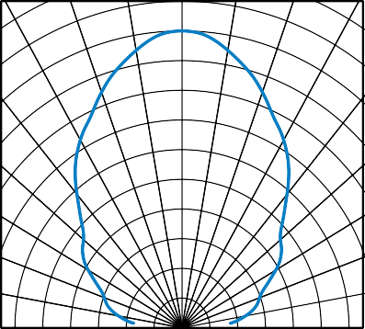50°

60°

70°

80°

0.6 0.4

0.2

0 0.2

0.4

0.6

drel. - Relative Transmission Distance

Fig. 8 - Directivity

The typical application of these devices is a reflective or beam break sensor with active low “detect” or “no detect” information contained in its output. The TSSP930.. is also suitable for fast (~ 15 ms) proximity sensor applications for ranges between 10 cm and 2 m, if a burst pattern with variable intensity is used.

Example for a sensor hardware:

IR detector



IR emitter

Separation to avoid crosstalk by stray light inside the housing

There should be no common window in front of the emitter and detector in order to avoid crosstalk via guided light through the window.

[](http://www.vishay.com/)

**PACKAGE DIMENSIONS** in millimeters

Cavity number

5

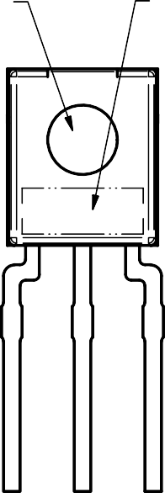Marking area

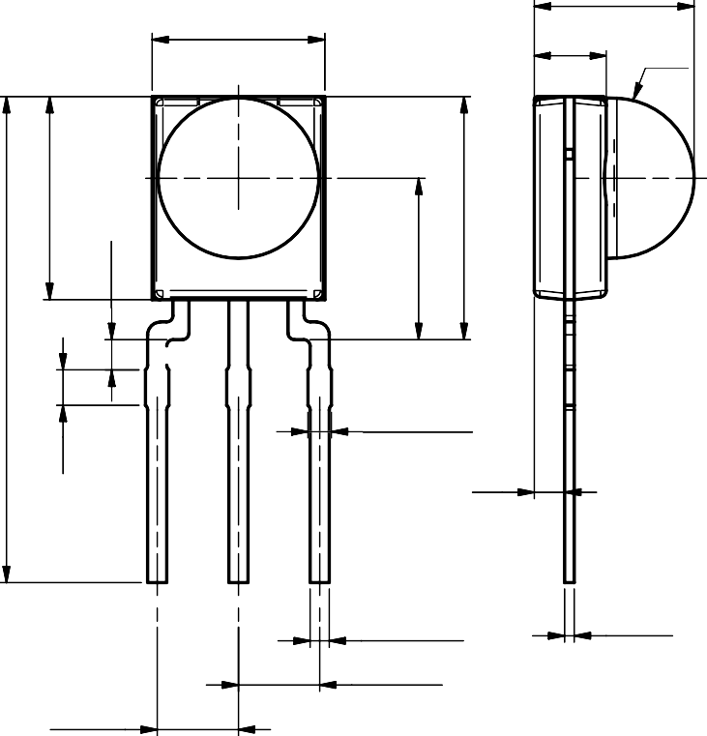

5.4

2.25

R2.5

(3 x) 0.85 max.

0.95

1

2

3

(3 x) 0.6 ± 0.1

(3 x)

0.3 ± 0.1

2.54 nom.

2.54 nom.

6.35

(0.95)

(5.05)

7.6

15.2 ± 0.3

(1.1)

 

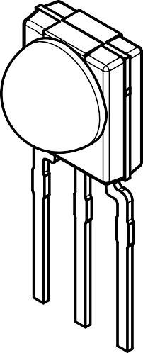Technical drawings according to DIN specifications

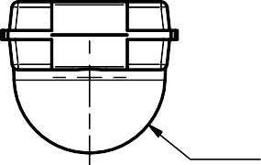

R2.5

Not indicated tolerances ± 0.2

Drawing-No.: 6.550-5335.01-4

Issue: 2; 02.07.19

## [www.vishay.com](http://www.vishay.com/) Vishay Semiconductors

### BULK PACKAGING

Standard shipping for minimold is in conductive plastic bags. The packing quantity is determined by weight and the number of components per carton may vary by a maximum of ± 0.3 %.

### ORDERING INFORMATION

#### Examples: TSSP93038SS1

For more information, see: [www.vishay.com/doc?80076](http://www.vishay.com/doc?80076)

### PACKAGING QUANTITY

* 300 pieces per bag (each bag is individually boxed)
* 6 bags per carton

[www.vishay.com](http://www.vishay.com/) Vishay

# Disclaimer

ALL PRODUCT, PRODUCT SPECIFICATIONS AND DATA ARE SUBJECT TO CHANGE WITHOUT NOTICE TO IMPROVE RELIABILITY, FUNCTION OR DESIGN OR OTHERWISE.

Vishay Intertechnology, Inc., its affiliates, agents, and employees, and all persons acting on its or their behalf (collectively, “Vishay”), disclaim any and all liability for any errors, inaccuracies or incompleteness contained in any datasheet or in any other disclosure relating to any product.

Vishay makes no warranty, representation or guarantee regarding the suitability of the products for any particular purpose or the continuing production of any product. To the maximum extent permitted by applicable law, Vishay disclaims (i) any and all liability arising out of the application or use of any product, (ii) any and all liability, including without limitation special, consequential or incidental damages, and (iii) any and all implied warranties, including warranties of fitness for particular purpose, non-infringement and merchantability.

Statements regarding the suitability of products for certain types of applications are based on Vishay's knowledge of typical requirements that are often placed on Vishay products in generic applications. Such statements are not binding statements about the suitability of products for a particular application. It is the customer's responsibility to validate that a particular product with the properties described in the product specification is suitable for use in a particular application. Parameters provided in datasheets and / or specifications may vary in different applications and performance may vary over time. All operating parameters, including typical parameters, must be validated for each customer application by the customer's technical experts. Product specifications do not expand or otherwise modify Vishay's terms and conditions of purchase, including but not limited to the warranty expressed therein.

Hyperlinks included in this datasheet may direct users to third-party websites. These links are provided as a convenience and for informational purposes only. Inclusion of these hyperlinks does not constitute an endorsement or an approval by Vishay of any of the products, services or opinions of the corporation, organization or individual associated with the third-party website. Vishay disclaims any and all liability and bears no responsibility for the accuracy, legality or content of the third-party website or for that of subsequent links.

Except as expressly indicated in writing, Vishay products are not designed for use in medical, life-saving, or life-sustaining applications or for any other application in which the failure of the Vishay product could result in personal injury or death. Customers using or selling Vishay products not expressly indicated for use in such applications do so at their own risk. Please contact authorized Vishay personnel to obtain written terms and conditions regarding products designed for such applications.

No license, express or implied, by estoppel or otherwise, to any intellectual property rights is granted by this document or by any conduct of Vishay. Product names and markings noted herein may be trademarks of their respective owners.

***© 2024 VISHAY INTERTECHNOLOGY, INC. ALL RIGHTS RESERVED***