Application url: https://github.com/rrosario333/spring-cloud-microservice-example-master

Eureka Server:

Deploy the Eureka Server war file in Tomcat webapps folder.

Tomcat Location :Tomcat 8.5\webapps

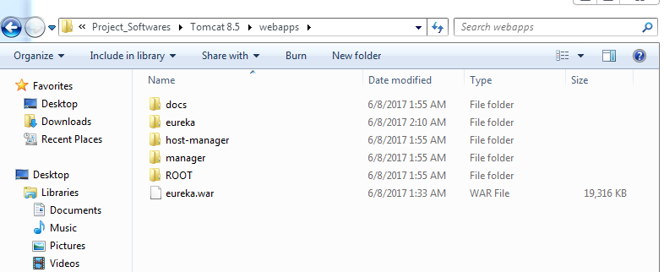

Start the tomcat:

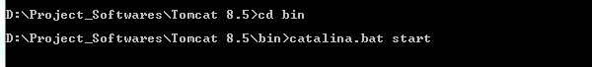

Confirm the server running: http://localhost:8080

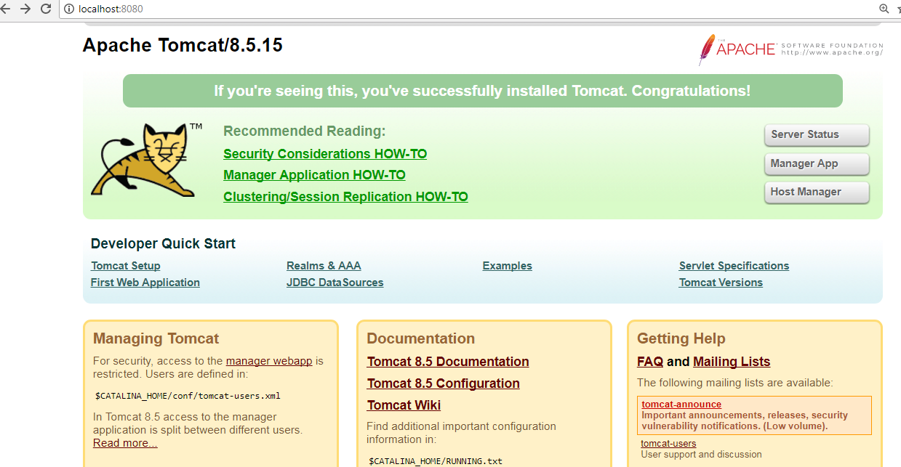

Run Eureka Server Url:<http://localhost:8080/eureka>

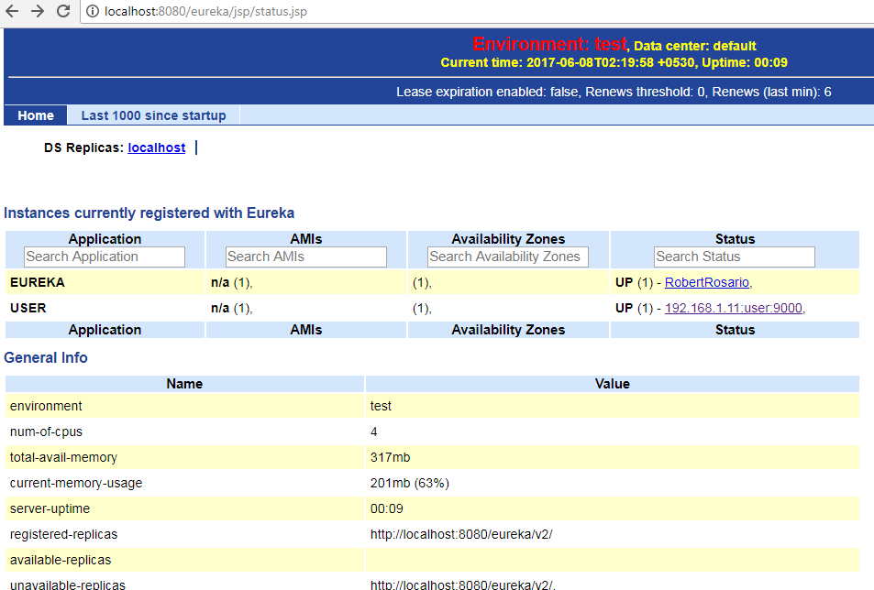

Configure the Eureka url in your application:

Application.yml file or properties file.

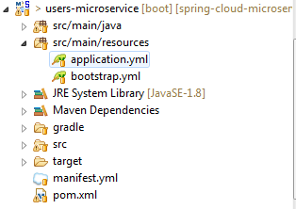

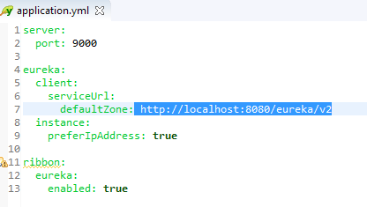

Run the application:

Log is showing your application register with Eureka Server:

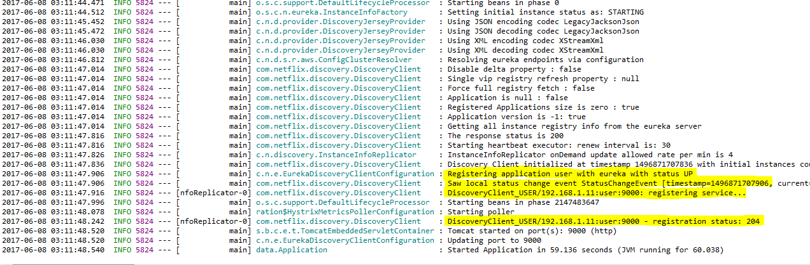

Eureka Server UI Console:

