Global Economic Freedom: Exploring Global Patterns in Economic Freedom and Societal Outcomes
DS 5610 Final Report
Maggie Tu, Roshan Siddartha, Laura Li
Motivation:
In a time of increasing global economic interconnectedness, understanding how economic freedom influences societal well-being has long been a central question in economic policy discussions. Economic freedom is often considered a cornerstone of prosperity, yet its impact on specific societal outcomes like happiness, healthcare, and food affordability remains less understood. As countries look to successful economies as models for development, there is particular value in understanding how different levels of economic freedom among top performing nations relate to social outcomes. Traditional economic measures like GDP provide only partial insights into national wellbeing, creating a need for more comprehensive analysis that considers both economic and social dimensions. By examining these relationships through multiple analytical approaches, this study aims to provide deeper insights into how economic freedom might be structured to promote both prosperity and quality of life.
- Introduction
This study offers a multifaceted examination of economic freedom, first analyzing its components and global patterns, then focusing on the world's most economically free nations to understand how subtle differences in economic freedom relate to prosperity and quality of life. Using the Economic Freedom Index, which measures five dimensions of economic liberty through 47 distinct components, we begin by identifying which aspects of economic freedom show the strongest statistical relationships with overall freedom scores, showing trade openness and regulatory efficiency to have the highest correlations. Through cluster analysis, we identify four distinct groups of economies, high-performing, emerging market, state-controlled developing, and low-freedom fragile economies, each exhibiting unique patterns across economic freedom dimensions. We then narrow our focus to examine how variations in economic freedom among top performing nations correlate with GDP per capita, healthcare expenditure, happiness levels, and food affordability. We provide insights into whether marginal differences in economic freedom translate into meaningful variations in societal outcomes. Our analysis reveals that even among the world's most economically free nations, the relationship between economic liberty and social welfare is complex and sometimes counterintuitive. While economic freedom generally correlates with positive outcomes, the relationships are nuanced and often influenced by country-specific factors. This focus on top performers is particularly relevant given the troubling global trend of declining economic freedom from 2015 to 2022 observed even among traditionally free economies, raising questions about the resilience of economic freedom and its continued impact on societal outcomes.
- Data Overview
The Economic Freedom of the World Index stands as a comprehensive measure of how national policies and institutions support economic liberty across the globe. At its core, the index evaluates the fundamental pillars of economic freedom: personal choice, voluntary exchange, market competition, and the security of private property. Published by the Fraser Institute, the 2024 edition of the dataset covers economic freedom from 1970 - 2022 across 165 countries. Each row represents a unique observation for a country in a specific year, while the columns represent scores for economic freedom, rankings, and related economic indicators used to evaluate overall economic freedom. This index employs 47 distinct data points to construct a summary measure and these metrics are organized into five fundamental areas, each capturing essential aspects of economic liberty. These five categories are weighted equally in calculating the overall freedom index, and higher scores in these categories as well as the overall index indicate higher levels of freedom in their respective areas. The size of government component examines how governmental expansion through spending, taxation, and state-owned enterprises may constrain individual economic choice. The legal system and property rights category evaluates judicial independence, impartial courts, and protection of property rights. Sound money measurements assess how inflation might erode earned wages and savings, looking at money growth, inflation volatility, and freedom to own foreign currency. The freedom to trade internationally dimension recognizes that economic freedom must extend beyond national borders for full realization. Finally, the regulatory environment assessment examines how governmental regulations might restrict exchange, credit access, labor markets, and business operations.
During our initial assessment of the Economic Freedom Index dataset, we identified a significant data quality challenge that required careful consideration. We discovered systematic patterns of missing values across years, predominantly affecting nations experiencing political instability or limited statistical infrastructure. For example, Somalia lacked Economic Freedom Index scores for 25 different years, while Comoros and Djibouti were missing scores for 23 years each, and Brunei Darussalam for 16 years, etc. This pattern of missing annual data presents limitations for our analysis, particularly regarding the representation of some developing nations and fragile states. Rather than risk introducing bias through data imputation, we opted for a complete case analysis approach by removing country-year observations with missing Economic Freedom Index scores and/or component scores. This decision was driven by the complex nature of economic freedom metrics and the specific contextual factors that led to these gaps in data collection over time. However, these data limitations affect only our ability to analyze some developing nations and fragile states, they have minimal impact on the portion of our analysis focusing on the world's most economically free nations. The countries we examine in detail including Singapore, Switzerland, New Zealand, Ireland, Denmark, and other top performers consistently maintain robust data availability. These nations have near-complete data coverage across all years and components of the index. Therefore, our focused analysis of how economic freedom relates to GDP per capita, healthcare expenditure, happiness levels, and food affordability among top-performing nations remains methodologically sound despite the broader dataset's limitations.
- Exploratory Analysis and Findings
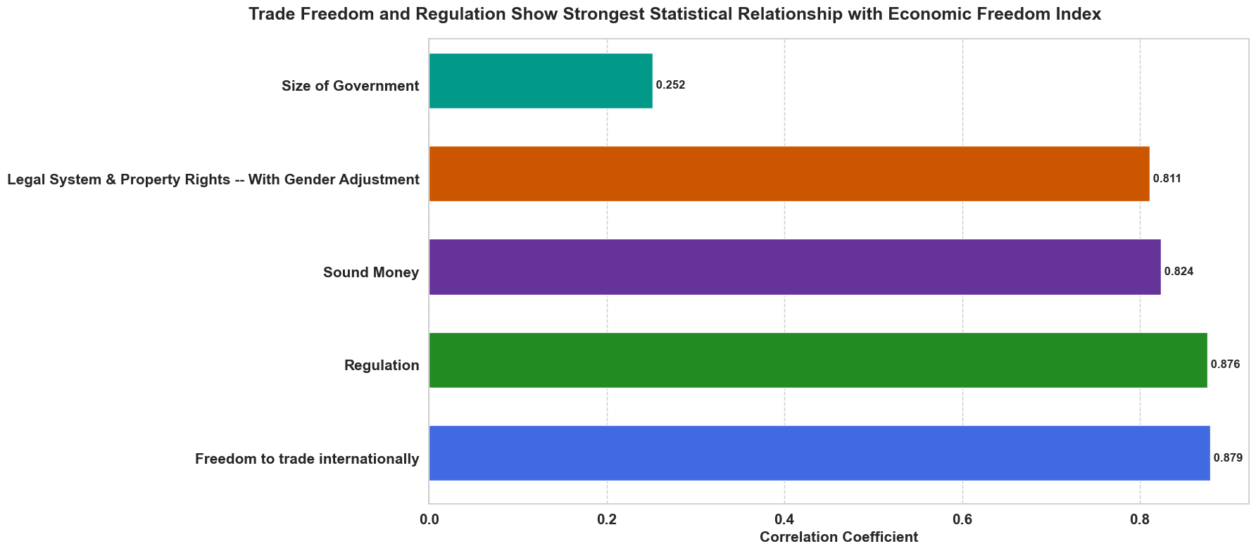
Economic Freedom of the World:
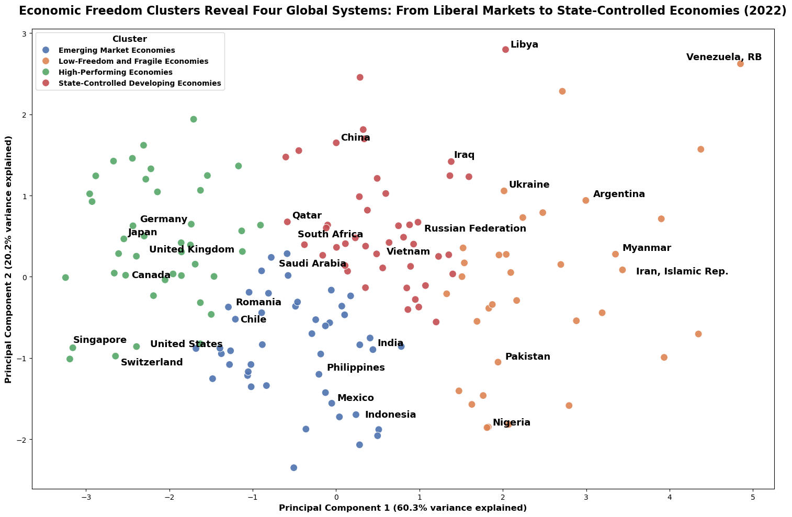
For our first visualization, we created a horizontal bar chart examining correlation coefficients between the 5 major components of economic freedom and the overall index. The x-axis represents the correlation coefficient values, ranging from 0 to 1, indicating the strength of the statistical relationship between each component and the overall index. The y-axis lists the five components of the Economic Freedom Index: Size of Government, Legal System & Property Rights, Sound Money, Regulation, and Freedom to trade internationally. Each bar in the plot represents the correlation coefficient for a specific component, with Freedom to trade internationally at 0.879 and Regulation at 0.876 showing the strongest statistical relationships with the overall index, while Size of Government shows a notably weaker correlation of 0.252. The stark contrast between the high correlations of trade freedom, regulation, sound money, and legal systems which are all above 8 versus the much lower correlation of government size suggests that economic freedom may be more strongly associated with the quality of institutions and regulatory frameworks than with the scale of government intervention. This pattern is particularly noteworthy given that all components carry equal weight in the index calculation, indicating that a country's economic freedom score tends to align more closely with its performance in trade openness, regulatory efficiency, monetary stability, and legal structures than with its government size. Furthermore, the similar correlation coefficients among the top four components suggest these aspects of economic freedom might be mutually reinforcing, potentially pointing to the interconnected nature of institutional quality in supporting economic freedom.
Our second visualization shows the clustering of countries based on their economic freedom characteristics in 2022. The x-axis represents the first principal component, which explains 60.3% of the variance in the economic freedom data across five categories. The y-axis represents the second principal component, explaining an additional 20.2% of the variance, together capturing over 80% of the total variation in the data. Each dot in the plot represents a country, with colors indicating its classification into one of four distinct economic clusters: high-performing economies (predominantly Western democracies and developed Asian economies), emerging market economies (including India and Mexico), state-controlled developing economies (including China and Russia), and low-freedom and fragile economies (including Venezuela and Iran). Using the elbow method, we determined that four clusters optimally capture the distinct patterns in economic freedom across countries.
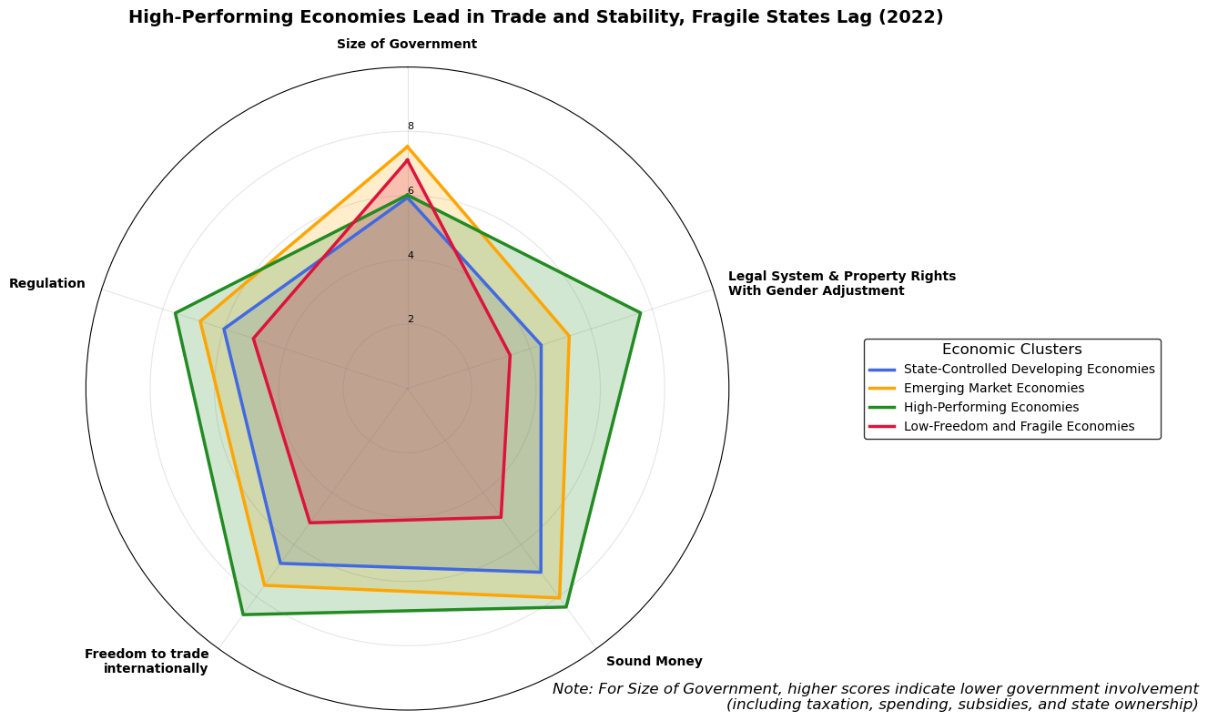
The clustering shows several noteworthy patterns: high-performing economies form the most compact cluster, suggesting a consistent set of economic freedom characteristics among developed nations, while low-freedom and fragile economies show the most dispersed pattern, potentially indicating diverse paths to economic challenges. The positioning of emerging market economies between high-performing and state-controlled clusters suggests a potential development pathway, with some countries like Chile and Romania positioning closer to high-performing economies. The distinct but overlapping positions of state-controlled and emerging market economies highlight how different economic governance approaches can achieve similar levels of development, though with varying degrees of economic freedom. Furthermore, the clear separation between clusters along the first principal component axis suggests that economic freedom characteristics create natural groupings of countries that align with broader development patterns and institutional frameworks.
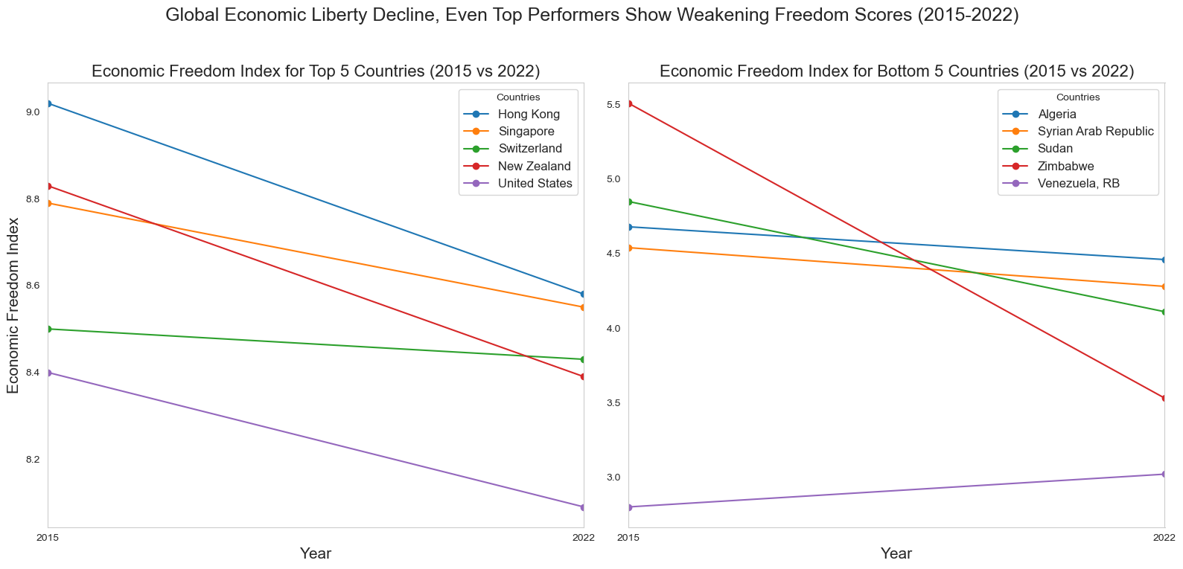
Our third visualization is a radar chart comparing the average scores across five economic freedom components for different economic clusters identified in the 2022 data. The plot uses a pentagonal shape where each vertex represents one of the five components: size of government, where higher scores indicate less government intervention through taxation, spending, subsidies, and state ownership, legal system and property rights, sound money, freedom to trade internationally, and regulation. The radial axes measure scores from 0 to 10 for each of these five dimensions, with each cluster's performance represented by a distinctly colored polygon. The radar analysis shows that high-performing economies demonstrate remarkable consistency across all dimensions, with particularly strong showings in legal systems and sound money. Though interestingly, they show similar scores to state-controlled economies in the size of government component, possibly reflecting their substantial role in providing public services, social safety nets, and infrastructure despite having freer markets overall. Emerging market and state-controlled economies maintain moderate performance in several areas but both show consistent weakness in legal system and property rights protection. Fragile economies face challenges across all dimensions, though with varying patterns of weakness that could suggest potential paths for improvement.
Our fourth visualization is a dual line graph that compares Economic Freedom Index changes between 2015 and 2022 for two distinct groups: the top five and bottom five performing countries, with each line representing the temporal change of a specific country. The left panel tracks the trajectories of leading economies, while the right panel follows struggling economies. The y-axes represent Economic Freedom Index scores, while x-axes span from 2015 to 2022. The visualization shows a universal decline in economic freedom aside from Venezuela, though with markedly different patterns and severities between the two groups. Among top performers, Hong Kong, New Zealand, and United States’ drastic declines stand out most starkly, potentially reflecting shifts in trade policies and increased government intervention during this period. Particularly in Hong Kong’s case, it likely reflects the increased mainland Chinese influence on its economic policies and business environment. These notable downward trends are suggesting that even the most economically free nations aren't immune to global pressures and regulatory challenges.
Among the bottom performers, Zimbabwe's drastic drop from 5.5 to 3.5 represents one of the steepest declines in the dataset, highlighting how political instability and economic mismanagement can rapidly erode economic freedom. Sudan also shows a sizable decline, which could potentially reflect its challenge of political upheaval and economic deterioration. What's particularly interesting is how these trends appear to be widening the gap between the most and least economically free nations. While there are clear declines in top performers, they maintain relatively high scores above 8.0, suggesting that robust institutional foundations help preserve economic freedom even under pressure. In contrast, bottom performers' steeper declines indicate how economic freedom can rapidly deteriorate when fundamental institutions are weak or failing. This divergence suggests that economic freedom, once established through strong institutions and market-friendly policies, creates a kind of resilience that helps countries weather global challenges more effectively. This temporal analysis could carry important implications for policymakers. The universal decline in economic freedom, even among top performers, suggests global challenges to market-oriented policies that may require coordinated international responses.
Economic Freedom and Happiness Score:
In addition to the Economic Freedom Index, to explore the human impact of economic freedom, we incorporated the World Happiness dataset, which annually evaluates global well-being based on individuals' assessments of their lives. The dataset includes the "Life Ladder" score, a measure of subjective well-being ranging from 0 to 10, reflecting how people rate their quality of life, with higher scores indicating greater happiness or satisfaction. By integrating this dataset with our economic freedom analysis, we aim to understand if and how economic freedom translates into tangible improvements in people's lives. This combination allows us to examine whether countries with greater economic liberties tend to create more fulfilling environments for their citizens, and how policies promoting economic freedom might impact overall life satisfaction. The relationship between economic institutions and subjective well-being is particularly relevant for policymakers seeking to understand the broader societal impacts of economic policies and reforms.
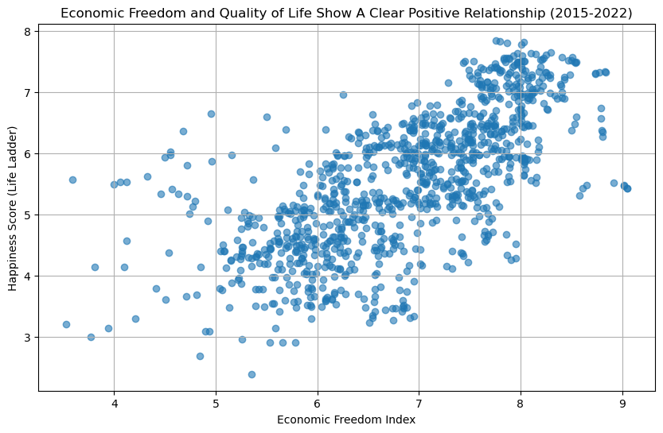
Our fifth visualization examines the relationship between economic freedom and quality of life through a scatter plot comparing the Economic Freedom Index with the World Happiness Report's Life Ladder scores from 2015 to 2022. The x-axis displays the Economic Freedom Index scores while the y-axis shows the Happiness scores, with each point representing a country-year observation. The plot reveals a clear positive correlation between economic freedom and happiness scores, with countries scoring higher on economic freedom generally reporting higher levels of life satisfaction. The visualization shows a concentrated cluster of observations in the upper right quadrant where both economic freedom and happiness scores are high, typically representing high-performing economies with strong institutions and robust market systems. The data points become more dispersed at lower levels of economic freedom, suggesting that while limited economic freedom generally corresponds with lower happiness scores, there is greater variability in life satisfaction among these countries. This pattern might indicate that societies with lower economic freedom may rely on different mechanisms or cultural factors to maintain well-being. There are some variety in the strength of the relationship, with the positive correlation becoming stronger as economic freedom increases, particularly after an index score of 6, suggesting possible threshold effects where the benefits of economic freedom for quality of life become more pronounced at higher levels of economic liberty. Furthermore, the consistency of the pattern across years indicates a stable relationship between economic freedom and subjective well-being, though the scatter in the data points reminds us that economic freedom is just one of many factors influencing happiness levels.
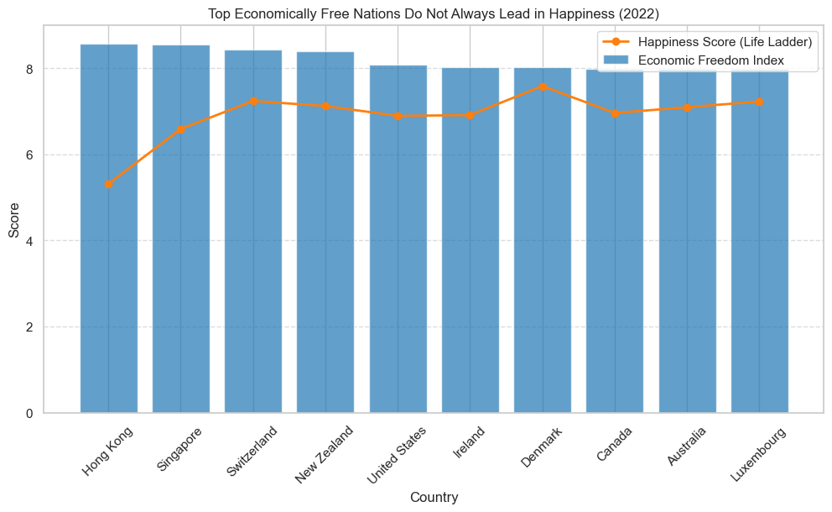
Our sixth visualization compares economic freedom and happiness scores among the top 10 economically free nations in 2022, showing complex patterns in the relationship between economic liberty and life satisfaction. The chart uses blue bars to represent Economic Freedom Index scores and an orange line for Happiness scores, with countries arranged along the x-axis and scores on the y-axis ranging from 0 to 10. The visualization highlights several interesting patterns in the data, particularly the notable divergence between economic freedom and happiness rankings. An especially striking feature is the "paradox" displayed by Hong Kong and Singapore, which despite leading in economic freedom with scores above 8.5, report substantially lower happiness scores around 5.5-6.5, suggesting that robust economic institutions alone may not guarantee higher levels of life satisfaction. In contrast, the rest of the countries do demonstrate a closer alignment between their economic freedom and happiness scores, potentially reflecting their success in balancing market freedoms with social welfare systems. The relatively uniform economic freedom scores across these top 10 nations contrasted with their varying happiness levels challenges simple assumptions about the relationship between economic liberty and subjective well-being. In addition, the presence of nations with different governance models and cultural contexts among the top performers suggests that high levels of economic freedom can be achieved through various institutional arrangements, though their impact on happiness may vary significantly based on broader societal factors such as work-life balance, social cohesion, and political stability.
Economic Freedom and GDP:
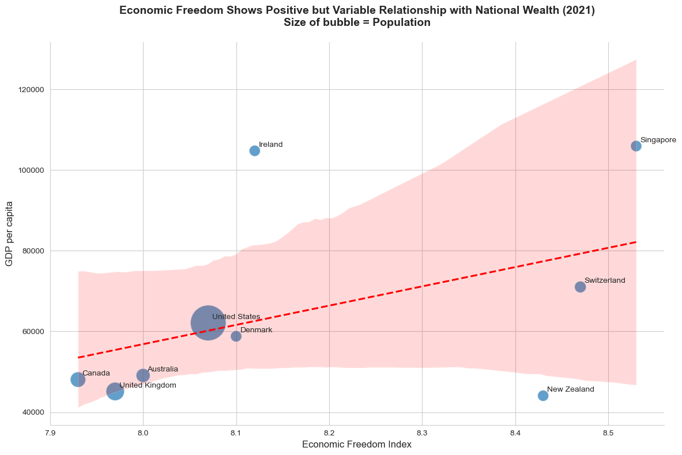
We also incorporated two complementary datasets to examine the relationship between economic freedom and economic well-being. We have a GDP data measured in Purchasing Power Parity (PPP) using constant 2017 international dollars. This dataset comprises of four essential components: country names (Entity), unique country identification codes (Code), measurement years, and PPP-adjusted GDP values. Using PPP-adjusted figures is crucial as it accounts for varying price levels across countries - acknowledging that the same amount of money might have different purchasing power in different economies. For instance, while $1 might buy different quantities of goods across countries due to local price variations, PPP adjustment normalizes these differences to enable more accurate cross-national comparisons of living standards. By using constant 2017 dollars as the base year, all values are inflation-adjusted, ensuring that our year-over-year comparisons reflect real economic changes rather than mere price fluctuations. To transform this into a more meaningful measure of individual economic well-being, we incorporated population data to calculate GDP per capita. This step is critical because while a country might have a high total GDP due to its size, GDP per capita provides a more accurate picture of average living standards by accounting for population differences. The combination of PPP-adjusted GDP and population data allows us to examine whether countries with higher economic freedom tend to achieve higher levels of individual economic well-being, while controlling for both purchasing power differences and population size. This approach provides a more nuanced and accurate assessment of how economic freedom policies might impact actual living standards across countries of varying sizes and price levels.
Our seventh visualization explores the relationship between economic freedom and national wealth for 9 countries that had top economic freedom scores in 2021, using a scatter plot enhanced with population data represented by bubble sizes. The x-axis displays the Economic Freedom Index scores, while the y-axis shows GDP per capita (PPP) in 2017 international dollars, ranging from approximately 40,000 to 120,000. The plot shows us a positive but varied relationship between economic freedom and national wealth, illustrated by the upward-sloping red trend line and its confidence interval in pink. Several distinct patterns emerge from this visualization. First, there's notable variation in how countries convert economic freedom into wealth, as evidenced by significant deviations from the trend line. Singapore and Ireland, for instance, achieve remarkably high GDP per capita despite different levels of economic freedom, suggesting that countries can reach similar levels of prosperity through different institutional arrangements. The presence of outliers like New Zealand, which maintains high economic freedom but relatively lower GDP per capita, and Ireland, which achieves exceptional wealth with a more moderate economic freedom score, indicates that the relationship between economic liberty and prosperity potentially is also moderated by other factors such as geographic location, natural resources, or historical circumstances. The visualization also reveals interesting clustering patterns, with several countries including Canada, the UK, and Australia grouped at the lower end of the economic freedom scale of 7.9-8.0 with similar GDP levels, while higher freedom countries show more varied economic outcomes. The population dimension, represented by bubble size, adds another layer of complexity to the analysis, with the United States standing out as a populous nation maintaining both high economic freedom and strong economic performance, demonstrating that the benefits of economic freedom could scale to larger populations.
Economic Freedom and Healthcare Expenditure:
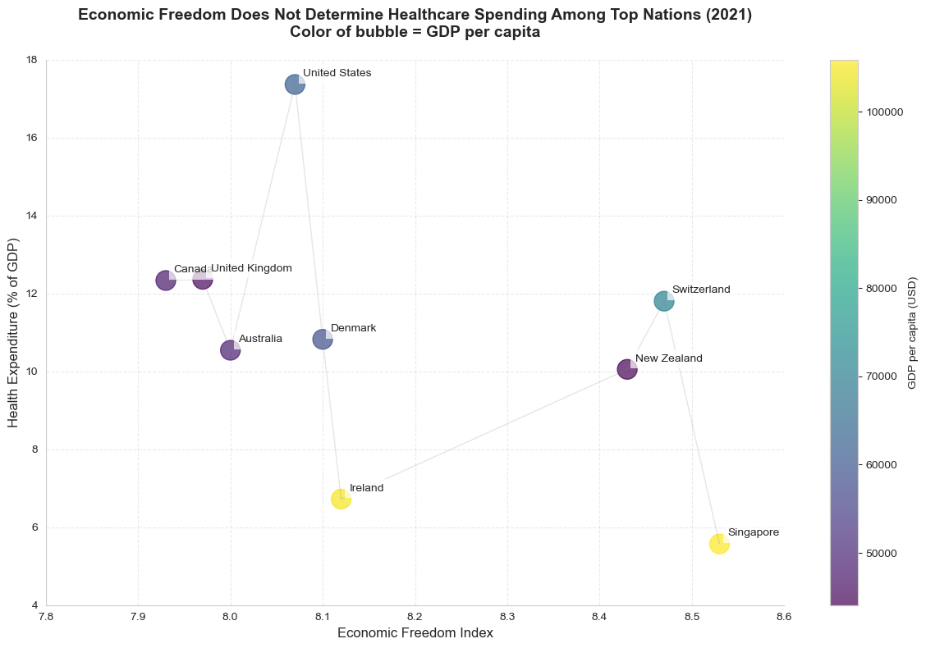
To add another layer of context, we incorporated the healthcare expenditure dataset with standardized measurements of current health expenditure as a percentage of GDP across nations. This dataset is structured around four key components: country identifiers, country codes, measurement years, and the percentage of GDP allocated to healthcare spending. The metric of current health expenditure encompasses both public and private healthcare spending, providing a holistic view of a nation's healthcare investment that includes health services provision, family planning activities, nutrition programs, and emergency health aid, while specifically excluding peripheral services such as water, sanitation, and hygiene. This deliberate exclusion ensures we analyze pure healthcare expenditure rather than broader public health infrastructure. By expressing healthcare spending as a percentage of GDP rather than absolute values, the dataset enables meaningful cross-country comparisons regardless of economic size or development status, offering insights into how different nations prioritize healthcare within their broader economic context. This dataset is particularly valuable for investigating whether countries with different levels of economic freedom demonstrate distinct patterns in healthcare spending, potentially revealing important insights about how economic systems influence healthcare resource allocation. Such analysis could be crucial for policymakers and researchers interested in understanding the intersection between economic policies and public health outcomes, particularly in how different economic frameworks might affect a nation's approach to healthcare investment and delivery.
Our eighth visualization examines the relationship between economic freedom and healthcare expenditure among leading economies in 2021, with GDP per capita information displayed through color gradients. The scatter plot maps Economic Freedom Index scores on the x-axis against healthcare expenditure as a percentage of GDP on the y-axis, with country wealth indicated by colors ranging from purple (lower GDP per capita) to yellow (higher GDP per capita). The visualization reveals surprising patterns that challenge basic intuition about the relationship between economic freedom and healthcare spending. Most notably, the United States emerges as a significant outlier, dedicating close to 18% of its GDP to healthcare despite moderate-high economic freedom, while Singapore, with the highest economic freedom score, spends just under 6% of its GDP on healthcare. This contrast suggests that economic freedom doesn't directly determine healthcare spending patterns. The plot also reveals some grouping patterns that provide further insights. There is a high-spending group including the UK, Canada, and Switzerland, a moderate-spending group comprising Denmark, Australia, and New Zealand, and a low-spending group with Singapore and Ireland. Particularly intriguing is the relationship between national wealth and healthcare spending efficiency, countries with the highest GDP per capita indicated by yellow coloring like Singapore and Ireland maintain notably lower healthcare spending percentages. Conversely, several nations with comparatively lower GDP per capita as shown in purple, allocate relatively higher percentages to healthcare, raising questions about system efficiency and healthcare delivery models. This complex pattern of relationships implies that healthcare spending levels are more likely determined by specific policy choices, healthcare system structures, and historical developments rather than economic freedom alone.
Economic Freedom and Healthy Food Affordability:
Lastly, to examine the impact of economic freedom on basic needs accessibility, we incorporated the 'Share of the population who cannot afford a healthy diet' dataset. This dataset provides crucial insights through four key components: country names, identification codes, measurement years, and the percentage of each population unable to afford a healthy diet. Unlike simpler measures of food security or caloric intake, this metric specifically evaluates access to nutritionally adequate food that meets dietary requirements for healthy living. The dataset's focus on healthy diet affordability rather than mere food availability offers a more nuanced understanding of nutritional accessibility, as it captures the economic barriers to maintaining proper nutrition rather than just avoiding hunger. We selected this dataset to investigate the relationship between economic freedom and a fundamental quality of life indicator, as it provides a direct window into whether economic policies translate into tangible benefits for populations' daily lives. The metric shows what proportion of a population faces economic barriers to proper nutrition and helps us understand whether the benefits of economic freedom extend across all segments of society or remain concentrated among smaller and potentially more privileged groups. This dataset adds a more grounded dimension to our analysis that complements macro-economic metrics like GDP and healthcare expenditure by focusing on a basic necessity that directly impacts people's well-being and ability to lead healthy, productive lives.
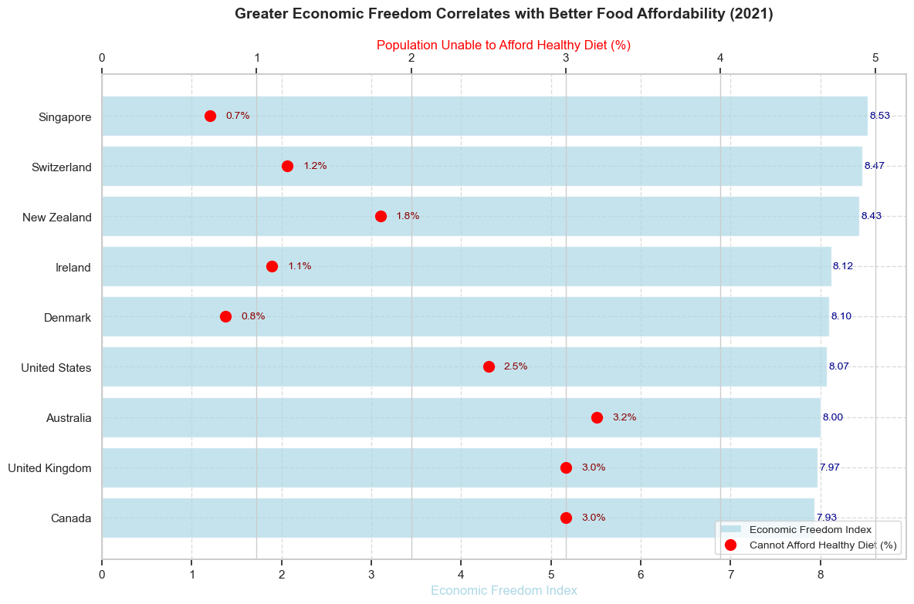
Our nineth, and final, visualization examines the relationship between economic freedom and food affordability across countries with leading economic freedom scores in 2021, using a dual-axis bar chart that contrasts Economic Freedom Index scores with the percentage of population unable to afford a healthy diet. The light blue bars each represent a country labeled on the y-axis and correspond to economic freedom scores listed on the x-axis, while red dots indicate the percentage of population facing healthy diet affordability challenges, with the scale on the top of the chart. We observe a compelling negative correlation between economic freedom and food affordability challenges, suggesting that higher economic freedom generally corresponds with better access to nutritious food. This relationship appears more consistent than what we observed with healthcare spending in our previous analysis. Particularly noteworthy is the distinct clustering pattern: the top five countries in economic freedom scores of Singapore to Denmark, all maintain affordability challenge rates at or below 1.8%, while the bottom three of Canada, UK, and Australia all show rates at or above 3.0%. Australia presents an interesting anomaly, with a moderate economic freedom score but the highest percentage of population unable to afford a healthy diet among the studied nations. This pattern suggests that while economic freedom appears to have a stronger and more direct relationship with food affordability than with other metrics like healthcare spending, factors such as food distribution systems, agricultural policies, and domestic market structures likely also play crucial roles in determining nutritional accessibility.
- Limitations and Methodological Considerations
Our analysis, particularly regarding the relationship between economic freedom and societal outcomes among top-performing economies in the last 3 visualizations, faces several important limitations that warrant discussion. First, our choice of 2021 as the focal year for analyzing relationships between economic freedom and societal outcomes (GDP per capita, healthcare spending, and food affordability) was driven by data availability rather than theoretical considerations. While this year provided the most complete data across all metrics, it represents a unique period during the global pandemic, potentially affecting the generalizability of our findings. The relationships we observed might reflect extraordinary circumstances rather than typical patterns.
The exclusion of Hong Kong from our final three visualizations, despite its historical prominence in the most economically free country group, represents another significant limitation. This omission was a result of incomplete data in healthcare expenditure and food affordability metrics, primarily due to Hong Kong's unique administrative status as a Special Administrative Region of China. Economic and social metrics for Hong Kong are increasingly reported as part of China's overall statistics rather than independently. While excluding Hong Kong maintains our analytical consistency, it potentially limits our understanding of how different models of economic freedom relate to societal outcomes. The focus on 2021 data also meant excluding more recent information from 2022 that might show important post-pandemic changes in these relationships. This temporal limitation is particularly relevant given the significant global economic adjustments that occurred as countries emerged from pandemic-related restrictions and policies.
To maintain methodological rigor and ensure consistency in cross metric comparisons, we prioritized data completeness over including partially represented regions. While this approach preserves the integrity of our comparative analysis, it potentially limits the comprehensiveness of our findings.
- Key Insights & Conclusion
In our exploratory analysis we found that trade freedom and regulatory efficiency show the strongest correlations with overall economic freedom, government size demonstrates a surprisingly weaker association. The emergence of four distinct economic clusters globally reveals how countries demonstrate characteristic patterns across economic freedom dimensions, with high-performing economies showing consistently higher scores across most dimensions while other clusters display varying degrees of limitations. Among the top performers, our analysis indicates more nuanced relationships between economic freedom and societal outcomes than often assumed based on pure intuition. While we found that higher economic freedom generally correlates with greater GDP per capita and better food affordability among top-performing nations, the relationships with healthcare spending and happiness levels prove more complex. The wide variations we observed, such as Singapore's high economic freedom but relatively low healthcare spending and happiness score, or the United States' moderate economic freedom but extensive healthcare expenditure, suggest that even among highly free economies, national priorities and policy choices significantly influence societal outcomes. These findings are particularly significant against the backdrop of declining economic freedom worldwide, including the countries with traditionally high economic liberty. The almost universal downward trend in economic freedom scores from 2015 to 2022 as observed in the top and bottom 5 performing countries, raises concerns about the sustainability of economic liberty in an increasingly complex global environment. This decline, coupled with our findings about the varied relationships between economic freedom and social outcomes, suggests that maintaining economic freedom alone may not be sufficient for optimal societal outcomes. Instead, countries must balance market freedoms with targeted policies that address specific societal needs. As policymakers face growing challenges to economic freedom, our findings suggest the need for a more nuanced approach that recognizes both the benefits and limitations of economic liberty in promoting societal well-being, while acknowledging the diverse paths countries may take to achieve and maintain economic freedom. Future research might explore how countries can maintain high levels of economic freedom while developing complementary policies that enhance quality of life across multiple dimensions.
- Implications & Recommendations
Our findings provide insights into the complex relationships between economic freedom and societal outcomes, though they should be interpreted with appropriate caution. While we observed strong statistical correlations between trade freedom, regulatory quality, and overall economic freedom scores, these correlations alone cannot establish causation or determine policy priorities. The divergent outcomes in healthcare spending and happiness levels among economically free nations indicate that the relationship between economic freedom and societal wellbeing is multifaceted and context dependent. For instance, Singapore's model of having high economic freedom with relatively low healthcare spending might not be directly transferable to nations with different demographic profiles or social expectations.
The clear clustering patterns we observed warrant further investigation through more sophisticated analytical approaches. While our cluster analysis identified four distinct groups of economies, future research could employ longitudinal studies to understand how and why countries transition between clusters over time. Particularly interesting would be detailed case studies of countries that have successfully moved from emerging market to high-performing status, which could provide valuable insights into economic development pathways. The consistent weakness we observed in legal systems and property rights scores across the three lower performing clusters could suggest this as a potentially fruitful area for focused research.
Our analysis of top performing economies revealed notably different approaches to healthcare spending and food affordability despite similar economic freedom scores. This variance suggests the need for more granular research into how specific policy implementations and institutional arrangements might explain these differences. Future studies might benefit from incorporating additional variables such as regulatory structure details, healthcare system design, and food distribution systems to better understand these relationships.
The universal decline in economic freedom scores since 2015 should also inspire more research into the resilience of economic structures under various internal and external pressures. This could help policymakers better protect economic freedom during challenging periods. Comparative studies of countries that have better maintained their economic freedom scores during this period could yield valuable insights.

- Appendix – Data Sources
Economic Freedom of the World:
https://www.fraserinstitute.org/categories/economic-freedom
Happiness - Cantril Ladder:
https://ourworldindata.org/grapher/happiness-cantril-ladder?tab=table&time=2015..2022&v=1&csvType=filtered&useColumnShortNames=false
Total healthcare expenditure as a share of GDP:
https://ourworldindata.org/grapher/total-healthcare-expenditure-gdp?tab=table
Share of population that cannot afford a healthy diet:
https://ourworldindata.org/grapher/share-healthy-diet-unaffordable?tab=table&time=2022
Gross domestic product (GDP):
https://ourworldindata.org/grapher/national-gdp-wb?tab=table&time=2021
Population:
https://ourworldindata.org/grapher/population?tab=table&time=2019..latest

