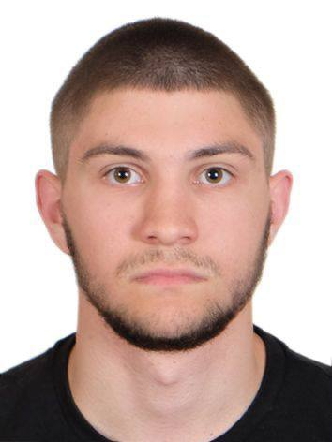
Rostyslav Koval
Trainee developer
E-mail: rostislaw.koval@gmail.com
Phone: +38 (098) 058-58-55

Experience

Assistant bot developer
- Assisted in developing SafeBot, a Telegram bot designed to scan files and links for malware and phishing threats.
- Implemented and tested bot commands for monitoring CPU and RAM usage.
- Developed handlers for message processing, including text replies and URL validation.
- Implemented an English localization file for bot responses.
- Added bot verification layer to prevent automated abuse and ensure human user interactions.

Education

2020 – 2024

Bachelor’s degree in cybersecurity, Lviv polytechnic national university

2024 – Present

master’s degree in cybersecurity, Lviv polytechnic national university

Skills

- Adaptability
- Time Management
- Teamwork
- Responsible
- Disciplined

Certificates

AWS Academy Graduate - Cloud Security Foundations - Training Badge

Upper - intermediate / b2 english course

