

Encryption of Application to

SQL Connections

**Version: 1.0 – April 2012**

# Document Information

|  |
| --- |
| Document Information |
|  |
| Document title: Encryption of Application to SQL Connections |
| Sub-title: |
| Version: |
|  |
| Status: |
| Effective date: |
| Type: |
|  |
| Commission by: |
| Compiled by / Author: Stefania Farrugia |

|  |
| --- |
| Document Control |
|  |
| Document Owner: |
| Document Classification: |
| Location: |
| Document Reference: |
|  |
| Approval by: |
| Distribution list: |
|  |

|  |  |  |  |
| --- | --- | --- | --- |
| Revision History | | | |
| Date | Revision Description | Version | Status |
| 25/04/2012 | Initial Version | 1.0 |  |
|  |  |  |  |
|  |  |  |  |

**Contents**

1. Document Information 2

1.1 Document Information 2

1.2 Document Control 2

1.3 Revision History 2

2. Purpose of this Document 4

3. Setting Up the Encryption 4

1. Profiling a Non-Secure Connection 4

2. Setting up the Encryption 5

3. Verifying the Encrypted Connection 6

4. Rolling Back 6

# Purpose of this Document

The purpose of this document is that of representing the necessary steps required in encrypting connections between applications and SQL servers for security purposes.

# Setting Up the Encryption

### Setting up the Encryption

In order to set up the encryption on the SQL server, we require a certificate. Fortunately, if no certificate is available, SQL Server provides us with a self-signed certificate (which is in fact used for logging in, regardless of whether encryption is requested or not). Forcing the use of this certificate will mean that all data transmitted across the network between an application and an SQL server is encrypted.

In order to view this, open the SQL Configuration Manager for the given SQL Server instance, click SQL Server Network Configuration, right-click Protocols for server instance, and set ‘Force Encryption’ to true in the Flags tab, as follows.

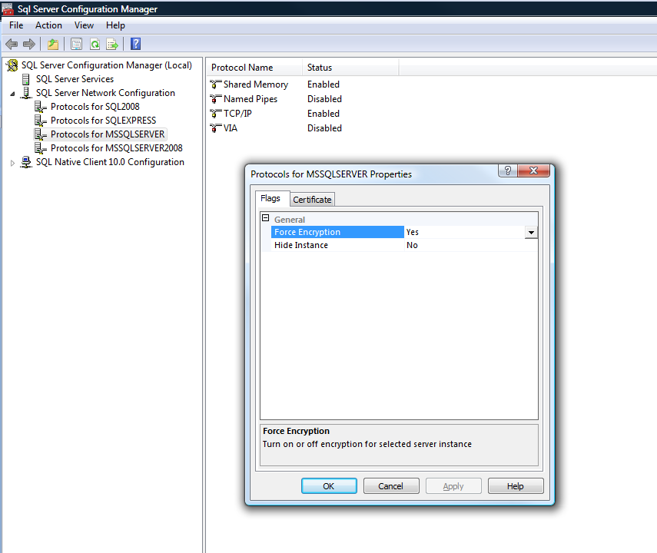

Note that in order for changes to take place, the sql server must be restarted.

### Rolling Back

If anything goes wrong, rolling back is easily achievable. In order to rollback, the ‘Force Encryption’ setting has to be set to false, i.e. open the SQL Configuration Manager for the given SQL Server instance, click SQL Server Network Configuration, right-click Protocols for server instance, and set ‘Force Encryption’ to false in the Flags tab.

The following figure shows the Protocols screen containing the ‘Force Encryption’ setting.

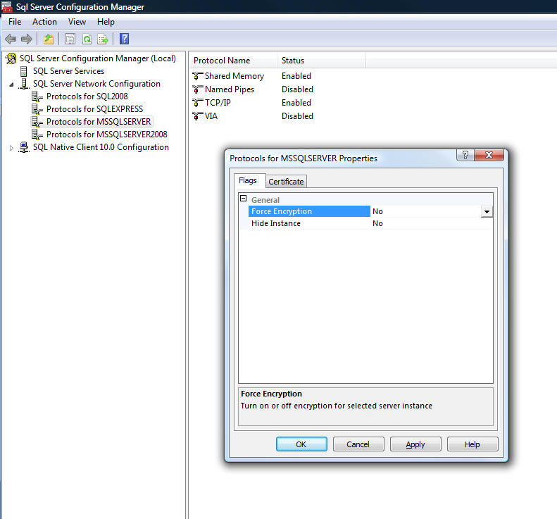

Again, the server must be restarted before changes are actually committed.