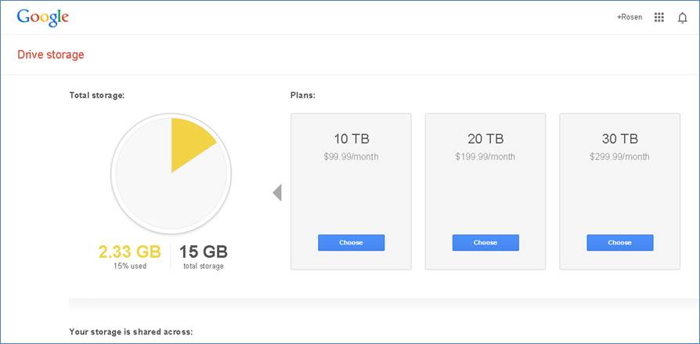

<https://www.google.com/settings/storage>

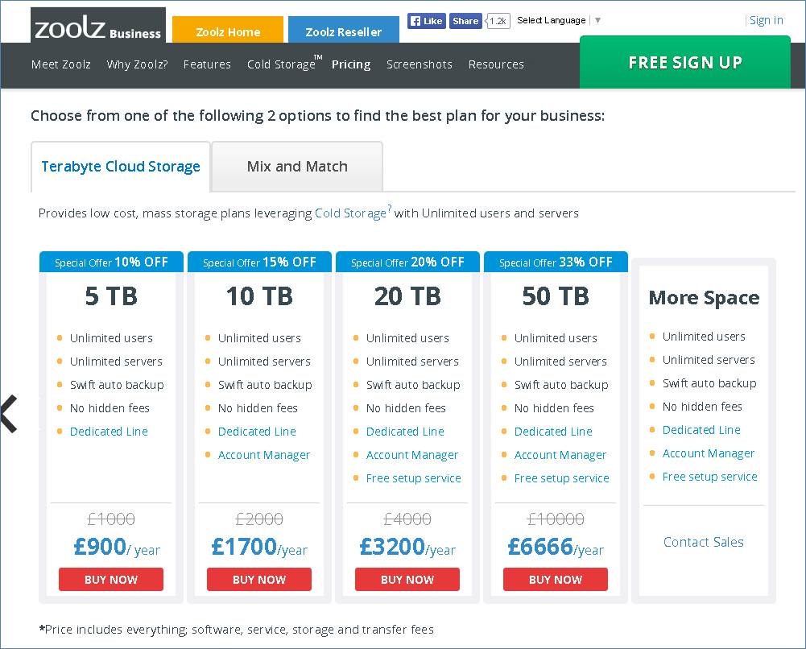

<https://www.zoolz.com/pricing>

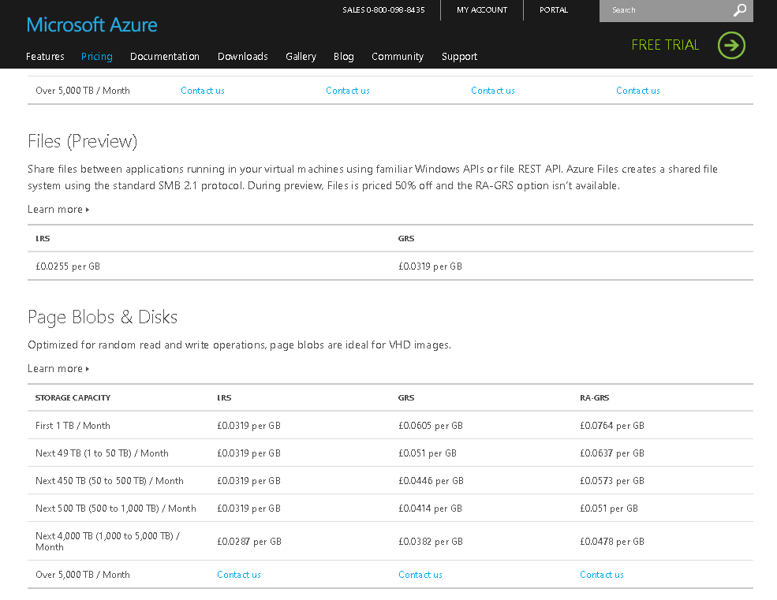

<http://azure.microsoft.com/en-gb/pricing/details/storage/>

<http://azure.microsoft.com/en-us/pricing/calculator/?scenario=data-management>