ScaN PROJECT
project Management plan
Version 1.0
27.11.2014

VERSION HISTORY

Version # | Implemented  By | Revision  Date | Approved  By | Approval  Date | Reason
1.0 | Rosen Rusev | 27/11/2014
TABLE OF CONTENTS
1 Introduction 3
1.1 Purpose of Project Management Plan 3
2 Executive Summary of Project Charter 3
2.1 Assumptions/Constraints 3
3 Scope Management 3
3.1 Work Breakdown Structure 4
3.2 Deployment Plan 4
3.3 Change Control Management 4
4 Schedule/Time Management 4
4.1 Milestones 4
4.2 Project Schedule 5
4.2.1 Dependencies 5
5 Cost/Budget Management 5
6 Quality Management 5
7 Human Resource Management 5
8 Communications Management 5
8.1 Communication Matrix 5
9 Risk Management 5
9.1 Risk Log 5
10 Issue Management 6
10.1 Issue Log 6
11 Procurement Management 6
12 Compliance Related Planning 6
Appendix A: Project Management Plan Approval 7
APPENDIX B: REFERENCES 8
APPENDIX C: KEY TERMS 9
APPENDIX D: SUMMARY OF SPENDING 10

Introduction

Purpose of Project Management Plan
The intended audience of the SCAN PROJECT PMP is all project stakeholders including the project sponsor, senior leadership and the project team.

Executive Summary of Project Charter
-

Assumptions/Constraints
-

Scope Management
Scope of this project is up to 01.2016.

Work Breakdown Structure

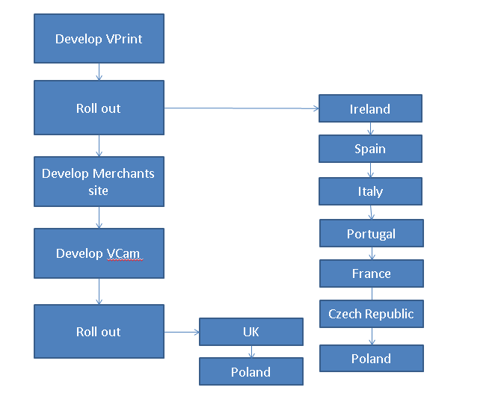

Deployment Plan
Server parts of the project are deployed directly to the server machines. Web sites of the project are deployed directly to the server machines. Client parts of the project are deployed by click-once deployment. Respectfully deployment is done to a server, clients open site and click download button. Application is installed automatically on client machine.

Change Control Management

Schedule/Time Management
-

Milestones
The table below lists the milestones for this project, along with their estimated completion timeframe.
Milestones | Estimated Completion Timeframe
Ireland(scanner app) | done
TRS integration | done
Spain (scanner app) | 10.2014-11.2014
Spain certification | 11.2014-02.2015
Merchants site design
Merchants site development
Ireland (scanner app) | done
Italy (scanner app) | done
Portugal (scanner app) | done
France (scanner app) | done
Portugal (scanner app) | done
Poland (scanner app)
Czech Republic (scanner app)
UK (camera app)
Poland (camera app)

Project Schedule
From 10.2014 to 31.12.2015

Dependencies
Network infrastructure – Network team

Cost/Budget Management
-

Quality Management
-

Human Resource Management
One person

Communications Management

Communication Matrix

Stakeholder | Messages | Vehicles | Frequency | Communicators | Feedback Mechanisms

Risk Management
-

Risk Log
-

Issue Management
-

Issue Log
-

Procurement Management
-

Compliance Related Planning

Appendix A: Project Management Plan Approval
The undersigned acknowledge they have reviewed the SCAN PROJECT Project Management Plan and agree with the approach it presents. Changes to this Project Management Plan will be coordinated with and approved by the undersigned or their designated representatives.

Signature: |  | Date:
Print Name: | Chris Parkin
Title: | Operations Manager
Role: | Project Sponsor

Signature: |  | Date:
Print Name: | AJ Reekie-Mayne
Title: | Group Programme Manager
Role:

Signature: |  | Date:
Print Name: | Ravi Bandaru
Title: | IT Project Manager
Role: | Project Manager

Signature: |  | Date:
Print Name: | Rosen Rusev
Title: | Senior C# Developer
Role: | Project Architect

APPENDIX B: REFERENCES

The following table summarizes the documents referenced in this document.
Document Name and Version | Description | Location

APPENDIX C: KEY TERMS
The following table provides definitions for terms relevant to this document.
Term | Definition
VPrint | Printing and scanning application
VCam | Camera application
Merchants site | Internet online sire where retailers can see their images
Image store | Remote file server where images are stored

APPENDIX D: SUMMARY OF SPENDING
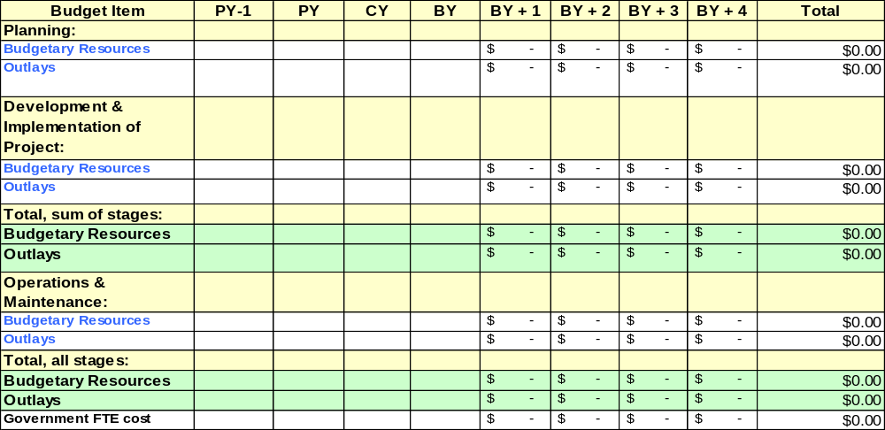PY: Previous Year; CY: Current Year; BY: Budget Year

