Motor Controller Firmware Framework
Implementation-Ready Specification for AI-Assisted C Firmware Generation
Target: STM32G474RET3, CubeMX-generated project, single reusable motor-axis module, BLDC/PMSM 3-shunt FOC initial backend with future brushed-DC backend allowance.
Version: v3 implementation expansion
Status: detailed specification for code generation, not a certified safety document

Contents
Use Word/LibreOffice to update the table of contents if required. The document is structured with heading styles for navigation.

1. Purpose and Coding-Agent Scope
This document expands the architecture into an implementation-ready specification intended to guide an AI coding agent while building the firmware in small, testable stages. It defines module responsibilities, data interfaces, timing-domain contracts, object dictionary behaviour, SPI framing, control equations, initial fault matrix, calibration architecture, persistence and basic module tests.
- The initial controlled plant is one reusable motor-axis module.
- The document covers both the network MCU and motor-control MCU boundary.
- The motor-control MCU target is STM32G474RET3 in a CubeMX-generated project.
- The initial electrical backend is three-shunt BLDC/PMSM FOC.
- The architecture must preserve a future path to a brushed DC backend using quadrature feedback.
- The implementation language is C. Do not use C++ features in the framework.

2. Locked Architecture Decisions
Decision | Specification
Axis scope | Single reusable motor-axis module; multi-axis coordination is outside this first implementation.
MCU split | Network MCU exposes external OD. Motor-control MCU has its own real internal index/subindex OD.
Inter-MCU transport | SPI with robust framed protocol carrying cyclic process data and object access messages.
External network | Not fixed. Treat as external client accessing network MCU OD through a protocol layer.
Command paths | Position modes use trajectory->position->velocity->torque/current->FOC. Joystick/profile velocity bypass trajectory and position loops. Torque/current mode bypasses outer loops.
Nested loops | Position loop outputs velocity demand; velocity loop outputs torque/iq correction; current loop regulates id/iq.
Timing | FOC/current: 20 kHz. Motion: 1-2 kHz. Slow comms/supervisory: 10-100 Hz.
Internal units | SI: rad, rad/s, rad/s^2, rad/s^3, Nm, A, V, deg C.
Numeric strategy | float for main control; optional CORDIC/FM AC or fixed-point inside fast FOC math where justified.
Stop behaviour | Normal stop/joystick release: controlled decel then hold. Quick stop: high-priority controlled decel when valid. Severe fault: immediate PWM/current disable.

3. Overall MCU Boundary
Figure 1 - External client, network MCU OD, SPI link, motor-control MCU OD and reusable axis module.

4. Command Paths and Nested Loops
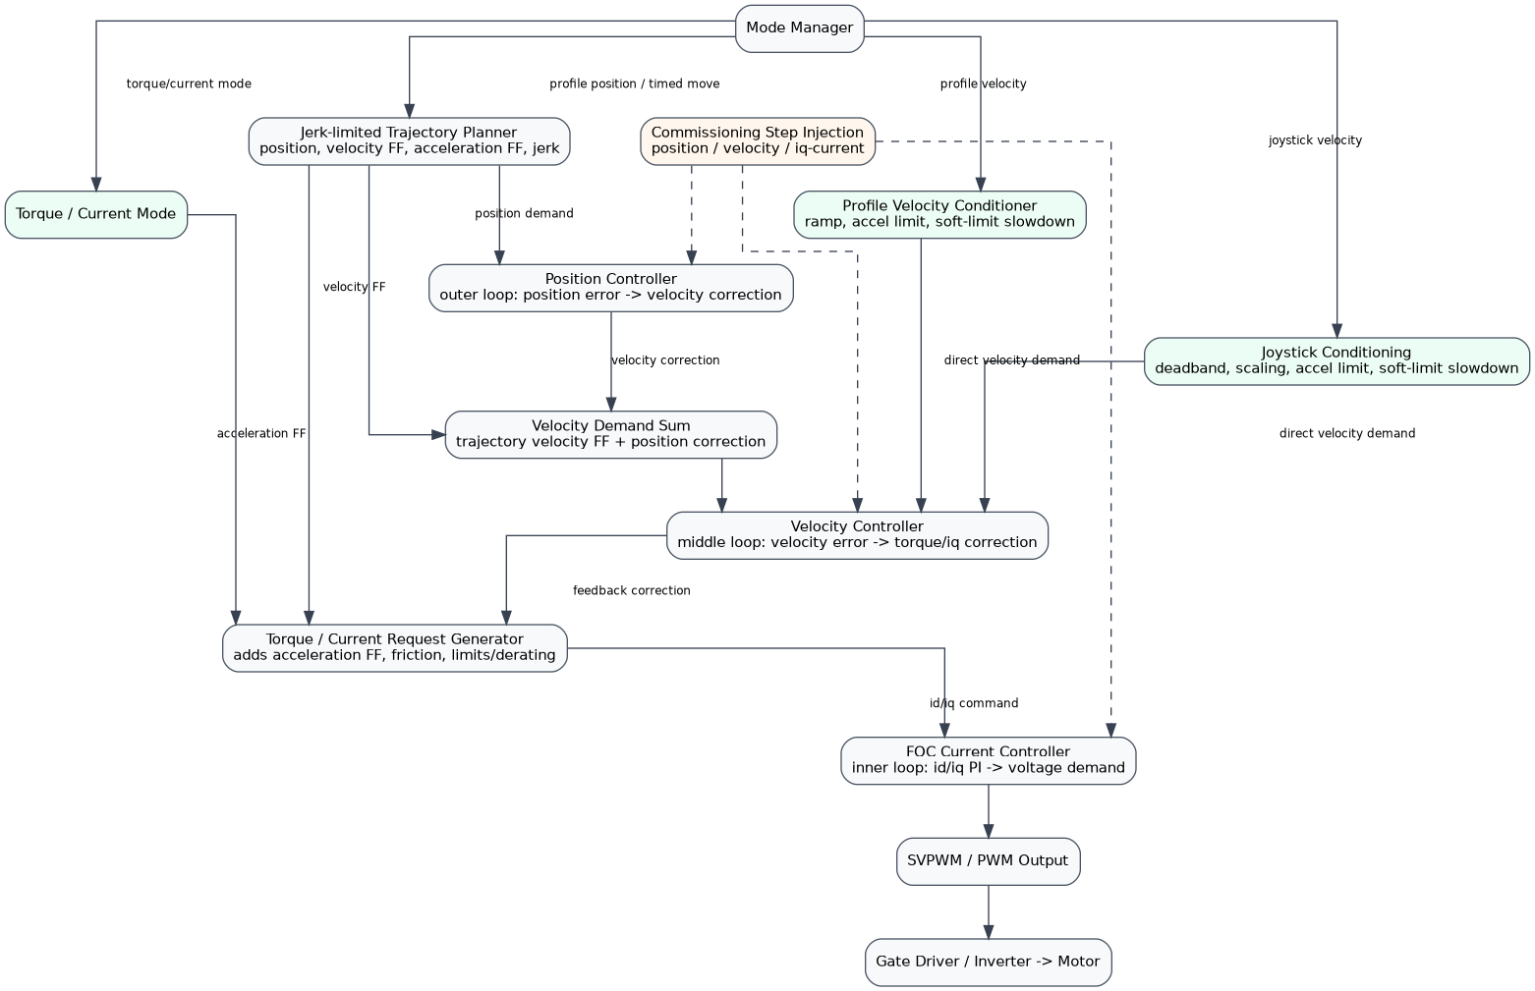
Figure 2 - Mode-dependent command paths. Joystick/profile velocity bypass trajectory and position controller but still enter the velocity loop.

5. Timing Domains
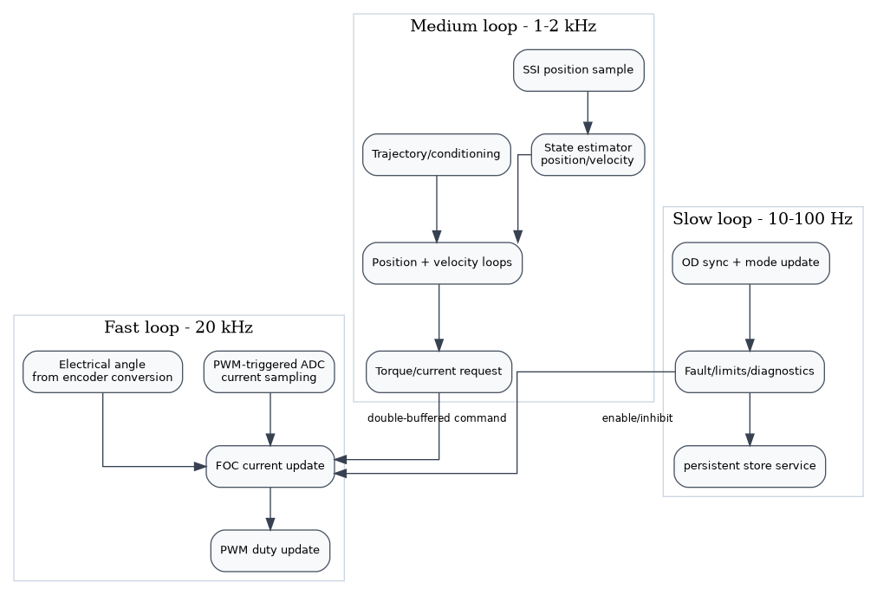
Figure 3 - Fast, medium and slow timing domains with explicit rate crossings.

6. Project Structure and CubeMX Boundary
The AI agent shall integrate into a CubeMX-generated STM32G474RET3 project. CubeMX owns peripheral initialisation. The motor-control framework owns application modules and integration hooks. Do not rewrite CubeMX-generated init code except inside USER CODE sections.
Core/
Inc/ CubeMX generated headers + USER CODE includes
Src/ CubeMX generated init + USER CODE hooks
mc/
include/ framework public headers
src/ framework implementation
target/stm32g474/ HAL/LL/register-level wrappers and fast-loop glue
tests/ simple host-buildable module tests where practical
docs/ Doxygen pages and diagrams
Area | Rule
CubeMX/user owns | Clock tree, GPIO, ADC channel selection, PWM timer selection, SPI setup, DMA setup, interrupt vector generation, HAL init files.
AI agent owns | mc_* modules, C interfaces, control algorithms, OD, SPI protocol above HAL, scheduler hooks, calibration/fault/mode logic.
Fast path rule | LL/register access is permitted in timing-critical wrappers such as ADC/PWM/fast-loop files. Keep it isolated and documented.
CORDIC rule | Optional STM32 CORDIC use is allowed behind mc_cordic_stm32.c style wrappers. Provide fallback math implementation.

7. Required Firmware Modules
Module | Responsibility
mc_types | Shared SI-unit data contracts and status types.
mc_pid | Reusable PID/PI primitive with derivative filtering, anti-windup, clamps, slew limit, reset/enable.
mc_od | Static object dictionary with typed read/write, callbacks, access/range checking.
mc_spi_protocol | Framed SPI transport messages, CRC16, sequence handling, object access and cyclic PD.
mc_mode_manager | CiA 402-style state/mode interpretation, command path selection, stop/quick-stop/fault transitions.
mc_trajectory | Jerk-limited S-curve planner with target-time attempt and time-stretch reporting.
mc_joystick | Deadband, scaling, acceleration limiting, soft-limit slowdown.
mc_velocity_conditioner | Profile velocity ramp/accel limit and soft-limit slowdown.
mc_position_controller | Position loop wrapper around PID primitive; output velocity correction.
mc_velocity_controller | Velocity loop wrapper around PID primitive; output torque/iq correction.
mc_current_request | Combines velocity-loop correction, acceleration FF, friction compensation, limits/derating into motor torque/current request.
mc_foc | BLDC/PMSM 3-shunt FOC backend: Clarke/Park, d/q PI, saturation, inverse Park, SVPWM.
mc_current_sense | STM32G474 PWM-triggered ADC current acquisition, offset calibration, scaling and validity.
mc_pwm | TIM1/TIM8 advanced timer PWM backend, duty update and safe-off.
mc_position_sensor | Generic position sensor interface.
mc_ssi_encoder | Configurable SSI absolute encoder backend over CubeMX SPI.
mc_state_estimator | Mechanical position/velocity estimate and electrical angle conversion.
mc_faults | Severity-based fault manager and codeable fault matrix.
mc_calibration | Calibration/homing state machines.
mc_persistent_store | Simple flash-backed parameter/calibration store with version and CRC.
mc_scheduler | Fast, medium and slow loop integration points and rate-crossing buffers.

8. Shared C Data Contracts
All shared structures that cross module boundaries shall use SI units unless explicitly marked as object-dictionary or raw-hardware units.
typedef struct {
float position_rad;
float velocity_rad_per_s;
float acceleration_rad_per_s2;
uint32_t timestamp_ticks;
bool position_valid;
bool velocity_valid;
bool absolute_position_valid;
} MC_MechanicalState_t;
typedef struct {
float electrical_angle_rad;
float electrical_velocity_rad_per_s;
bool electrical_valid;
} MC_ElectricalState_t;
typedef struct {
float position_rad;
float velocity_rad_per_s;
float acceleration_rad_per_s2;
float jerk_rad_per_s3;
bool valid;
bool complete;
} MC_MotionSetpoint_t;
typedef struct {
float torque_nm;
float current_limit_a;
bool enable;
} MC_MotorTorqueRequest_t;
typedef struct {
float id_a;
float iq_a;
bool enable;
} MC_FocCurrentCommand_t;

9. Timing-Domain and Data-Ownership Contracts
- Fast loop runs at PWM/current rate, initially 20 kHz. It must not block, allocate memory, call slow object-dictionary functions, or access flash.
- Medium loop runs at 1-2 kHz. It owns trajectory updates, joystick/profile velocity conditioning, position and velocity controllers, state estimator update and torque/current request generation.
- Slow loop runs at 10-100 Hz. It owns communications servicing, OD synchronisation, diagnostics, non-critical fault processing and persistence commands.
- Rate crossings shall use explicit buffers. The medium loop writes a complete motor torque/current command into a double buffer. The fast loop reads the latest complete command atomically.
- Fault inhibit and safe-off flags shall be readable by the fast loop with minimal latency. Severe faults must force PWM/current disable without waiting for the slow loop.
- Object dictionary writes that affect active control shall not directly mutate controller internals from an ISR. They set pending configuration values or request callbacks processed in the appropriate loop.
void MC_FastLoop_20kHz(void); /* called from PWM/ADC timing domain */
void MC_MotionLoop_1kHz(void); /* called from timer task */
void MC_SlowLoop_10_100Hz(void); /* called from main loop or RTOS task */
/* Atomic copy/swap style boundary */
bool MC_CommandBuffer_WriteFromMotion(const MC_MotorTorqueRequest_t *cmd);
bool MC_CommandBuffer_ReadForFast(MC_MotorTorqueRequest_t *cmd);

10. Mode Manager and CiA 402-Style State Behaviour
The implementation is CiA 402-style, not a claim of complete CiA 402 compliance. Controlword/statusword bits are defined here as the project contract. Any later standards-compliance work must verify against the official profile.
Bit | Name | Meaning
0 | switch_on | Request transition toward ready/switched-on state.
1 | enable_voltage | Permit power-stage voltage if safety allows.
2 | quick_stop_not_requested | 0 requests quick stop; 1 permits operation.
3 | enable_operation | Request operation enabled.
4 | new_setpoint | Profile position/timed-move new command strobe.
5 | change_set_immediately | If supported, replan active move rather than queue.
6 | relative | Target position is relative when profile position mode supports it.
7 | fault_reset | Reset latched faults when reset conditions are met.
8 | halt | Controlled halt according to active mode.
9-15 | manufacturer/project-specific | Reserved; use manufacturer objects for tuning-step enable rather than normal controlword bits where possible.
Bit | Statusword flag
0 | ready_to_switch_on
1 | switched_on
2 | operation_enabled
3 | fault
4 | voltage_enabled
5 | quick_stop_condition_ok
6 | switch_on_disabled
7 | warning
8 | manufacturer
9 | remote
10 | target_reached
11 | internal_limit_active
12 | setpoint_ack
13 | following_error
14-15 | manufacturer
Mode | Required behaviour
Disabled | PWM/current disabled. Controllers reset or held inactive. Can transition to Position Hold/operational when controlword allows and no faults exist.
Position Hold | Captures hold position on entry. Uses position->velocity->current cascade to hold.
Profile Position / Timed Move | Uses jerk-limited trajectory, position loop, velocity loop, torque/current request and FOC.
Joystick Velocity | Joystick conditioner feeds velocity controller directly. On release, controlled decel to zero then position hold.
Profile Velocity | OD target velocity through velocity conditioner into velocity controller. Stop/halt ramps to zero then hold or disabled per command.
Torque/Current Mode | Bypasses position and velocity loops; commands torque/current request layer directly subject to safety limits.
Homing/Calibration | Mode manager delegates to calibration manager. Motion commands are generated by calibration state machines.
Quick Stop | High-priority controlled decel when feedback/control valid. If not valid, fault supervisor may disable PWM/current.
Fault | Motion inhibited. Severe faults force immediate PWM/current disable. Reset requires reset command and reset conditions.

11. Object Dictionary Implementation
Both MCUs shall implement real OD-style index/subindex tables. The network MCU exposes the external OD. The motor-control MCU exposes an internal OD used by SPI object access and local firmware. Object values crossing into control modules shall be converted to SI units at the boundary.
typedef enum { MC_OD_U8, MC_OD_U16, MC_OD_U32, MC_OD_I8, MC_OD_I16, MC_OD_I32, MC_OD_F32 } MC_OdType_t;
typedef enum { MC_OD_RO = 1, MC_OD_WO = 2, MC_OD_RW = 3 } MC_OdAccess_t;
typedef enum { MC_OD_OK = 0, MC_OD_ERR_NOT_FOUND, MC_OD_ERR_ACCESS, MC_OD_ERR_TYPE, MC_OD_ERR_RANGE, MC_OD_ERR_CALLBACK } MC_OdStatus_t;
typedef MC_OdStatus_t (*MC_OdReadCallback_t)(void *dst, uint32_t size);
typedef MC_OdStatus_t (*MC_OdWriteCallback_t)(const void *src, uint32_t size);
typedef struct {
uint16_t index;
uint8_t subindex;
MC_OdType_t type;
MC_OdAccess_t access;
void *data;
uint32_t size_bytes;
float min_value;
float max_value;
bool pdo_mappable;
bool persistent;
MC_OdReadCallback_t read_cb;
MC_OdWriteCallback_t write_cb;
} MC_OdEntry_t;
Object | Name | Type | Access | Units | Notes
0x1000:00 | Device type | U32 | RO | - | Generic drive type.
0x1001:00 | Error register | U8 | RO | bitfield | Updated by fault manager.
0x1010:01 | Store parameters | U32 | WO | command | Triggers persistent save with signature.
0x1011:01 | Restore defaults | U32 | WO | command | Factory reset selected persistent objects.
0x603F:00 | Error code | U16 | RO | code | Active primary error code.
0x6040:00 | Controlword | U16 | RW | bitfield | Mode/state command.
0x6041:00 | Statusword | U16 | RO | bitfield | Drive state/status.
0x6060:00 | Mode of operation | I8 | RW | enum | Requested mode.
0x6061:00 | Mode display | I8 | RO | enum | Actual active mode.
0x6064:00 | Position actual | I32 | RO | scaled | From state estimator.
0x606C:00 | Velocity actual | I32 | RO | scaled | From state estimator.
0x6071:00 | Target torque/current | I16/I32 | RW | scaled | Used in torque/current mode.
0x6077:00 | Torque actual | I16/I32 | RO | scaled | Estimated/commanded torque feedback.
0x607A:00 | Target position | I32 | RW | scaled | Profile position target.
0x6081:00 | Profile velocity | U32 | RW | scaled | Trajectory velocity limit.
0x6083:00 | Profile acceleration | U32 | RW | scaled | Trajectory acceleration limit.
0x6084:00 | Profile deceleration | U32 | RW | scaled | Trajectory deceleration limit.
0x6085:00 | Quick stop decel | U32 | RW | scaled | Quick-stop deceleration.
0x60FF:00 | Target velocity | I32 | RW | scaled | Profile velocity target.
0x2000:* | Axis/motor config | mixed | RW | SI/scaled | Motor type, pole pairs, Kt, inertia, limits.
0x2100:* | Trajectory config/status | mixed | RW/RO | SI/scaled | Jerk limit, requested time, planned time, time-stretched flag.
0x2200:* | Position PID | F32 | RW | SI | Kp/Ki/Kd, clamps, derivative filter.
0x2300:* | Velocity PID | F32 | RW | SI | Kp/Ki/Kd, clamps, derivative filter.
0x2400:* | Current PI/FOC | F32 | RW | SI | d/q gains, voltage limit, FOC status.
0x2500:* | Encoder config | mixed | RW | raw/SI | SSI bit config, zero offset, direction, scale.
0x2600:* | Fault/status diagnostics | mixed | RO/RW | - | Fault bits, reset, counters, timestamps.
0x2700:* | Calibration commands/status | mixed | RW/RO | - | Start calibration, state, result, stored values.
0x2800:* | Commissioning step injection | mixed | RW | SI | Enable, injection point, amplitude, duration, status.

12. SPI Inter-MCU Protocol
The SPI link shall use a robust framed protocol. It carries cyclic process data and object-access messages. Exact SPI instance, chip-select and DMA details are CubeMX/user integration choices.
#define MC_SPI_SYNC_WORD (0xA55Au)
#define MC_SPI_PROTOCOL_VER (1u)
#define MC_SPI_MAX_PAYLOAD (256u)
typedef enum {
MC_SPI_MSG_CYCLIC_CMD = 0x01,
MC_SPI_MSG_CYCLIC_STATUS = 0x02,
MC_SPI_MSG_OD_READ_REQ = 0x10,
MC_SPI_MSG_OD_READ_RESP = 0x11,
MC_SPI_MSG_OD_WRITE_REQ = 0x12,
MC_SPI_MSG_OD_WRITE_RESP = 0x13,
MC_SPI_MSG_HEARTBEAT = 0x20,
MC_SPI_MSG_ERROR = 0x7F
} MC_SpiMessageType_t;
typedef struct __attribute__((packed)) {
uint16_t sync;
uint8_t version;
uint8_t message_type;
uint16_t payload_length;
uint16_t sequence;
uint16_t header_crc;
} MC_SpiFrameHeader_t;
typedef struct __attribute__((packed)) {
uint16_t payload_crc;
} MC_SpiFrameFooter_t;
Topic | Implementation rule
CRC | CRC16 over header fields excluding header_crc, plus separate payload CRC over payload bytes.
Endianness | Little-endian for all multi-byte numeric fields unless later changed explicitly.
Sequence | Increment per transmitted frame. Receiver reports missed or repeated sequence. Cyclic data may use latest valid frame.
Timeout | If no valid cyclic command is received within configured timeout, motor MCU requests controlled stop or severe action depending state.
Version | Unsupported protocol version returns MC_SPI_MSG_ERROR and does not apply payload.
Object access | OD read/write requests include index, subindex, type, size and value payload. Responses include OD status.
Cyclic PD | Fixed command/status payloads contain mapped core objects. They are not dynamically remapped in first implementation.
typedef struct __attribute__((packed)) {
uint16_t controlword;
int8_t mode_of_operation;
int32_t target_position;
int32_t target_velocity;
int32_t target_torque_current;
uint32_t profile_velocity;
uint32_t profile_acceleration;
uint32_t profile_deceleration;
uint32_t command_counter;
} MC_SpiCyclicCommand_t;
typedef struct __attribute__((packed)) {
uint16_t statusword;
int8_t mode_display;
int32_t position_actual;
int32_t velocity_actual;
int32_t torque_current_actual;
uint16_t error_code;
uint32_t status_counter;
} MC_SpiCyclicStatus_t;

13. Trajectory Planner Specification
The trajectory planner shall implement a jerk-limited S-curve profile for profile-position/timed-move commands. It shall attempt to reach the target position at the requested target time. If physically infeasible within limits, it may stretch the planned time and must report that stretching occurred.
typedef enum {
MC_TRAJ_OK = 0,
MC_TRAJ_DONE,
MC_TRAJ_TIME_STRETCHED,
MC_TRAJ_ERR_INVALID_REQUEST,
MC_TRAJ_ERR_INVALID_LIMITS,
MC_TRAJ_ERR_UNSUPPORTED_BOUNDARY,
MC_TRAJ_ERR_NUMERIC
} MC_TrajStatus_t;
typedef struct {
float max_velocity_rad_per_s;
float max_acceleration_rad_per_s2;
float max_deceleration_rad_per_s2;
float max_jerk_rad_per_s3;
} MC_TrajLimits_t;
typedef struct {
MC_MechanicalState_t start;
float target_position_rad;
float target_velocity_rad_per_s; /* first implementation supports 0 */
float target_acceleration_rad_per_s2; /* first implementation supports 0 */
float requested_time_s;
MC_TrajLimits_t limits;
} MC_TrajRequest_t;
typedef struct {
float requested_time_s;
float planned_time_s;
bool time_stretched;
MC_TrajStatus_t status;
} MC_TrajPlanInfo_t;
- Initial planner must support non-zero start velocity for replanning while moving.
- Initial planner normally ends at zero velocity and zero acceleration. Non-zero target velocity/acceleration may be present in the interface but can return MC_TRAJ_ERR_UNSUPPORTED_BOUNDARY.
- Replanning during active motion shall evaluate the current planned setpoint, use it as the new start state, generate a new plan, and atomically replace the old plan only if generation succeeds.
- If the new plan fails, the old active plan shall continue and an error/status shall be reported.
- The output per medium-loop tick shall include position, velocity, acceleration and jerk.
- For exact requested time, stretch constant-velocity/constant-acceleration/constant-jerk phases as required. If requested time is too short, compute minimum feasible time and report time_stretched=true.

14. Reusable PID/PI Primitive and Controller Wrappers
A reusable PID primitive shall be implemented and used by position, velocity and FOC d/q current controllers. Architecture-level modules remain semantically separate wrappers.
typedef struct {
float kp, ki, kd;
float sample_period_s;
float output_min, output_max;
float integrator_min, integrator_max;
float derivative_filter_hz;
float slew_rate_limit_per_s;
bool integrator_enabled;
bool derivative_enabled;
bool derivative_on_measurement;
} MC_PidConfig_t;
typedef struct {
float integrator;
float prev_error;
float prev_measurement;
float derivative_state;
float prev_output;
bool enabled;
} MC_Pid_t;
float MC_Pid_Update(MC_Pid_t *pid, const MC_PidConfig_t *cfg,
float setpoint, float measurement, bool allow_integrator);
void MC_Pid_Reset(MC_Pid_t *pid);
- Position controller default behaviour: P-only, output velocity correction in rad/s.
- Velocity controller default behaviour: PI, output torque/iq feedback correction conceptually in Nm or implementation iq equivalent.
- Current controller default behaviour: two PI loops, one d-axis and one q-axis, output vd/vq voltage commands.
- Derivative term shall be filtered with first-order low-pass if enabled. Derivative-on-measurement is preferred to avoid setpoint kick.
- Anti-windup shall use conditional integration and/or back-calculation. Integrator shall not accumulate further into saturation.
- All controllers shall define reset conditions on disable, mode change, fault and calibration entry.

15. Torque / Current Request Generator
This block combines velocity-loop feedback correction with trajectory acceleration feedforward, friction compensation and safety limits before producing the motor-backend request. Keep the public interface generic so a future brushed-DC backend can reuse the outer loops.
typedef struct {
float inertia_kg_m2;
float torque_constant_nm_per_a;
float static_friction_nm;
float viscous_friction_nm_per_rad_s;
float current_limit_a;
} MC_TorqueModelConfig_t;
/* Example computation */
torque_ff = inertia_kg_m2 * acceleration_ff_rad_per_s2;
torque_friction = sign(velocity) * static_friction_nm + viscous_friction_nm_per_rad_s * velocity;
torque_cmd = velocity_feedback_correction_nm + torque_ff + torque_friction;
torque_cmd = clamp(torque_cmd, -torque_limit_nm, +torque_limit_nm);
- For BLDC/PMSM FOC, the backend maps torque to iq using Kt and normally commands id=0 in the first implementation.
- For future brushed DC, the backend may map torque to signed armature current and H-bridge PWM without changing outer loops.
- Limits from fault/limit manager and thermal derating shall be applied here before FOC.

16. BLDC/PMSM Three-Shunt FOC Backend
The first backend shall be an implementable basic FOC for a three-shunt BLDC/PMSM topology. It shall not initially include field weakening, MTPA, overmodulation, sensorless observer or single-shunt reconstruction.
/* Clarke, amplitude-invariant convention */
alpha = ia;
beta = (ia + 2.0f * ib) * ONE_OVER_SQRT3;
/* Park */
id = alpha * cos(theta) + beta * sin(theta);
iq = -alpha * sin(theta) + beta * cos(theta);
/* PI current controllers */
vd = PI_d(id_cmd - id);
vq = PI_q(iq_cmd - iq);
/* Voltage vector limiting */
if (sqrt(vd*vd + vq*vq) > v_limit) {
scale vd/vq to v_limit;
apply current-loop anti-windup;
}
/* Inverse Park */
valpha = vd * cos(theta) - vq * sin(theta);
vbeta = vd * sin(theta) + vq * cos(theta);
/* SVPWM converts valpha/vbeta and bus voltage to duty_a/b/c */
Item | Specification
Inputs | id/iq command, measured phase currents, electrical angle, bus voltage, enable/fault state.
Outputs | PWM duty cycles, voltage saturation flag, measured id/iq, status flags.
Current sampling | PWM-triggered ADC sampling using CubeMX configured ADC/timer. Offset correction and scaling to amps before FOC.
Electrical angle | Derived from SSI mechanical position using pole-pair count and electrical offset.
PWM | TIM1 or TIM8 centre-aligned 3-phase PWM, complementary outputs if required, dead-time configured by CubeMX.
CORDIC | Optional for sin/cos/vector magnitude. Must provide fallback math path.

17. Feedback, SSI Encoder and State Estimator
typedef struct {
uint8_t total_bits;
uint8_t position_bits;
uint8_t position_lsb;
int8_t error_bit; /* -1 if unused */
int8_t warning_bit; /* -1 if unused */
bool parity_enabled;
bool parity_even;
float counts_per_rev;
float mechanical_zero_offset_rad;
int8_t direction; /* +1 or -1 */
float sample_period_s;
} MC_SsiEncoderConfig_t;
typedef struct {
uint32_t raw_position;
float position_rad;
bool valid;
bool error;
bool warning;
uint32_t timestamp_ticks;
} MC_PositionSensorSample_t;
- The initial feedback backend is configurable SSI absolute encoder over a CubeMX-configured SPI peripheral.
- The same mechanical encoder position is used for outer-loop mechanical state and FOC electrical angle conversion in the initial BLDC implementation.
- The architecture shall allow a future quadrature encoder backend to feed the same MC_PositionSensorSample_t / state estimator interface.
- Velocity estimation may initially use filtered finite difference or a simple observer. It must expose validity flags and timestamped samples.
- Electrical angle = mechanical_position_rad * pole_pairs + electrical_offset_rad, wrapped to 0..2*pi.

18. Calibration and Homing Architecture
Calibration is a first-class part of the framework. Each routine shall be a state machine with preconditions, command outputs, timeouts, abort conditions, success criteria and stored results.
Routine | Codeable behaviour
Current offset calibration | PWM disabled or zero-current state. Sample ADC offsets over N samples. Store offsets and validity flag.
SSI encoder validation/alignment | Read stable absolute frames, verify parity/error bits, apply direction and zero offset. Store mechanical zero if commanded.
Phase order detection | Apply limited controlled current/voltage sequence, observe encoder direction response, determine phase/electrical sign consistency.
Electrical angle offset | Align rotor with known d-axis current vector at safe current. Capture mechanical angle and compute electrical offset.
Soft-limit learning | Move under controlled velocity/current limits toward allowed endpoints or accept manually taught positions. Store min/max soft limits.
Homing sequence | Use configured homing method. On success define home position/offset and transition to hold.
Calibration storage | Persist selected calibration objects through parameter store with version and CRC.

19. Fault Manager and Codeable Fault Matrix
Fault handling is severity-based. Warnings report/derate. Recoverable faults perform controlled stop, inhibit new motion, latch and require reset. Severe faults immediately disable PWM/current where necessary, latch and require reset.
ID | Fault | Detection | Threshold | Severity | Action | Latch | Reset | OD report
F001 | SPI cyclic timeout | No valid cyclic command for timeout | comm_timeout_ms | Recoverable | Quick stop/controlled stop; then inhibit | Latched | Valid link + reset | 0x603F, 0x2600
F002 | Encoder invalid | No valid position sample for N ticks or SSI error | encoder_timeout_ticks | Severe | PWM/current off | Latched | Valid encoder + reset | 0x603F, 0x2600
F003 | Following error | abs(pos_error)>limit for debounce | following_error_rad | Recoverable | Controlled stop | Latched | Error cleared + reset | statusword bit13
F004 | Overcurrent fast | abs(phase current)>fast trip | phase_current_trip_a | Severe | Immediate PWM off | Latched | Current normal + reset | error code
F005 | DC bus overvoltage | bus_v > threshold for debounce | bus_ov_v | Severe | PWM off or quick stop if safe | Latched | Voltage normal + reset | error code
F006 | DC bus undervoltage | bus_v < threshold for debounce | bus_uv_v | Recoverable | Inhibit operation | Latched | Voltage normal + reset | error code
F007 | Overtemperature warning | temp > warn threshold | temp_warn_c | Warning | Derate current | Not latched | Temp below hysteresis | error register
F008 | Overtemperature fault | temp > trip threshold | temp_trip_c | Severe | PWM/current off | Latched | Temp normal + reset | error code
F009 | Soft limit active | motion would exceed soft limit | soft limits | Warning | Slow/inhibit into limit | Not latched | Move away | statusword bit11
F010 | FOC saturation | voltage saturation too long | sat_time_ms | Warning/Recoverable | Report/limit; optional stop | Configurable | Condition clear/reset if latched | diagnostic
F011 | ADC/current invalid | current sample invalid/missing | adc timeout | Severe | PWM off | Latched | ADC valid + reset | error code
F012 | Calibration failed | routine timeout or invalid result | routine-specific | Recoverable | Abort calibration; inhibit op if required | Latched | Reset/redo calibration | cal status

20. Persistent Parameter Store
- Store selected OD values, calibration data, controller gains, motor/encoder configuration and soft limits in MCU flash.
- Parameter block shall include magic, version, length, CRC32 or CRC16, payload and optional generation counter.
- On boot, load persistent block only if magic/version/CRC are valid; otherwise load compiled defaults and report default-loaded status.
- Provide OD commands for save parameters and factory reset. Do not write flash from the fast loop.
- Wear levelling and profile rollback are out of scope for first implementation.
typedef struct {
uint32_t magic;
uint16_t version;
uint16_t length;
uint32_t crc;
} MC_ParamStoreHeader_t;

21. Basic Module Tests
Test area | Minimum expected test
Build test | All mc_* modules compile with -Wall-like warnings enabled.
OD tests | Read/write valid objects, reject unknown object, reject wrong type/access/range, invoke callbacks.
SPI tests | Encode/decode frames, reject bad CRC/version/length, sequence counter handling.
PID tests | P/PI outputs, output clamp, integrator clamp, reset, derivative filter sanity.
Trajectory tests | Rest-to-rest move reaches endpoint, non-zero start velocity replan continuity, time-stretch status is reported.
FOC math tests | Clarke/Park inverse sanity at known angles, voltage limit clamps vector, SVPWM duties remain in 0..1.
Fault tests | Fault debounce/latch/reset logic for representative warning, recoverable and severe faults.
Calibration tests | State machines progress/timeout/abort in simulated conditions.

22. AI Coding-Agent Brief
This section is deliberately written as direct instructions for an AI coding agent.
- Implement in small stages. After each stage, keep the project buildable and provide a short summary of files changed.
- Do not modify CubeMX-generated initialisation except inside USER CODE sections. Prefer separate mc_* modules.
- Use C, not C++. Avoid dynamic allocation in real-time control modules. Avoid blocking calls in fast and medium loops.
- Start with shared types, PID primitive, OD framework, SPI frame encode/decode and scheduler stubs before implementing control algorithms.
- Keep hardware-specific STM32G474 code isolated in target/stm32g474 wrappers. Provide mockable interfaces where practical.
- Use SI units internally. Convert object-dictionary scaled integers at the OD/application boundary.
- Keep FOC, id/iq and SVPWM in the BLDC/PMSM backend. Do not leak BLDC-only concepts into generic outer motion modules.
- Implement basic module tests where possible. The user will test hardware behaviour interactively during code generation.
- When hardware details are not specified, create a clearly named TODO or configuration field rather than inventing pin/channel assignments.
- Safety note: this document is not a certified functional-safety design. Do not claim SIL/PL compliance.

