**Board Game Index**

*Anthony Cerritelli, Patryk Ilinski, Ian Gardner, Robert Rotaru*

**Instructions**

1. Extract the submission folder from the zipped file.
2. Open up the project in NetBeans.
3. Right click Java DB under Databases and select properties.
4. Hit browse for Database Location and find the folder named BoardGameIndex. Select it.
5. You may have to set up a connection pool for the database if you do not already have a connection pool.
   1. Database name: HW3DB  
      User: APP  
      Password: pass
6. Set up a JDBC resource using this connection pool and j”dbc/FinalProjectDB” as the resource name.
7. Open up the project in NetBeans and Build it, then Run the project.

**Demonstrating Requirements**:

* Database: HW3DB, Persistence Unit: jdbc/FinalProjectDB
  + Tables: BOARDGAME, IMAGE (one to many relationship with foreign key BID on BOARDGAME.ID), ADMIN
  + SQL create statement for ADMIN table.
* JPA Entity Beans: Boardgame entity, Image entity
  + Create, Update, Delete, Find: BoardgameController functions createBoardgame(), updateBoardgame(), deleteBoardgame() (delete contains find as well).
* Managed Beans: ParamData session-scoped bean, Boardgame entity, Image entity
* JSF Validation: Built-in input length validation, custom URL validation using regex matching.
* AJAX: Asynchronous update and render of board games table based on text box input
* Complex Flow Elements:
  + Submitting under the boardgameAdd JSF can either confirm creation of a new boardgame, confirm update of fields on an existing one, or confirm deletion.
  + Accessing the boardgameAdd form through the Edit button on the search page will fill out the form with the existing data and the hidden boardgame ID.
* Good MVC Practices:
  + Models: Boardgame (JPA entity bean), Image (JPA entity bean), ParamData (Session Scoped Managed Bean).
  + Views: index (JSF), boardgameAdd (JSF), boardgameSearch (JSF), confirmationSaved (JSF), confirmationDeleted (JSF), error (JSF)
  + Controllers: BoardgameController (Managed Bean), adminAuthFilter (WebFilter), authServlet (WebServlet), urlValidation (JSF Custom Validation)

**Screenshots**

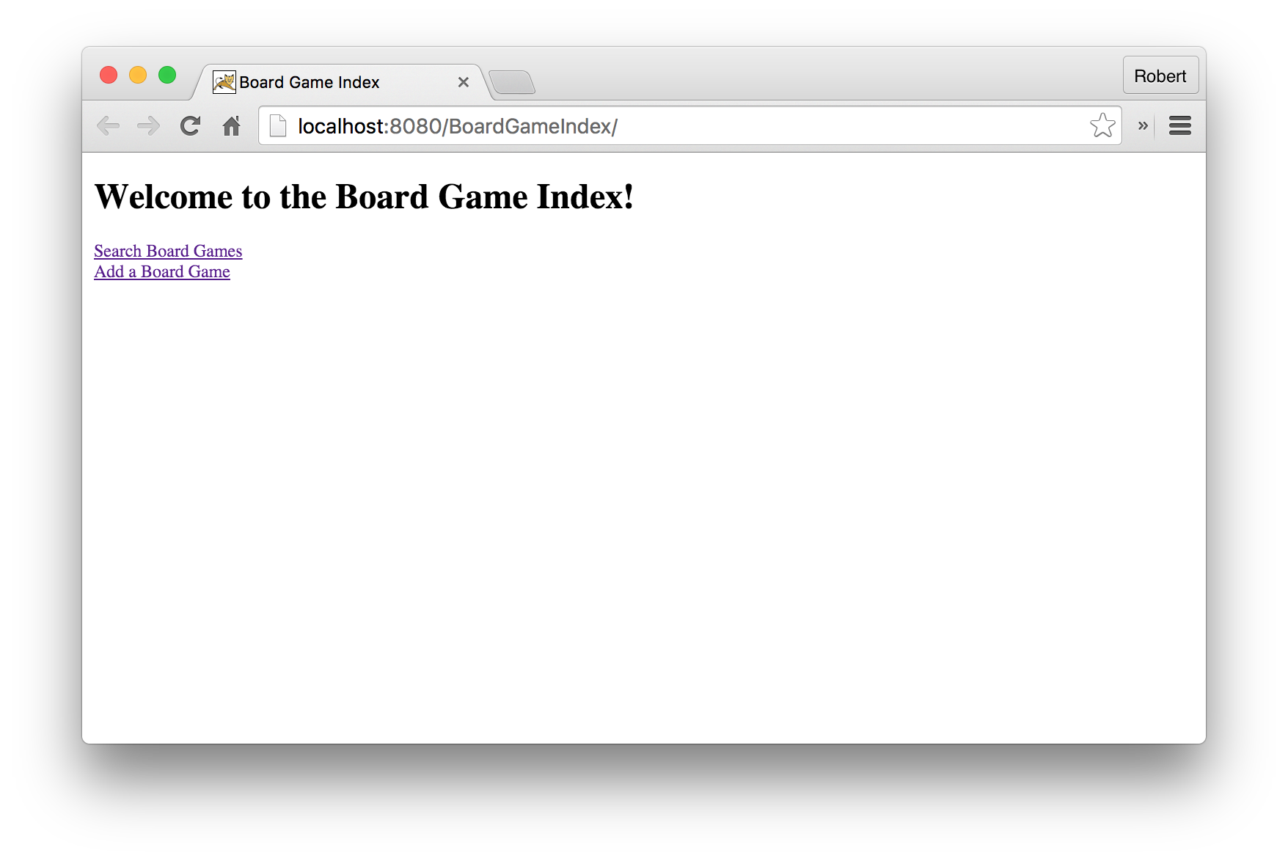

Figure : Index Page

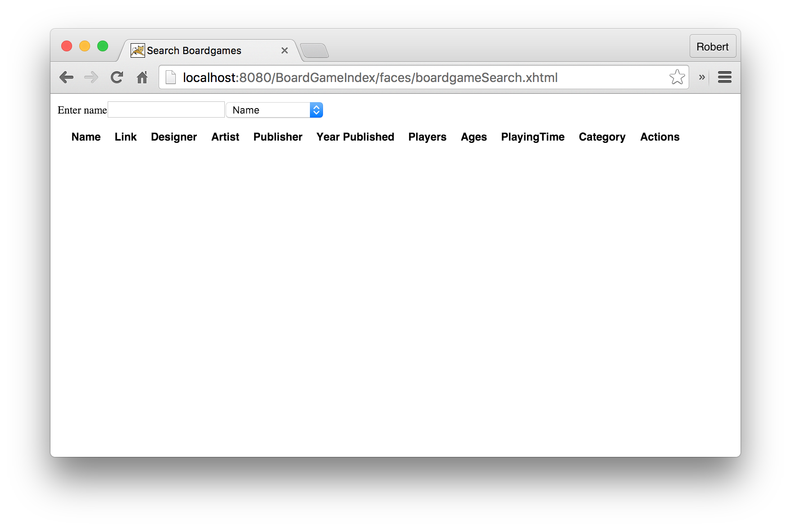

Figure : Search Page

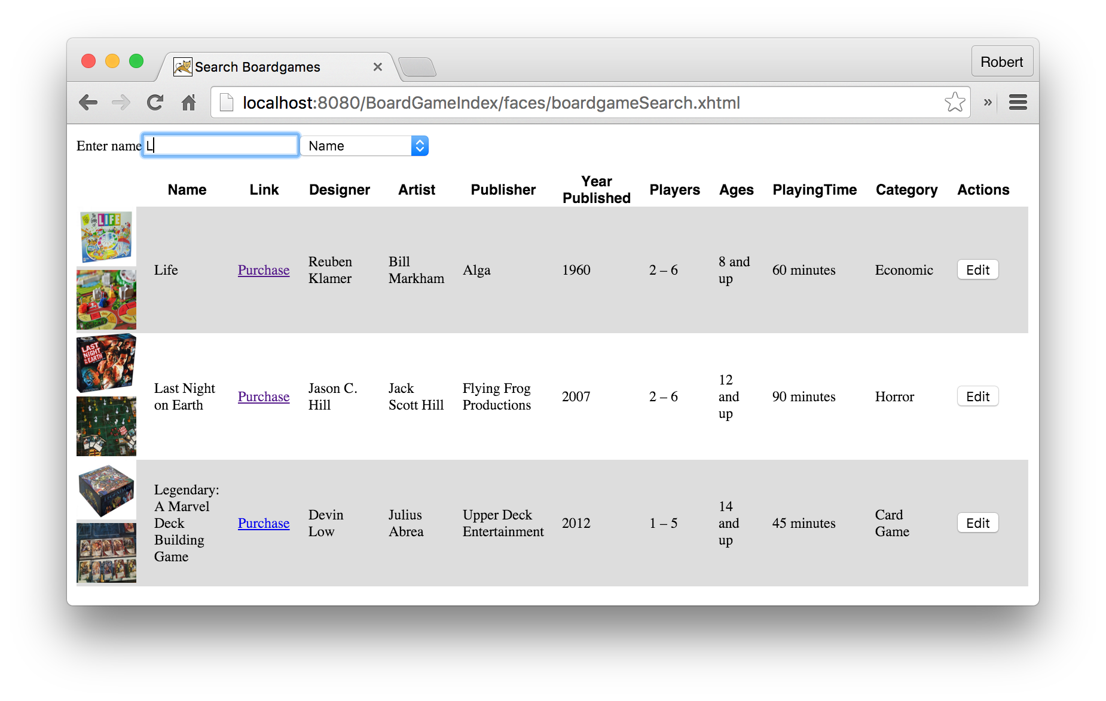

Figure : AJAX on Search Page

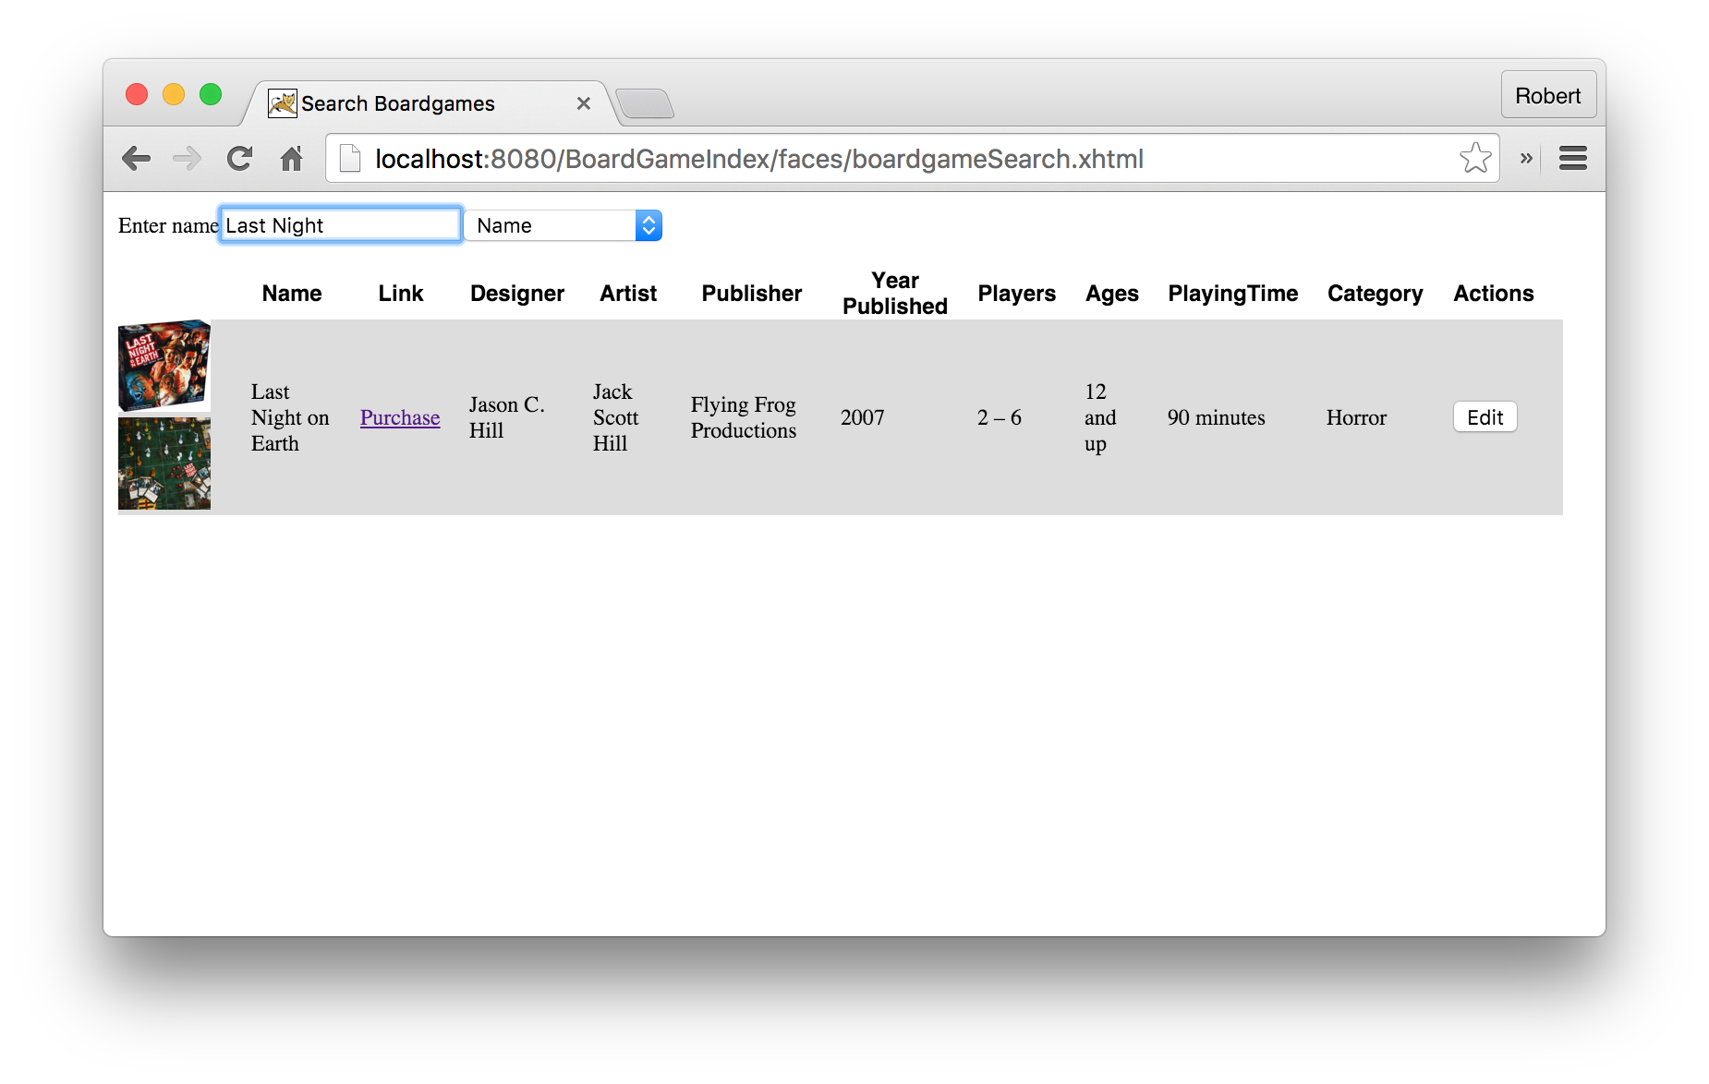

Figure : Search Page Filters Results

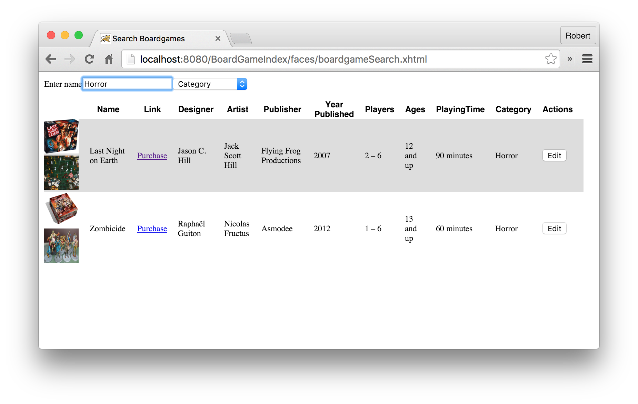

Figure : Searching by Category

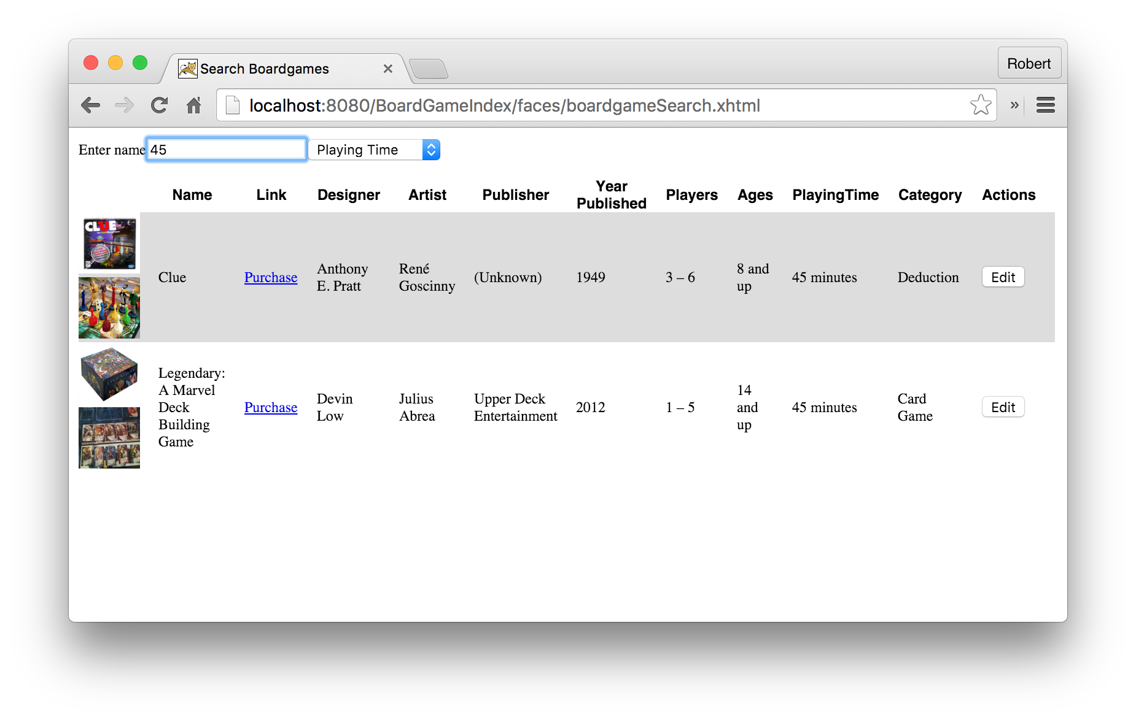

Figure : Searching by Playing Time

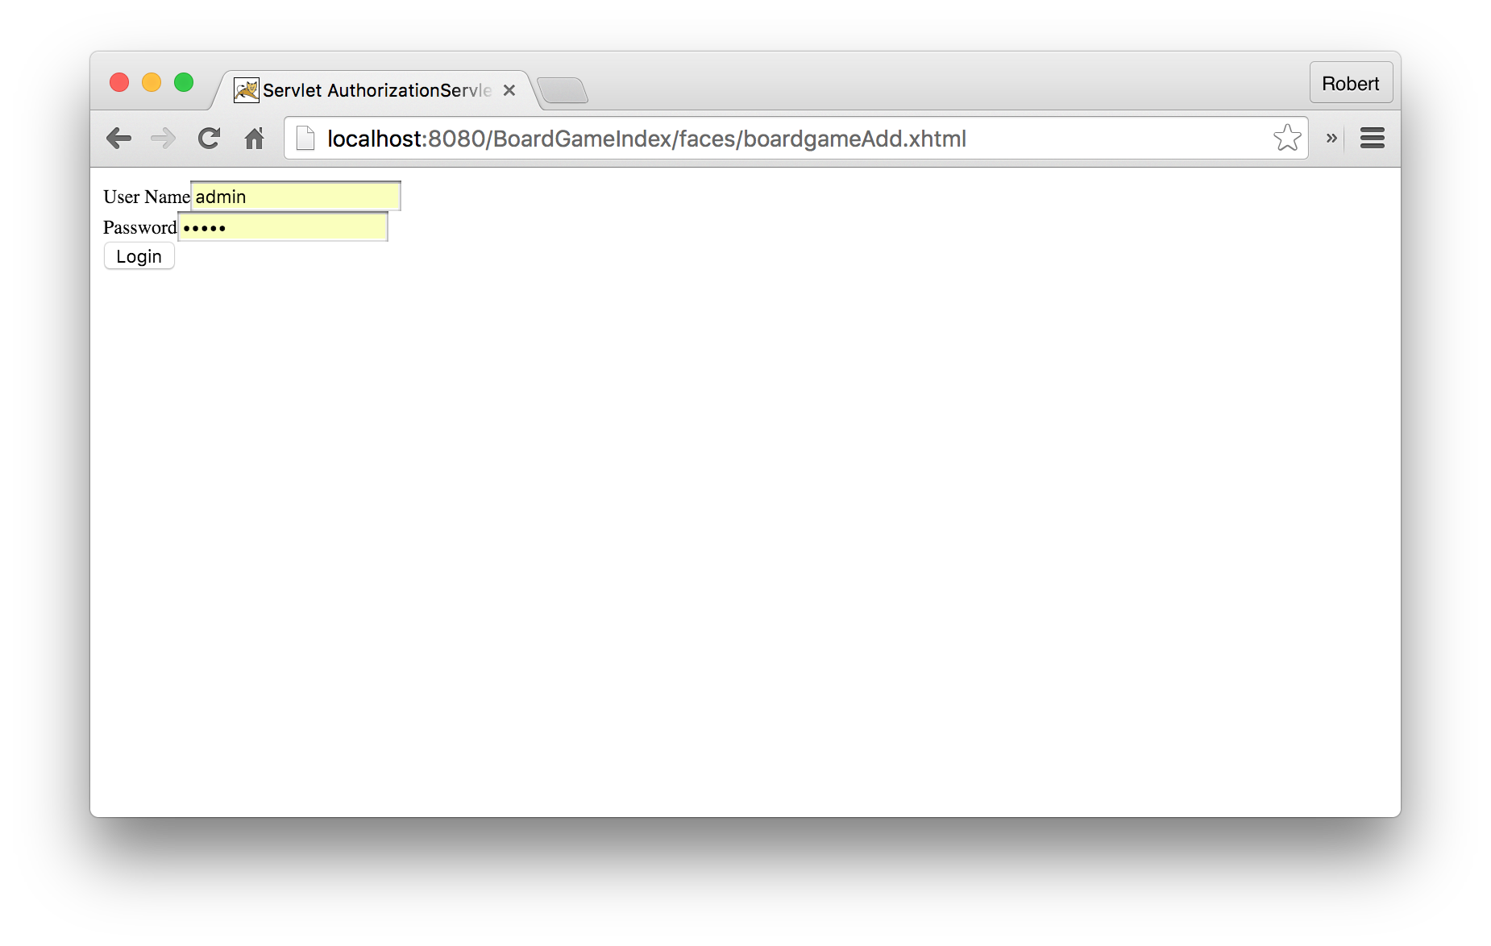

Figure : Authorization Filter for Adding Board Games

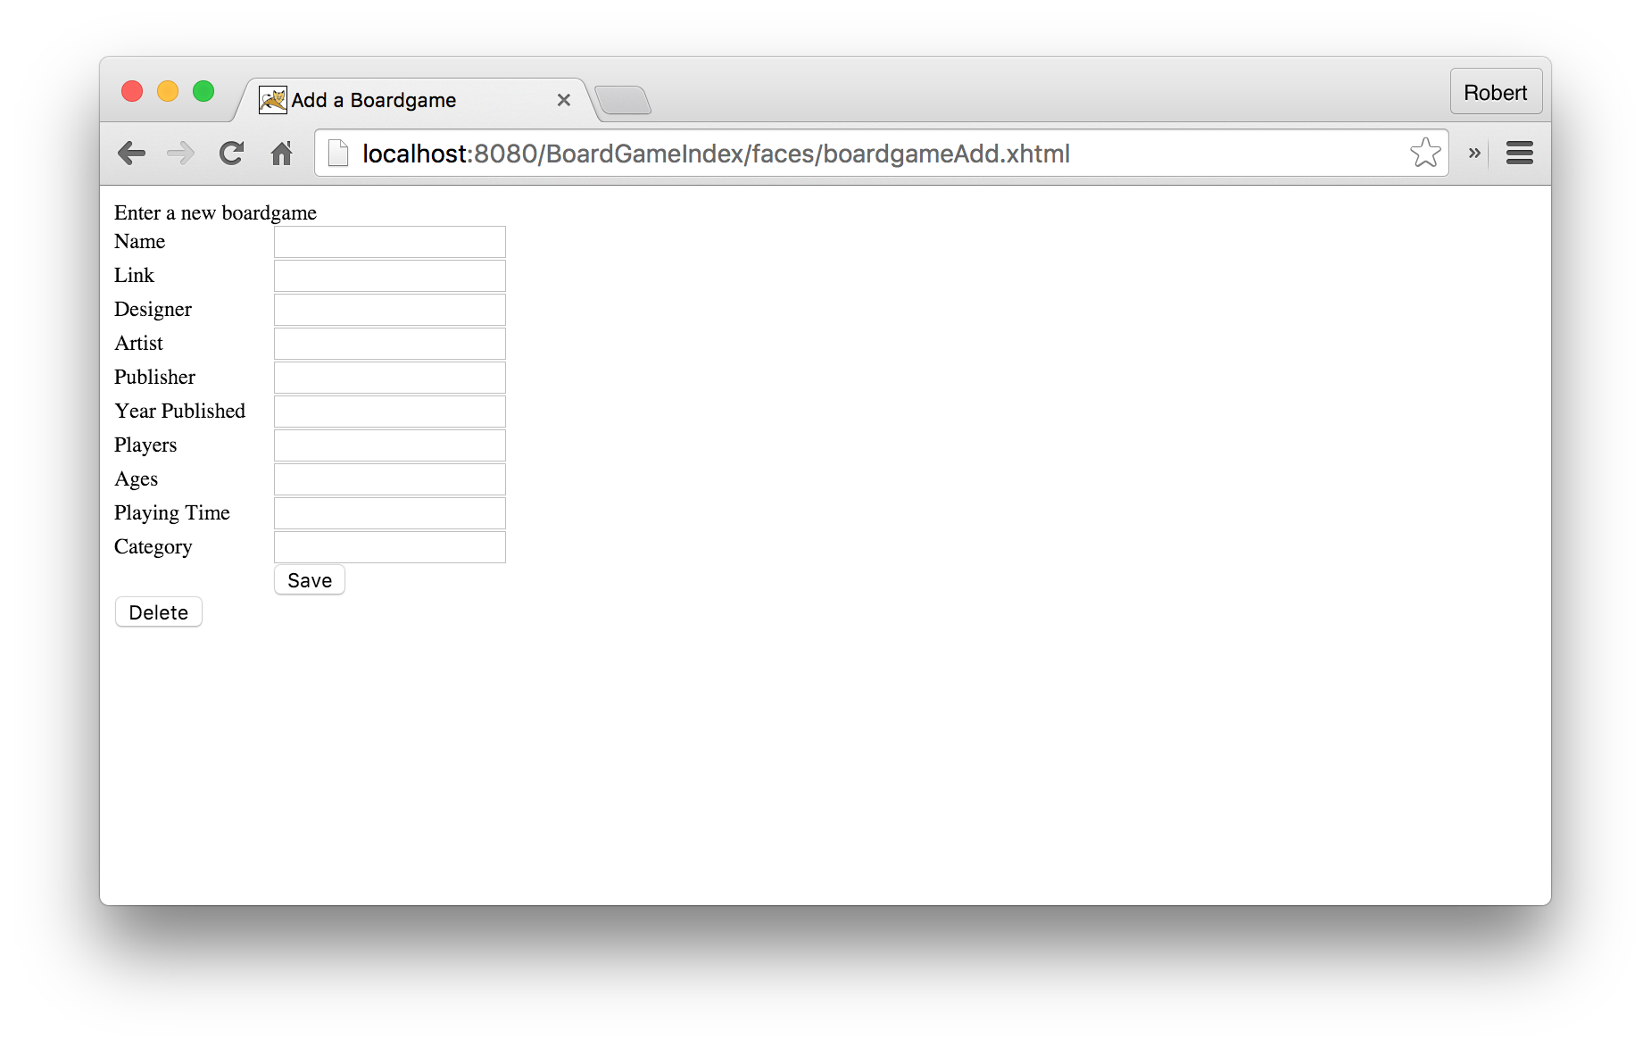

Figure : Board Game Add Form

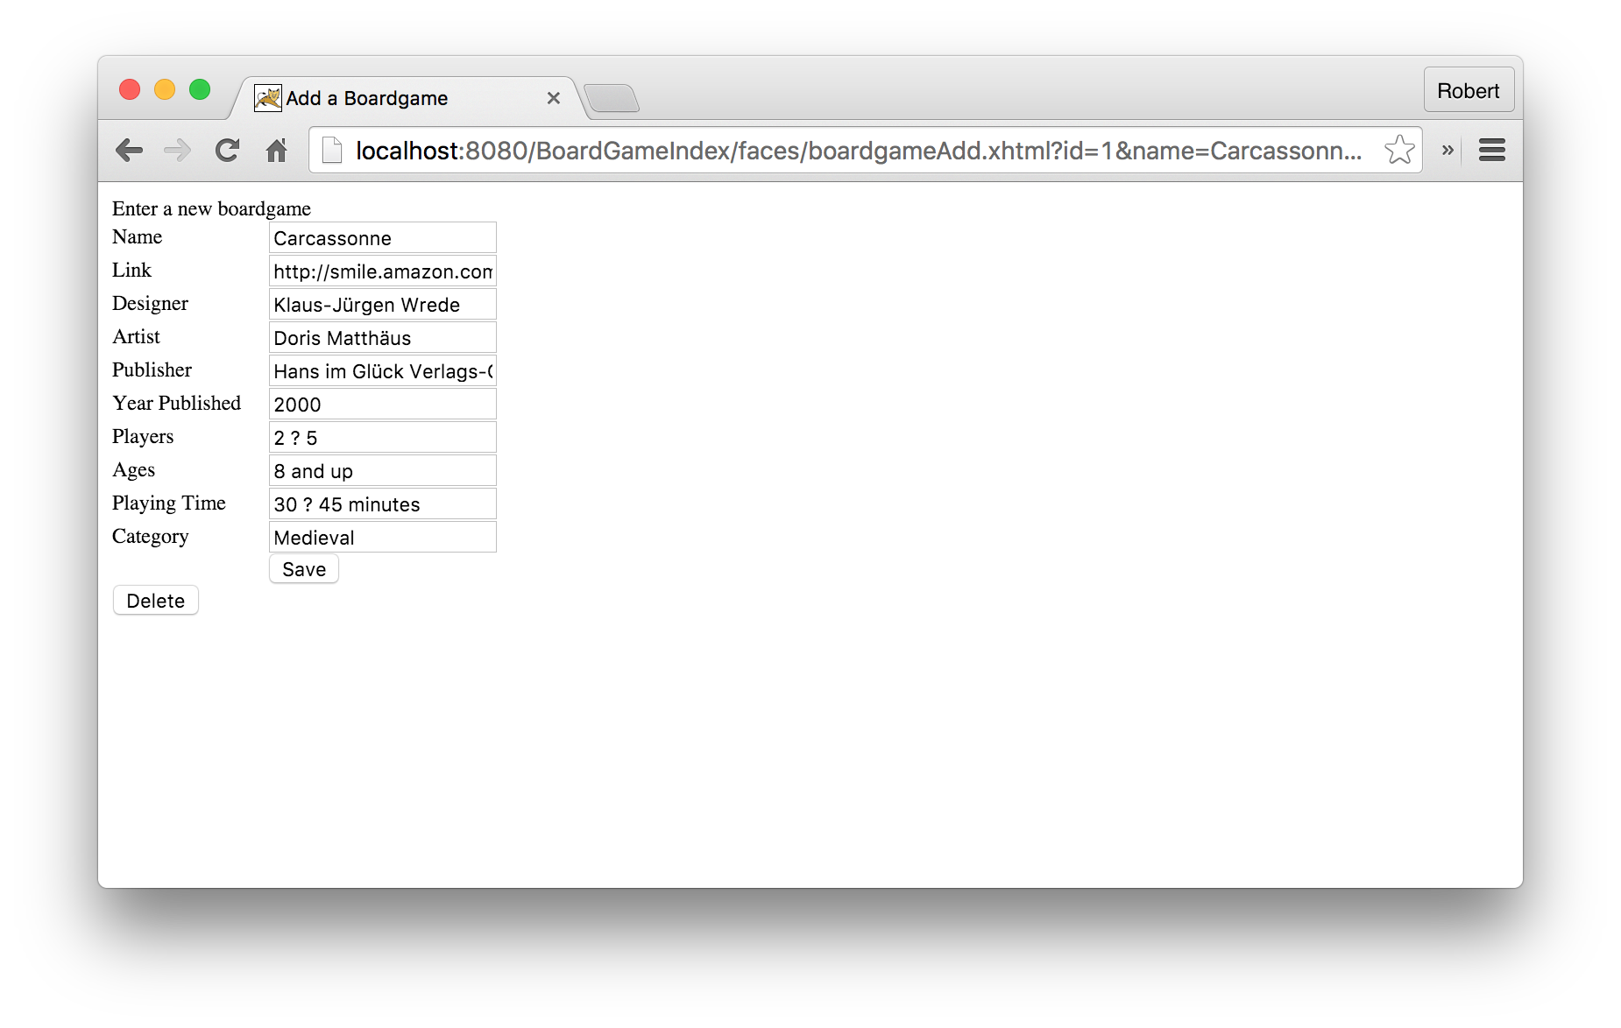

Figure : Completed New Board Game or Updating Board Game

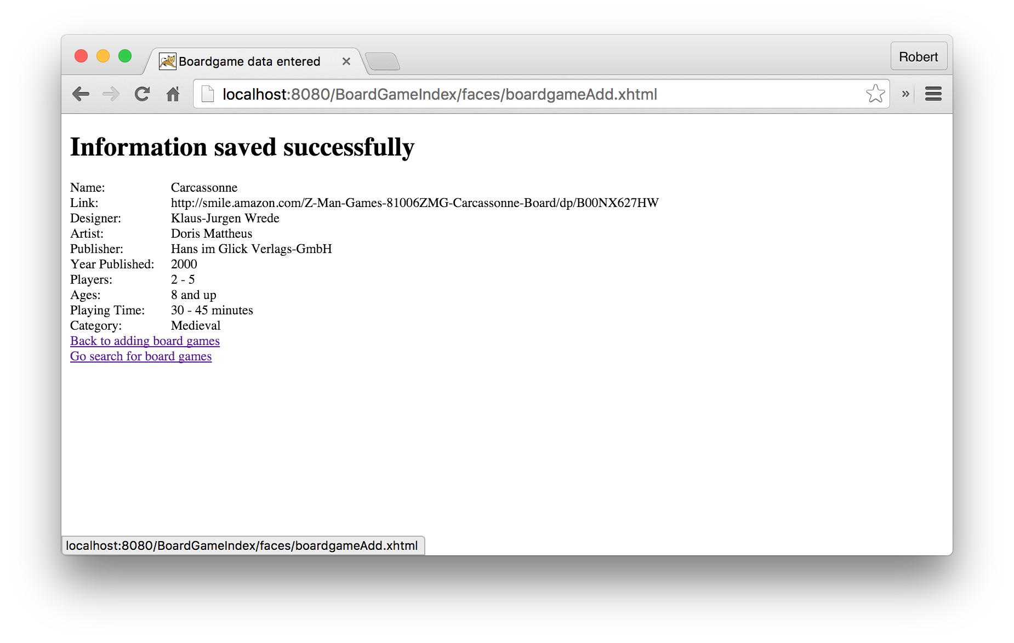

Figure : Confirmation of Board Game Addition or Update

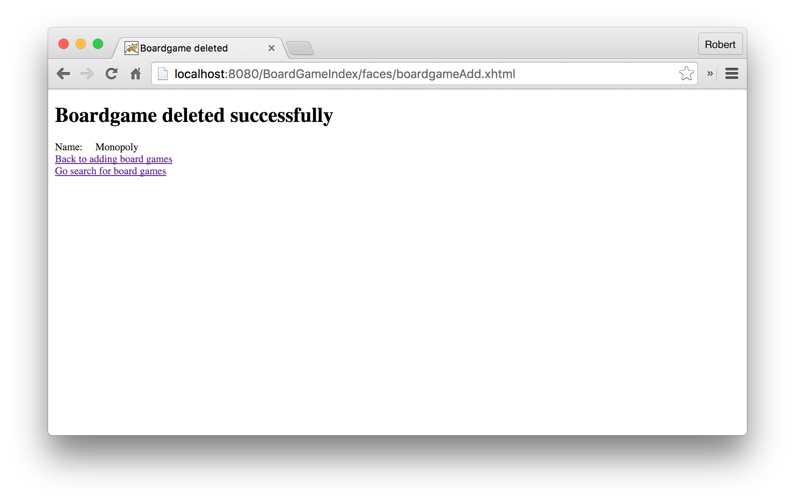

Figure : Confirmation of Deletion