**Assignment 3**

**Name: Raghad Rowaida**

**ID: 101166931**

Here we are assigned to implement Tutte Embedding for **three different weight sets**:  
- Uniform Laplacian  
- Geometric Laplacian (Laplace-Beltrami with cotangent weights)  
- Mean value weights

Implementation is testes on 4 different types of mesh structure. These 4 mesh structures have their own distinct properties that made them unique for different types of observation on the algorithms.

1. Mesh ‘beetle.obj’ is not watertight and has smoother surface (uniform change in normals)

2. Mesh ‘crater.obj’ is also not watertight, but has rough surface (nonuniform change in normals)

3. Mesh ‘camel_cut.obj’ is watertight and it has details features

4. Mesh ‘sphere_cut.obj’ is also watertight and is has uniformed smooth surface

These for different types of input meshes helped us to understand the ‘Tutte Embedding’ algorithm for different shapes and conditions.

**Result Analysis:**

Parameterized pictures of the ‘beetle.obj’ mesh (the only mesh with multiple holes in the surface) helps us visualize that 3 different weights (uniform, geometric, mean value) works differently.

|  |  |  |
| --- | --- | --- |
|  |  |  |
| Uniform Laplacian | Geometric Laplacian | Mean value weights |

When we add texture to the parameterized mesh and reconstruct, then we understand that what these changes represent. Below texture is added on all of our test meshes which has sharp square patterns.

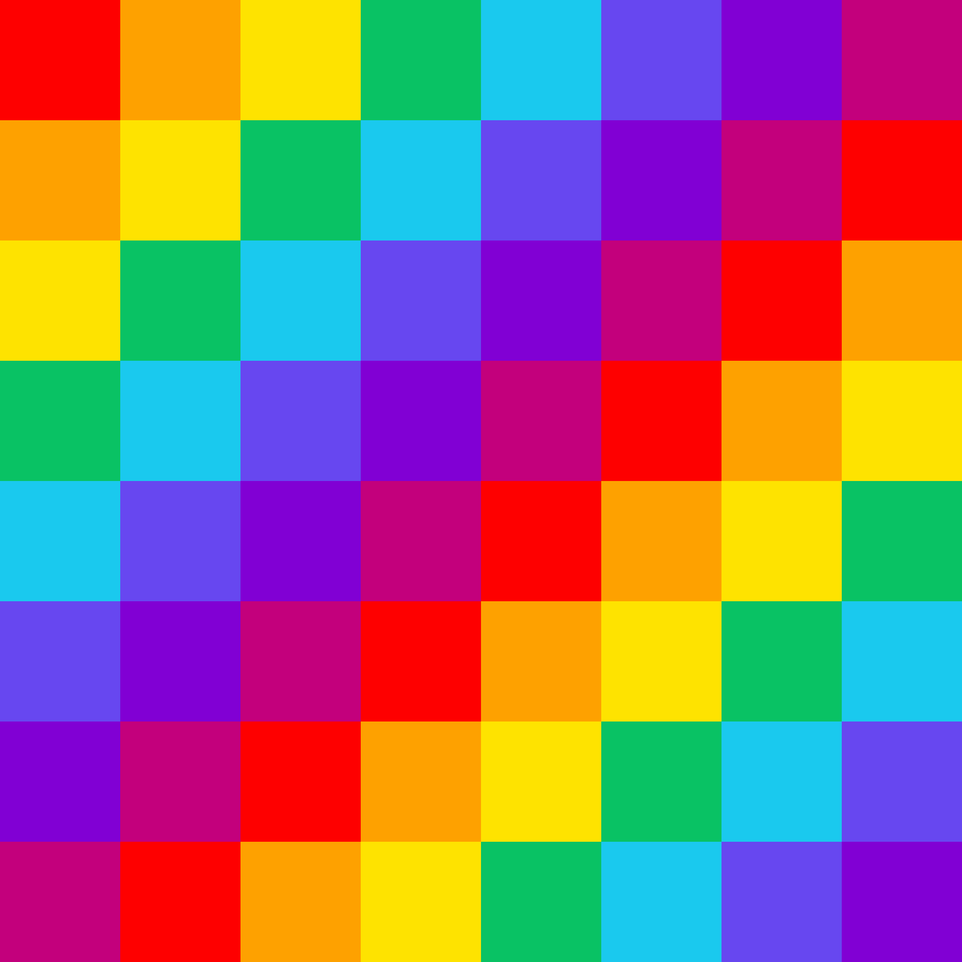

Texture comparison on ‘beetle.obj’ for different weights:

|  |  |
| --- | --- |
|  | Weight: Uniform Laplacian  Observation: Sharpe edge of the square shapes are not preserved |
|  | Weight: Geometric Laplacian  Observation: Sharpe edge of the square shapes are preserved nicely |
|  | Weight: Mean value weights  Observation: Sharpe edge of the square shapes are quite preserved also the texture inherits some of the curves of the mesh structure and they blend together. It shows the in-between property of the first and second weights. |

These methods have been applied on the all other meshes. And they showed similar result. Although as no other shapes has holes in their surface, so all of them showed same parameterized mesh structure, which is a ‘circle’. We used the given ‘boundary’ files with each mesh structure as the boundary cut. So, we are omitting ‘parameterized’ and ‘boundary’ picture for the next mesh comparison. We will compare them on the final texture reconstructed forms

Texture comparison on ‘camel_cut.obj’ for different weights:

|  |  |  |
| --- | --- | --- |
|  |  | Weight: Uniform Laplacian  Observation: Edges of the squares appears curvy; angles are not preserved. Well-sealed in the cut area but a little stretched from the original shape of the texture. |
|  |  | Weight: Geometric Laplacian  Observation: Edges of the squares has less curve; angles are almost preserved. Well-sealed in the cut area. |
|  |  | Weight: Mean value weights  Observation: Edges of the squares has less curve; angles are almost preserved. Well-sealed in the cut area. Distribution of the texture is different from form previous two. More stretched where shape is narrow (legs) |

Texture comparison on ‘crater.obj’ for different weights:

|  |  |
| --- | --- |
|  | Weight: Uniform Laplacian  Observation: Edges of the squares appears curvy; angles are not preserved. Distortion in the texture is high. |
|  | Weight: Geometric Laplacian  Observation: Edges of the squares almost smooth; angles are almost preserved. Distortion is minimum |
|  | Weight: Mean value weights  Observation: Edges of the squares has curves, better than ‘uniformed Laplacian’, but Geometric Laplacian seems better. |

Texture comparison on ‘sphere_cut.obj’ for different weights:

|  |  |  |
| --- | --- | --- |
|  |  | Weight: Uniform Laplacian  Observation: Edges are a little wavy. Angles are almost preserved. Changes proportion toward cut area. |
|  |  | Weight: Geometric Laplacian  Observation: Edges are straight. Angles are almost preserved. Changes proportion toward cut area. |
|  |  | Weight: Mean value weights  Observation: Almost same as Geometric Laplacian. |