Ryan Rozema
CPSC 310, Fall 2016
Dr. Bowers
15 December 2016
Adult Data Classification
For my final project, I used a dataset that has general information about adults with attributes such as age, job type, marital status, and salary. It was the most logical and interesting to classify on the salary attribute so I performed the K-Nearest Neighbors, Naive Bayes, Decision Trees, and Random Forests classifying algorithms on my dataset that all classify based on salary (whether an individual makes more than or less than $50,000 a year). After running these algorithms on my dataset and calculating the accuracy for each classifier, I found that K-Nearest Neighbors had the highest accuracy and was the best predictor of salary with about 80% accuracy.
The first thing I did when I started my data analysis was I eliminated some attributes because I felt like they were not as important to the dataset. After removing these attributes, the ones that I was left with were age, job type, degree, marital status, ethnicity, gender, country, and salary. In my opinion, these attributes are some of the biggest factors in determining the salary of an individual. Second, I cleaned the dataset by removing instances with NA values. I started with about 33,000 instances but after removing the instances with an null value, I was left with 30,169. I chose to remove the instances with NA values because it was the strategy that made the most sense; almost every attribute in my dataset was categorical, so I could not take the average or pick something that seemed correct very easily.
Continuing with my data analysis, my next step was to collect summary statistics on my dataset. For example, I used a dot chart to calculate the age range in my dataset (see Figure 1) as well as a frequency diagram and pie chart for marital status (Figure 2 and Figure 3 respectively), degree (Figure 4 and Figure 5 respectively), and ethnicity (Figure 6 and Figure 7 respectively). The dot chart for the ages was important for my dataset because it showed me that I have a wide range ages in my dataset, which eliminates any bias in the other attributes. Similarly, the frequency diagrams also some interesting data. One of the most important and interesting results came from the frequency diagram and bar chart of my degree attribute. I found that there were many more people who only had high school degrees than those who had bachelors or master’s degrees. This is important to keep in mind because it could skew the salaries to represent that less than $50,000. Finally, I created a pie chart for gender (Figure 8). This pie chart was also very important to see because I noticed that almost two thirds of my dataset were male. This is important to keep in mind because it could skew the dataset for the amount
After completing the data analysis, I performed some classification algorithms on my dataset. Some of the algorithms I used were K-Nearest Neighbors, Naive Bayes, Decision Trees, and Random Forests. For K-Nearest Neighbors, I used the code from assignment 3 as a guideline. Because most my attributes were categorical, I needed to go through and map each of the columns to give them a continuous number that represented the categorical value. This helped me do the calculations as well as print out the confusion matrix much easier. After running the program multiple times, the highest accuracy for k-nearest neighbor classification is 79.4% with a random sample, and a 79.8% accuracy with the stratified cross folds. The highest recognition in the confusion matrix was 91.8% for salary 0 (less than or equal to 50k) and 43.7% recognition for salary 1 (greater than 50k). Even though K-Nearest Neighbors was the slowest of the four classification methods, it was the most accurate.
For Naive Bayes, I used code from assignment four as a reference. Like K-Nearest Neighbors, because most my attributes were categorical, I needed to go through and map each of the columns. Similarly, this helped me do the calculations as well as print out the confusion matrix much easier. After running the program multiple times, the highest accuracy for Naive Bayes classification is 77.2% with a random sample, and a 77.5% accuracy with the stratified cross folds. The highest recognition in the confusion matrix was 91.9% for salary 0 (less than or equal to than 50k) and 33.6% recognition for salary 1 (greater than 50k). The Naive Bayes algorithm was the second slowest, but had a bit of a drop off in the accuracy.
For Decision Trees, I used code from assignment 5 as a reference. Like K-Nearest Neighbors and Naive Bayes, many my attributes were categorical, so I had to repeat the same step of discretization as I did for K-Nearest Neighbors and Naive Bayes and map each of the columns. This helped me do the calculations as well as print out the confusion matrix much easier. After running the program multiple times, the highest accuracy for Decision Trees classification is 77.4% accuracy with the stratified cross folds. The highest recognition in the confusion matrix was 95.9% for salary 0 (less than or equal to 50K) and 21.3% recognition for salary 1 (greater than 50k). Unfortunately, the rules that I got were not as interesting as I had hoped. For example, the rules explained to me that if someone only has a high school degree, no matter what their ethnicity or gender is, they will earn less than $50,000 a year. Similarly, on average, if an individual has a Masters, Doctorate, or Professional degree, then they will make more than 50,000 a year. On the other hand, every individual with any other degree makes less than $50,000 a year. The Decision Tree algorithm was very efficient, but had a similar accuracy to Naive Bayes which was less than K-Nearest Neighbors.
Finally, for Random Forests, I used the code from assignment six as a reference. Like all the classification methods above, most of my attributes were categorical data, I had to repeat the same step of discretization and map each of the columns to give them a number. I picked very specific N, M, and F values that gave me the highest accuracy. For example, N = 3000, M = 215, F = 2 gave me an accuracy of 77.8%. The highest recognition in the confusion matrix was 95.7% for salary 0 (less than or equal to 50k) and 20.8% recognition for salary 1 (greater than 50k). The Random Forest efficiency depended on the N, M, and F values that the user gets to input. Because my values for these parameters were relatively small, I was able to get an efficient forest. Random Forests had a similar accuracy to the Naive Bayes and Decision tree accuracy, which is still less than K-Nearest Neighbors. In conclusion, K-Nearest Neighbors is the slowest but most accurate predictor of salary.
I learned a lot from this final project, such as cleaning my own dataset, visualizing my data in graphs, and classifying my dataset. After completing the project, I found that I know a lot more about my dataset and how to predict salaries given a random instance. One of the challenges I faced when using this dataset was the cleaning. The names of the attributes were not very readable, so going through and making sure to change each one was very difficult. After cleaning and classifying the dataset, I found that K-Nearest Neighbors had the best classification accuracy of about 80%. I would be able to improve the accuracy of my classifiers by excluding obvious attribute values. For example, I would assume that if an individual only has a high school degree, they would make less than $50,000 a year. Similarly, I would be able to improve the interestingness of my dataset by including a more diverse ethnicity range. In conclusion, I had a lot of fun and learned a lot using a dataset that I picked out myself.
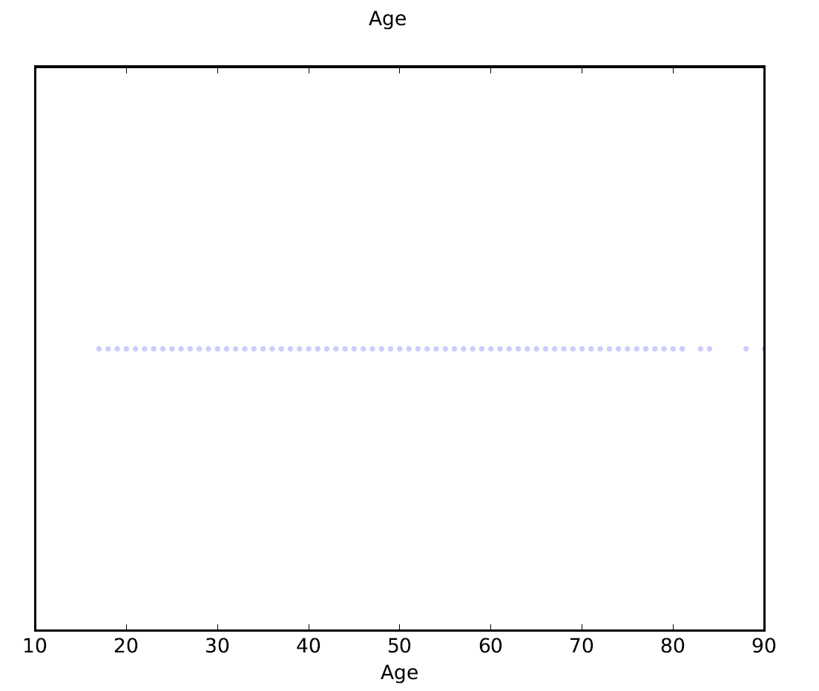
Figure 1
This is a dot chart that shows the distribution of ages across my dataset. Notice how evenly distributed the ages are; this will eliminate any age bias in the classification results.

Figure 2
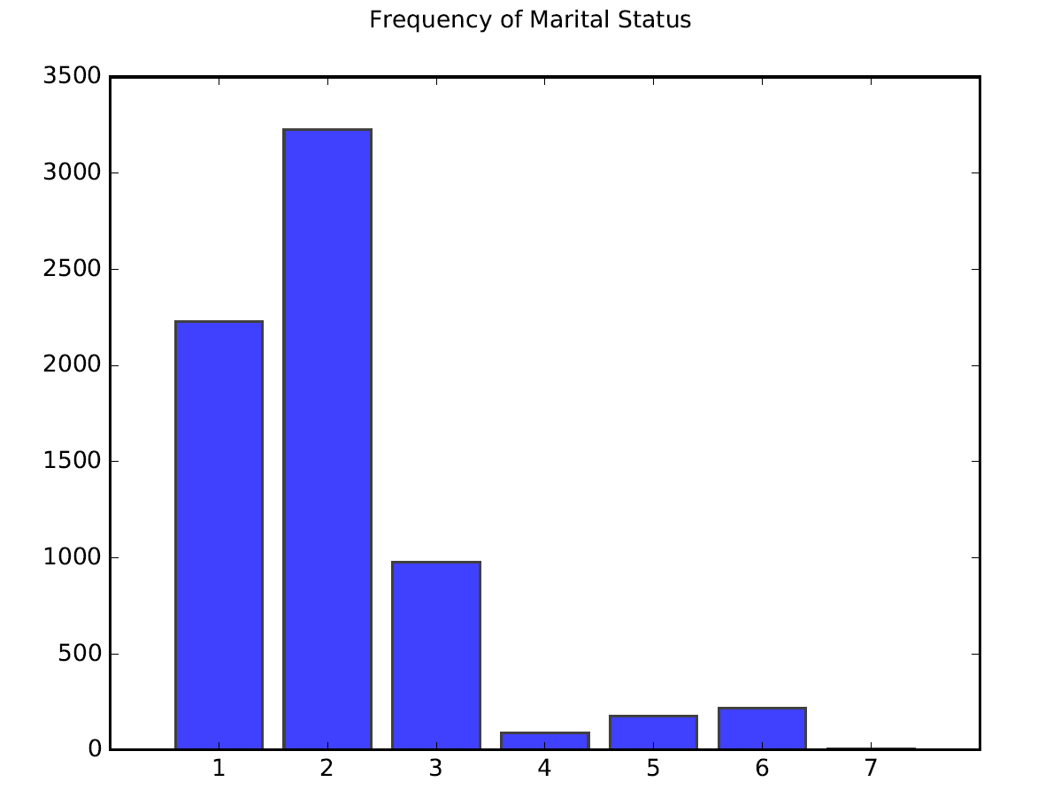
This is frequency diagram that shows the amount of each form of marriage represented in the dataset. One way that I can eventually improve my results is to increase the representation of the lesser represented values.

KEY:
1 = never married
2 = married
3 = divorced
4 = married, spouse absent
5 = widowed
6 = separated
7 = other

Figure 3
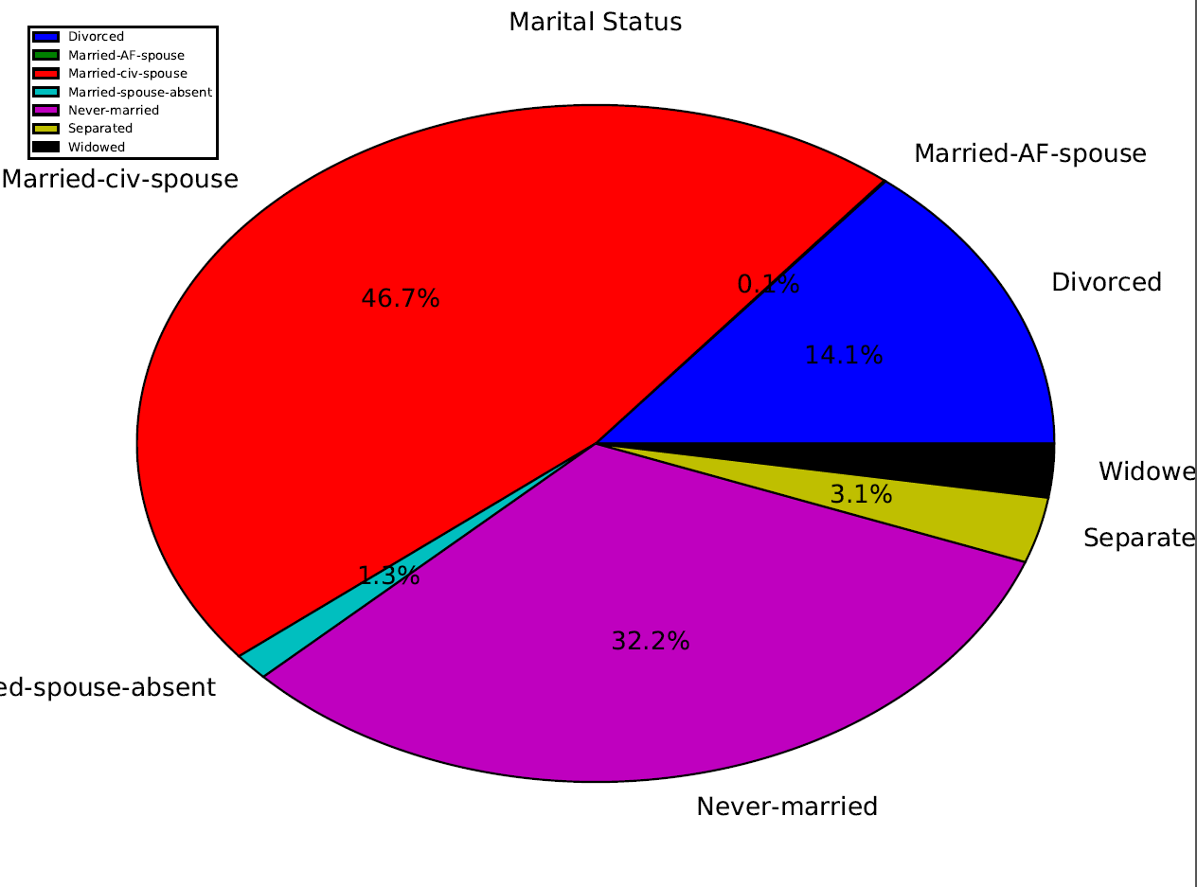

This is pie chart that shows percentage of each marriage type represented in the dataset. One way that I can eventually improve my results is to increase the representation of the lesser represented values.

See key in the upper left hand corner of the figure.
Figure 4
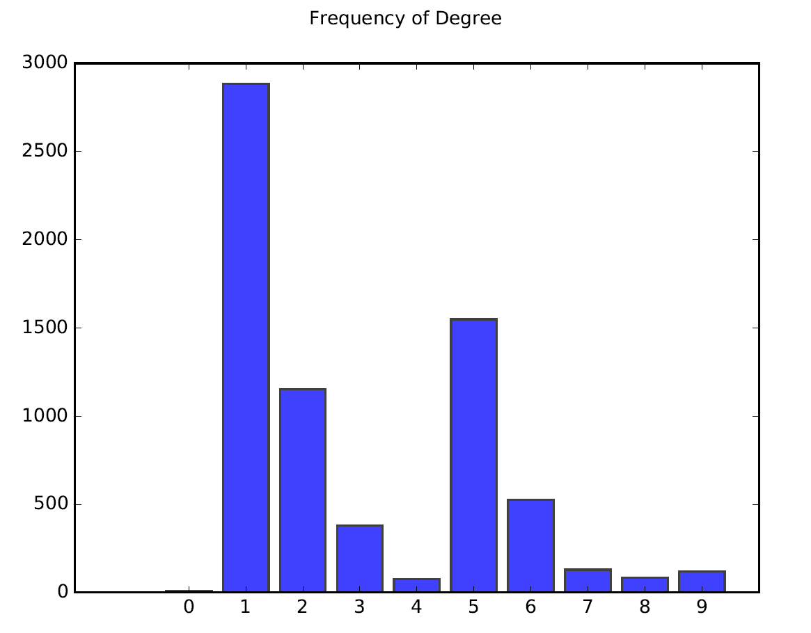
This is frequency diagram that shows the amount of each degree represented in the dataset. One way that I can eventually improve my results is to decrease the amount of those with a high school degree and increase the amount of college degrees (e.g. Bachelor’s, Master’s, etc.).

KEY:
1 = High school
2 = Bachelor’s
3 = Master’s
4 = Doctorate
5 = College drop out
6 = Associate degree
7 = Middle school
8 = Elementary school
9 = Professional education
0 = other

Figure 5
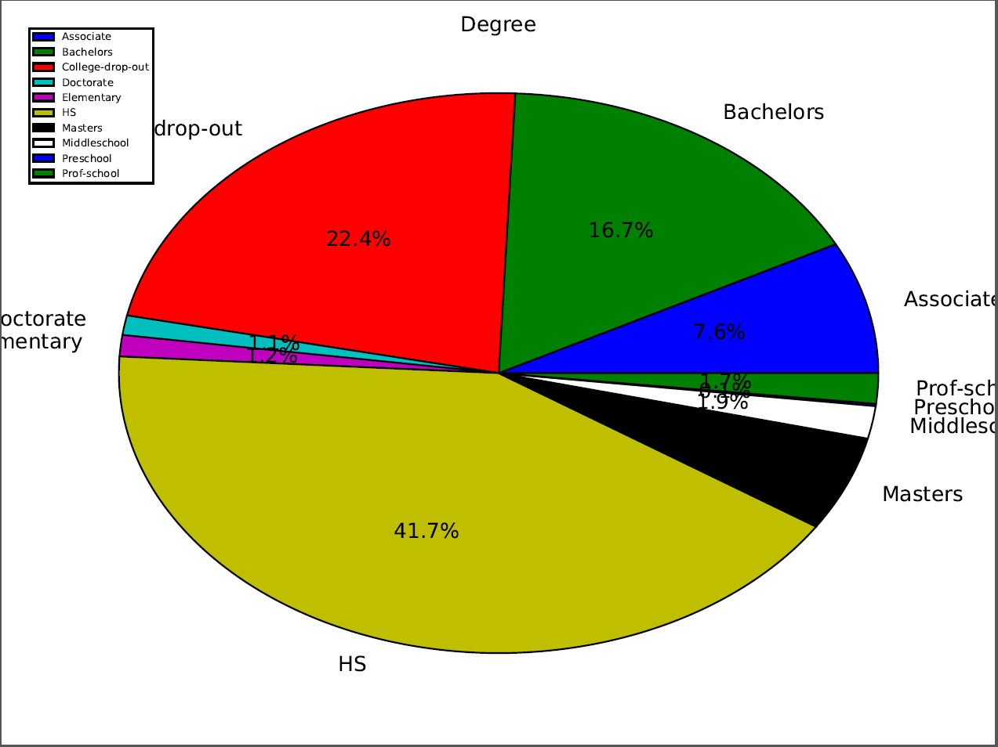

This is pie chart that shows percentage of each degree represented in the dataset. One way that I can eventually improve my results is to decrease the amount of those with a high school degree and increase the amount of college degrees (e.g. Bachelor’s, Master’s, etc.).

See key in the upper left hand corner of the figure.
Figure 6
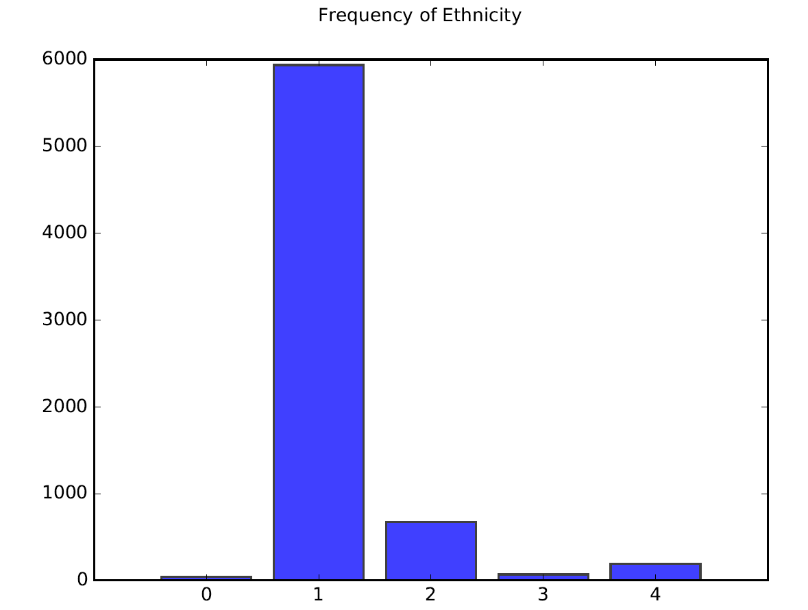

This is frequency diagram that shows the amount of each ethnicity represented in the dataset. One way that I can eventually improve my results is to increase the representation of the lesser represented values to get an even distribution. This way I will be able to use ethnicity as a better determination of salary.

KEY:
1 = White
2 = Black
3 = Native American / Eskimo
4 = Asian Pacific islander
0 = other
Figure 7
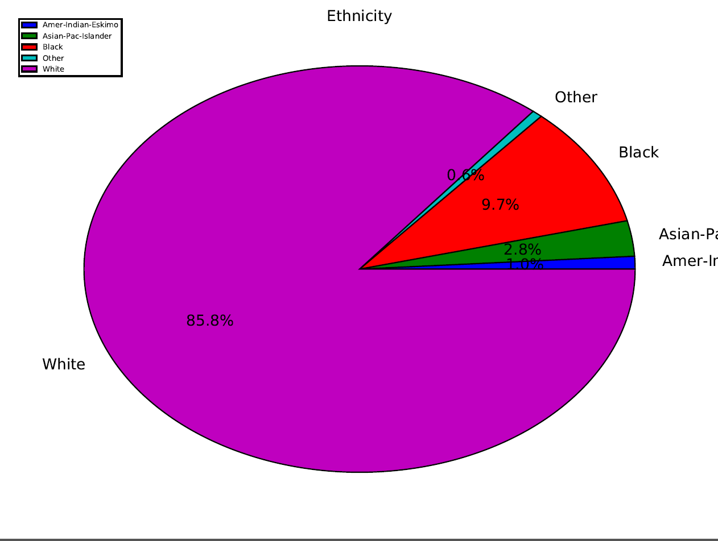
This is pie chart that shows percentage of each ethnicity represented in the dataset. One way that I can eventually improve my results is to increase the representation of the lesser represented values to get an even distribution. This way I will be able to use ethnicity as a better determination of salary.

See key in the upper left hand corner of the figure.

