

**Basic Linux Commands Assignments**

Assignment-1

Connect and disconnect with login Access

* What happens when you login a non-existent users or username?
  + Provide Screenshot and what you understand, explain in short brief?

**Answer: - When we try to login a non-existence username it didn’t get login and while inputting password it fire an error that “SORRY, THAT DIDN’T WORK. PLEASE TRY AGAIN. As shown in below**

**Screenshot:-**

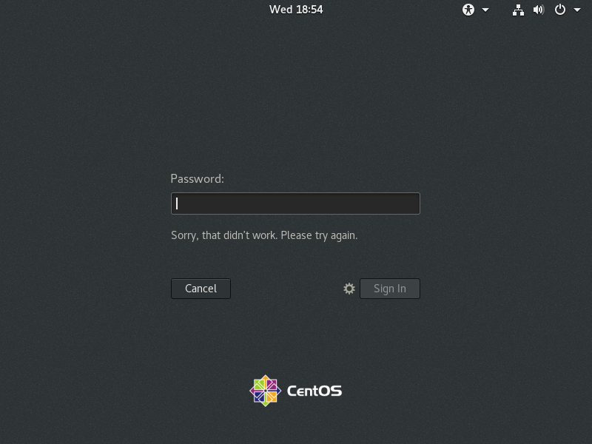

Assignment-2

Password changing

* Login into your account and then change password?
  + Change your password into **IneuR0n#42** and hit the **Enter** key
    - Explain what happen and give screenshot?

**ANSWER: - Changing password using the terminal by entering command**

**(Sudo passwd root).**

**It will ask for new password and we have to enter the password twice to match the password, it will show the message that “ALL AUTHENTICATION TOKENS UPDATED SUCCESSFULLY.” As shown in the below screenshot**

**Screenshot:-**

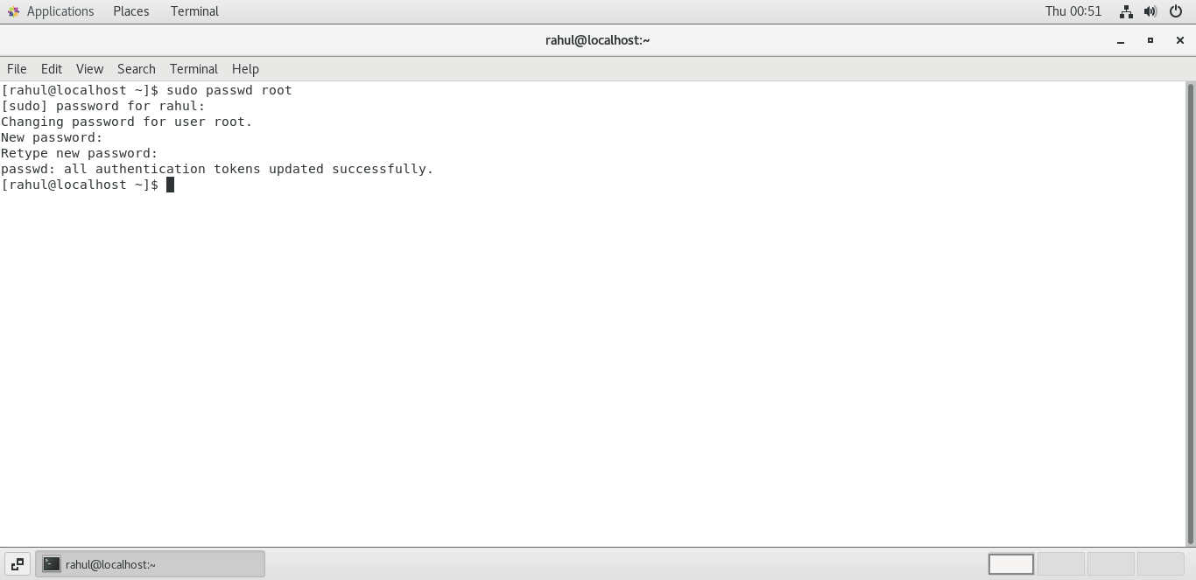

* + Try again to change password but use like password ***1234*** or ***abcd***
    - Explain what happen and give screenshot?

**ANSWER: - As it use a same procedure to change the password but after we input the password**

**At first it show a warning that**

**“BAD PASSSWORD: - THE PASSWORD IS SHORTER THAN 8 CHARCHTER”**

**Meanwhile after retype the same password it show a message that**

**“PASSWD: - all authentication tokens updated successfully**

**Screenshot:-**

**1.**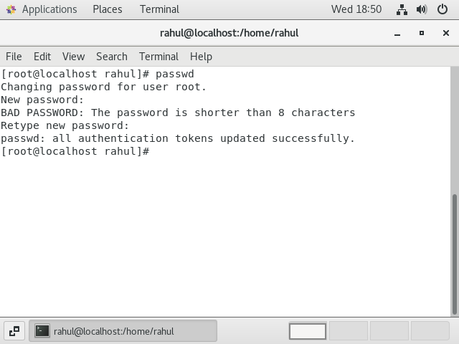

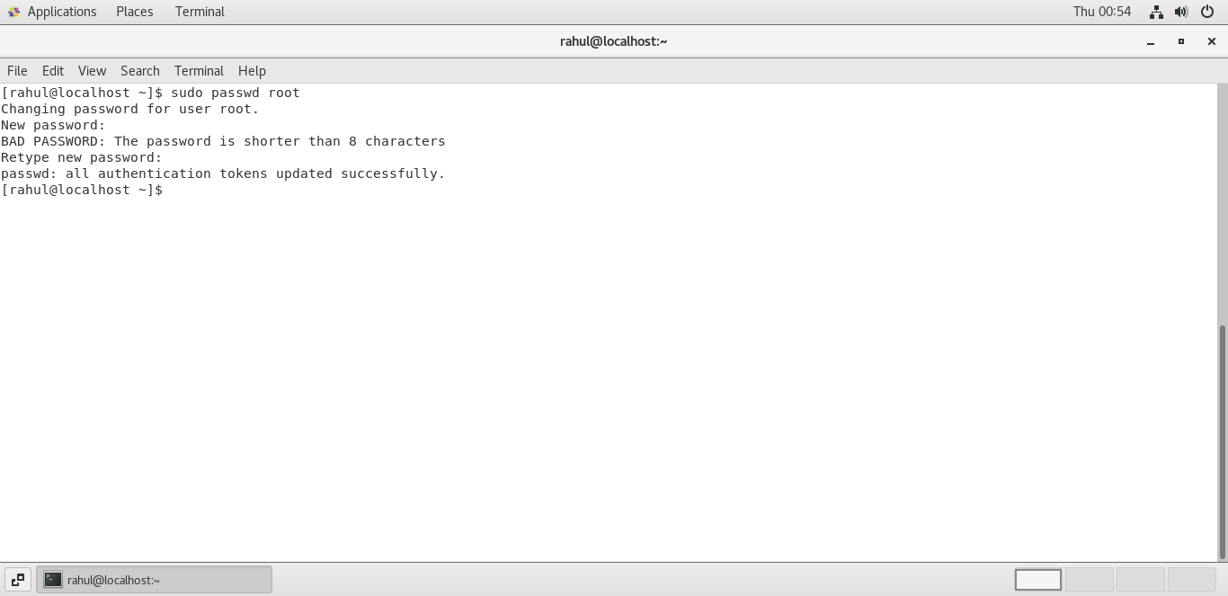**2**

* + Try again to change password but now don’t use any password just hit **Enter** key
    - Explain what happen and give screenshot?

**ANSWER:- after changing password and hitting enter two time it fire an error that that it’s a BAD PASSWORD and show a message that “PASSD: AUTHETICATION TOKEN MANIPULATION ERROR”**

**As shown below.**

**Screenshot:-**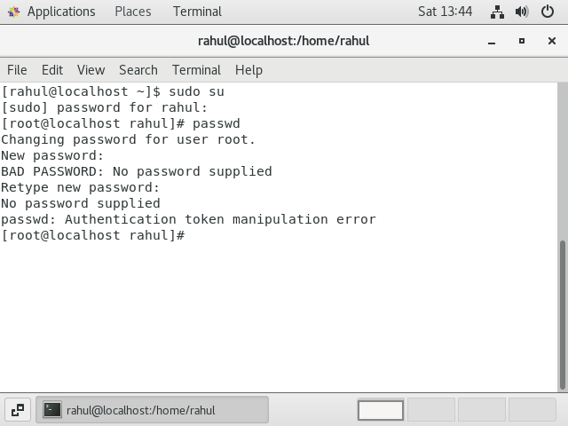

Assignment-3

Working with Directories

* Enter the command **cd /** and then **ls** and then hit **Enter** key
  + Take screenshot and explain what output we got?

**Answer :- after hitting cd / and ls command its shows the complete directory present for instance**

**Bin,dev,home,boot etc. as shown in below screenshot.**

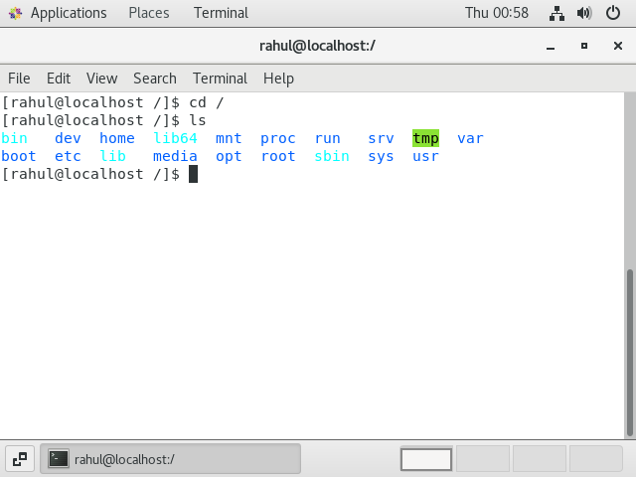**Screenshot:-**

* Enter the command now **cd /home** and then hit **Enter** key
  + Do **ls,** provide screenshot and explain what is **/home** directory used for?

**Answer: - A home directory is a file system directory on a multi-user operating system contacting files for a given user of the system.**

**After firing command cd /home and ls it change the current working directory to home and list out the directory present in home directory as shown below**

**Screenshot:-**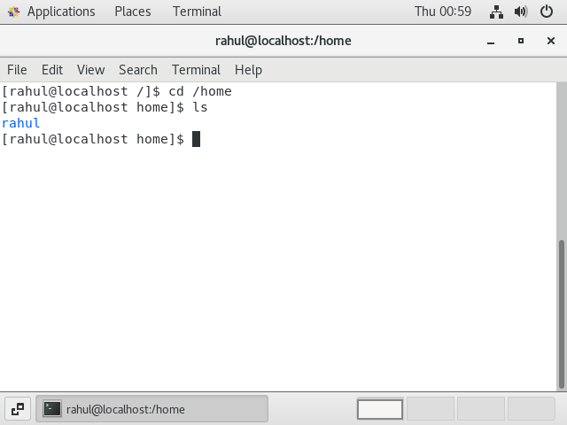

* Enter **cd ..** and hit **Enter** key [ *Note: here we have space after cd then use double dot*]
  + Check what happen and give screenshot?

**Answer: - After hitting cd .. In the terminal it change the directory to home as shown in the below screenshot**

**Screenshot:-**

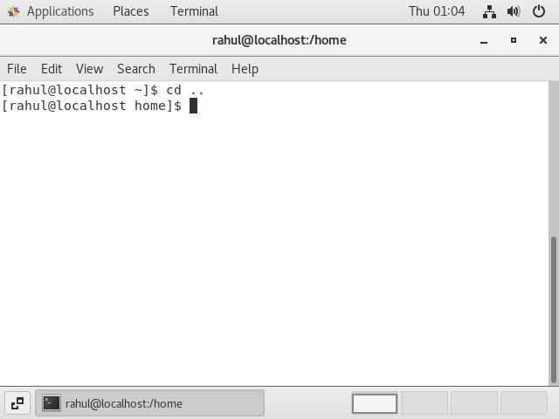

* Now enter **cd /var/www/html** and then type **cd** and hit **Enter** key
  + Explain what happen and give screenshot?

**Answer: - it shows that no such file or directory**.

**Screenshot:-**

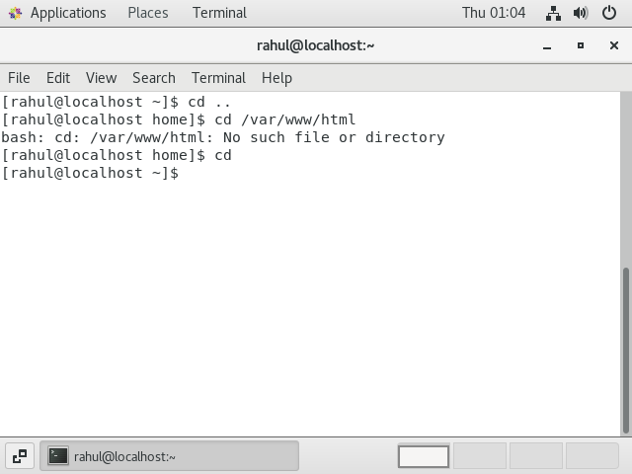

Now type **cd /root** and then hit **Enter** key

* + Do **ls,** check any output we have on screen if yes then take screenshot?

**Screenshot:-**

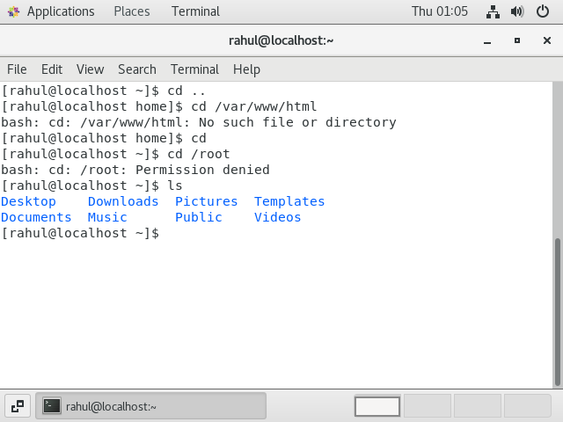

Assignment-4

Working with File Listing

* Go to **cd /etc** and type **ls**
  + Take screenshot and explain what files you have seeing?

**Answer: - it display all the file’s and folder available in the root for example adjtime, mtab etc.**

**Screenshot:-**

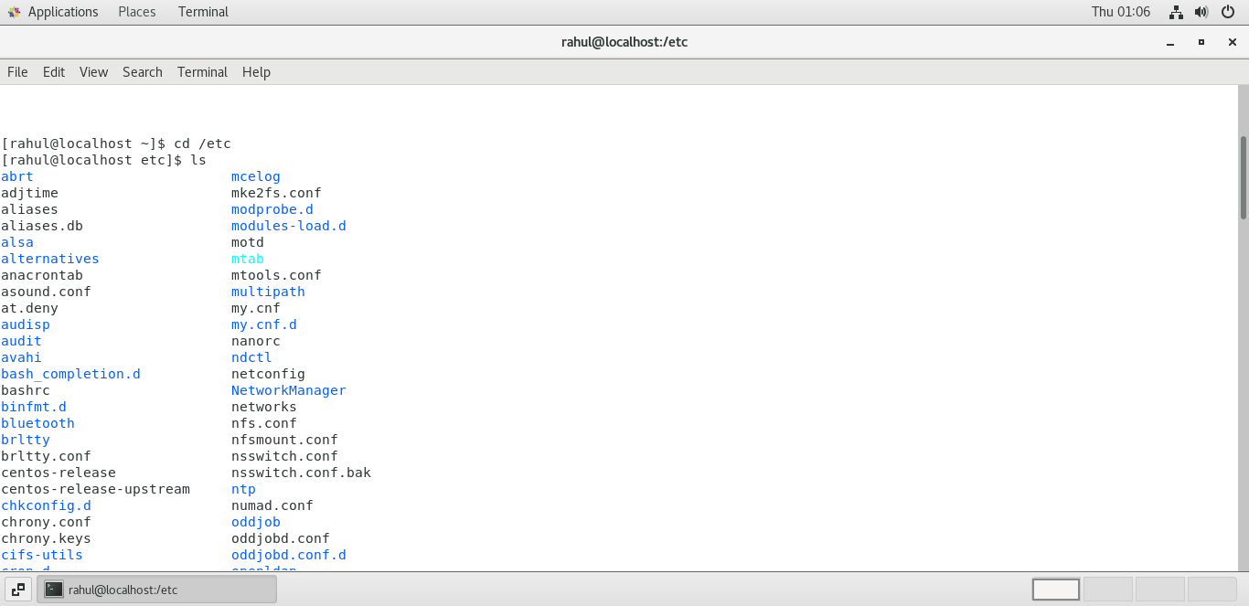

* + Take screenshot and explain what different output you found compare to previous command you used?

**Answer:- it display the entire file and folder available in the root directory**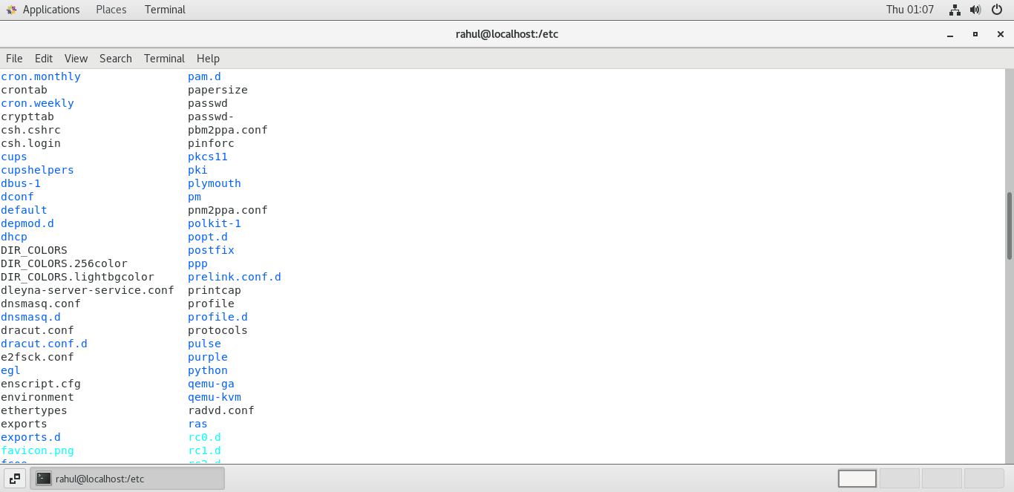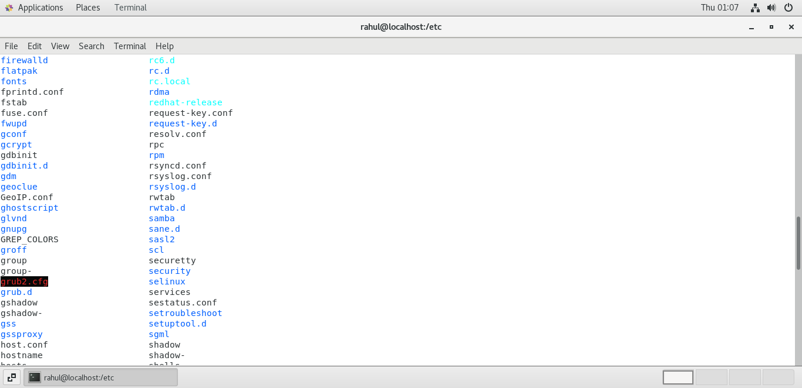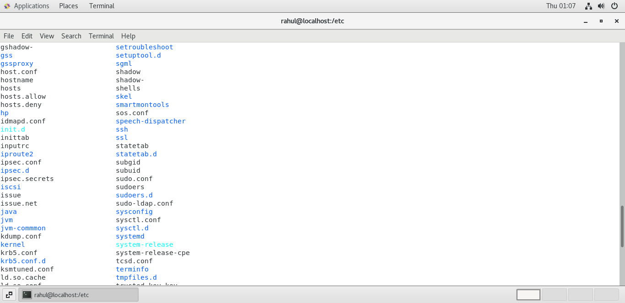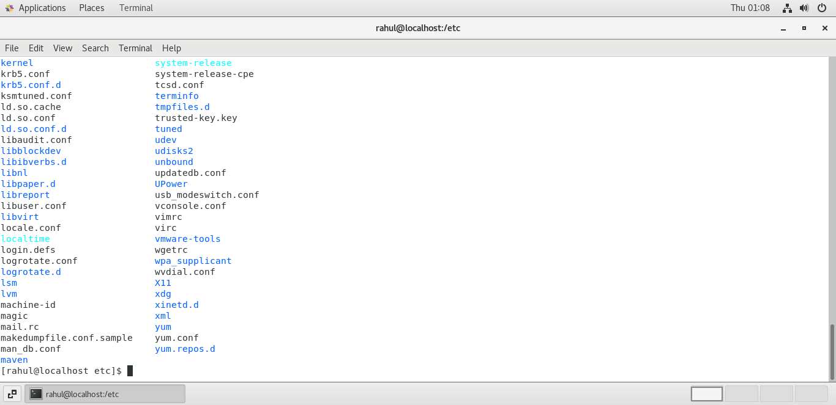

* Then type **ls -al** and hit **Enter** key
  + Take screenshot and explain what new file or directory you found?

**Answer: - its show the file and folder of root with permission, date time and file/folder name.**

**Screenshot:-**

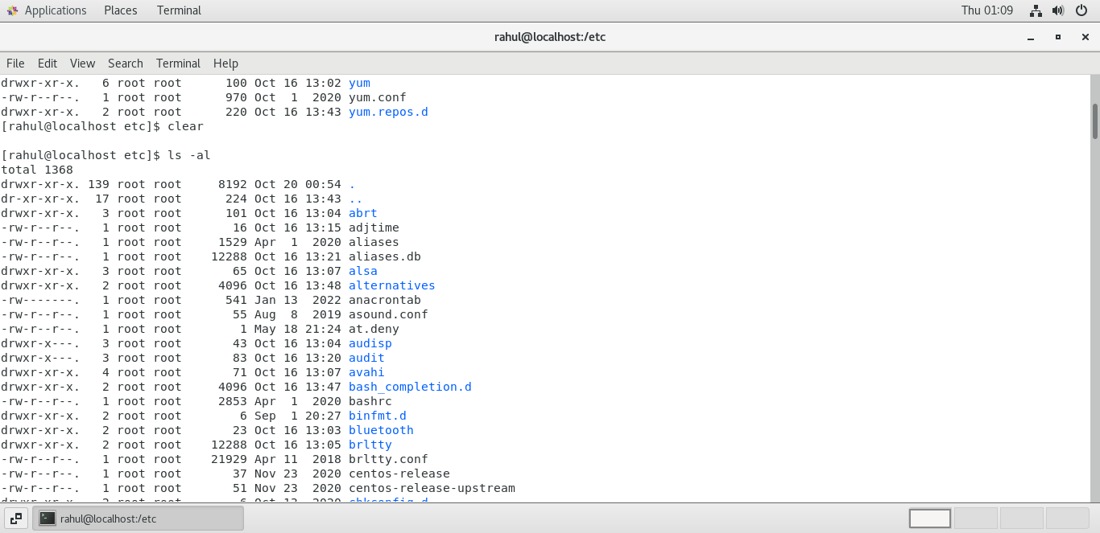

* Then use **ls -i** and hit **Enter** key
  + Now see what different output its shows and take screenshot?

**Answer: - it show the file and folder name with size of folder and file.**

**Screenshot:-** 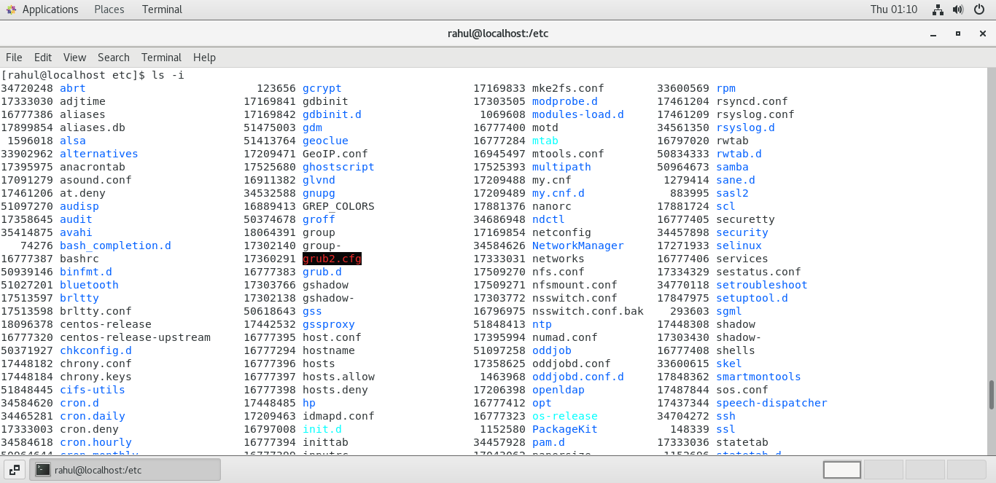

* Then use **ls –help** and see other options about **ls** command
  + Explore it and try with other attribute we can use with **ls** command

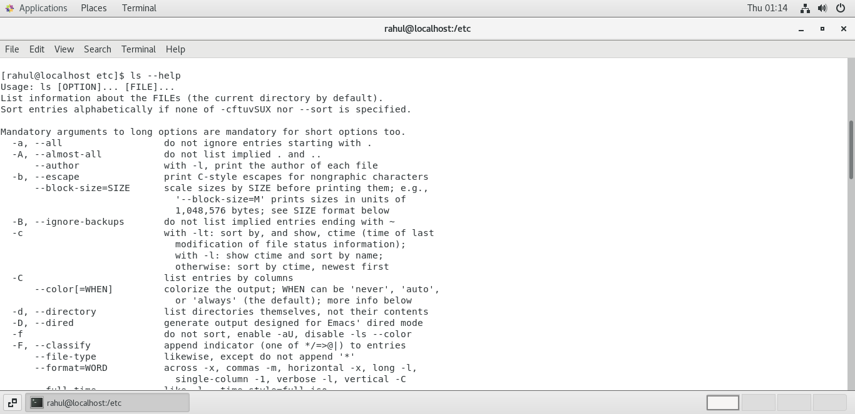**Screenshot:-**

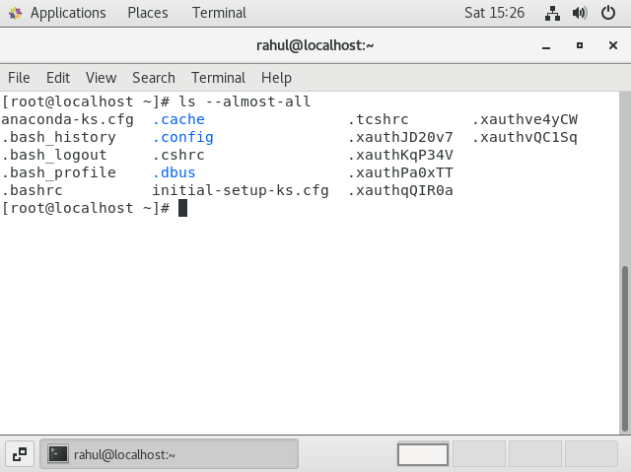

Assignment-5

Know where you are and where you working

*Here we use* ***pwd, cd and ls*** *as combine task to understand where you working on terminal and how you can switch from one directory to another one.*

* Open terminal after restart the linux
  + Check which location you working, type **pwd** and take screenshot

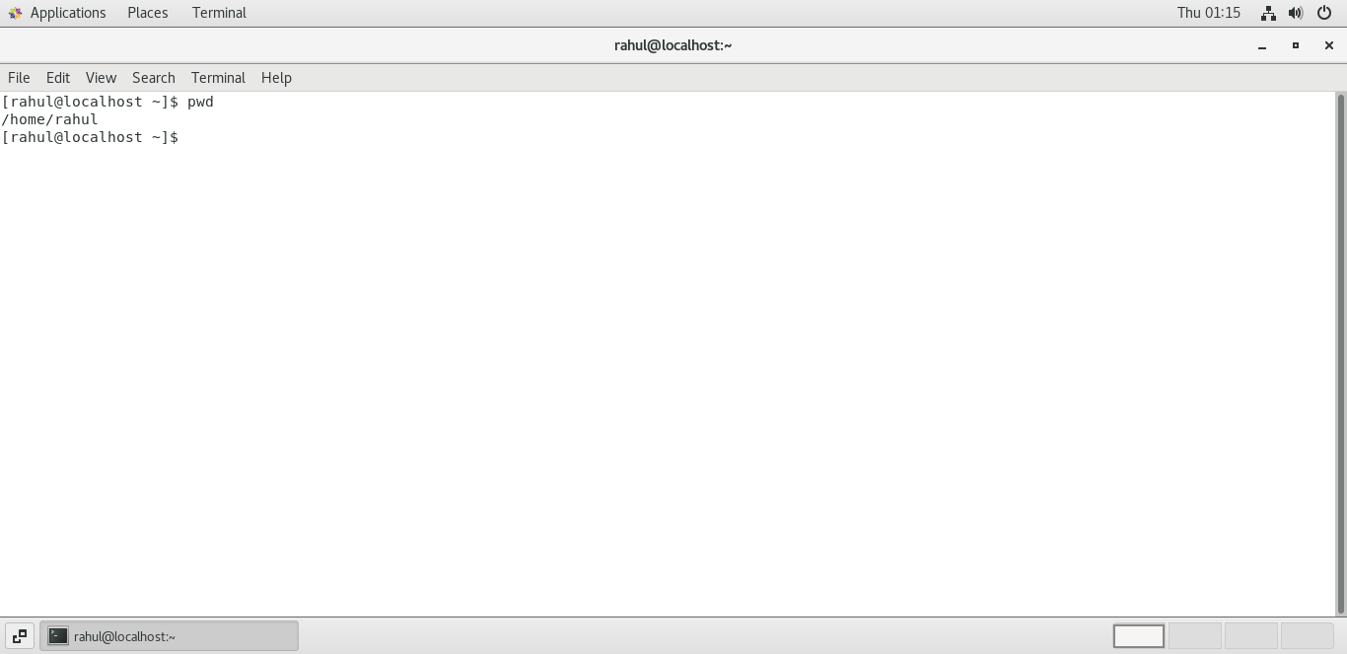

* Now use **cd /var** and hit **Enter** key
  + Do **ls,** and see what output comes, give screenshot?

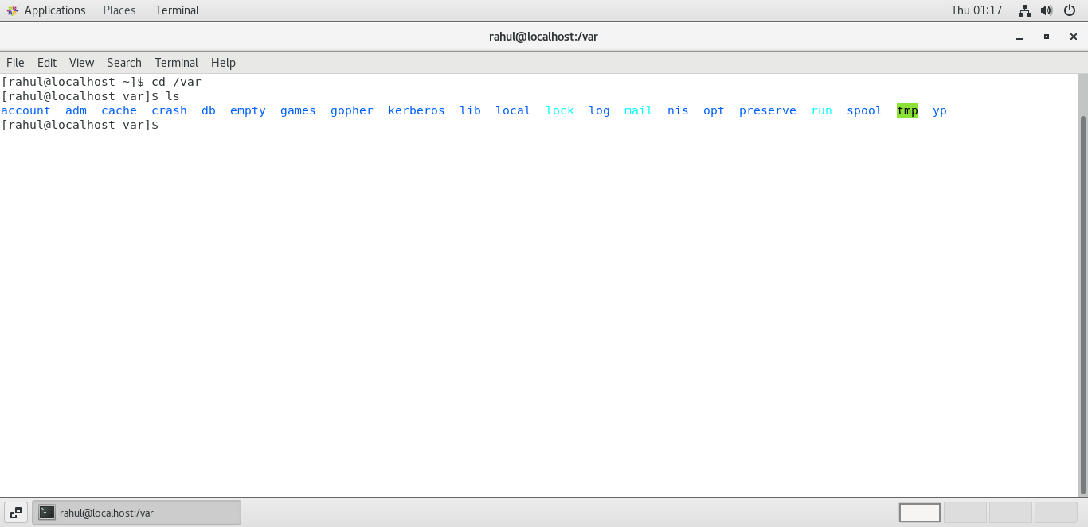

* Do explore other help options of each command to learn more other things we can do with these commands