My profile

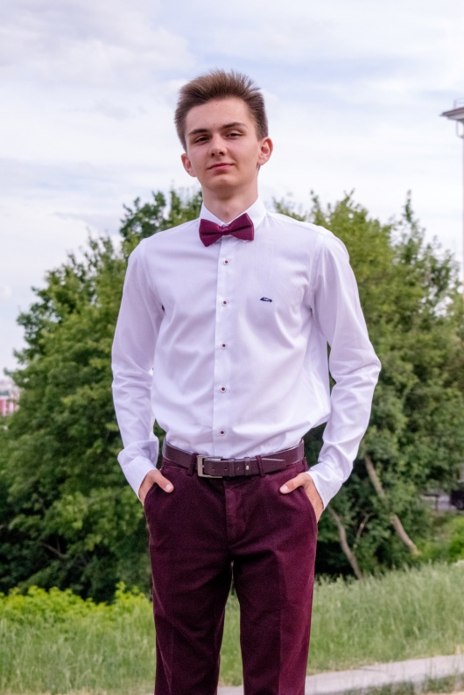

My name is Vlad. My surname is Larin. I am 18 years old. I am Russian by nationality. I am from Orel. I’d like to live in St. Petersburg. My hobby is a football. In the future I would like to become a programmer.