專題計畫書
成員
目錄
- 研究動機與背景

- 研究目的

- 系統架構
diagram
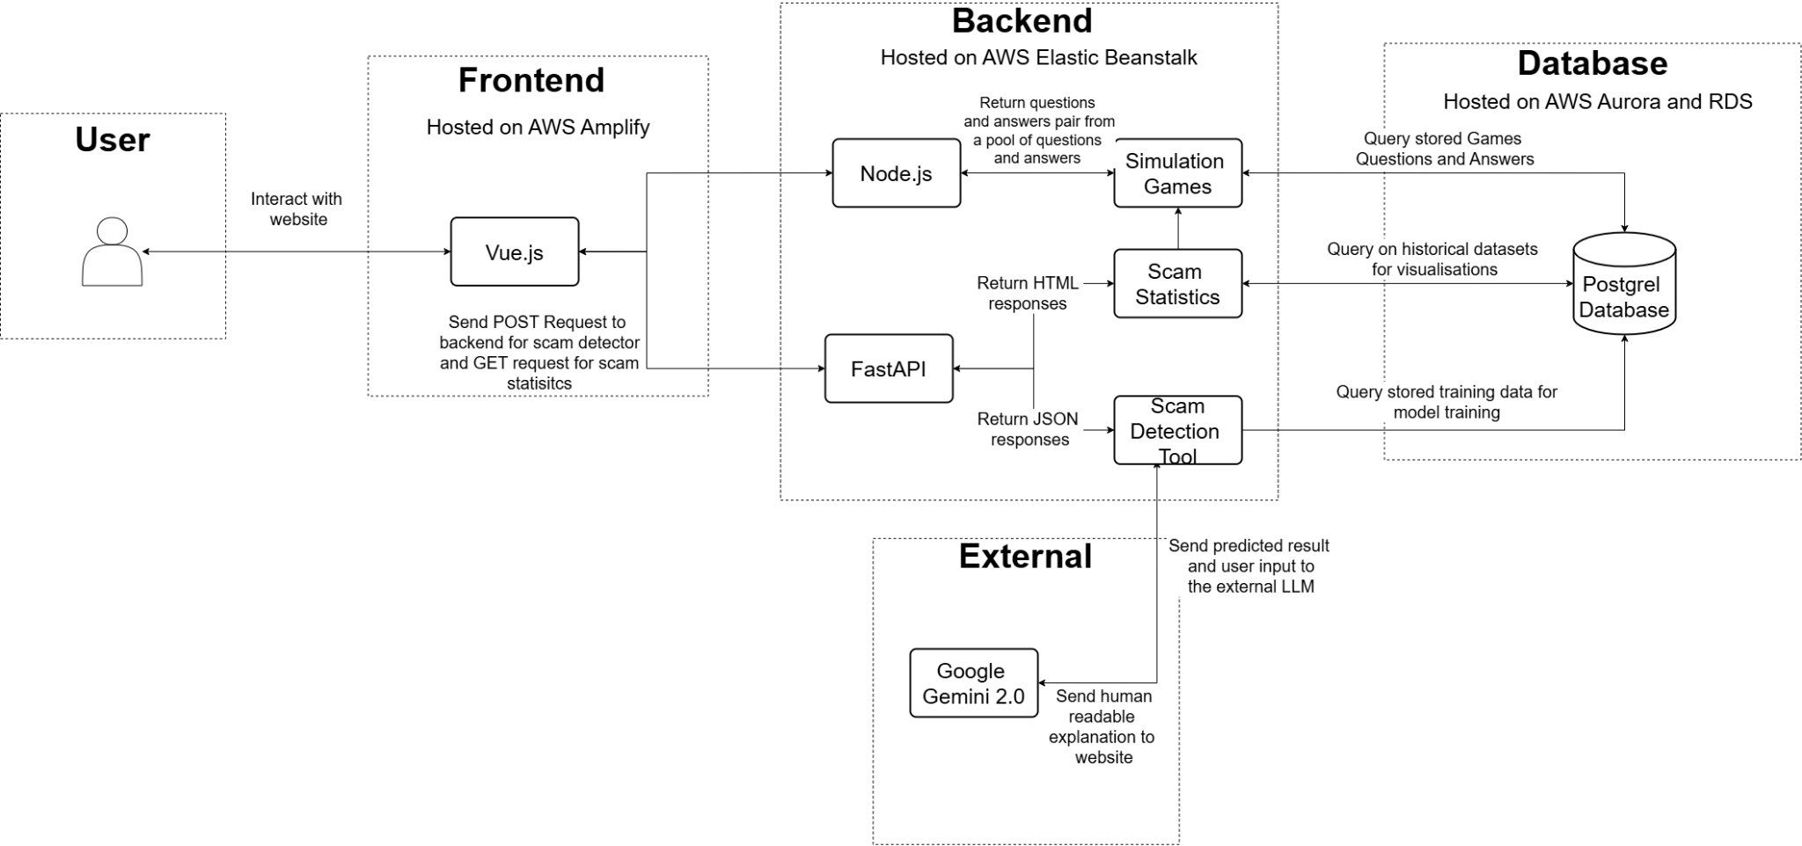

Architecture Explanation
Component | Description
Vue.js Frontend | A dynamic multi-page application (MPA) built for responsiveness and clarity. It handles user interaction, integration requests to backend and presentation of results.
Node.js Microservice Backend | Hosts the routing functions on simulation games and query lists of question and answer pairs to send to the frontend.
Python FastAPI Backend | Internal system integration  - Hosts the scam detection model and scam statistics function by managing prediction or data visualisation requests.  External system integration  - Manages the request to the external Google Gemini model and processes Google Gemini’s responses for displaying results on the frontend.
PostgreSQL Database | Stores model training data, dictionary of question and answer pairs for simulation games, and historical scam data from the year 2021 to 2025.
Deployment Infrastructure | - Frontend - AWS Amplify  - Backend - AWS Elastic Beanstalk  - Database - AWS Aurora and RDS
- 開發環境與技術
PC, OS, Python version, libraries,
- 系統功能設計
圖和解說
- GitHub 專案
- PostgreSQL
- 態網頁爬蟲 Selenium/ Playwright
- 資料分析
- 分配表
- 未來期望

