Hi Lisa, Could you please extract the attached Zip file into a folder on a USB Stick.

You should then have a folder with the following contents.

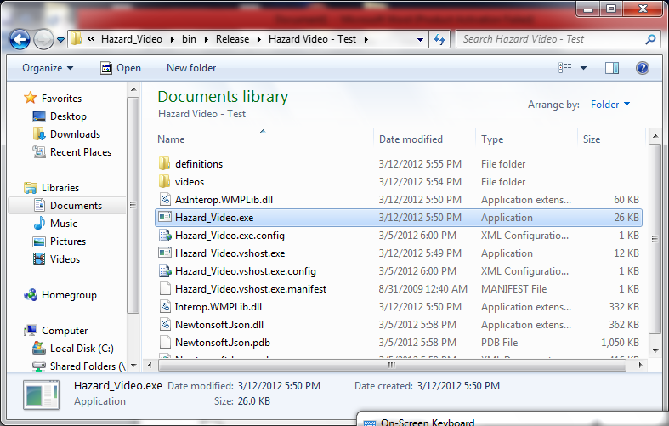

Run the Hazard_Video.exe program, which will start the Hazard Tests program.

If you get a prompt about an unverified publisher, press ‘Run’ to start the program.

You should then see a window similar to the following: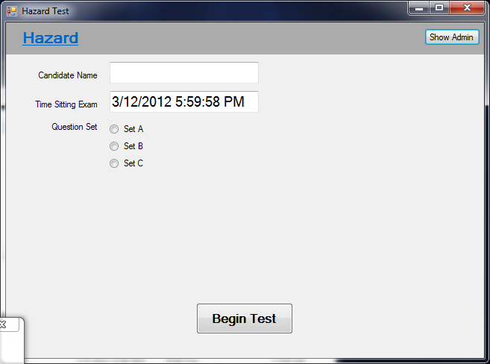

Could you please enter your name in the candidate name field, choose question set A, and press ‘Begin Test’. You should now see one of the videos you emailed me begin to play (This means it worked!).

**Other things you can see**

If you click the ‘Hazard’ text at the top of the window while the test is playing, or click the video, a sound will play to show you (as the test candidate) think a hazard has occurred. When the video finishes, a new window will come up for you to try the next question.

When you have tried all the questions, a final screen will show to say ‘You’ve finished the test, here is your final score’. *

The candidates score is added to an excel file in the definitions folder – this will list all test candidates, results, and which type of test they sat. *

**Administration – setting up the test**

If you click the ‘Show Admin’ button at the top, you will be asked for a password (“wyburd”) to show the admin options. **You’ll need to set everything up in here once before everyone takes the real test.**

Firstly you need to copy all of your hazard test videos to the videos subfolder, then click ‘Add new’ in the Hazard Test Admin Area to tell the program they are there. It’ll make a list of videos it finds.

Watch each video in the list by clicking on it. When a hazard begins occurring, click ‘Start’ in the ‘Add new Hazard area’ to record position in the video. When the hazard is over, click ‘End’, to again record the video position. You then add it to the video test question by clicking ‘Add Hazard’.

All the hazards stored against the video are in the ‘Existing Hazards’ Section.

When you’ve done this for all the videos, the test is ready to go.

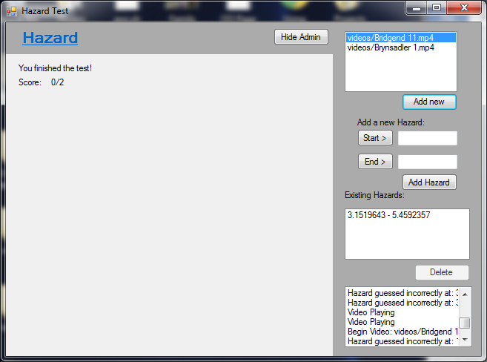

This is just a log of what the video player does. It’ll keep track of when you click for a hazard, when a video starts and stops, etc.

This is where you’ve said a hazard occurs in the video. You can add new ones or delete old ones*.You can have multiple hazards per video if you need.

Here is where you add a new hazard to the current playing video. Click ‘Start’ when a hazard begins in the video, and ‘End’ when one ends. Click ‘Add Hazard’ to store it for when a user takes the test

Here is the videos the user will be shown in their test. Click ‘Add new’ to check the videos folder for new videos (mp4 and avi only)

Click a video in the list to play it.

**\*I haven’t spent much time here yet, so don’t consider this finished.**