Sram_controller: 1271

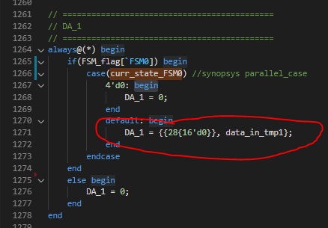

Why not DA_1 = {32{data_in_tmp1}}??

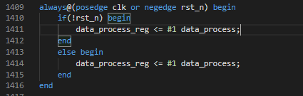

Why doo we need this data_process_reg ??

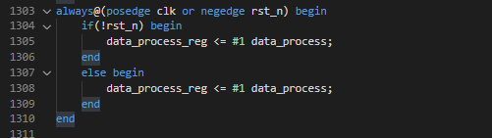

These lines seem no function.