Answer-1

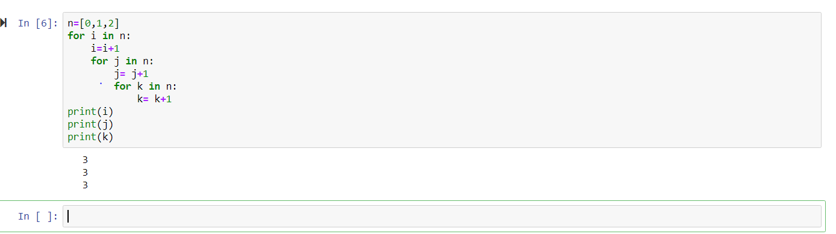

Answer-2

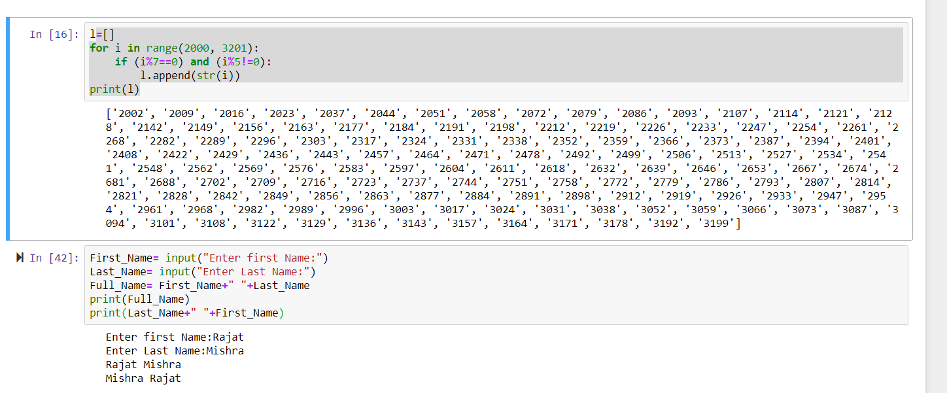

Answer-3

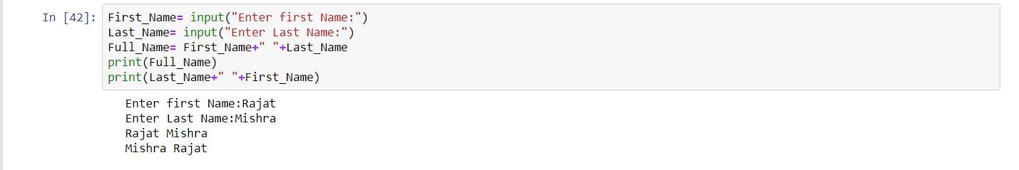

Aswer-4

