Answer-1

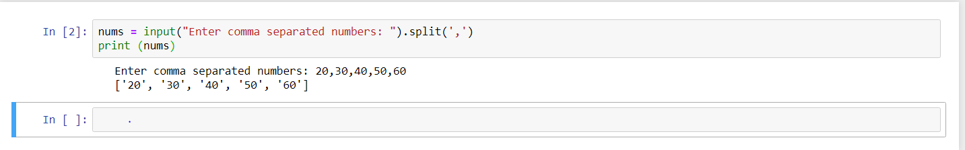

Answer-2

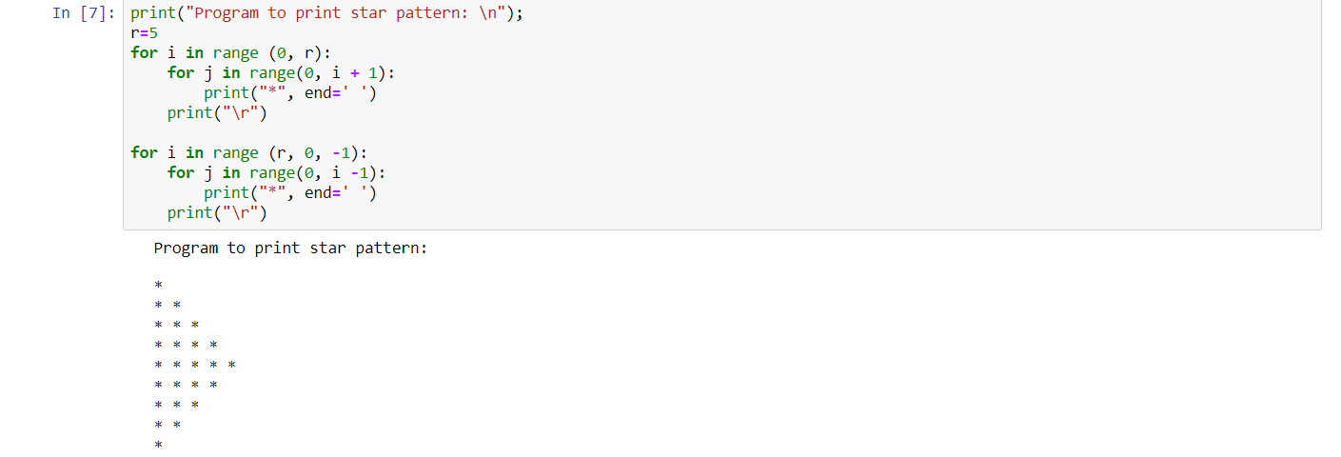

Answer-3

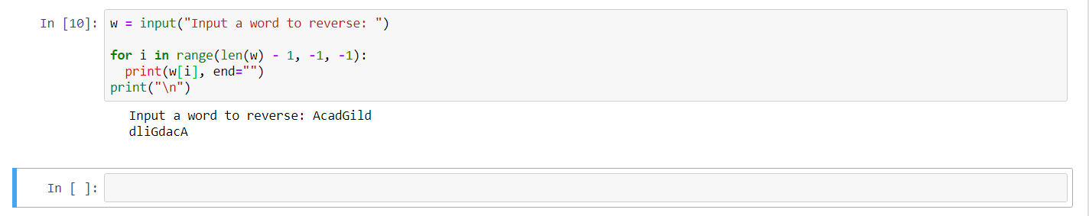

Answer-4

