**准备工作：**

 1、安装WIN8/WIN8.1的SDK，MS网站下载

2、修改项目配置文件（*.csproj）

    2.1、使用记事本打开项目配置文件

    2.2、在“project”节点下，添加子节点  
            <PropertyGroup>  
                <TargetPlatformVersion>8.1</TargetPlatformVersion>  
            </PropertyGroup>

    2.3、记得保存修改

3、打开项目（如果项目已经打开，请重新加载）

4、点击引用，发现左侧菜单比平时多出“Windows 8”(/“Windows 8.1”)，当然，所谓多出，只发生在第一次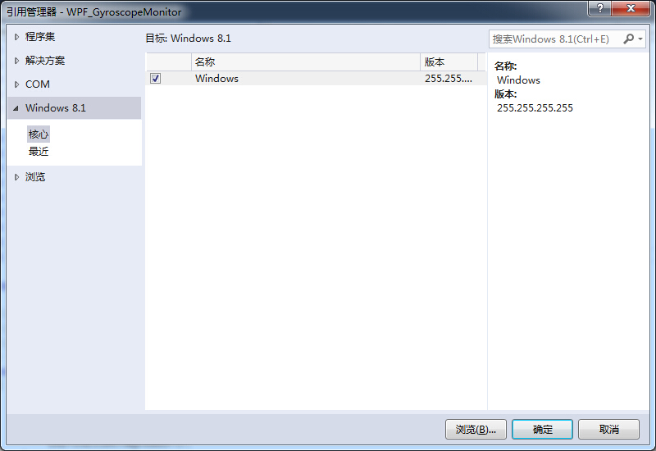

5、在核心下选择根据你的需要，勾选条目，我这里仅仅选择了“Windows”条目

6、回到cs文件中，引用 Windows.Devices.Sensors命名空间（"using Windows.Devices.Sensors;"）成功

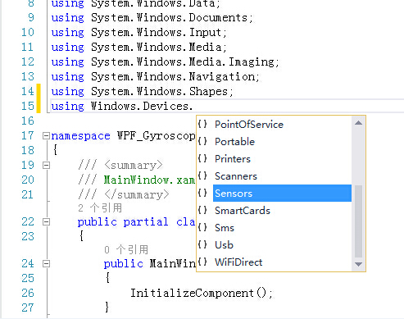

7、欧耶，over.

**调用键盘：**

private const Int32 WM_SYSCOMMAND = 274;

private const UInt32 SC_CLOSE = 61536;

[DllImport("user32.dll", SetLastError = true, CharSet = CharSet.Auto)]

private static extern bool PostMessage(IntPtr hWnd, int Msg, int wParam, int lParam);

[DllImport("user32.dll", SetLastError = true, CharSet = CharSet.Auto)]

private static extern bool PostMessage(IntPtr hWnd, int Msg, uint wParam, uint lParam);

[DllImport("user32.dll", SetLastError = true, CharSet = CharSet.Auto)]

private static extern bool PostMessage(IntPtr hWnd, uint Msg, IntPtr wParam, IntPtr lParam);

[DllImport("user32.dll", SetLastError = true, CharSet = CharSet.Auto)]

private static extern IntPtr FindWindow(string lpClassName, string lpWindowName);

[DllImport("user32.dll", CharSet = CharSet.Auto, SetLastError = true)]

private static extern int RegisterWindowMessage(string lpString);

//显示屏幕键盘

public static int ShowInputPanel()

{

try

{

dynamic file = "C:\\Program Files\\Common Files\\microsoft shared\\ink\\TabTip.exe";

if (!System.IO.File.Exists(file))

return -1;

Process.Start(file);

return SetUnDock();

}

catch (Exception)

{

return 255;

}

}

//隐藏屏幕键盘

public static void HideInputPanel()

{

IntPtr TouchhWnd = new IntPtr(0);

TouchhWnd = FindWindow("IPTip_Main_Window", null);

if (TouchhWnd == IntPtr.Zero)

return;

PostMessage(TouchhWnd, WM_SYSCOMMAND, SC_CLOSE, 0);

}

**调用定位：**

  using System;

using System.Collections.Generic;

using System.ComponentModel;

using System.Data;

using System.Drawing;

using System.Linq;

using System.Text;

using System.Threading.Tasks;

using Windows.Devices.Sensors;

using Windows.Devices.Geolocation;

using Windows.Devices.Geolocation.Geoposition;

using Windows.Foundation;

namespace Hello_Location

{

public partial class Form1 :

{

public Form1()

{

InitializeComponent();

}

async private void Form1_Load(object sender, EventArgs e)

{

Geolocator loc = new Geolocator();

try

{

loc.DesiredAccuracy = PositionAccuracy.High;

Geoposition pos = await loc.GetGeopositionAsync();

var lat = pos.Coordinate.Latitude;

var lang = pos.Coordinate.Longitude;

Console.WriteLine(lat+ " " +lang);

}

catch (System.UnauthorizedAccessException)

{

// handle error

}

}

private void button1_Click(object sender, EventArgs e)

{

}

}

}

来源： <<http://stackoverflow.com/questions/13125793/getting-location-in-windows-8-desktop-apps>>