Shelly Power Controller Dashboard
Overview
The ASCOM Shelly Controller Switch Driver supports most combinations of Shelly Relay devices. A Shelly Relay device can consist of 1, 2 or 4 relays. Relays are generally 120VAC, but many types are available including 12VDC. Shelly only provides phone app software to control its relays.

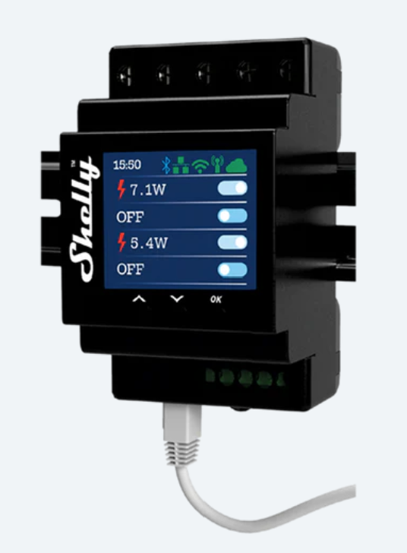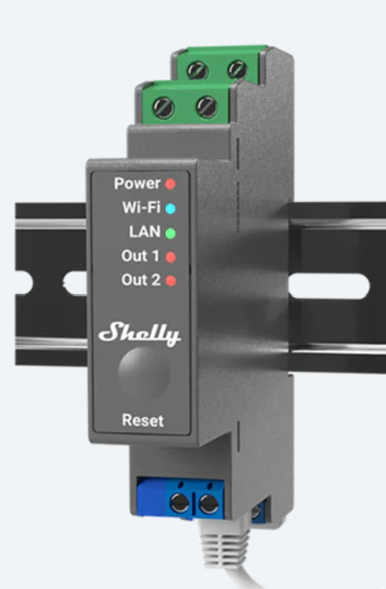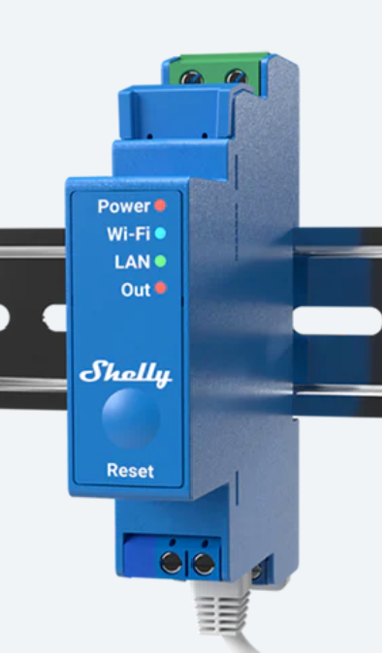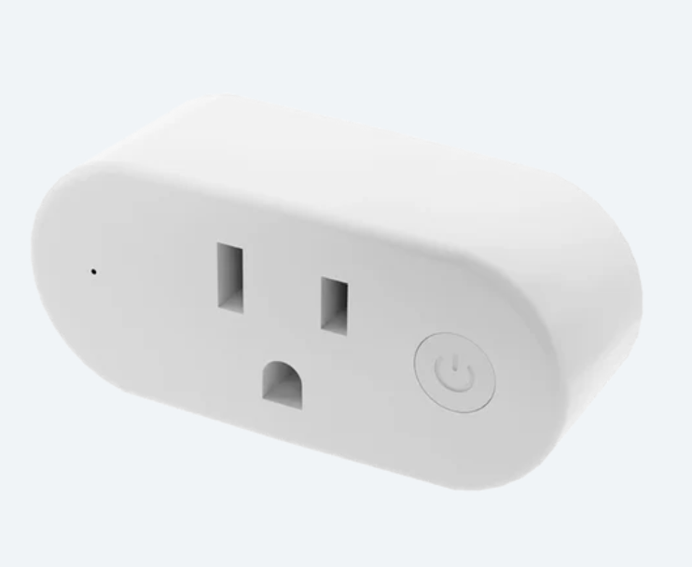
Shelly Relay devices can connect via Ethernet or WiFi. In the latter case, the Shelly phone application must be installed on the user’s smart phone and used to configure the device to the user’s wifi network. Once the device has been initialized on either an ethernet or wifi network, the assigned IP address is used in the Properties Setup to identify the device and its relay compliment.
Using this application, the user can configure multiple relays from one or more Shelly devices. Each relay can be uniquely named for display.
Shelly relays will retain their state upon launch or close of a client application and will resume their prior state following power outage. The Relay names may or may not be retained through a power outage.

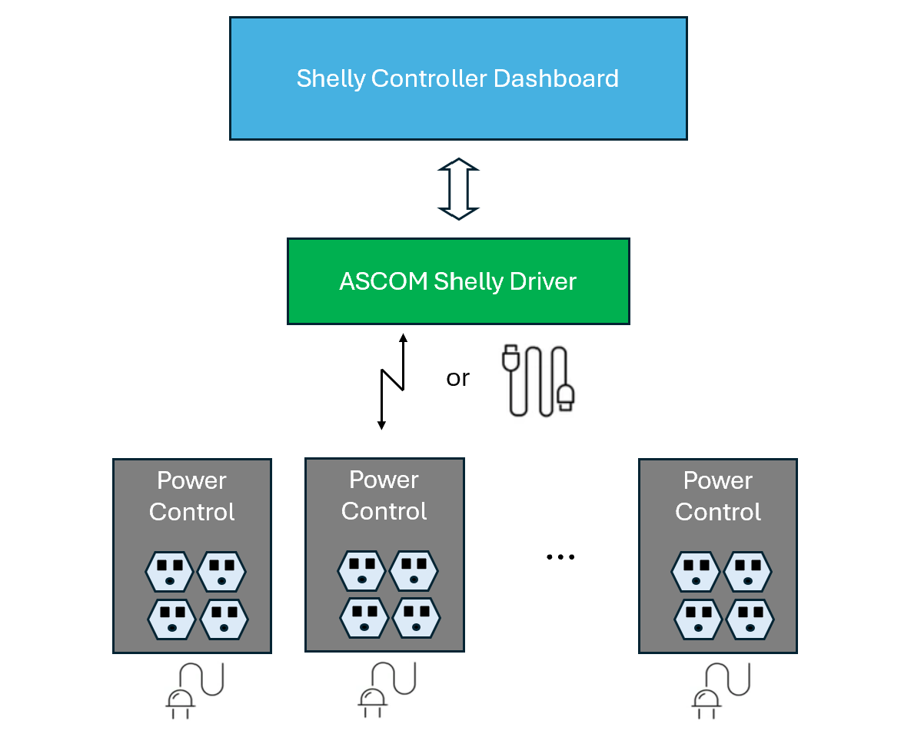

Hardware Installation
- Ethernet Instructions (Option 1)
  - Connect Shelly Control Box to Ethernet
  - Power up Shelly Control Box
  - Read IP Address
    - Hold Shelly “OK” button down for 3 seconds or so
    - Use Shelly arrow buttons to select “Status” and press “OK” button
    - Record Ethernet IP Address
- WiFi Instructions (Option 2)
  - Use Shelly Phone App (Store) to configure Shelly Relay device
  - Read IP Address
    - Hold Shelly “OK” button down for 3 seconds or so
    - Use Shelly arrow buttons to select “Status” and press “OK” button
    - Record WiFi AP IP Address

Software Installation
- Install ASCOM Driver for Shelly Controller
  - Open and extract ShellyControllerSetup.zip from https://github.com/rrskybox/ShellyController/tree/master/Installation
  - Launch ShellyControllerSetup.exe and follow instructions
Dashboard Instructions
When configuring the driver, select ASOM Switch Driver for ShellyRelayControllers from the drop-down menu.
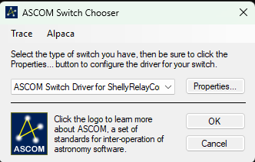
Select “Properties”.
The Shelly Relay Set Up window should display, initially blank.
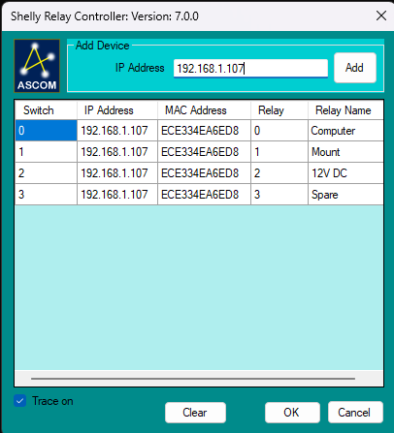
Enter the IP address for the first (or only) Shelly Device and select Add. One to four switch devices should display in a grid. Relay Names may be blank.
Enter a Relay Name for each Output relay.
Follow the same steps for any additional devices. The list can be cleared to start over if desired (“Clear” button).
Enter “OK to accept device configuration.
Then enter “OK” in the Properties Set Up window to accept driver configuration.

