

La Salle University
College of Computer Studies, Engineering, and Architecture

SystAdmin

LABORATORY 1-3
Setting Up Azure Resource Manager template

This activity introduces the process of creating and deploying an Azure Resource Manager (ARM) template using Visual Studio Code and Azure CLI. Students begin by setting up a basic ARM template, then deploy it to Azure within a resource group. They proceed to modify the template by adding a storage account resource and redeploy it with an updated deployment name. Finally, they verify the deployment results in the Azure portal, gaining hands-on experience in infrastructure as code and Azure resource management.

Objectives:
- Identify the basic structure and components of an ARM template, including parameters, variables, resources, and outputs.
- Deploy and modify an ARM template in Azure by creating a storage account resource and analyzing the deployment results in the Azure portal.

Create an ARM template
- Open Visual Studio Code and create a new file called azuredeploy.json.
- Copy and paste the following code into the file.
- JSON
{
"$schema": "https://schema.management.azure.com/schemas/2019-04-01/deploymentTemplate.json#",
"contentVersion": "1.0.0.0",
"parameters": {},
"functions": [],
"variables": {},
"resources": [],
"outputs": {}
}
- Notice that this file has all of the sections of an ARM template that we described in the previous unit.
- Save the changes to the file by pressing Ctrl+S.

Deploy the ARM template to Azure
To deploy the template to Azure, sign in to your Azure account using the Visual Studio Code terminal. Make sure the Azure CLI tools are installed before proceeding.
- Select Terminal > New Terminal to open a terminal window.
- If the command bar of the terminal window says bash, you have the right shell to work from and you can skip to the next section.
  - If not, select the drop-down and choose Select Default Profile.
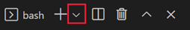
  - Select Git Bash.
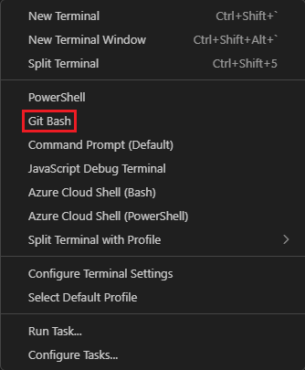
- Change directory to the folder containing your ARM template file.

Sign in to Azure
In the terminal window, run this command to sign in to Azure.
Azure CLI
az login

In the browser window that appears, sign in to your account. Once signed in, the terminal will display a list of subscriptions linked to your account, with the default subscription marked by an asterisk (*). If you have more than one subscription, choose the one you want to use for this exercise.

Next, create and set the default resource group.

In the Azure CLI
az group create --name <resource-group-name> --location <location>

Replace <resource-group-name> with a unique name for your resource group. Replace <location> with the Azure region closest to you. For example, use eastus for East US.
By setting the default resource group, you can omit that parameter from the Azure CLI commands in this exercise. To set the resource group, run the following command.
Azure CLI
az configure --defaults group="<resource-group-name>"

Replace <resource-group-name> with your resource group name.

Deploy the template to Azure
Run the following commands to deploy the ARM template to Azure. The ARM template doesn't have any resources yet, so there aren't any resources created. You should get a successful deployment.

Azure CLI
templateFile="azuredeploy.json"
today=$(date +"%d-%b-%Y")
DeploymentName="blanktemplate-"$today

az deployment group create \
--name $DeploymentName \
--template-file $templateFile

The upper part of the code defines Azure CLI variables, including the template file path and the deployment name. The lower part, az deployment group create, executes the deployment to Azure. Notice that the deployment name is set as blanktemplate with the current date appended as a suffix.
You should see Running... in the terminal.
When you deploy your ARM template to Azure, go to the Azure portal.
- In the resource menu, select Resource groups.
- Select the resource group you created in this exercise.
- On the Overview pane, you see that one deployment succeeded.
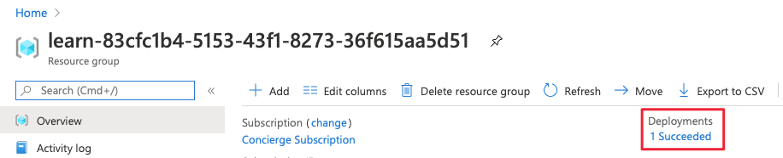
- Select 1 Succeeded to see the details of the deployment.
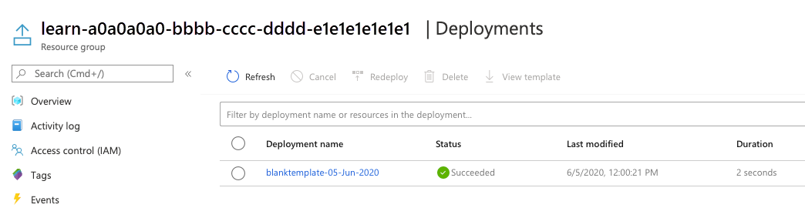
- Select blanktemplate to see what resources were deployed. In this case, it's empty because you didn't specify any resources in the template yet.
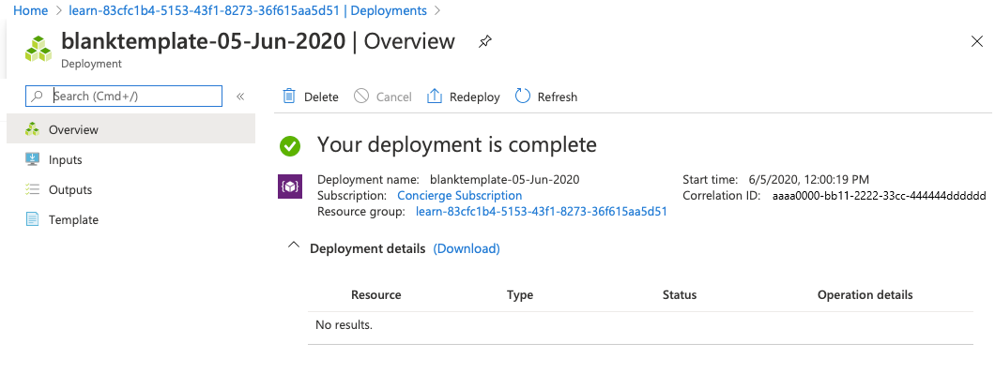
- Leave the page open in your browser so that you can check on deployments again.

Add a resource to the ARM template
In the previous task, you created and deployed a blank template. Now, you will proceed to deploy a real resource by adding an Azure Storage Account to the ARM template.
- In the azuredeploy.json file in Visual Studio Code, update the file so it looks like:
- JSON
{
"$schema": "https://schema.management.azure.com/schemas/2019-04-01/deploymentTemplate.json#",
"contentVersion": "1.0.0.0",
"parameters": {},
"functions": [],
"variables": {},
"resources": [
{
"type": "Microsoft.Storage/storageAccounts",
"apiVersion": "2025-01-01",
"name": "storageaccount1",
"tags": {
"displayName": "storageaccount1"
},
"location": "[resourceGroup().location]",
"kind": "StorageV2",
"sku": {
"name": "Standard_LRS"
}
}
],
"outputs": {}
}

- Change the values of the resource name and displayName to something unique (for example, learnexercise12321). This name must be globally unique across Azure, contain 3 to 24 characters, and include only lowercase letters, numbers, and hyphens.
- The resource location is set to the same location as the resource group where the resource is deployed. Leave the default here.
- Save the file.

Deploy the updated ARM template
Update the deployment name to better reflect its purpose, then execute the following Azure CLI command

Azure CLI
templateFile="azuredeploy.json"
today=$(date +"%d-%b-%Y")
DeploymentName="addstorage-"$today

az deployment group create \
--name $DeploymentName \
--template-file $templateFile

Check your deployment
- Once the deployment is complete, return to the Azure portal in your browser. Open your resource group, where you will now see two successful deployments. Click the link to view them.
- You will notice that both deployments are listed.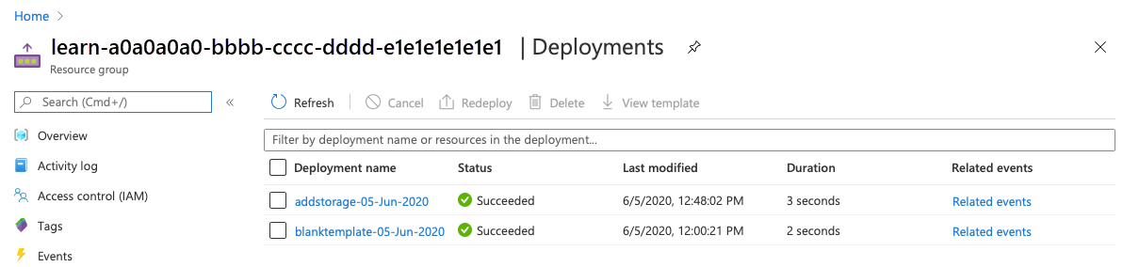
- Select addstorage.
- 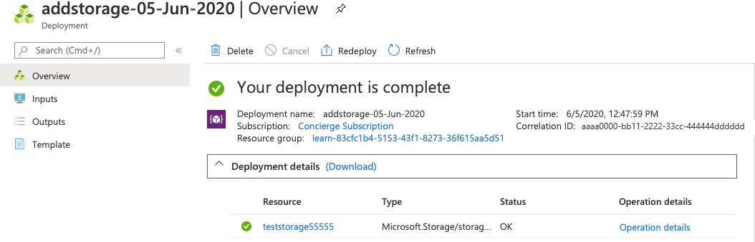
Notice that the storage account is deployed.

