Login to Console

Services => ec2=>Launch Instance

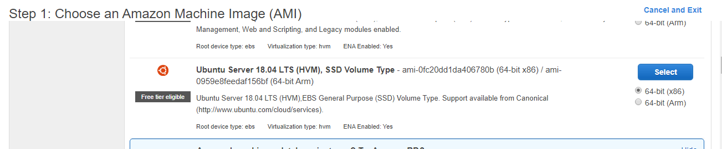

Keep Configulation default:

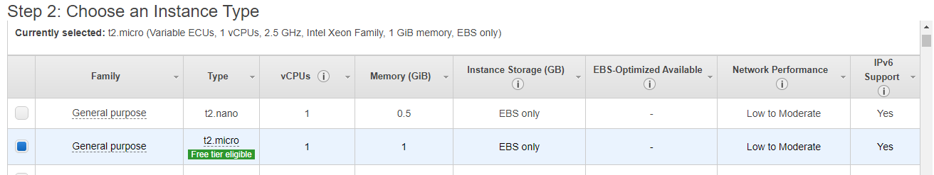

vCPU = 1

Memory = 1 GiB (8 GB)

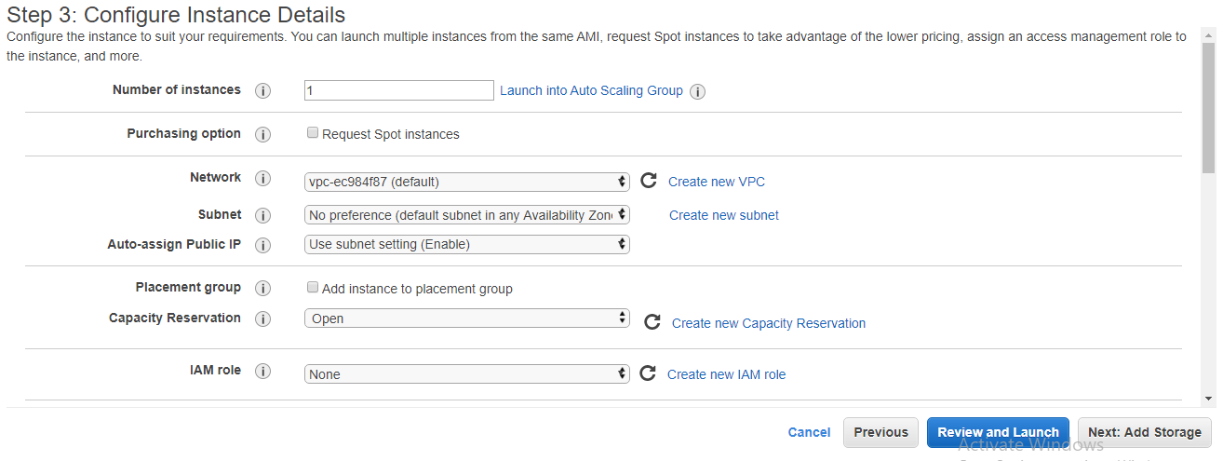

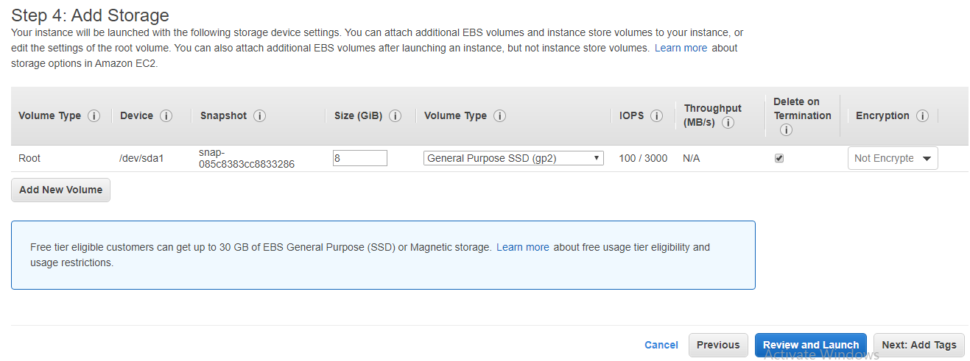

Add a Tag below

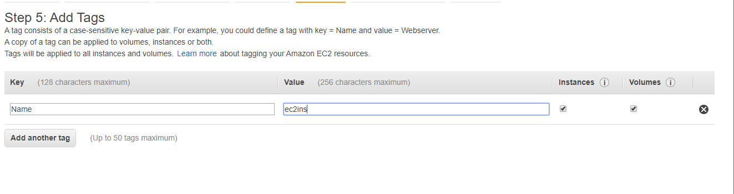

For Demo Added security group to allow all type of inbound calls and from any ip

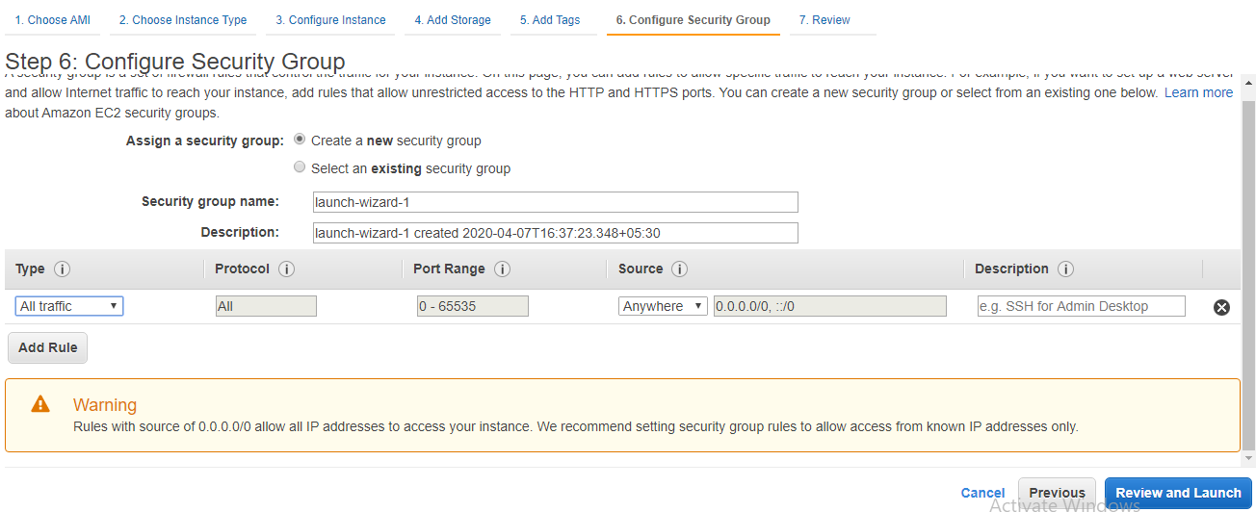

Create a new Key ssh key and download and save in local for passwordless connection

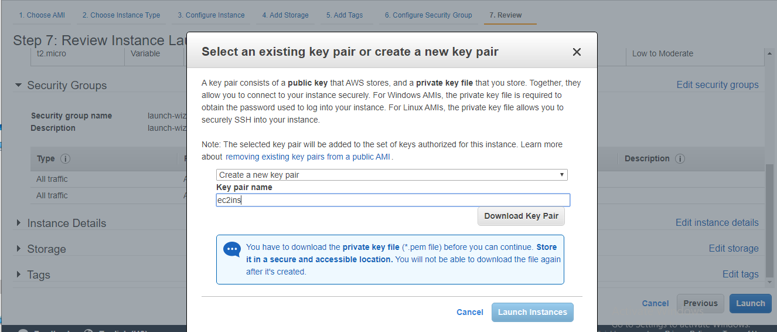

Running instance

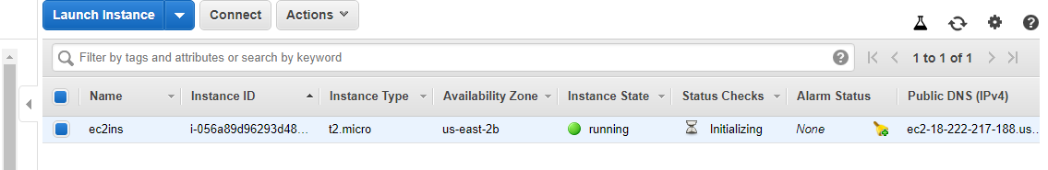

**For Connection from local**

1. Download & install Putty

<https://www.chiark.greenend.org.uk/~sgtatham/putty/latest.html>

1. Select puttykeygen

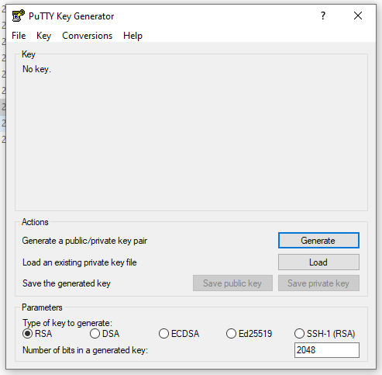

1. Choose **Load**. By default, PuTTYgen displays only files with the extension .ppk. To locate your .pem file, choose the option to display files of all types.

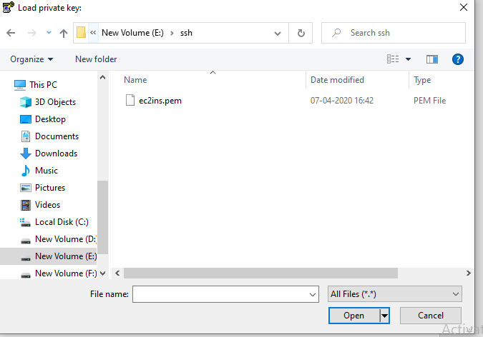

1. Select your .pem file for the key pair that you specified when you launched your instance and choose **Open**. PuTTYgen displays a notice that the .pem file was successfully imported. Choose **OK**.

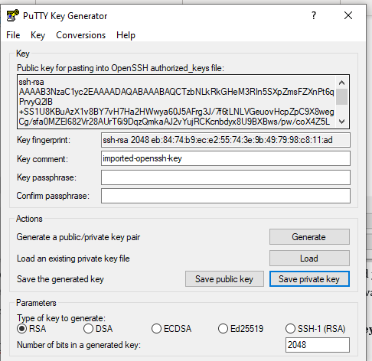

1. To save the key in the format that PuTTY can use, choose **Save private key**. PuTTYgen displays a warning about saving the key without a passphrase. Choose **Yes**. Save with name **ec2ins.ppk**

**To access your instance:**

Access Putty

1. In Session

Hostname : ec2-18-217-15-231.us-east-2.compute.amazonaws.com

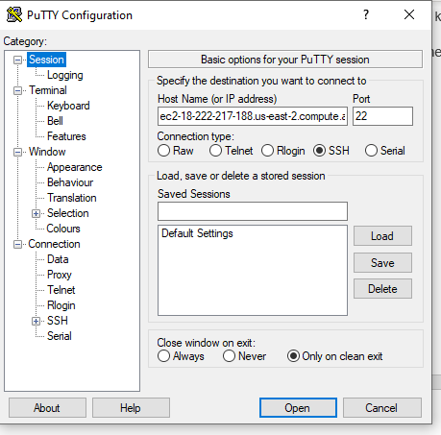

1. In Connection/Data

Logical Name: **ubuntu**

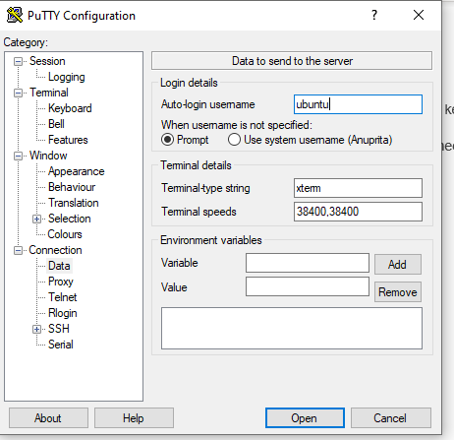

1. In SSH/Auth : Browse to PPK location

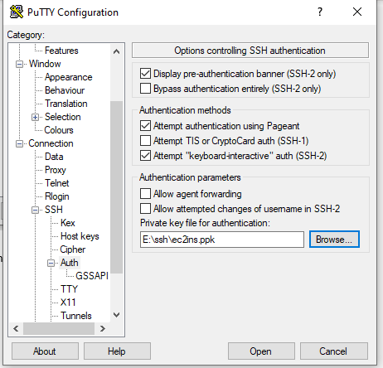

1. Save the session and open

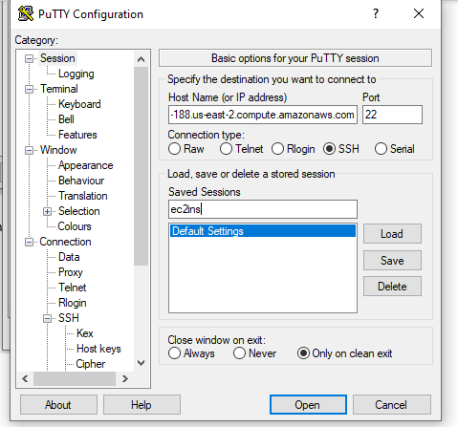

**Deploy Code to EC2 instance**

1. Download winscp

<https://winscp.net/eng/download.php>

1. Open Winscp

Hostname : ec2-18-217-15-231.us-east-2.compute.amazonaws.com

Port:22

Username : ubuntu

<https://skype.pnc.com/meet/taylor.egen/JPDFY2HP>

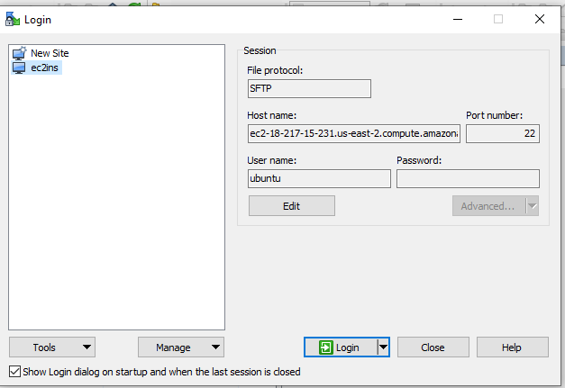

**“Double Click on Advanced”**

1. Go to ssh->Authentication and browse ppk location and click ok

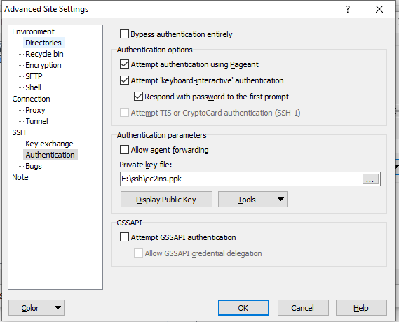

1. Click login
2. Scp Window will be open, enter your deployable in your folder
3. 